**Executive Order 17**

**Recognizing the Value of Recycling and Waste Reduction**

**Report on Food Waste Reduction Strategies**

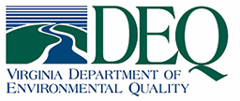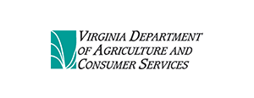

**December 2023**

Contents

Executive Summary 1

Background and Process 2

Strategy 1: Reduce Wasted Food 5

Strategy 2: Donate Extra Food 15

Strategy 3: Feed Animals 20

Strategy 4: Industrial Uses 23

Strategy 5: Composting 27

References 29

Appendices 31

Appendix 1: Executive Order 17 32

Appendix 2: Stakeholders 35

Appendix 3: Virginia Law Relating to Food Donation 36

Appendix 4: Example Food Donation Forms 38

# Executive Summary

Executive Order 17, *Recognizing the Value of Recycling and Waste Reduction* (EO 17), signed by Governor Glenn Youngkin on April 7, 2022, notes that “food waste is the single largest substance by volume sent to solid waste sites across Virginia and the United States.”[1] At the same time, the U.S. Department of Agriculture’s (USDA) Economic Research Service reported that in 2020, 8.5% of Virginia households were food insecure, meaning that at times during the year, these households were uncertain of having, or unable to acquire, enough food to meet the nutritional needs of all their members because they had insufficient money or other resources for food.

EO 17 charges the Department of Environmental Quality (DEQ), in conjunction with the Department of Agriculture and Consumer Services (VDACS), to “work in partnership with large-scale suppliers of food such as food manufacturers, grocery retailers, sports arenas, schools, hotels, and banquet facilities to identify appropriate strategies to reduce food waste in their respective sectors by encouraging donations to needy individuals, food for animals or for composting purposes.” DEQ staff conducted research on food management solutions being employed within the Commonwealth as well as elsewhere in the country. In addition, large-scale food suppliers within Virginia were surveyed for their best practices as well as real and perceived barriers to reducing food waste.

This report outlines food waste reduction strategies for large-scale food providers. The recommended strategies are (in order of preference):

1. **Reduce Wasted Food**: Implementing steps such as monitoring food waste, inventorying supplies, modifying menus, ensuring proper storage and being creative with excess foods can be implemented by the large-scale suppliers of food identified in EO 17. All large-scale suppliers of food in the Commonwealth should consider incorporating or expanding their food waste prevention strategies in their operations.
2. **Donate Extra Food**: All large-scale suppliers of food in the Commonwealth should consider donations of the following food items: products that are unsellable due to product imperfections not affecting product safety or stock issues, commercially packaged non-perishable foods, perishable foods, commercially packaged products that have time/temperature controls for safety of the foods, and excess prepared cold and cooked foods.
3. **Feed Animals**: Food manufacturers should ensure that their byproducts (inedible or unpalatable food scraps) are captured and processed into commercial feed for animals. Other large-scale suppliers of food in the Commonwealth should consider establishing partnerships with local farms to divert food scraps to animal feed.
4. **Industrial Uses**: Large-scale food suppliers in Virginia should consider turning inedible, unsold food into industrial products through rendering, anaerobic digestion, and the production of biodiesel.
5. **Composting**: Large-scale food suppliers in Virginia should consider their on-site and off-site composting options.

# Background and Process

Executive Order 17, *Recognizing the Value of Recycling and Waste Reduction* (EO 17), signed by Governor Glenn Youngkin on April 7, 2022, notes that “food waste is the single largest substance by volume sent to solid waste sites across Virginia and the United States.” The U.S. Environmental Protection Agency (EPA) has estimated that “over one-third of the food produced in the U.S. is never eaten, wasting the resources used to produce it and creating a myriad of environmental impacts”.[2] Food waste is the single most common material landfilled and incinerated in the U.S., accounting for 24% of landfilled material and 22% of incinerated material. EPA has also estimated that the environmental impacts of food waste in the U.S. (excluding impacts of waste management, such as landfill methane emissions) include greenhouse gas emissions equaling more than 42 coal-fired power plants, enough water and energy to supply more than 50 million homes, the amount of fertilizer used in the U.S. to grow all plant-based foods for U.S. human consumption, and an area of agricultural land equal to California and New York combined.[3]

At the same time, the U.S. Department of Agriculture’s (USDA) Economic Research Service reported that in 2020, 8.5% of Virginia households were food insecure, meaning that at times during the year, these households were uncertain of having, or unable to acquire, enough food to meet the needs of all their members because they had insufficient money or other resources for food. Nationally, household food insecurity affected 14.8% of households with children in 2020.[4]

EO 17 charges the Department of Environmental Quality (DEQ), in conjunction with the Department of Agriculture and Consumer Services (VDACS), to “work in partnership with large-scale suppliers of food such as food manufacturers, grocery retailers, sports arenas, schools, hotels and banquet facilities to identify appropriate strategies to reduce food waste in their respective sectors by encouraging donations to needy individuals, food for animals or for composting purposes.” DEQ staff conducted research on food management solutions being employed within the Commonwealth as well as elsewhere in the country. In conjunction with VDACS, DEQ gathered information from stakeholders such trade associations, relevant state and federal agencies, academia, manufacturers of food waste handling technology and engaged non-governmental organizations (see Appendix 2). In addition, large-scale food suppliers within Virginia were surveyed during the last quarter of calendar year 2022 for their best practices as well as real and perceived barriers to reducing food waste.

This report presents food waste reduction strategies for the sectors noted in the EO (food manufacturers, grocery retailers, sports arenas, schools and hotels/banquet facilities) and includes Virginia examples identified through the surveys.[5] Note that the report also includes strategies for food banks and presents those for schools in two categories: K-12 and colleges/universities. The strategies included are presented consistent with those that comprise Virginia’s Food Management Hierarchy (with the exception of the least preferred approach, landfill/incineration, as that is outside the scope of the EO):

* 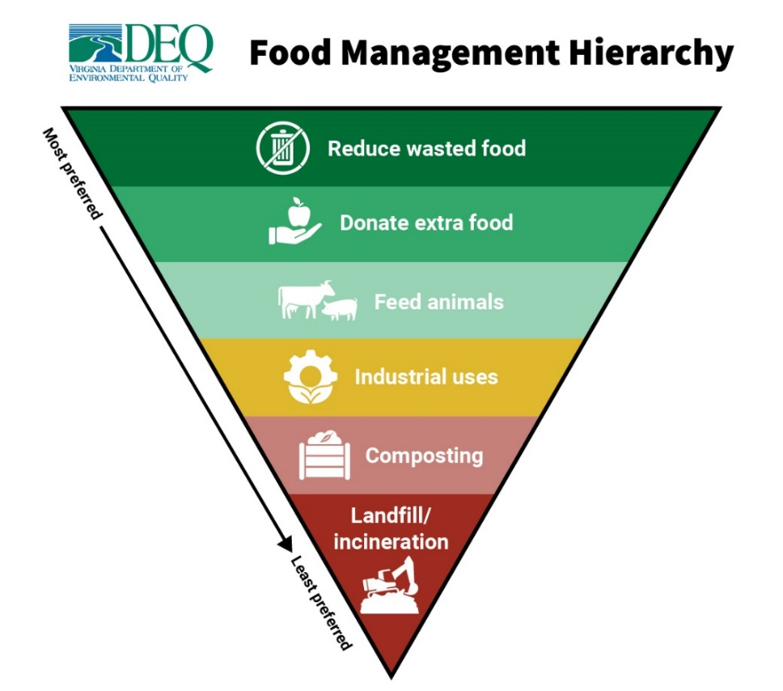**Reduce Wasted Food:** Reduce the volume of surplus food generated.

**Virginia Food Management Hierarchy**

* **Donate Extra Food**: Donate extra food to food banks, soup kitchens, and shelters (typically raw and prepared foods).
* **Feed Animals**: Divert food scraps to animal feed (typically fruits, vegetables, baked goodw, e.g., bread).
* **Industrial Uses**: Render fat, oil and grease into a raw material to make biodiesel, soaps, cosmetics and other products. Anaerobic digestion of food scraps and waste oils produces biogas that can generate heat and electricity, fiber that can be used as a nutrient-rich soil conditioner and liquid that can be used for fertilizers.
* **Composting**: Create a nutrient-rich soil amendment (typically spoiled produce, produce preparation scraps, coffee grounds and any other organic materials accepted by the composter, including paper towels, compostable dishware and utensils).

Additional resources and information, including food waste reduction techniques for households, which produce almost 40% of wasted food in the U.S., is posted on DEQ’s website at <https://www.deq.virginia.gov/get-involved/pollution-prevention/executive-order-17>. [6]

It should be noted that there are currently two bills in Congress related to food waste reduction:

* The Zero Food Waste Act establishes an EPA program to award competitive grants to state, tribal and local governments (with a total of $650 million to be awarded annually through 2031). Grants can support the development of policies, programs and infrastructure at the local level focused on preventing food from going to waste, measuring food waste generation, rescuing surplus food and recycling food scraps. Eligible projects include measurement and assessment activities to identify local generators of food waste and help create plans for regular food waste measurement (essential to tracking the success and progress of food waste reduction initiatives). Other eligible projects can focus on any type of food waste mitigation projects across the hierarchy of prevention, rescue and recycling, including creating new markets and demand for compost products.
* The Cultivating Organic Matter through the Promotion of Sustainable Techniques (COMPOST) Act designates composting as an approved conservation practice (like cover crops) for USDA conservation programs and would make compost projects eligible to receive federal funding and assistance. Additionally, the Act creates a USDA grant and loan guarantee program to provide $200 million annually over ten years for composting infrastructure projects, including organics collection and processing at the industrial, community or household level.

## Strategy 1: Reduce Wasted Food

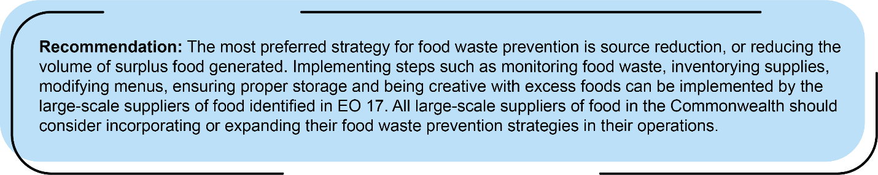

There are numerous source reduction strategies for large-scale food suppliers, ranging from the traditional pollution prevention strategy of conducting a waste audit to newer approaches that use software and social media apps to more accurately manage food and prevent food waste. The table below summarizes the primary source reduction strategies and indicates which of the large-scale food suppliers should consider implementing them.

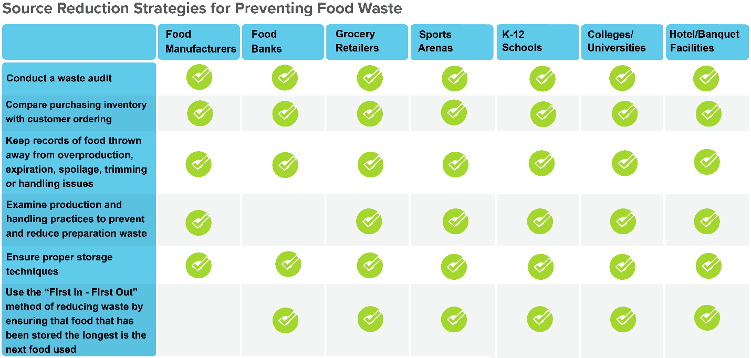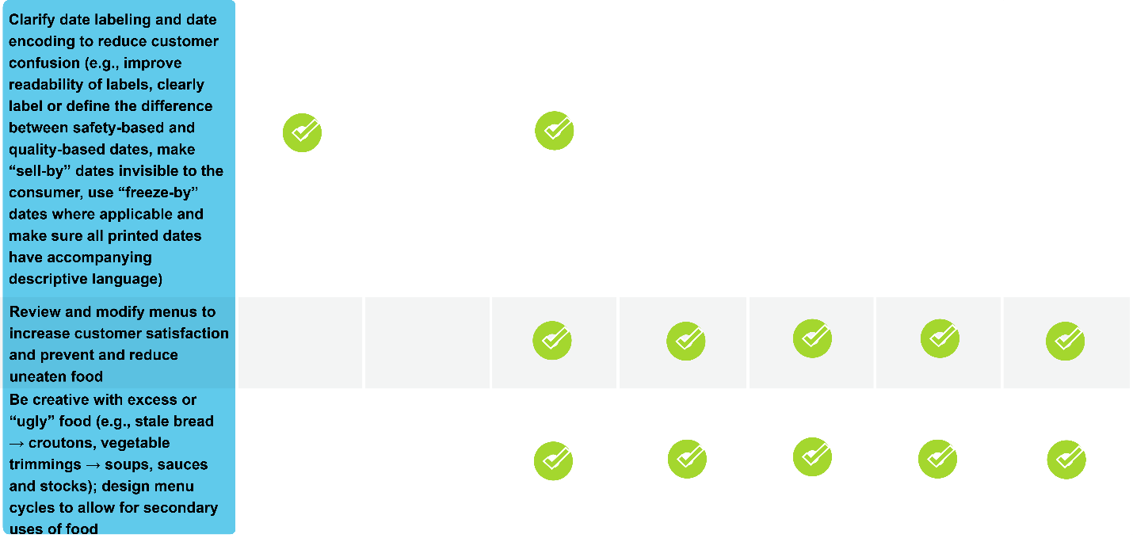

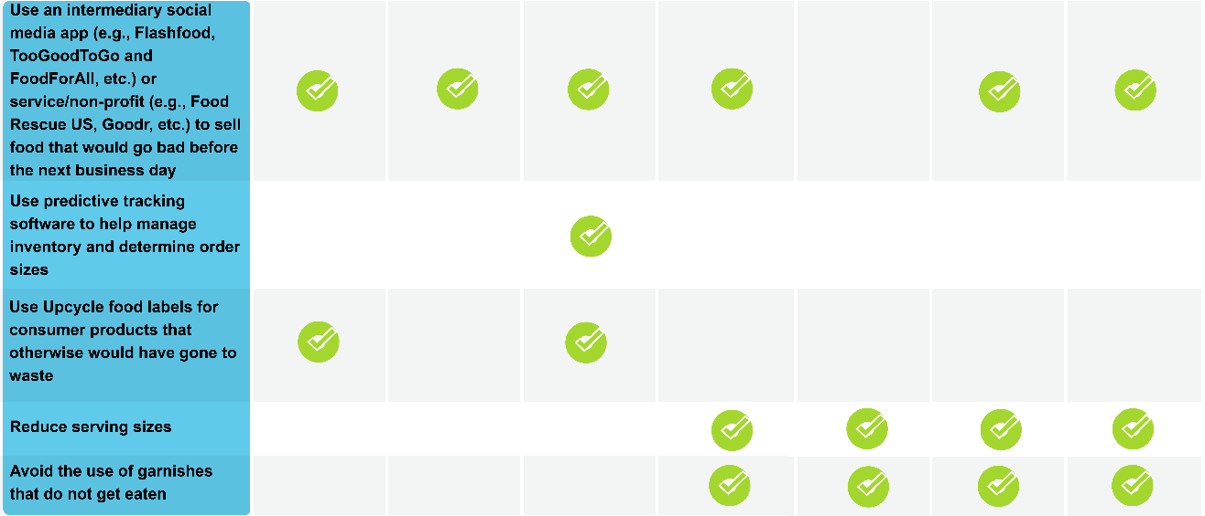

Additional information, including food loss and waste prevention tip sheets developed by EPA for manufacturers, grocery retailers, K-12 schools, colleges/universities and restaurants (hotel and banquet facilities) are available on DEQ’s website at <https://www.deq.virginia.gov/get-involved/pollution-prevention/executive-order-17>.

**Waste Audits**

All large-scale suppliers of food are encouraged to conduct a food waste audit, which serves as the foundation for future reduction efforts. Food waste audits identify the quantity of food that is being wasted, the type of food that is being wasted (which provides crucial data to help understand why food is being wasted and how to reduce that waste), the amount of high quality, edible food that can be diverted from the waste stream and donated to feed those in need, and potential handling and storage constraints that can affect whether food can be donated. EPA has developed a number of food waste assessment tools which can benefit food service establishments by:

* Saving money by reducing over-purchasing and disposal costs
* Reducing environmental impacts
* Supporting efforts to eliminate hunger
* Increasing tax benefits by donating food
* Supporting community waste reduction efforts

The tools, which are available at <https://www.epa.gov/sustainable-management-food/tools-preventing-and-diverting-wasted-food>, include the following:

* **Food Waste Assessment Guidebook**: The guidebook is intended to assist those just starting to consider measuring and tracking their wasted food and takes minimal labor and time to complete. The assessment identifies what is being thrown away, why it is being thrown away and ultimately, the amount of food that can be diverted for donation, feeding animals, industrial uses or composting.
* **Toolkit for Reducing Wasted Food & Packaging**: The toolkit was developed for those seeking higher levels of cost savings and waste reduction and tracks the daily amount, type of, and reason for wasted food and packaging; it requires a minimum of two weeks of daily tracking by staff and weekly data entry for best results.
  + **A Step-by-Step Guide to Conducting a Wasted Food Assessment with the Reducing Wasted Food & Packaging Toolkit**: An online training on using the toolkit.
  + **Reducing Wasted Food & Packaging a Guide for Food Services and Restaurants**: Developed to accompany the toolkit, the guide provides source reduction strategies and case studies of food service establishments where audit results resulted in food waste prevention.
  + **Paper Tracking Waste Log:** A printable form to track the quantity and reason for waste.
* **Guide to Conducting Student Food Waste Audits - A Resource for Schools:** Developed by EPA, the USDA and the University of Arkansas, the guide provides students and school personnel with information on why and how to do a food waste audit and how to use the data collected. It also includes food waste prevention strategies for schools.

The Green Sports Alliance is an environmentally-focused trade organization that convenes stakeholders from around the sporting world to promote healthy, sustainable communities. The Alliance has produced a number of guidance manuals, including the Food Waste Diversion and Compostable Packaging Playbook,[7] which may be helpful for those managing sports venues throughout the Commonwealth.

**Food Date Labeling**

In an effort to reduce food waste, it is important that Virginians understand that many manufacturers’ dates applied to food are for quality and *not* for safety. Food products are often safe to consume past the date on the label. Regardless of the date, Virginians should evaluate the quality of the food product prior to its consumption. As noted by a recent study[8] by the University of Maryland, “many people don’t realize that date labels on food products … are entirely at the manufacturer’s discretion and are not supported by robust scientific evidence.” The same study found more than fifty different food labels on products sold in the U.S., leading to consumer confusion and wasted food.

Virginia requires date labeling for shellfish, where shellfish packages smaller than 64 fluid ounces must be marked with a “sell-by” or “best if used by” date, and shellfish packages with a capacity of 64 fluid ounces or more must be labeled with the date of shucking.[9] Virginia also requires date labeling for dairy products. Sales of past-date dairy products are prohibited; donation of any past-date item is not restricted.[10]

Additionally, certain foods held more than twenty-four hours in a food establishment in Virginia must be labeled with the date by which the food shall be consumed on the premises, sold or discarded. These foods are packaged foods or prepared foods that require refrigeration (time/temperature control for safety food); the date may not exceed seven days when the day of preparation or product opening is counted as day one.[11]

As noted above, product dating is not required by Federal regulations,[12] with the exception of infant formula and grade A milk products.[13] If, however, USDA-regulated foods (i.e., meats, poultry and egg products) are dated, they must include a day and month (and year for frozen or shelf-stable products) as well as an explanatory phrase, such as “sell by” or “use before”. Manufacturers provide dating to help consumers and retailers decide when food is of best quality based on considerations such as the length of time and the temperature at which a food is held during distribution and offered for sale, the characteristics of the food, and the type of packaging.

In the U.S., there are no uniform or universally accepted descriptions used on food labels. Examples of commonly used phrases (none of which are safety dates, with the exception of the use of “Use By” for infant formula):

* A “Best if Used By/Before” date indicates when a product will be of best flavor or quality.
* A “Sell-By” date tells the store how long to display the product for sale for inventory management.
* A “Use-By” date is the last date recommended for the use of the product while at peak quality.
* A “Freeze-By” date indicates when a product should be frozen to maintain peak quality.

Codes are a type of closed dating which enable the tracking of product in interstate commerce, enabling manufacturers to rotate their stock and locate their products in the event of a recall, and refer to the date the product was canned. The codes are not meant for the consumer to interpret as a “Best if Used By” date. Containers may also display “open” or calendar dates which are typically “Best if Used By” dates.

The Food Date Labeling Act of 2021 was introduced in Congress in December 2021 to establish uniform, national date label standards to reduce wasted food.[14] Specifically, the proposed legislation would develop a standardized dual date labeling scheme that only allows for either a quality-based or a safety based date on each food product, expressly permit the sale or donation of past quality-based date labeled food, and launch a nationwide consumer education campaign (led by the federal government in partnership with industry) on the new date labeling scheme.

In the absence of regulatory requirements for food date labeling, many large-scale food suppliers such as manufacturers, restaurants and retailers have voluntarily made changes in how they label food products, including the following:

* Use “freeze by” dates (where applicable) so that the customer knows that they have that option
* Remove “best before” or other quality dates from shelf-stable, non-perishable foods for which safety is not a concern
* Ensure printed dates on products have descriptive language included with the date
* Improve readability of labels (e.g., color, font, size, etc.)
* Clearly label or define the difference between safety-based and quality-based dates
* Change how products nearing “sell-by” dates are handled

In 2022, several grocery chains in the United Kingdom voluntarily began removing date labels on fresh produce following the release of a report[15] that suggested that consumers interpreted “best before” dates as the date that the produce should be disposed of and that removing the labels may encourage consumers to eat produce as long as it appears fresh.

**Virginia Examples:**

Based on responses to the surveys, the following are common food waste reduction strategies employed in Virginia:

Grocery Retailers:

* + Date Labelling:
    - Changed how products nearing “sell-by” dates are handled
    - Make sure all printed dates on private brand products have descriptive language and not just a date
  + Purchasing:
    - Take an accurate inventory before ordering food
    - Send order estimates more frequently to better align production planning with order timings
    - Include methods or techniques to prevent food loss such as innovative packaging in contracts
    - Use food waste reduction as a key indicator in operations, supply chain, and employee performance
    - Source more local suppliers, thus reducing the distance and time the food has to travel
  + Food Preparation and Storage:
    - Use leftovers from the day before
    - Utilize a first-in-first-out (FIFO) method of using ingredients when preparing foods
    - Train staff on knife skills to make more efficient knife cuts to use more of the food being prepared
    - Train staff on storage techniques for different foods
    - Use see-through storage containers to easily see what is available and to keep an eye on freshness
    - Allow prepared food to run out near store closing instead of making a new batch
    - Track prepared foods and make as much as can be sold
    - Utilize a first-in-first-out (FIFO) method of setting out products for purchase
    - Set up a discount shelf for ripe, near-to-expire, discontinued or slightly damaged food (providing clear communication about the reduced-price section)
  + Engaging with Customers:
    - Provide taste samples
    - Offer various options to customers on produce (e.g., whole, sliced and mixed fruit)
    - Discount food close to or at its best by date

Sports Arenas: According to research conducted by the University of Mary Washington, sports arenas typically reduce food waste through menu choices.[16] Examples include menus that require minimal preparation, can be cooked quickly and have limited options. These strategies reduce the amount of ready-to-eat food unsold at the end of the event.

K-12 Schools:

* + Purchasing:
    - Take an accurate inventory before ordering food
    - Source from local[17] farmers, either through the Virginia Farm to School program or independently
  + Food Preparation and Storage:
    - Repurpose leftovers
    - Utilize a first-in-first-out (FIFO) method of using ingredients when preparing foods
    - Train staff on knife skills to make more efficient knife cuts to use more of the food being prepared
    - Train staff on storage techniques for different foods
    - Use see-through storage containers to easily see what is available and keep an eye on freshness
    - Track prepared foods and only make as much as can be sold
  + Engaging with Students:
    - Provide taste samples
    - Market meals to make them more appealing so that students will eat more and waste less
    - Have students buying lunch put in their order in the morning in order to know how much to prepare
    - Designate a “share table” in the school cafeteria where students can place unopened, nutritious, sealed containers of food or whole, intact produce (such as a banana) for donation

Colleges/Universities:

* + Purchasing:
    - Take an accurate inventory before ordering food
    - Send order estimates more frequently to better align production planning with order timing
    - Use food waste reduction as a key indicator in operations, supply chain and employee performance
    - Source food from local farmers

Other strategies used at a few institutions include communicating with suppliers on ways to reduce food waste and requiring suppliers to have a food waste reduction or food donation program.

* + Food Preparation and Storage:
    - Utilize a first-in-first out (FIFO) method of using ingredients when preparing food
    - Train staff on knife skills to make more efficient knife cuts to use more of the food being prepared
    - Train staff on storage techniques for different foods (e.g., do not store tomatoes and lettuce in the same container or near each other)
    - Use see-through storage containers to easily see what is available and to keep an eye on freshness
    - Cook, freeze, juice or otherwise process foods that are approaching the end of their peak freshness to prolong their useful life
    - Track prepared foods and only make as much as can be sold
    - Repurpose leftovers

Hotels and Banquet Facilities:

* Purchasing:
  + Take an accurate inventory before ordering food
* Food Preparation and Storage:
  + Utilize a first-in-first out (FIFO) method of using ingredients when preparing food
  + Train staff on knife skills to make more efficient knife cuts to use more of the food being prepared
  + Train staff on storage techniques for different foods (e.g., do not store tomatoes and lettuce in the same container or near each other)
  + Use see-through storage containers to easily see what is available and to keep an eye on freshness
  + Cook, freeze, juice or otherwise process foods that are approaching the end of their peak freshness to prolong their useful life
* Utilization of Technology or Treatment Processes for Food Waste:
  + Composting

Food Banks:

* Date Labeling:
  + All of the food banks responding to the survey (Fredericksburg Regional Food Bank, Foodbank of Southeastern Virginia, Virginia Peninsula Food Bank, Feeding Southwest Virginia, Feedmore [metropolitan Richmond] and the Blue Ridge Area Food Bank) indicated that they have taken steps to educate current and prospective food donors about labeling and provided these specific examples:
    - Designated Quality Assurance team responsible for supervising the food salvage process
    - Have printed guidelines about how long food can be safely used
    - Have staff available to answer questions from food donor organizations about date labels
* Purchasing:
  + - Take an accurate inventory before ordering food
  + Receive surplus or odd-shaped produce from farms or wholesalers that would otherwise be wasted and sell it at a discount
  + Communicate with suppliers and/or donors on ways to reduce food waste
  + Use food waste reduction as a key indicator in operations, supply chain, and employee performance
* Food Preparation and Storage:
  + Utilize a first-in-first out (FIFO) method of using ingredients when preparing food
  + Train staff on knife skills to make more efficient knife cuts to use more of the food being prepared
  + Train staff on storage techniques for different foods
  + Use see-through storage containers to easily see what is available and to keep an eye on freshness
* Set Up and Display:
  + Make perishable items available to agencies at no cost
  + Encourage produce displays at pantries to encourage the selection of produce and perishable items

Other specific examples provided in survey responses:

* Albertson’s (Safeway and Balducci’s) have implemented a program called “Fresh Rescue”, which has a goal of diverting all food waste from being landfilled by 2030. For items marked with a “best by” date, they make sure to freeze them by that date so that the food can be donated. Currently, they are working with yogurt manufacturers on expiration dates.
* Prince William County Schools, which operates the Commonwealth’s second-largest school district with more than 90,000 students and 95 buildings, has conducted food waste audits.
* Both Prince William County Schools and Mathews County Public Schools track their organic waste.
* Mathews County Public Schools indicated they also send order estimates more frequently to better align production planning with order timing, use food waste reduction as a key indicator in operations, supply chain, and employee performance, and reconstitute stalky vegetables that have wilted by immersing them in warm water.
* Alleghany-Highlands Public Schools cooks/freezes/juices/otherwise processes foods that are approaching the end of their peak freshness to prolong their useful life.
* Fairfax County public schools uses these food waste reduction strategies: send order estimates more frequently to better align production planning with order timings; communicate with suppliers on ways to reduce food waste; require suppliers to have a food waste reduction or donation program; cook/freeze/juice/otherwise process foods that are approaching the end of their peak freshness to prolong their useful life; and extend lunch period from 20 to 30 minutes.
* The University of Virginia (UVA) has done food waste audits at the dish return sites in the dining halls. This year they increased the frequency of the food waste audits in order to get more accurate and helpful data on post-consumer food waste and to bring awareness to the issue of food waste. UVA has also implemented a centralized waste system in all academic buildings and continually refines its outreach and engagement strategies. UVA Green Dining, a group of student interns directed by the Sustainability Coordinator, works on grounds to provide locally sourced food, reduce waste, and educate students on the importance of food sustainability. Green Dining endeavors to help UVA reach its sustainability goals and promote sustainable eating within the UVA community.
* Virginia Commonwealth University (VCU) contracts their food services and operations to a third party. The vendor continually assesses food waste and adjusts production and ordering and conducts food waste awareness promotional campaigns to reduce food waste. Students are served rather than self-serve, which has reduced food waste. VCU also grows microgreens on campus for consumption in their dining halls.
* James Madison University (JMU) has conducted food waste audits on the customer-facing side of residential dining halls. The audits have helped inform and guide messaging towards students/customers in reducing post-consumer food waste and illuminated areas where most food waste occurs, which helps in developing outreach messaging.
* The College of William and Mary (W&M) added an all-access meal plan option which allows students to select the cadence and amounts of food (meaning they can come and go as often as they like); it immediately resulted in less waste. Prior to adding this option, students were putting more on their plates to ensure “value” was received. W&M does not require suppliers to have waste reduction and donation programs; however, they are strongly encouraged. The College has a Student Culinary Council whose members serve as campus champions (in conjunction with the Student Sustainability Council) to message and promote food waste reduction.
* Virginia Tech (VT) conducts a “sustainable eats” tour of select dining facilities that students can attend.
* Longwood University (LU) and VCU have eliminated the use of trays in their dining halls. Without trays, students have to select more carefully and therefore are more likely to eat all of the food they have selected.
* LU has “dining with the director” meetings for student government and individuals to provide feedback on meals.
* The University of Mary Washington (UMW) hosts food waste education events where students can weigh food waste in the dining hall to better appreciate the issue. For example, in the fall of 2022, students were asked to scrape their food waste into a central container before leaving the main dining hall. In a follow-up survey, students remarked that seeing the amount of food waste helped them to internalize their role in creating food waste; a week after this strategy was implemented, the dining hall experienced a 15% reduction in food waste.
* The Virginia Community College System (VCCS) sources food from small businesses, including fresh local seafood.
* UVA and JMU both utilize a system called Enable that allows for accurate tracking of food purchasing, production, waste, and inventory. It allows the universities to better pinpoint how much food to prepare per specific recipe based on previous performance in dining halls as well as track where food waste is occurring (such as during production, service or post-service).
* The Virginia Beach Convention Center found that the food waste audit created awareness, especially among operators of concession stands. The Convention Center often has repeat events, and the audit has helped them to better estimate the amount of food needed. When they have excess food, they donate to their local food bank.
* The Westfields Marriott in Chantilly has successfully used production planning, repurposing leftovers in associate dining and menu matching (which cross utilizes products).
* The Hilton Richmond Downtown uses leftovers from events or production as meals for associates.
* The Blue Ridge Area Food Bank sends order estimates more frequently to better align production planning.
* The Fredericksburg Regional Food Bank noted that they use leftovers from the day before, allow prepared food to run out near facility closing, and track prepared foods and only make as much as will be consumed.
* FeedMore reported that they reconstitute stalky vegetables that have wilted by immersing them in warm water and cook/freeze/juice/otherwise process foods that are approaching the end of their peak freshness to prolong their useful life.

**Potential Barriers to Food Waste Reduction:**

Survey respondents identified the following as potential barriers to food waste reduction:

* One K-12 school system noted that due to COVID protocols, they are not currently able to offer share tables in school cafeterias.
* Another K-12 school system responded that they are short-staffed, which hinders their food waste reduction efforts.
* One banquet center noted that they would prefer to send excess food for animal feeding but are unaware of opportunities to do that.
* Several hotel/banquet facilities noted that the top barriers to food donations include liability concerns as well as a lack of staff resources, infrastructure and knowledge/experience.
* Food banks noted the following common food donation barriers:
  + Retailers do not have time to glean their departments thoroughly.
  + Retailers have implemented zero-waste initiatives which has drastically reduced the amount of potential donations.
  + It can be difficult for retailers to store products until they are picked up.
  + Rising transportation and labor costs present challenges.

## Strategy 2: Donate Extra Food

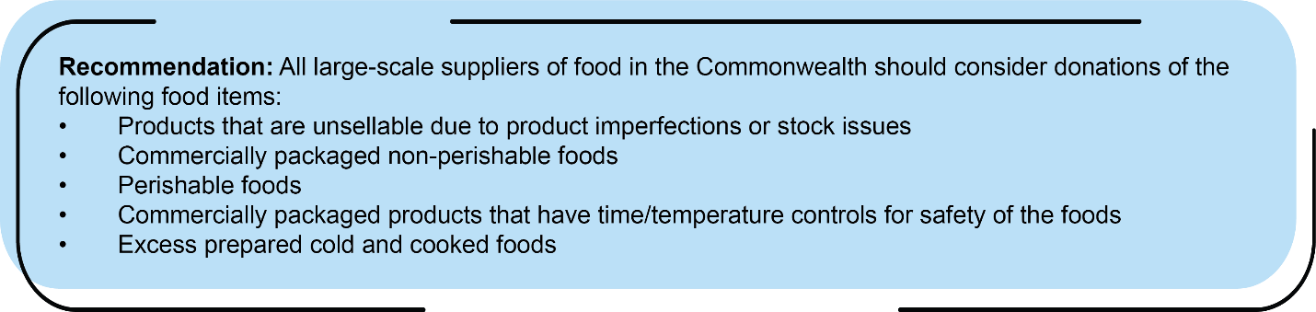

The second tier of Virginia’s Food Management Hierarchy is donating extra food to insecure families and communities. As noted previously in this report, in 2020 USDA reported that 8.5% of Virginia households were food insecure. Food donation feeds people, supporting local communities and saving the resources that went into producing the food from becoming waste. If the transaction is managed properly, many non-perishable and unspoiled perishable foods can be donated. Certain legal and health requirements govern food donation; they are outlined below.

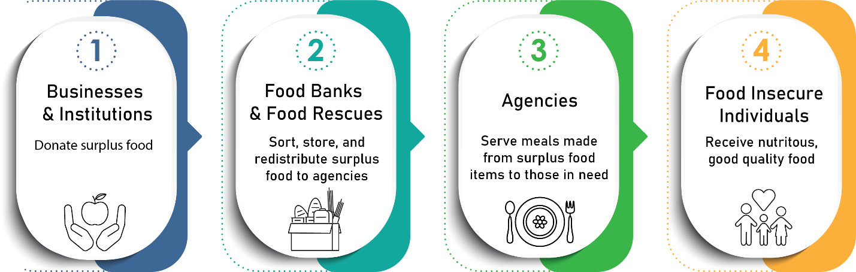

**Food Safety Concerns for Handling Donated Foods**

Donated food must be safe for consumption, especially since it is often served to persons with weakened immune systems such as young children and the elderly. The Centers for Disease Control has identified five risk factors that contribute to foods becoming unsafe to eat: [18]

1. Food from an unapproved source
2. Improper cooking temperatures
3. Inadequate holding temperatures
4. Pool personal hygiene
5. Contaminated equipment and utensils

**Laws Related to Feeding Food Donations for Human Consumption**

Donating food for human consumption is regulated by both the federal government and the Commonwealth.

#### **Federal Law Related to Food Donations for People:** The Bill Emerson Good Samaritan Food Donation Act[19] establishes Federal protection from civil and criminal liability for persons involved in the donation and distribution of food and grocery products to needy individuals when certain criteria are met. The donation must be made in good faith (i.e., the food must be apparently wholesome) and must be donated to a nonprofit organization for distribution to needy individuals. The Act also provides protection against civil and criminal liability to the receiving nonprofit organization. Congress amended the act in 2022 by clarifying and broadening liability protections for retailers to donate surplus food; it was signed into law on January 5, 2023. Specifically, the bill expands liability protections to include donations of an apparently fit grocery product or apparently wholesome food: (1) for which the recipient is charged a good Samaritan reduced price that is no greater than the cost of handling, administering and distributing the food or product; or (2) that is donated directly to a needy individual by a retail grocer, wholesaler, agricultural producer, restaurant, caterer, school food authority or institution of higher education.

**Virginia Law Related to Food Donations:** §§ 3.2-5144 and 35.1-14.2 of the *Code of Virginia* provides both civil and criminal protections for eligible donors that donate apparently wholesome food to a food organization (a non-profit food bank that maintains a food storage facility certified by VDACS and, where required by law, the Virginia Department of Health). Eligible donors include farmers, processors, distributors, wholesalers, food service establishments, restaurants, or retailers of food. Protections still apply to food that is past-date and regardless of compliance with regulations on the quality or labeling of food so long as parties are informed.

The 2023 General Assembly renewed the wholesome food donation tax credit for taxable years 2023 and extending until the end of 2027. This provision allows for farmers in the Commonwealth who donate wholesome food (food that meets all quality standards imposed by federal, state and local laws or regulations that is readily marketable) to a nonprofit food bank to claim a tax credit of 50 percent of the fair market value of the donation, not to exceed $10,000 per person for all such donations during a year.

Additional information on Virginia law related to food donation can be found in Appendix 3.

The Conference for Food Protection has developed a step-by-step guide[20] for food donation for use by both food donors and feeding organizations:

**Food Donors:**

* **Partner with a charity**. Decide together what food can be donated, how much will be donated, how often the donations will be made and how it will be transported.
* **Prepare food according to applicable health regulations.** Only donate foods that have been handled and stored safely. Foods that have been cross-contacted with a major food allergen must be labeled as such.
* **Package food in clean, food-grade packaging.** Some charitable feeding organizations may provide reusable food-grade containers. Unopened food items should be donated in their original commercial packaging.
* **Label food.** Donated food should be labeled with the name of the food, the date the food was prepared, information on any allergens in the food, the donor’s contact information, and safe handling instructions if the food is not ready to eat.
* **Store food properly.** Foods should be covered to prevent cross-contamination, stored according to cooking temperatures, and stored separately from unsafe, spoiled or recalled foods. Refrigerated food must be stored at 41°F or below.
* **Transport food properly.** Ensure that the vehicle has the equipment needed to maintain the proper temperature for the donated food such as insulated coolers, insulated blankets, frozen ice packs, hot boxes or refrigerated compartments. Maintain records of the name and location of the food donor, the date the food was prepared, type of food being donated, food temperature at pickup and the name of the person who is transporting the food.

**Feeding Organizations:**

* 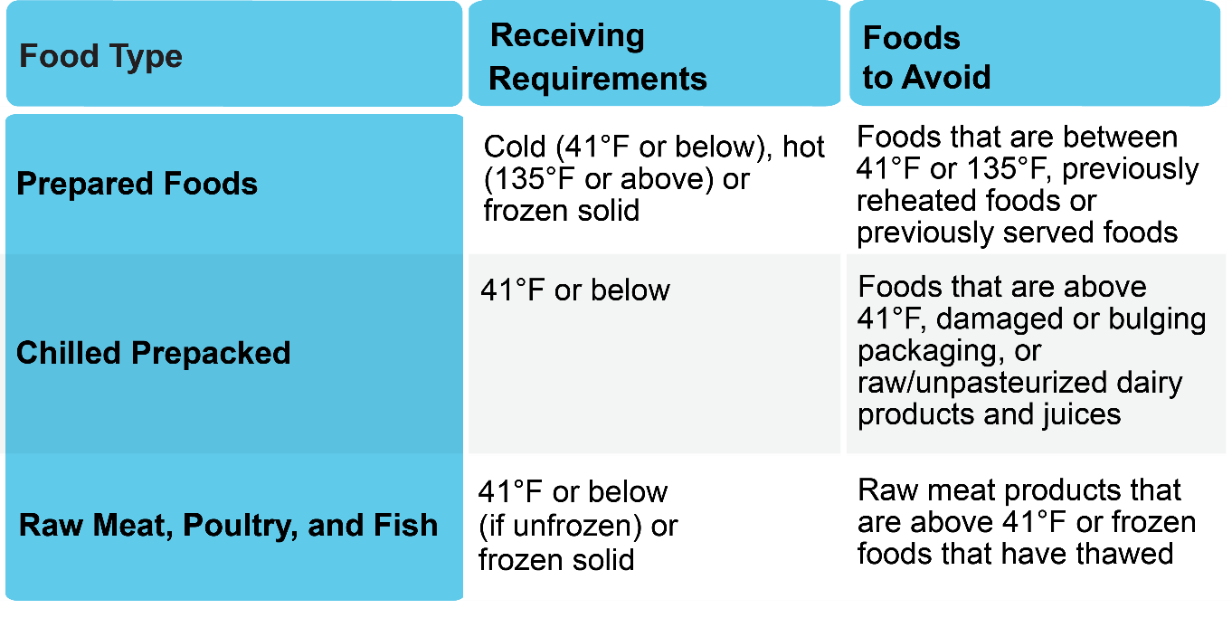When receiving food donations, make sure that: the food is from approved suppliers; manufactured food is in original, sealed and undamaged packages; and, food prepared at retail establishments is labeled with food name, date prepared, major allergens, and the establishment’s contact information. The Conference for Food Protection has also developed a useful table for organizations receiving food donations which outlines receiving requirements and foods to avoid accepting:[21]

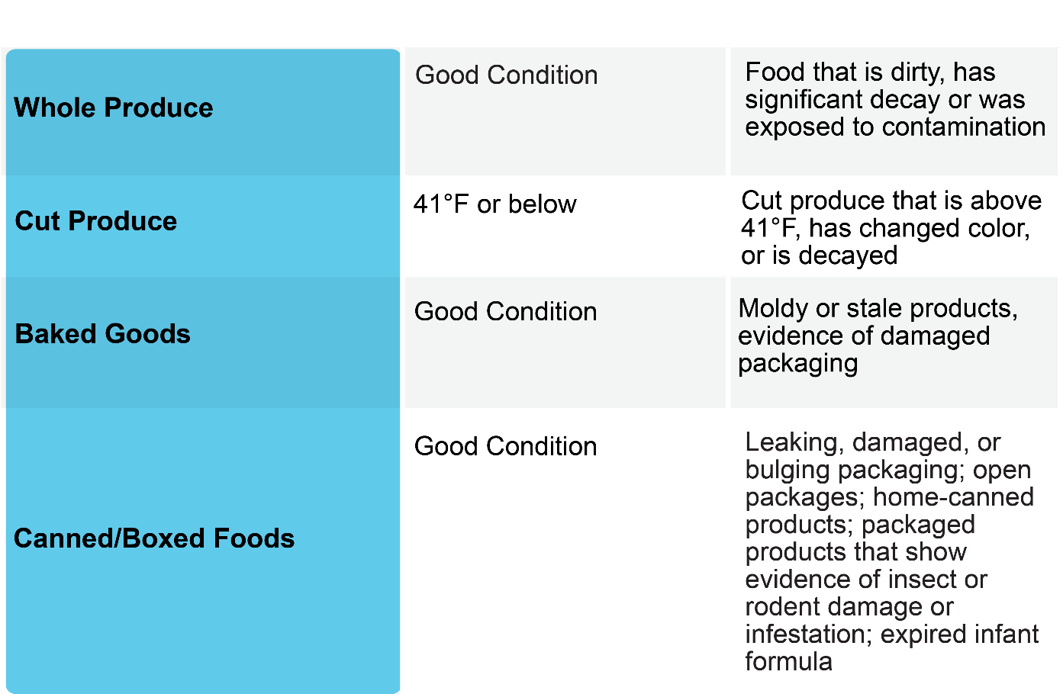

Some programs have developed forms for donors and feeding organizations to use to track donations. Massachusetts’ RecyclingWorks’ Food Donation Agreement Form, which identifies the food to be donated, how that food will be handled and stored and how frequently the food will be transported, and Combined Agency Pickup and Delivery Temperature Log, which is used to ensure that food in transported safety and appropriately, are included as examples in Appendix 4.[22]

**Virginia Examples:**

* Through Albertson’s (Safeway and Balducci’s) “Fresh Rescue” program, their food donations have increased significantly, and they donate as much as they can whereas before they only donated canned goods. They take advantage of tax incentives available for food donation.
* One grocery retail chain that responded to the survey indicated that they have regular food bank pickups at nearly all of their locations.
* Donating excess food to local food banks is a common practice among Virginia’s public colleges and universities. Some specific examples include:
  + JMU routinely donates baked goods from their Panera Bread outlet to local non-profits and the on-campus food pantry. JMU also donates all perishable foods to local food banks before school breaks, including Thanksgiving, winter, spring, and summer breaks.
  + W&M donates meal equivalency swipes for use in their dining halls in support of the College’s efforts to address food insecurity.
  + Students at CNU and UMW coordinate food donations to community partners.
  + VT has a program called “The Market of Virginia Tech” that provides free weekly groceries to 115 students who identify as food insecure. The university also has a program called “Campus Kitchen” that diverts unserved food from dining centers to local good access organizations; since 2015 the program has diverted over 275,000 pound of excess food.
* VCU has an on-campus Learning Garden; produce from the garden is donated to their on-campus food pantry.

**Potential Barriers to Excess Food Donation:**

Survey respondents identified the following as potential barriers to food donation:

* Grocery retailers have a high employee turnover rate, so it can be a challenge to keep staff up to date on corporate policies related to excess food donation. Storing food for donation can be a challenge for some retailers.
* Some areas of the state do not have partner organizations capable of transporting cold or frozen products.
* One K-12 school system suggested that it would be helpful if the Commonwealth would make it easier to support donations while remaining compliant with the federal requirements associated with the National School Lunch Program.
* One university noted that the need to transport food to shelters can be a barrier and that some recipients are hesitant to accept prepared foods.
* Several universities noted that the temperature and holding time requirements for food that is to be donated can become a barrier because it requires staff time and training.
* Food banks noted that grocery retailers do not have time to glean their departments thoroughly and that the zero-waste initiatives implemented by grocery chains have drastically reduced the amount of potential donations.

## Strategy 3: Feed Animals

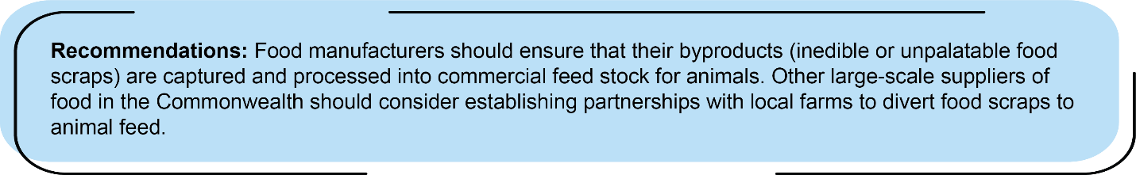

Using food scraps as animal feed, the third tier of Virginia’s Food Management Hierarchy, was common worldwide until the 1980s, when several disease outbreaks linked to unsafe animal feed occurred. In response, laws and regulations were enacted at the federal and state levels, which placed restrictions on the practice, resulting in its decline. However, despite the decline in using food scraps at the informal, farm-scale level, the byproducts of food manufacturing are captured by large-scale food processing and feed production facilities, and food that is human-inedible or unpalatable portions of the food supply are processed into commercial feedstock for animals.

Additionally, a recent report cited “rising interest in the practice of using a wider array of safe, properly-treated food scraps from a range of sources – including unsold retail and post-consumer food scraps – as animal feed”, a practice that can be mutually beneficial and reduce waste disposal and feed costs while making the operations of both the producer and the farmer more sustainable.[23] The same report identified the numerous benefits of using food scraps as animal feedstock or feed supplement:

* **Farmers can save money**, as feed is often the costliest and most constant input needed for animal agriculture.
* **Businesses can save money on waste disposal costs**.
* **New partnerships could result in educational opportunities**, such as between K-12 schools and colleges/universities and farms that could lead to field trips, research projects, etc.
* **Diversion may shift commodity demand and reduce the environmental impact**, as more food scraps are recycled for animal feed, less energy, water, and other resources are needed to grow crops for animal feed.[24]

**Laws Related to Donating Food to Feed Animals**

The use of food scraps in animal feed is regulated by both the Federal government and the Commonwealth.

**Federal Law Related to Using Food Scraps to Feed Animals:** The use of food scraps in animal feed is regulated by the federal government through requirements which concern the type of animals that may be fed food scraps and the kind of food scraps that may be fed to those animals. The federal statutes and regulations on feeding food scraps to animals are encompassed in the Swine Health Protection Act, the Ruminant Feed Ban Rule, the Food Safety Modernization Act Rules on Preventive Controls, and FDA regulations regarding adulteration and misbranding. Taken together, federal law generally allows that food scraps can be fed to animals, as long as the scraps are heat-treated by a licensed facility before being fed to swine and scraps containing animal-derived by-products are not fed to ruminants such as cattle, sheep and goats.

* Swine Health Protection Act (SHPA): Mandates that, before being fed to swine, food waste containing meat and animal byproducts must be heat-treated (212 degrees F) for at least thirty minutes by a licensed facility. Food waste containing only certain processed items, such as industrially processed and rendered animal products, bakery waste, candy, eggs, domestic dairy products and certain types of fish, do not need to be heat-treated. SHPA does not prevent a family farm from feeding its pigs with kitchen scraps, including those that contain untreated meat. (9 CFR §§ 166.1, 166.2, 166.7)
* Transmissible Spongiform Encephalopathy (TSE)/Ruminant Feed Ban Rule: Prohibits the feeding of mammalian protein (i.e., animal tissue, such as beef or pork) in animal feed for all ruminal animals, including cows, sheep and goats. (21 CFR § 589.2000).
* Food Safety Modernization Act (FSMA): Regulates animal feed that consist of human food byproducts such as culls, peels, trimmings and pulp from vegetable manufacturing or processing, by requiring animal food processing facilities to implement food safety controls.[25]
* Food, Drug and Cosmetic Act (FDCA): Asserts that animal feed, like human food, cannot be unadulterated, meaning filthy or decomposed, packaged or held under unsanitary conditions or contain any poisonous or deleterious substance. Animal feed is considered misbranded if the information on the product label is false or misleading. (21 U.S.C. §§ 301-392 (Supple.5 1934))

**Virginia Law Related to Using Food Scraps to Feed Animals:** Under Virginia law, the feeding of animal-derived and vegetable waste to swine is allowed, provided that it has been properly heat-treated by a licensed commercial feed facility. Virginia does not exempt the feeding of household garbage to swine from the “garbage-feeding” rules. (§ 3.2-6031-6034, § 3.2-4803)

**Best Practices for Using Food Scraps as Animal Feed**

The *Leftovers for Livestock* [26] report from the Harvard Food Law and Policy Clinic and the University of Arkansas School of Law outlines a series of considerations to help livestock facilities develop a food scrap feeding program that is economically viable, environmentally sensitive and legally compliant.

Preliminary Considerations:

* Identify the type of animals being fed.
* Identify the type of food that will be fed to the animals.
* Articulate reasons for feeding food scraps to animals and assess the feasibility of doing so.
* Separate animals that may be fed food scraps from those that may not.
* Develop a plan for acquiring, treating, transporting, and/or storing food.
* Obtain – or ensure partner facilities have obtained – requisite permits, licenses, and/or certifications.

Other Legal/Regulatory Considerations:

* Ensure that your food scrap-feeding model complies with all applicable federal laws.
* Contact the Division of Animal and Food Industry Services at VDACS to confirm compliance with state laws and for further advice.[27]

**Virginia Examples**:

* JMU and VCU send their fryer oil to a company that uses it to create animal feed.
* Most food banks responding indicated that they donate food waste to local farmers.

## Strategy 4: Industrial Uses

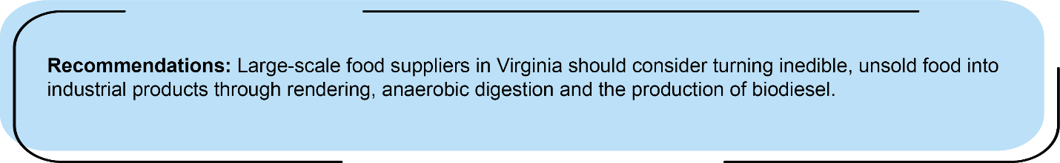

There are several industrial uses for food that cannot be fed to people or animals, including rendering, anaerobic digestion and the production of biodiesel. Converting food waste into industrial products is the fourth tier of DEQ’s Food Management Hierarchy.

**Rendering**

Solid meat products and liquid fats can be converted into animal food, cosmetics, soap, biodiesel and other products by rendering companies. A recent journal article defines rendering as “the act of processing and cooking undesired, or uneaten livestock and poultry meat (and used cooking oil) that remains after a meat animal has been slaughtered and the meat used for consumption has been harvested.[28] Rendering then safely and hygienically processes it to create products so nothing is wasted. Renderers upcycle that unused material (fat, protein, feathers, bone, etc.) for new, secondary uses.”

Considered one of the oldest recycling practices, rendering has existed for centuries, starting with making soap and candles in a kettle over an open fire to today’s upcycling of unwanted meats and oils into products such as animal feed ingredients, pet food, beauty, household/industrial products and biofuels. According to the National Renderers Association, annually in the U.S., 50% of the 147.2 million head of cattle, calves, hogs and sheep slaughtered and 10 billion chickens and turkeys processed is considered inedible and is sent to renderers.[29] Renderers collect 4.4 billion pounds of used cooking oil per year in the U.S. and Canada. Grocery stores in the U.S. send 1.92 billion pounds of scraps, fat, bone, expired meat, and used cooking oil to renderers each year.

According to DEQ records, there are seven rendering plants in the Commonwealth (with additional transfer stations): four in the Shenandoah Valley, two in southeastern Virginia and one on the Eastern Shore. One of them, Darling Ingredients, provided this summary of their industry and their company’s operations:

The rendering industry is a key service provider to the food processing industry, including meat and poultry packing operations, butchers, and food processors (which also includes the collection and recycling of used cooking oil). The circular nature of the rendering process takes would-be waste and transforms it into value-added feed, pet food, and renewable fuel products. Darling process/diverts approximately 1 million metric tons of raw material through its rendering business worldwide. Its facilities generate negligible amounts of waste that require disposal because they convert organic residuals into value-added products. The company operates five facilities across Virginia with over three hundred employees; its Eastern Regional Office is located in Winchester.

**Anaerobic Digestion**

Through anaerobic digestion, biodegradable materials such as food scraps, animal manure, fats, oils, etc., can be recycled into renewable energy in the form of biogas. EPA notes that while the designs of different digesters may vary, all anaerobic digestion systems adhere to the same basic principles, whether the feedstock is food waste, animal manure, or wastewater sludge. [30] The primary types of digesters are stand-alone digesters, on-farm digesters and digesters at wastewater treatment plants. For the purposes of this report on food waste reduction strategies for large-scale food producers, stand-alone digesters, which primarily process food waste, are the most relevant.

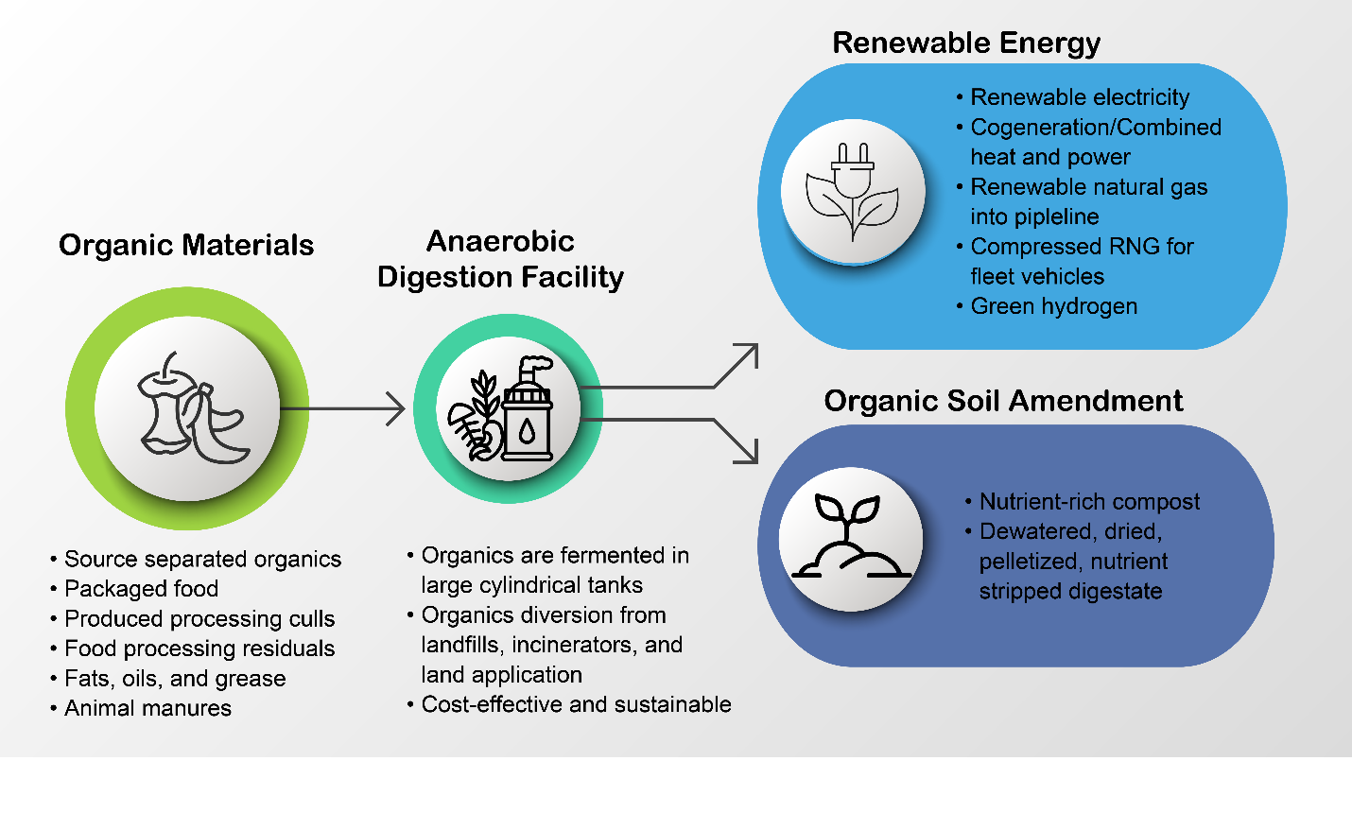As interest in diverting food waste from landfills has grown in recent years, demand for stand-alone digesters, which can be co-located at food manufacturing/processing facilities, operated as organics recycling businesses or operated by a municipality to manage residential food waste.[31] Stand-alone digesters are divided into two categories:

* **Multi-source food waste digester** (accepts and processes feedstocks from offsite sources for tipping fee revenue and/or biogas yield potential)
* **Industry-dedicated digester** (developed to manage food waste generated from a single business such as a grocery store chain or food/beverage processing plant).

EPA’s most recent report on anaerobic digesters, which was published in January, 2021, identifies the top five feedstock sources for anaerobic digestion in order as food/beverage processors, restaurants and food service, grocery stores, industrial sources, and biodiesel production.[32] The report also identified the top five feedstocks accepted (in order) as fats/oils/greases, food processing industry waste, beverage processing industry waste, fruit/vegetative waste, and food service waste (pre- and post-consumer). At the time this report was prepared, there were no stand-alone anaerobic digesters in Virginia.

**Biodiesel**

There is increasing interest in using vegetable oils and animal fats to make biodiesel fuels for several reasons, including rising petroleum prices, economic and national security aspects of dependence on imported petroleum, and environmental impacts from fossil fuel extraction and use. Biodiesel is cleaner than diesel,with fewer pollutants, less soot, hydrocarbons, carbon monoxide, and sulfur dioxide emissions. It is non-toxic and biodegradable. Biodiesel is also safer than petroleum diesel with a much higher flashpoint of 150°C (versus 52°C for petroleum diesel).

Vegetable or animal oils and fats consist of triglycerides. Biodiesel is produced from these sources by a process known as transesterification, in which the triglyceride molecules are broken into alkyl ester molecules (the biodiesel product) and glycerol (the by-product) by reaction with an alcohol in the presence of a catalyst. Both the biodiesel and glycerol by-product have beneficial uses. Pure grades of glycerol (99.7%) can be used as a raw material in other industrial sectors such as food products, cosmetics, toiletries, toothpaste, drugs, animal feed, plasticizers, tobacco, and emulsifiers. While glycerol is useful for other applications, the catalyst-contaminated glycerol by-product of biodiesel production can pose waste management challenges with significant economic and regulatory ramifications. Research on alternative beneficial uses for glycerol is ongoing.

Biodiesel fuel can be used pure or “neat” (called B100) or, more typically, blended with petroleum diesel fuel in 5% (B5) or 20% (B20) proportions before sale to the final user. Numerous resources are available related to biodiesel. Virginia Clean Cities[33] and the National Biodiesel Board[34] are two such resources.

According to Virginia Clean Cities, there are two commercial biodiesel producers in the Commonwealth:

* Virginia Biodiesel Refinery in West Point, Virginia’s oldest biodiesel production facility, which is a five million gallon per year, multi-feedstock capable, third-party quality assured refinery, certified as a “tier I” producer (guaranteeing a quality-made product) which uses waste oils and cooking oil as feedstock.
* Reco Biodiesel in Richmond, a leading producer and blender of biodiesel with a five million gallon per year capacity, every gallon of which is ASTM-certified quality biodiesel, which uses waste oils and soybean oil as feedstock.

**Virginia Examples:**

* Since 2013, all of the kitchen grease generated at the Hilton Downtown Richmond has been sent to RVA Bioride, where it is converted into useable diesel fuel for their fleet of vehicles, earning them a small stipend.
* CNU, VCCS, W&M and JMU sends their fryer oil to facilities that use it to create a biofuel.
* Three grocery retail chains responding to the survey indicated that they are investigating anaerobic digesters. One noted that they send waste to be converted to biogas and to renderers.

## Strategy 5: Composting

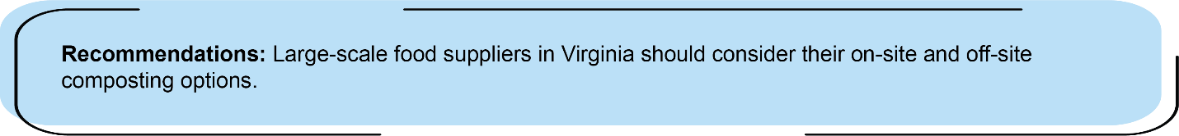

As noted by EPA, even when all actions have been taken to reduce food waste, certain inedible parts will remain and can be turned into compost to feed and nourish the soils.[35] However, EPA estimates that in 2018, only 4.1% of wasted food in the U.S. was composted (2.6 million tons). Compost, which is added to soil to improve its physical properties, is created by combining organic waste, such as wasted food and yard trimmings, with bulking items such as wood chips to accelerate its breakdown and then stabilizing the finished material through a curing process. The benefits of composting include reducing the need for chemical fertilizers, producing higher yields of crops, improving contaminated, compacted, and marginal soils, remediating contaminated soils, enhancing the ability of soils to retain water, and sequestering carbon.

**Virginia Examples**:

* One grocery retail chain responding to the survey indicated that they are composting food waste.
* In 2021, Prince William County, received a grant from USDA’s Office of Urban Agriculture and Innovative Production to collect food leftovers from six schools (four elementary schools, one middle school and one high school) as one of the nation’s first pilot projects in the Community Compost and Food Waste Reduction program. The food waste is sorted, bagged and collected before being mixed with organic yard waste and processed into compost at the county’s recycling center. The county uses an innovative process that aerates the compost while it matures, which has shortened the time between collection and resale from twelve to six months. In 2021, 49 tons of food scraps were collected and composted.
* LU is permitted to compost its food waste on-site; the finished compost is used with organic landscape material to produce compost used on campus for landscaping or lawn topdressing.
* JMU composts all back of house food waste and all post-consumer food waste in their residential dining halls.
* Virginia Tech composts food waste through a private offsite vendor.
* UVA Dine has partnered with the university’s Office for Sustainability to introduce composting to some athletic concession spaces. Starting in the spring 2022 season, composting was provided for fans at Palmer Park, which is where the softball team plays. Sustainability Student Employees set up compost bins along the concourse prior to games, helped fans sort waste appropriately, and collected any leftover food from concessions. As a result of their efforts, 320 pounds of compostable materials were collected at 14 home games and were composted rather than landfilled. UVA hopes to use the success at Palmer Park at other athletic venues. UVA Dine also worked with Office for Sustainability students to bring composting into the back of house at the Starbucks café in Newcomb Hall.
* CNU plans to include organics hauling services in their upcoming Request for Proposals for waste removal.
* The Hilton Richmond Downtown added food waste composting to their sustainability program in 2011, the first hotel in the region to do so. The hotel started with a one-day assessment of every item in every bag of trash, which helped them determine that approximately 20-25% of the total wastes generated by the hotel were food wastes. In 2020 and 2021, the hotel collected 10,070 pounds and 8,790 pounds for composting. Guests can learn about the composting program through the hotel’s atrium chef’s garden, which grows herbs, tomatoes, and peppers, and educates guests about how food waste can become a valuable soil amendment.

**Potential Barriers to Composting Food Waste**

Survey respondents identified the following as potential barriers to food waste composting:

* One university noted that the cost of composting programs is limiting because there are few nearby locations that can accept the amount of food waste generated.
* Another university noted that corporate policies of campus food vendors can be a barrier to composting.

# References

(2022, December). Retrieved from Clean Fuels Alliance America: https://www.biodiesel.org/

(2022, December). Retrieved from Virginia Clean Cities Web site: https://vacleancities.org/

Commonwealth of Virginia. (2022, April 7). Retrieved from Office of the Governor: https://www.governor.virginia.gov/media/governorvirginiagov/governor-of-virginia/pdf/eo/EO-17-Recognizing-The-Value-of-Recycling-and-Waste-Reduction.pdf

Florida Department of Agriculture and Consumer Services. (2022, November). *What are the risk factors that contribute to foodborne illness?* Retrieved from https://www.fdacs.gov/Consumer-Resources/Health-and-Safety/Foodborne-Illnesses-FAQ/What-are-the-risk-factors-that-contribute-to-foodborne-illness

Green Sports Alliance. (2022). *Food Waste Diversion and Compostable Packaging Playbook.* Retrieved from https://greensportsalliance.org/wp-content/uploads/2022/08/2022_FINAL_GSA-Food-Diversion-Playbook.pdf

Harvard Food Law and Policy Clinic and University of Arkansas School of Law. (2016, August). Retrieved from Center for Health Law and Policy Innovation: https://chlpi.org/wp-content/uploads/2013/12/Leftovers-for-Livestock_A-Legal-Guide_August-2016.pdf

*How Food Establishments Can Donate Food.* (2021). Retrieved from Conference for Food Protection Web site: http://www.foodprotect.org/media/guide/1a-handout-how-food-establishments-can-donate-food-12-7-21-compressed.pdf

North American Renderers Association. (2022). *Rendering is Recycling.* Retrieved from https://nara.org/wp-content/uploads/2019/12/Rendering-is-Recycling-Update.pdf

Pennington, M. (2021, January). *Anaerobic Digestion Facilities Processing Food Waste in the United States (2017 & 2018).* Retrieved from United States Environmental Protecion Agency: https://www.epa.gov/sites/default/files/2021-02/documents/2021_final_ad_report_feb_2_with_links.pdf

*Reducing the Impact of Wasted Food by Feeding the Soil and Composting*. (2022, November 15). Retrieved from United States Environmental Protection Agency: https://www.epa.gov/sustainable-management-food/reducing-impact-wasted-food-feeding-soil-and-composting

Sevilla, N., & Keating, M. (2022, April). *Preventing Wasted Food Across the Food Supply Chain*. Retrieved from Natural Resources Defense Council: https://www.nrdc.org/experts/nina-sevilla/preventing-wasted-food-across-food-supply-chain

The Waste Resources and Action Programme UK. (2022, February). *Helping people to reduce fresh produce and dairy waste: Citizen insights on the influence of packaging and date labels on disposal decisions.* Retrieved from https://wrap.org.uk/sites/default/files/2022-02/Citizen-insights-on-the-influence-of-packaging-and-date-labels-on-disposal-decisions_0.pdf

U.S Department of Agriculture. (2022, October). *Economic Research Service*. Retrieved from https://www.ers.usda.gov/topics/food-nutrition-assistance/food-security-in-the-u-s/key-statistics-graphics/

U.S Environmental Protection Agency. (2021, November). *From Farm to Kitchen: The Environmental Impacts of U.S Food Waste.* Retrieved from https://www.epa.gov/system/files/documents/2021-11/from-farm-to-kitchen-the-environmental-impacts-of-u.s.-food-waste_508-tagged.pdf

U.S Environmental Protection Agency. (2022, February). *How to Prevent Wasted Food Through Source Reduction*. Retrieved from https://www.epa.gov/sustainable-management-food/how-prevent-wasted-food-through-source-reduction

United States Environmental Protection Agency. (2022, July 20). *Types of Anaerobic Digesters*. Retrieved from https://www.epa.gov/anaerobic-digestion/types-anaerobic-digesters

Watters, S. (2020, April). *New study highlights the importance of interdisciplinary collaborations to reduce global food waste due to date labelling, a growing research trend*. Retrieved from University of Maryland College of Agriculture and Natural Resources: https://agnr.umd.edu/news/umd-researchers-seek-reduce-food-waste-and-establish-science-behind-date-labeling-food

Wilkinson, A. D., & Meeker, D. L. (2021, May 17). *How Agricultural rendering supports sustainability and assists livestock's ability to contribute more than just food: Animal Frontiers*. Retrieved from Oxford Academic Web site: https://academic.oup.com/af/article/11/2/24/6276831?login=false

# Appendices

1. **Executive Order 17**
2. **Stakeholders**
3. **Virginia Law Related to Food Donation**
4. **Example Food Donation Forms**

## Appendix 1: Executive Order 17

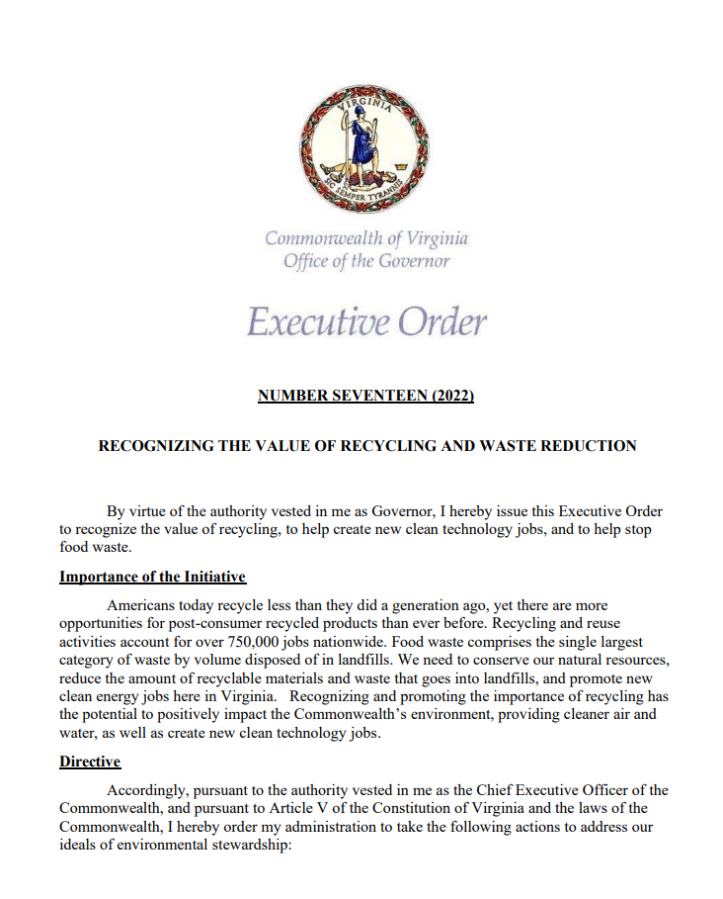

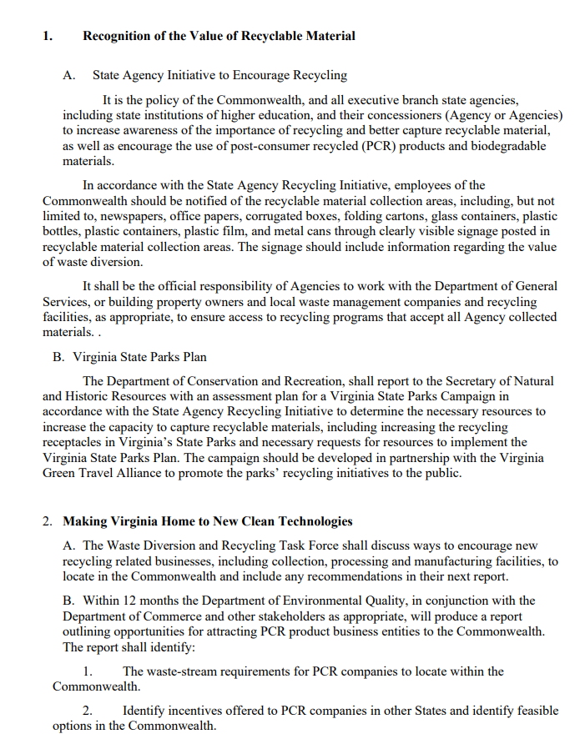

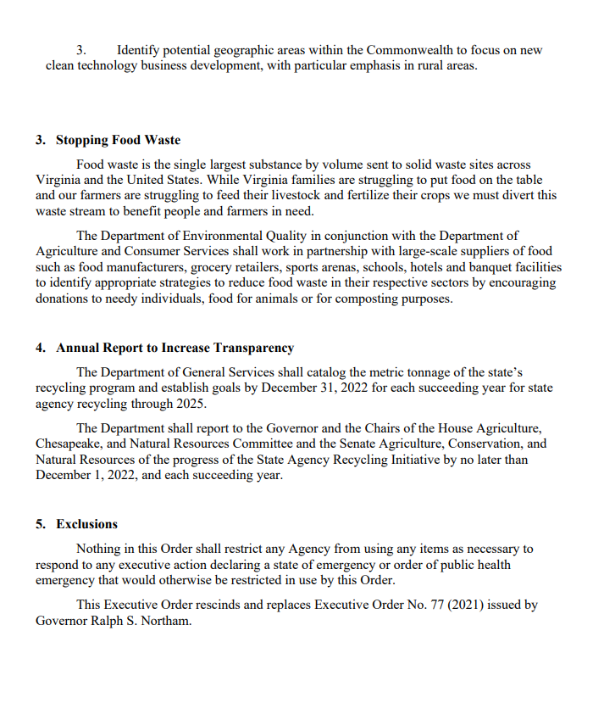

Appendix 2: Stakeholders**\***

Melissa Assalone, Executive Director, Virginia Food Industry Association

Dr. John Bovay, Assistant Professor, Department of Agricultural and Applied Economics, Virginia Tech; Extension Specialist, Virginia Cooperative Extension

Kristin Clay, Senior Policy Analyst, Virginia Department of Health

Alan Edwards, Strategic Planning and Policy Studies Director, State Council of Higher Education for Virginia

Tom Griffin, Executive Director, Virginia Green Travel Alliance

Julie Henderson, Director, Office of Environmental Health Services, Virginia Department of Health

Zach Jacobs, Legislative Specialist, Governmental Relations, Virginia Farm Bureau Federation

Kashef Majid, Associate Professor of Marketing, College of Business, University of Mary Washington

Robert Melvin, Director of Government Affairs, Virginia Restaurants and Lodging Association

Eddie Oliver, Executive Director, Federation of Virginia Food Banks

Jactone Ogejo, P.E., Associate Professor/Extension Specialist, Department of Biological Systems Engineering, Virginia Tech

Karen Corbett Sanders, Virginia School Board Association

Dr. H. Lester Schonberger, Associate Extension Specialist, Department of Food Science and Technology, Virginia Tech

Eric Terry, President, Virginia Restaurants and Lodging Association

Brett Vassey, President and CEO, Virginia Manufacturers Association

Paige Wernig, Government Affairs Manager, Virginia Manufacturers Association

*Stakeholders provided input and feedback to the report but their inclusion here is not meant to indicate that every organization supports every recommendation in the report.

## Appendix 3: Virginia Law Relating to Food Donation

**§ 3.2-5144: Exemption from civil and criminal liability:**

* Any *entity* donating food to any *food organization* for use or distribution by the organization shall be exempt from civil liability arising from any injury or death resulting from the nature, age, condition or packaging of the donated food (not applicable if the injury or death results from the gross negligence or intentional act of the donor). If the donor is a food service establishment or a restaurant, the donor shall comply with the regulations of the Board of Health with respect to the safe preparation, handling, protection and preservation of food, including necessary refrigeration or heating methods.
* No food donor or food organization shall be criminally or civilly liable for donating or receiving food past the best-by date as long as all parties are informed and the food is labeled as not meeting all labeling and date requirements (not applicable if injury or death results from gross negligence or intentional misconduct of the food donor or food organization).
* Any farmer who gratuitously allows persons to enter upon his own land for purposes of removing any crops remaining after harvesting shall be exempt from civil liability arising out of any injury or death resulting from the nature or condition of the land or nature, age or condition of the crop (not applicable if the injury or death directly results from gross negligence or intentional act of the farmer).
* “Entity” means a farmer, processor, distributor, wholesaler, food service establishment, restaurant or retailer of food, including a grocery, convenience or other store selling food or food products.
* “Food organization” means a food bank or any Feeding America certified food bank or food bank member charity that is exempt from taxation under §501©(3) of the Internal Revenue Code that maintains a food storage facility certified by the Department of Agriculture and Consumer Services and, where required by ordinance, by the State Department of Health.

**§ 35.1-14.2: Donations of food to charitable organizations**:

* Any restaurant, licensed by the Department of Health, and any processor, distributor, wholesaler or retailer of food may donate unserved excess foods to any charity organization that is exempt under §509(c)(3) of the Internal Revenue Code and to political subdivisions for distribution to needy persons. Charitable organizations engaged in food distribution programs for the needy shall notify the local political subdivision of their programs. Upon notification, the local political subdivision shall provide a list of such charitable organizations within its jurisdiction to those restaurants and other food suppliers upon request.
* Charitable organizations (i.e., nonprofit homeless shelters and hunger prevention programs) engaged in food distribution programs for needy persons are exempt from state and local regulations and local ordinances governing food service and preparation. Such organizations also may accept food prepared by their employees or volunteers in private homes or in facilities otherwise licensed.
* No food donor or food organizations shall be criminally or civilly liable for donating or receiving (i) commercially processed food past the best-by or sell-by date as long as the food meets all labeling and date requirements or (ii) date-marked prepared foods not past the marked disposition date, when the marked date does not exceed seven calendar days from the date or preparation, with the day of preparation counted as day one (not applicable if injury or death directly results from the gross negligence or intentional misconduct of the donor or done).

## Example of Food Donation Agreement Form.Appendix 4: Example Food Donation Forms

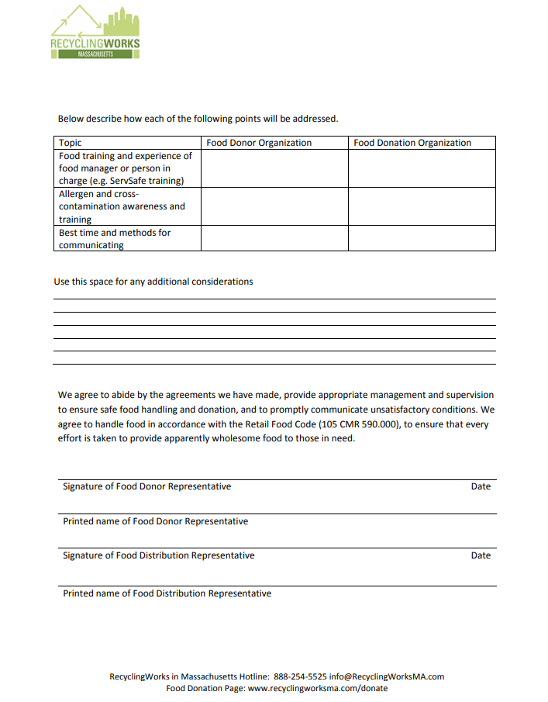

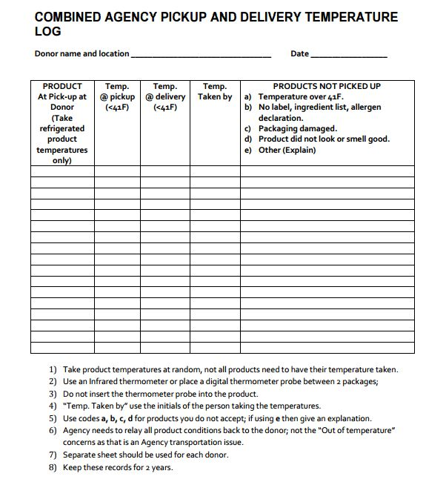

1. Governor Glenn Youngkin website: <https://www.governor.virginia.gov/media/governorvirginiagov/governor-of-virginia/pdf/eo/EO-17-Recognizing-The-Value-of-Recycling-and-Waste-Reduction.pdf>
2. U.S. Environmental Protection Agency, *From Farm to Kitchen: The Environmental Impacts of U.S. Food Waste (Part 1)*, November 2021, page ii, <https://www.epa.gov/system/files/documents/2021-11/from-farm-to-kitchen-the-environmental-impacts-of-u.s.-food-waste_508-tagged.pdf>
3. U.S. Environmental Protection Agency website: <https://epa.gov/land-research/farm-kitchen-environmental-impacts-us-food-waste>
4. U.S. Department of Agriculture website: <https://www.ers.usda.gov/topics/food-nutrition-assistance/food-security-in-the-u-s/key-statistics-graphics/>
5. Note: DEQ did not receive enough survey responses from food manufacturers or sports arenas to be able to identify best practices in those sectors.
6. <https://www.nrdc.org/experts/nina-sevilla/preventing-wasted-food-across-food-supply-chain>
7. Green Sports Alliance website: <https://greensportsalliance.org/wp-content/uploads/2022/08/2022_FINAL_GSA-Food-Diversion-Playbook.pdf>
8. *Evaluation of Global Research Trends in the Area of Food Waste Due to Date Labeling Using a Scientometrics Approach,* <https://www.sciencedirect.com/science/article/abs/pii/S0956713520302231?via%3Dihub>
9. 2VAC5-585-400
10. 2VAC5-531-60
11. 12VAC5-421-830
12. USDA website: <https://www.fsis.usda.gov/food-safety/safe-food-handling-and-preparation/food-safety-basics/food-product-dating>
13. Source: <https://law.lis.virginia.gov/admincode/title2/agency5/chapter490/section40/>
14. Food Date Labelling Act of 2021: <https://www.congress.gov/bill/117th-congress/senate-bill/3324/text?q=%7B%22search%22%3A%5B%22food%22%2C%22food%22%5D%7D&r=9&s=2> and <https://www.congress.gov/bill/117th-congress/house-bill/6167?q=%7B%22search%22%3A%5B%22food+date+labeling%22%2C%22food%22%2C%22date%22%2C%22labeling%22%5D%7D&s=1&r=2>
15. <https://wrap.org.uk/sites/default/files/2022-02/Citizen-insights-on-the-influence-of-packaging-and-date-labels-on-disposal-decisions_0.pdf>
16. Conversation with University of Mary Washington Associate Professor of Marketing Kashef Majid, December 2, 2022.
17. Source: <https://fns-prod.azureedge.us/sites/default/files/resource-files/June22F2SProcurementGuide508.pdf#page=8>
18. VDH website: [https://vdh.virginia.gov/environmental-health/food-safety-in-virginia/food-safety-basics](https://vdh.virginia.gov/environmental-health/food-safety-in-virginia/food-safety-basics/)
19. 42 U.S.C 1791 – Bill Emerson Good Samaritan Food Donation Act
20. Conference for Food Protection website: <http://www.foodprotect.org/media/guide/1a-handout-how-food-establishments-can-donate-food-12-7-21-compressed.pdf>
21. Conference for Food Protection website: <http://www.foodprotect.org/media/guide/1a-handout-how-food-establishments-can-donate-food-12-7-21-compressed.pdf>
22. RecyclingWorks Massachusetts website: <https://recyclingworksma.com/donate/>
23. *Leftovers for Livestock: A Legal Guide for Using Food Scraps as Animal Feed,* Harvard Food Law and Policy Clinic and University of Arkansas School of Law,August 2016, page 2
24. Ibid, pp.2-3
25. FDA Food Safety Modernization Act, Public Law 353, U.S. Statutes at Large 124 (2010): 3885-3973
26. *Leftovers for Livestock: A Legal Guide for Using Food Scraps as Animal Feed,* Harvard Food Law and Policy Clinic and University of Arkansas School of Law,August 2016, pp. 11-12
27. General Information: (804) 786-2483 or vastatevet@vdacs.virginia.gov
28. *Animal Frontiers*, Volume 11, Issue 2, March 2021, pages 24-34, <https://academic.oup.com/af/article/11/2/24/6276831?login=false>
29. National Renderers Association website: <https://nara.org/wp-content/uploads/2019/12/Rendering-is-Recycling-Update.pdf>
30. EPA website: <https://www.epa.gov/anaerobic-digestion/types-anaerobic-digesters>
31. Ibid
32. Anaerobic Digestion Facilities Processing Food Waste in the United States (2017 & 2018), Survey Results, January 2021, EPA/903/S-21/001, <https://www.epa.gov/sites/default/files/2021-02/documents/2021_final_ad_report_feb_2_with_links.pdf>
33. Virginia Clean Cities website: <https://vacleancities.org/about/>
34. National Biodiesel Board website: <https://www.biodiesel.org/>
35. <https://www.epa.gov/sustainable-management-food/reducing-impact-wasted-food-feeding-soil-and-composting>