# CHAPTER 7.8. WETLANDS ASSESSMENT AND PROGRAM INITIATIVES

**Overview**

Wetlands are lands transitioning between terrestrial and deep-water habitats where the water table is usually at or near the land surface or where the land is covered by shallow water (Cowardin *et al*., 1979). Virginia has many different types of wetlands, including salt marshes, estuarine wetlands along freshwater portions of tidal streams, interdunal swales, pocosins, palustrine wetlands in freshwater floodplains, freshwater swamps, bogs, fens, wet meadows, and isolated wetlands.

Wetlands may be defined in different ways with regard to jurisdictional issues, but all wetlands have in common a seasonal pattern of hydrology or continuous inundation, characteristic hydric soils, and vegetation adapted to growing under saturated condition. For example, the Wetlands Act of 1972 (Title 62.1 of the Code of Virginia) defines tidal wetlands for the purposes of protecting the resource and regulating development. As such, vegetated tidal wetlands are defined in the Act as "all land lying between and contiguous to mean low water and an elevation above mean low water equal to the factor 1.5 times the mean tide range at the site of the proposed project in the county, city or town in question," and on which are growing one or more of 37 specified species of wetlands vegetation. Non-vegetated wetlands are defined as all other lands between mean low water and mean high water. The Act does not include a definition for non-tidal wetlands, nor does it include all lands that are considered to be wetlands under federal law. The definition of wetlands contained in the DEQ's Virginia Water Protection Permit Program Regulation 9VAC25-210-10 *et seq*. parallels the federal definition of wetlands contained in Section 404 of the Clean Water Act: "Wetlands mean those areas that are inundated or saturated by surface or ground water at a frequency and duration sufficient to support and, under normal circumstances do support, a prevalence of vegetation typically adapted for life in saturated soil conditions. Wetlands generally include swamps, marshes, bogs and similar areas." Wetlands are part of State Waters per Section 62.1-44.3 of the Code of Virginia. State Waters means “all water, on the surface and under the ground, wholly or partially within or bordering the commonwealth or within its jurisdiction, including wetlands.”

Wetlands occupy approximately four percent of Virginia’s land mass (Dahl, 1990). United States Fish and Wildlife Service National Wetlands Inventory mapping and research from state scientists have estimated that vegetated palustrine wetlands cover approximately 1,075,443 acres of Virginia; estuarine wetlands cover approximately 190,996 acres; lacustrine wetlands cover about 193 acres; and riverine wetlands cover about 380 acres (Hershner *et al*., 2000). Approximately 72 percent of the wetland areas in Virginia, including all the estuarine wetlands and most of the large nontidal palustrine wetlands, are in the Coastal Plain (Tiner and Finn, 1986). Approximately 22 percent of the wetlands in Virginia are in the Piedmont, and the remaining 6 percent are in the Appalachian Plateau (Tiner and Finn, 1986; Harlow and LeCain, 1991). Virginia has worked with local scientists to develop geographic information system-based (GIS) estimates of wetland acreage and wetland type by watershed, which can be used in cumulative wetland impact assessments, as discussed further in the Wetland Monitoring and Assessment section of this report.

Development activities in wetlands in Virginia are regulated by the U.S. Army Corps of Engineers (the Corps) through Section 404 of the Clean Water Act; by the Department of Environmental Quality, through the Virginia Water Protection Permit Program and Section 401 of the Clean Water Act; by the Virginia Marine Resources Commission (VMRC); and by local Wetland Boards through the Virginia Tidal Wetlands Act of 1972. For more information about wetlands, the historical development of the program, applicable laws/regulations, and permitting, see the VWP Permit Program web page at: <https://www.deq.virginia.gov/water/wetlands-streams>.

Virginia has experienced losses of wetlands as a result of human-related development. In the 1780’s, wetlands covered about 1,849,000 acres (more than 7 percent) of Virginia (Dahl, 1990). By the mid-1980’s, when permits began to be required for most impacts to wetlands, about 1,075,000 wetland acres remained in Virginia – an overall loss of about 42 percent in 200 years (Dahl, 1990).

Agriculture and forestry, industrial and urban development, and recreation have led to the draining, dredging and ditching, filling, diking, and damming of wetlands in Virginia. According to a Chesapeake Bay Foundation fact sheet (2001), Virginia lost more than 770,000 acres of wetlands, for an average annual loss of 3,870 acres, during the 200-year period from the 1780s to the 1980s. From mid-1980 to the late 1990’s, 80 percent of estimated losses of freshwater vegetated wetlands (mostly forested systems) occurred in the Coastal Plain. Wetland trends for the Norfolk/Hampton region of Virginia indicated a loss of about 4,800 acres of vegetated wetlands between 1982 and 1989-90 (Tiner and Foulis, 1994). During 1998 and 1999 alone, more than 2,500 acres of non-tidal wetlands in Virginia were ditched for development. The net loss of wetland areas has slowed since 2000 due to stricter laws, greater enforcement, and new mitigation strategies.

The following figure (Figure 7.8-1) provides regulatory data on the amount of permitted impacts and the amount of compensatory mitigation (rounded), as required by law and regulation and tracked by the Virginia Water Protection (VWP) Permit Program, for state fiscal 2013 to 2020. Voluntary efforts to restore wetlands, such as those supported by federal, state, and local land conservation programs, grants, and incentives, are not included here but would be expected to contribute to the net offset of statewide impacts. State Water Control Law (SWCL) and VWP Permit Program regulations require compensation for unavoidable, permanent impacts to surface waters that are sufficient to achieve no net loss of existing wetland acreage and function and no net loss of function in all surface waters (See,§ [62.1-44.15:21](https://law.lis.virginia.gov/vacode/title62.1/chapter3.1/section62.1-44.15:21/) and [9VAC25-210-116 (A](https://law.lis.virginia.gov/admincode/title9/agency25/chapter210/section116/))). The figure below shows that no net loss of wetlands is being met through the VWP permitting program.

Figure 7.8-1 No Net Loss of Non-Tidal Wetlands

**Wetland Monitoring and Assessment**

***Background***

A key aspect of the Commonwealth of Virginia’s nontidal wetlands program is ensuring that there is no net loss of wetland acreage and function through permitted impacts and a net gain in wetland resource through voluntary programs. To accomplish these goals, the Virginia Water Protection (VWP) Permit Program received grants from EPA from 2003 to 2018 to determine the status of wetland resources in Virginia, in terms of location, extent, and overall quality of wetlands in each watershed. Using this information, the VWP Permit Program tracks changes in wetland acreage and functions, target certain watersheds, and help determine the effectiveness of compensatory mitigation replacing lost wetland acreage and function. As a first step, Virginia developed a long-term Wetland Monitoring and Assessment Strategy for wetland monitoring and assessment, including the goals and objectives of a monitoring and assessment program and a time frame for implementation. The strategy provides a framework for an ongoing assessment of the status of the commonwealth's wetland resources and the success of both our wetland regulatory and voluntary programs. The end result of the ten-year strategy is expected to be the incorporation of wetland monitoring and assessment data into the commonwealth's water quality monitoring programs.

Virginia has narrative water quality standards for all surface waters, including wetlands. The overall water quality for state waters is determined based on whether or not the condition of the waterbody being assessed allows citizens to safely enjoy the six designated uses of the water (aquatic life use, fish consumption use, swimming use, public water supply use, shellfish consumption use, and wildlife use), as described in the Virginia Water Quality Standards (9VAC25-260 et seq). Part of the above-referenced monitoring and assessment strategy includes 1) the evaluation of these designated uses for their applicability to a wetland’s condition, and 2) the assessment of whether other designated uses of wetlands may apply. The strategy may also support the agency’s goal of developing specific wetland quality standards as narrative use criteria.

The wetland monitoring and assessment strategy incorporates the EPA March 2003 "Elements of a Wetland Monitoring and Assessment Program Checklist" and the EPA May 2006 “Application of Elements of a State Water Monitoring and Assessment Program for Wetlands” (a supplement to the 2003 EPA document). The strategy uses a three-tiered census approach to wetlands assessment, using a suite of core and supplemental indicators, to assess whether or not a particular wetland is performing at a similar condition as an identified reference wetland. The first tier (Level 1 analysis) consists of a comprehensive coverage of all mapped wetlands using a GIS-based analysis of remotely sensed information. The second tier of assessment (Level 2) is intended for use in a statistically selected sub-sample of the watershed wetland population and involves a more sophisticated analysis of remotely sensed information and a site visit for verification and additional data collection. The third tier assessment (Level 3) is designed to specifically evaluate performance of functions in wetlands under varying degrees of stress, as indicated by the results of Levels I and II.

Since 2003, the overall wetland monitoring and assessment strategy has been to establish baseline conditions in various broad contexts, such as land use, watershed, and wetland type. The elements of the wetland monitoring and assessment program are listed in Table 7.8-1 below.

|  |  |
| --- | --- |
| Monitoring Strategy | 1. Establish baseline condition of nontidal wetlands by broad category scalable from individual wetland to small watershed to physiographic province to entire State. 2. Guide management decisions regarding restoration, compensation, and regulation of wetlands. |
| Monitoring Objectives | 1. Support regulatory decision-making. 2. Report wetland condition. 3. Guide policy development. 4. Evaluate cumulative impacts of wetland loss. 5. Evaluate wetland restoration and compensatory mitigation effectiveness. |
| Survey Design | Three-Tiered: Sample Frame = all NWI wetlands   1. Enhanced GIS analysis (census) – Level I (Model Development). 2. Probability-based sampling for field assessment of anthropogenic stressors – Level II (Model Calibration). 3. Intensive study of biological endpoints (birds, amphibians, water quality) along stressor gradient – Level III+ (Model Validation). |
| Assessment Indicators and Methods | 1. Level I (Model Development): land use adjacent, within 200m, and within 1000m of wetland, wetland size, type, hydroperiod, proximity to other wetlands, road type, road density, and road alignment. 2. Level II (Model Calibration): field assessment of anthropogenic stressors within 30m of wetland assessment point and within 100m of wetland assessment point. 3. Level III (Model Validation): population and community structure metrics for birds and amphibians. Water quality modification metrics. |
| Quality Assurance | An EPA-approved Quality Management Plan coupled with the Virginia Institute of Marine Science (VIMS) Quality Assurance Plan used to prevent random and systematic errors. Techniques include direct electronic field data assimilation to prevent transcription error as well as random return site visits and redundant QA assessment loops. |

Table 7.8-1 Wetland Monitoring and Assessment Program Elements

***End Result***

The data collected from the assessment has been compiled into an online GIS-based wetland data viewer identified as the Wetland Condition Assessment Tool (WetCAT) developed in partnership with the Virginia Institute of Marine Science (VIMS) – Center for Coastal Resources Management (CCRM) and DEQ’s Office of Wetlands and Stream Protection (OWSP). One unique aspect of WetCAT is its online interactive user interface, which allows users to overlay data such as previously permitted impacts and impaired waters and run various geoprocessing tools to visualize cumulative impacts, downstream flow, and upgradient drainage areas.

The goal of WetCAT is to support DEQ’s regulatory decision-making, allow reporting of wetland condition, and provide information for policy development. One of the advantages of the Virginia protocol is a comprehensive assessment of secondary impacts to wetland resources arising from activities that do not directly impact wetlands. This information can guide policy discussions on general land use management, stormwater, and land use planning. Linking decisions in these areas to wetland policy will be essential to achieving Virginia’s statutory requirement of no net loss of wetland acreage and function, and aid local governments with planning tools at a watershed level. Additional data sets and GIS layers will allow Virginia to continue to develop a wetland data viewer for use by regulatory agencies and the general public. Our success will be measured by an increasing trend in the statistically-reliable Level I protocol and a decreasing trend in cumulative wetland impacts over time.

***Current and on-going initiatives***

DEQ’s monitoring objectives are designed to support regulatory decision-making, allow reporting of wetland conditions, and provide information for policy development. Products from the wetlands monitoring and assessment strategy directly support Goal 4 of EPA’s Strategic Plan to provide *“…additional focus on assessment of wetland condition”* and the National Priority of “*wetlands monitoring and assessment”.* Table 7.8-2 provides an overview of the strategy’s milestones and the status of each.

|  |  |  |  |
| --- | --- | --- | --- |
| Phase 1 | Oct. 2003 | Begin Level I assessment for Virginia. | Complete |
| Dec. 2004 | Begin Level II site assessment of Coastal Plain wetlands. | Complete |
| Dec. 2005 | Complete Level I assessment of Virginia, Complete Level II site assessment of Coastal Plain, Develop protocol for Level III assessment for Coastal Plain physiographic province. | Complete |
| Phase 2 | Dec. 2005 | Begin Level II site assessment of Piedmont physiographic province. | Complete |
| Sept. 2007 | Complete Level II site assessment of Piedmont. Begin Level III sampling for coastal plain sites. | Complete |
| Phase 3 | Oct. 2007 –Sept. 2008 | Complete enhanced wetland site selection for Ridge and Valley Level II site assessment using a protocol for probable wetlands location. Complete Level II site assessment for Ridge and Valley physiographic provinces. Continue Level III sampling for Coastal Plain. | Complete |
| Phase 4 | Oct. 2008 – Sept 2010 | Begin Level III (model validation) sampling for Piedmont, and Ridge and Valley. Begin Level II re-sample coastal plain subset for calibration. | Complete |
| Phase 5 | Oct. 2010 | Begin Level I re-sample of Virginia for trends analysis. | Complete |
| Phase 6 | Oct. 2010 | Development of a Wetland Program Comprehensive Plan, refinement of our environmental database, and continued development of the wetlands monitoring and assessment program. | Complete |
| Phase 7 | Oct. 2011 –  Dec 2014 | Collaborate with VDOT to incorporate linear transportation projects into the wetland data viewer, potentially review and update the monitoring and assessment strategy to incorporate completed tasks and re-evaluate the direction of the strategy. Continued re-calibration of the assessment model. | Complete |
| Phase 8 | Oct 2014 - 2018 | New data collection equipment have been distributed to DEQ monitoring staff and the training field staff is complete. Development and testing of new protocols for DEQ field staff that provides for integrated data collection and quality assurance in support of the recalibration effort and non-mapped NWI wetland identification is ongoing. Coordination with Army Corps of Engineers, Virginia Department of Transportation to optimize utility. Continuing the model recalibration and developing additional datasets for WetCAT. | Complete |
| Phase 9 | Oct  2016-2017 | Improve software platform for WetCAT by transitioning over to JavaScript. Parcel level maps incorporated as a layer into WetCAT. Recalibration of Piedmont and Ridge & Valley stressors with incorporation of Headwater wetland subcategory. | Complete |
| Sept 2018 | Incorporate the US Army Corp of Engineers permit data into WetCAT. | Complete |
| Sept 2018 -2020 | Incorporate enhanced data collection by DEQ aquatic biologist in support of WetCAT reporting. Design and implement a reporting program to generate critical wetland assessment information for DEQ and VDOT staff. Provide outreach and training for local government and the public on the utilization of WetCAT. | Ongoing |

Table 7.8-2: Long-term wetlands field assessment strategy for Virginia

**The following summarizes some key results of the strategy effort to date:**

VIMS-CCRM worked with the VADEQ aquatic biologists to incorporate enhanced data collection in support of WetCAT. This builds on ongoing work where DEQ aquatic biologists were outfitted with tablets with a Level II sampling protocol and trained to collect wetlands data when in the field. The DEQ freshwater probabilistic monitoring program is conducted twice a year on randomly selected stream sites. This work combined the WetCAT Level II survey with the aquatic biologists’ regular data collection of benthic macroinvertebrates on a subset of at least 30 sites to begin assimilation of wetland condition data adjacent to stream systems catalogued by the freshwater stream program. Correlations between wetland stress condition and stream health as defined by Virginia Coastal Plain Macroinvertebrate Index (VCPMI) scores were examined (Table 7.8-3) by matching the nearest wetland scores in WetCAT with the biological monitoring station (Figures 7.8-2 and 7.8-3). The most recent VCPMI scores available were obtained from the 2014 Report on Toxics Reduction in State Waters, Virginia Department of Environmental Quality, January 2015, Appendix H1. These correlations may be updated in the future with more recent VCPMI scores.

| Wetland Stress Condition | Rank | VCPMI | Rank |
| --- | --- | --- | --- |
| Slightly Stressed | 1 | Excellent | 1 |
| Somewhat Stressed | 2 | Good | 2 |
| Somewhat Severely Stressed | 3 | Moderately Impaired | 3 |
| Severely Stressed | 4 | Severe Impairment | 4 |

Table 7.8-3. Wetland stress condition rank matched with VCPMI rank.

There was a modest correlation between ranking class for WetCAT water quality stress condition and VCPMI (Spearman Rho correlation 0.33, p = 0.036) and a stronger correlation between ranking class for WetCAT habitat stress condition and VCPMI (Spearman Rho correlation 0.46, p = 0.003). When comparing continuous scores of the predictor variable, habitat stress condition, with the continuous scores of the response variable, VCPMI, there is a significant linear relationship between reduced habitat stress and reduced impairment (R-sq (adj) = 20.4%, p = 0.002, n = 39) (Habitat stress condition score = 0.4791 + 0.003694 (VPCMI score)). This suggests a relationship between adjacent and nearby wetland condition to stream health (as measured by the VPCMI).

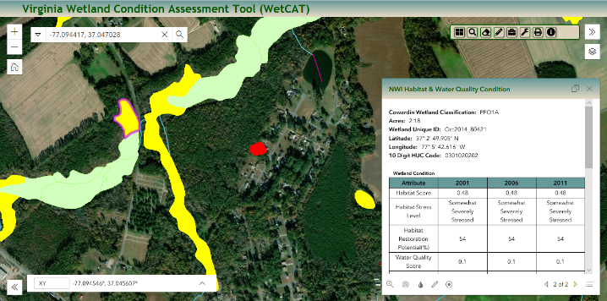

Biological monitoring station (VCPMI)

Figure 7.8-2. Virginia Coastal Plain Macroinvertebrate Index score of “Severe Impairment”; WetCAT

Habitat score of “Somewhat Severely Stressed” and a Water Quality score of “Severely Stressed”

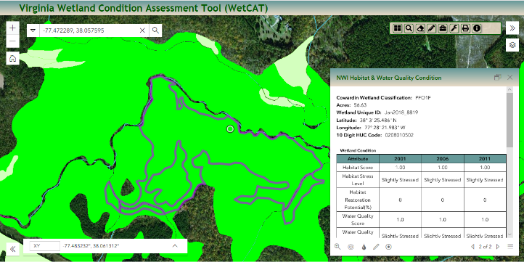

Biological monitoring station (VCPMI)

Figure 7.8-3. Virginia Coastal Plain Macroinvertebrate Index score of “Reference”; WetCAT

Habitat score of “Slightly Stressed” and a Water Quality score of “Slightly Stressed”

Parcel level maps were incorporated as a layer in WetCAT, where available, to assist local governments in planning, avoiding and minimizing impacts to wetlands, targeting potential wetland restoration sites, and providing property level resolution for local governments.

The Virginia assessment model hinges on an assumption about the stressors created by land development patterns. As agricultural practices and urban/suburban development practices evolve, it is essential that the model relationship be regularly recalibrated. Virginia has worked to develop a monitoring and assessment strategy for nontidal wetlands that can support regulatory decision making at the state level. In this project the headwater sampling protocol developed in the previous EPA State Wetland Grant project (CD96316401-0) was extended as part of the Level II re-calibration process. This protocol considered a larger buffer area for the predictive algorithm in headwater systems. The stressor prediction algorithm requires field sampling to document stressor presence and landuse/landcover composition at enough headwater systems to characterize the relationship. From the previous work, these relationships are known to vary across the geomorphic provinces in Virginia (coastal plain, piedmont, and ridge and valley). This portion of the project included the re-calibration for the Piedmont and Ridge & Valley physiographic provinces. The purpose of the recalibration effort was to capture changes in surrounding landcover – stressor relationships at 3-5 year intervals to ensure that the condition assessment model remains statistical valid. The initial Level II Piedmont calibration sample was 600 sites with the re-calibration of 60 sites (10%) and Ridge & Valley calibration sample of 300 sites with re-calibration of 30 sites. Sample methods were identical to the previous re-calibration work (EPA Grant BG 98392503-7). This work resulted in enhanced model validation of wetland condition (habitat and water quality) in the Piedmont and Ridge & Valley physiographic regions of Virginia.

Generating information and guidance to facilitate better decision-making for DEQ and VDOT personnel is a crucial part of the utility of WetCAT for NEPA studies. VIMS-CCRM worked with DEQ staff in designing and implementing a reporting program to generate critical wetland condition assessment information for DEQ and VDOT staff as well as cumulative impact analysis. Sites selected for report generation will prioritize high ecological value aquatic resources, such as headwater wetland systems, and projects that require a high degree of cumulative analysis, such as those associated with transportation corridors. As the reports are used, VIMS-CCRM will assist DEQ in working with the permit staff and NEPA reviewers to further refine the most useful information needed to facilitate their decisions. This will increase the effectiveness of the reports and enhance the engagement of agency personnel in considering cumulative impacts to aquatic resources in both the planning and permitting stages.

The US Army Corps of Engineers (Corps) Operations and Maintenance Business Information Link (OMBIL) Regulatory Module (ORM) data was incorporated into WetCAT. ORM was developed as a central database for standardization in all 38 Corps districts, and is used to support electronic permit applications. ORM is capable of recording and interlinking regulatory actions and storing associated data such as dates, acres, etc. It was apparent that access to the ORM data (Figure 3) would be a valuable enhancement to WetCAT to increase capacity for wetland protection and management decisions.

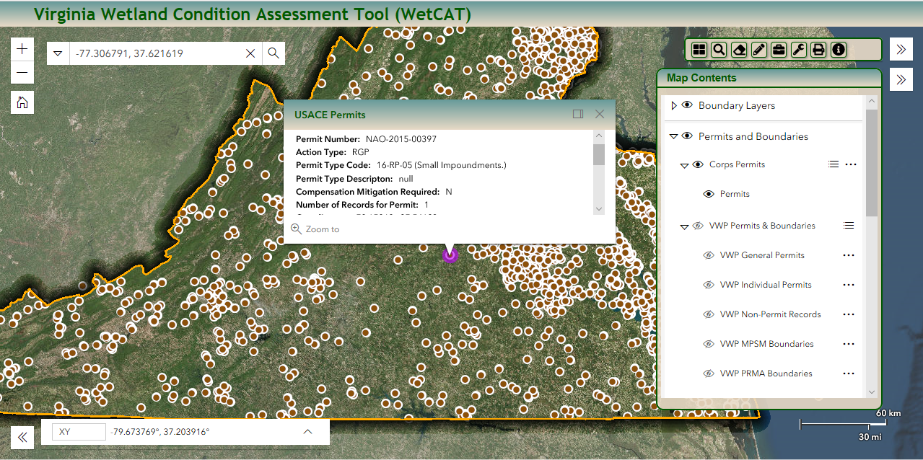

Figure 7.8-4. Corps permit layer added to WetCAT

***Future actions***

WetCAT presently allows a high level of analytical power for resource managers and the public in regard to nontidal wetlands however there is a strong interest from managers and EPA (R3 Regional Monitoring Network Workshop) to integrate management of wetlands along a watershed from tidal to nontidal. This project incorporates the Virginia Shoreline and Tidal Marsh Inventory into the WetCAT online tool. The VS/TMI was started in the 1970’s and describes the condition of tidal shorelines for individual localities in the Commonwealth of Virginia. The task output includes the integration of the tidal marsh shoreline inventory and the shoreline management model into WetCAT to allow for cumulative analysis of wetlands along continuum from nontidal to tidal. Providing the tidal marsh and shoreline information in conjunction with nontidal wetlands will allow managers to comprehensively assess wetland condition and potential cumulative impact, provide improved wetland inventories and baseline condition assessments, and increase inter and intra agency coordination.

The Virginia assessment model hinges on an assumption about the stressors created by land development patterns. As agricultural practices and urban/suburban development practices evolve, it is essential that the model relationship be regularly recalibrated. Virginia has worked to develop a monitoring and assessment strategy for nontidal wetlands that can support regulatory decision making at the state level. The purpose of the recalibration effort is to capture changes in surrounding landcover – stressor relationships at 3-5 year intervals to ensure that the condition assessment model remains statistical valid. The initial Level II Coastal Plain calibration field sample was 1,200 sites with the recalibration of 120 sites (10%), the Piedmont calibration sample was 600 sites with the re-calibration of 60 sites and the Ridge & Valley calibration sample of 300 sites with re-calibration of 30 sites. Recent advances in remote sensing technology, in particularly LIDAR coverage, has provided the opportunity to increase sample sizes while reducing field effort and expense. This task will involve randomly selecting 600 sites in the Coastal Plain. These sites will be reviewed remotely utilizing the stressor Level II protocol. Of the sites reviewed, 10% will be randomly selected to test the accuracy of the remote review process. In addition, a hind cast protocol will select 30 sites that were visited and the remote review process will be conducted as an additional test of the accuracy of the process. Any sites where the remote review and field visit differ will be revisited to determine the cause of the discrepancy. Sample methods will be identical to the previous re-calibration work (EPA Grant BG 98392503-7). This task will result in protocol and model validation of stressor-landuse relations and wetland condition (habitat and water quality) in the Coastal Plain physiographic regions of Virginia and test remote review versus field review correlation. The outcomes include improved wetland inventories, improved cumulative impact analysis, increased understanding of wetland condition, enhanced knowledge of wetland location and extent, increased use of WetCAT in permit decisions, increased use of WetCAT to avoid high value aquatic resources, and increased coordination between local, state, and federal agencies in wetlands management.

Virginia and 43 counties in North Carolina drains into the estuary, a watershed area of almost 31,500 square miles. Second only to the Chesapeake Bay, the Albemarle-Pamlico estuarine system supports a wide array of ecological and economic functions that are of regional and national importance. In the MOU, Virginia and North Carolina agree to a coordinated effort to develop and implement strategies to protect, restore, and maintain the chemical, physical, and biological integrity of the three constituent shared watersheds (Chowan, Pasquotank, and Roanoke) within the Albemarle-Pamlico watershed. This task involves the incorporation of wetlands from the shared waterways into WetCAT to allow bi-State coordinated assessment, protection, and restoration of wetlands. Presently wetlands are managed separately within each State’s regulatory program. Integrating wetlands from both North Carolina and Virginia into WetCAT and providing tools for a common framework for comprehensive and cumulative analysis will allow better communication and coordination regarding wetland management in the shared waterways. VADEQ staff will coordinate with NCDEQ and the Albemarle-Pamlico National Estuary Partnership, a bi-state partnership, and VIMS-CCRM to develop a common wetland condition assessment that can be used within the shared watershed. This will entail discussion and coordination between NC and VA on wetland condition assessment methods (i.e. Virginia Wetland Condition Assessment Tool and NC Coastal Region Evaluation of Wetland Significance). Development of a common wetland condition assessment and testing in a pilot are as the precursor to development of a shared waterways wetland condition GIS layers. Outcomes include improved wetland inventory of wetlands within the shared waterways, increased understanding and coordination regarding wetland condition, and enhanced ability to conduct cumulative impact analysis across state borders.

In 2004, the DEQ secured a Wetland Development Grant (WDG) to empanel a group of botanical experts with the singular goal of creating a Coefficient of Conservatism (C-value) list for a subset of species occurring in the State of Virginia. Recent reviews on the use of Floristic Quality Assessment (FQA) to evaluate wetland ecosystem integrity have highlighted the conservatism concept – the theoretical basis for C-value assignments – as the most valuable aspect of the FQA approach. A key to the success of this concept is developing a *comprehensive* C-value list for all species within a region. Although the C-value list developed for Virginia has been used in multiple studies, its full utility has yet to be realized due to the 2000+ native and naturalized species not yet assigned C-values in Virginia. An EPA grant was obtained in 2018 to complete the work in the original effort from the 2004 WDG that will be used as a resource for assessment of wetlands and other natural areas in Virginia, and it will allow DEQ to update its interactive floristic quality assessment tool (the Virginia FQAI Calculator). Additionally, the current list (1131 species already assigned) will be updated with appropriate taxonomic/ nomenclatural treatments vis-à-vis the *Flora of Virginia*. Outcomes include increased understanding of wetland condition based on C-values, improved wetland protection based on cumulative impact analysis, improved wetland baseline condition assessment, and better wetland determinations. This will give researchers, regulators, managers, consultants, and the regulated public access to the most up-to-date and accurate information on species conservatism in Virginia.

DEQ Wetland staff will provide policy documentation for local government and public use of WetCAT. Generating all of the information and guidance to facilitate better decision-making at the local level is only part of the process. DEQ and VIMS-CCRM have developed tutorials and curriculum on how to use WetCAT effectively. Training materials will continue to be refined for localities as well as provide presentations at the Association of State Wetland Managers and the Society of Wetland Scientists.

**References**

Cowardin, L.M., Carter, Virginia, Golet, F.C., and LaRoe, E.T. Classification of wetlands and deepwater habitats of the United States. U.S. Fish and Wildlife Report, FWS/OBS-79/31, 131 p.

Dahl, T.E. 1990. Wetlands – losses in the United States, 1780’s to 1980’s. U.S. Fish and Wildlife Service Report to Congress, Washington, D.C. 13 p.

Harlow, G.E., Jr. and LeCain, G.D. 1991. Hydraulic characteristics of, and ground-water flow in, coal-bearing rocks of southwestern Virginia. U.S. Geological Survey Open-File Report 91-250. p.48

Tiner, R.W. 1987. Mid-Atlantic wetlands – a disappearing natural treasure. U.S. Fish and Wildlife Service, Newton Corner, Mass., and U.S. Environmental Protection Agency cooperative publication. 28 pp.

Tiner, R.W. and Finn, J.T. 1986. Status and recent trends of wetlands in five mid-Atlantic states – Delaware, Maryland, Pennsylvania, Virginia, and West Virginia. U.S. Fish and Wildlife Service, National Wetlands Inventory project technical report. 40 pp.

Tiner, R.W. and Foulis, D.B. 1994. Wetland trends in selected areas of the Norfolk/Hampton region of Virginia (1982 to 1989/90). U.S. Fish and Wildlife Service, Hadley, MA. Ecological Services report R5-93/16, 18 pp.

Virginia Department of Conservation and Recreation. 1990. The Virginia nontidal wetlands inventory. Department of Conservation and Recreation, Richmond, VA. 19 p., 3 app.

U.S. Geological Survey. 1997. **National Water Summary on Wetland Resources,** United States Geological Survey Water Supply Paper 2425.

Hershner, C., K. Havens, L. Varnell, and T. Rudnicky. 2000. Wetlands in Virginia. Virginia Institute of Marine Science, Center for Coastal Resources Management. Special Report 00-1, 12 pp.

Chesapeake Bay Foundation. 1999, 2000, 2001. CBF Fact Sheet - Virginia Nontidal Wetlands Resources Act -- Common Questions and Answers. Available: <http://www.cbf.org/resources/facts/tulloch_2.htm>

Virginia Institute of Marine Science Wetlands Program. 1999. *Virginia Nontidal Wetlands Impacts Data Home Page* [Online]. Available: <http://www.vims.edu/ccrm/wetlands>.