**CHAPTER 7.6 VIRGINIA COASTAL ZONE MANAGEMENT PROGRAM**

**Description of the Virginia Coastal Zone Management Program**

Virginia’s coastal zone encompasses all of Virginia’s Atlantic coast watershed as well as parts of the Chesapeake Bay and Albemarle/Pamlico Estuary watersheds. This coastal zone area, also known as Tidewater, Virginia, includes 29 counties, 15 cities and 42 towns as well as all waters within and out to the three-mile Territorial Sea boundary.

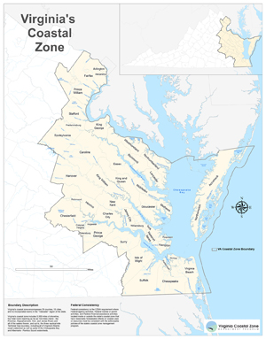

Figure 7.6 -1 Map of Virginia’s Coastal Zone

The Virginia Coastal Zone Management (CZM) Program was established in 1986 to protect and enhance Virginia’s coastal resources. The Virginia CZM Program is a network of state agencies and Tidewater local governments and the Virginia CZM laws and policies they implement. Through this network, the program manages sand dunes, wetlands, underwater lands, fisheries, point and nonpoint source air and water pollution, shoreline sanitation and a variety of other areas of particular concern such as ocean planning, marine debris, climate resilience, coastal wildlife habitats, public access, waterfront redevelopment and underwater historic sites. See <https://www.deq.virginia.gov/coasts/about-czm> for more details about the laws and policies that define the program.

In September 2018, Governor Ralph Northam submitted to the National Oceanic and Atmospheric Administration a “Letter to Continue the Virginia Coastal Zone Management Program in Perpetuity.” As with previous Executive Orders signed by previous administrations, this letter directs all state agencies to carry out their legally established duties consistent with this Program in a manner that promotes coordination among all government agencies. It is through this coordination that the Virginia CZM Program has been able to achieve great strides in achieving its goals and objectives.”

Core regulatory agencies in the Virginia CZM Program network include the Marine Resources Commission (VMRC), the Department of Environmental Quality (DEQ), the Department of Wildlife Resources (DWR), the Department of Conservation and Recreation (DCR), and the Department of Health (VDH). Other agencies assisting with the Program include the Department of Historic Resources (DHR), Department of Forestry (DOF), Department of Agriculture and Consumer Services (VDACS), Virginia Energy, the Virginia Institute of Marine Science (VIMS), the Virginia Economic Development Partnership (VEDP), the Department of Emergency Management (VDEM), and the Department of Transportation (VDOT). DEQ serves as the lead agency for Virginia’s networked CZM Program and helps agencies and localities to develop and implement coordinated coastal policies. Facilitating cooperation among these agencies is the Coastal Policy Team. The mission of the CPT is to: identify coastal policy issues that cut across agency jurisdictions and develop policy recommendations; and, to guide the development of measures or indicators to analyze the effectiveness of Virginia's CZM Program and current health and status of our coastal resources and guides the future activities of the Program. For a list of CPT members, visit <https://www.deq.virginia.gov/coasts/about-czm/virginia-coastal-policy-team>.

By virtue of having a federally approved coastal zone management Program, Virginia also has the authority to require that federal actions, including federally funded or permitted actions, within the coastal zone be consistent with Virginia’s CZM Program. Environmental impact review staff at DEQ review federal actions in the coastal zone for consistency with Virginia’s CZM Program laws and policies.

**Coastal Zone Management Act Funding Received by Virginia**

In addition to providing a forum for development and coordination of cross-cutting coastal issues, the Virginia CZM Program provides grant assistance to state agencies and local governments. Having a federally approved coastal zone management program qualifies Virginia to receive just under $3 million per year in federal funds under a formula allocation based on miles of shoreline and coastal zone population. The Office for Coastal Management at the National Oceanic and Atmospheric Administration (NOAA) allocates these funds under the Coastal Zone Management Act (CZMA). These grant funds are 50 percent matched by Virginia’s state agencies and local governments.

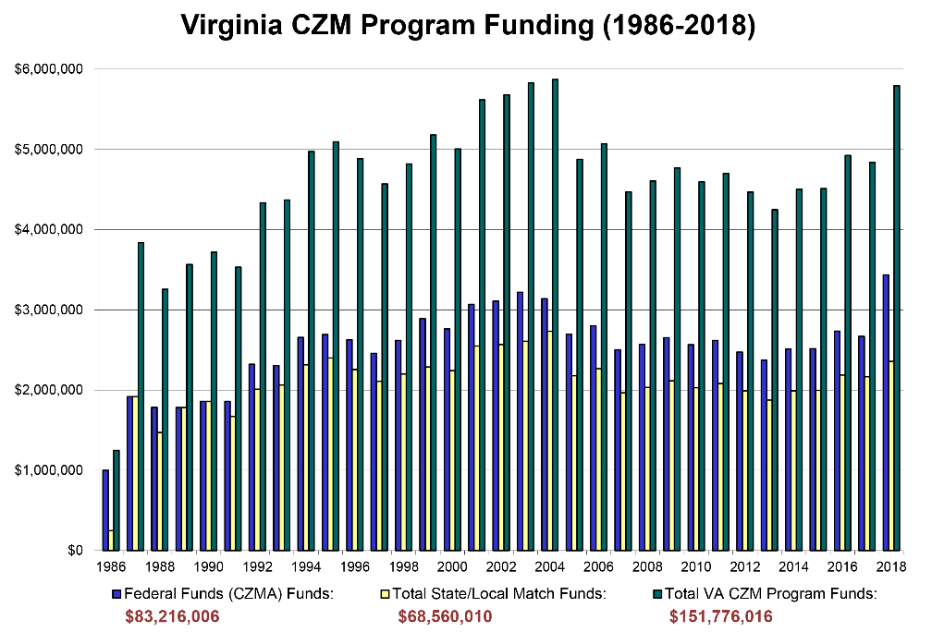

Figure 7.6-2 Virginia CZM Program Funding (1986-2018)

Since 1986, Virginia has received almost $89 million dollars in federal CZMA funds, matched by over $73 million in state and local funds. This includes match from the [Virginia Water Quality Improvement Fund](http://law.lis.virginia.gov/vacode/title10.1/chapter21.1/) which finances nutrient reduction technology at publicly owned wastewater treatment plants and local projects funded through the Stormwater Local Assistance Fund (SLAF). Together these funds are used to implement the Virginia CZM Program and to carry out a broad scope of state and local projects in the areas of coastal technical assistance, enforcement, environmental management, habitat monitoring and restoration, land acquisition, local government planning and comprehensive plans, public access planning and construction, public education, shoreline management, special area management planning, wetlands surveys and policy, and water quality monitoring/protection and improvements.

**Virginia Coastal Zone Management Program Initiatives Benefiting Water Quality**

Several initiatives exemplify the Virginia CZM Program’s unique opportunity to fund and support projects that protect the commonwealth’s coastal resources, while encouraging intergovernmental coordination and partnerships with a broad constituency. Highlighted below are Virginia CZM Program initiatives that address water quality and focus on education, monitoring and restoration of living resources to improve water quality in Virginia’s coastal waters.

**Virginia CZM Program GIS-Mapping Efforts: Coastal GEMS and Coastal VEVA**

***Virginia Coastal Geospatial and Educational Mapping System (GEMS*)**

In February 2007, the Virginia CZM Program launched “Coastal GEMS” (Coastal Geospatial and Educational Mapping System). Coastal GEMS integrates and provides access to a wide range of coastal resource data, fact sheets, relevant projects, regulatory information, and important Web links. Coastal GEMS is a robust, one-stop, data gateway for federal, state, and local government decision makers. It facilitates data sharing among governments, NGOs, and the public and promotes standards for environmental data management within the region. Coastal GEMS allows its users to explore and describe patterns and relationships among water and land ecosystem elements across broad (i.e., landscape-level) spatial scales.

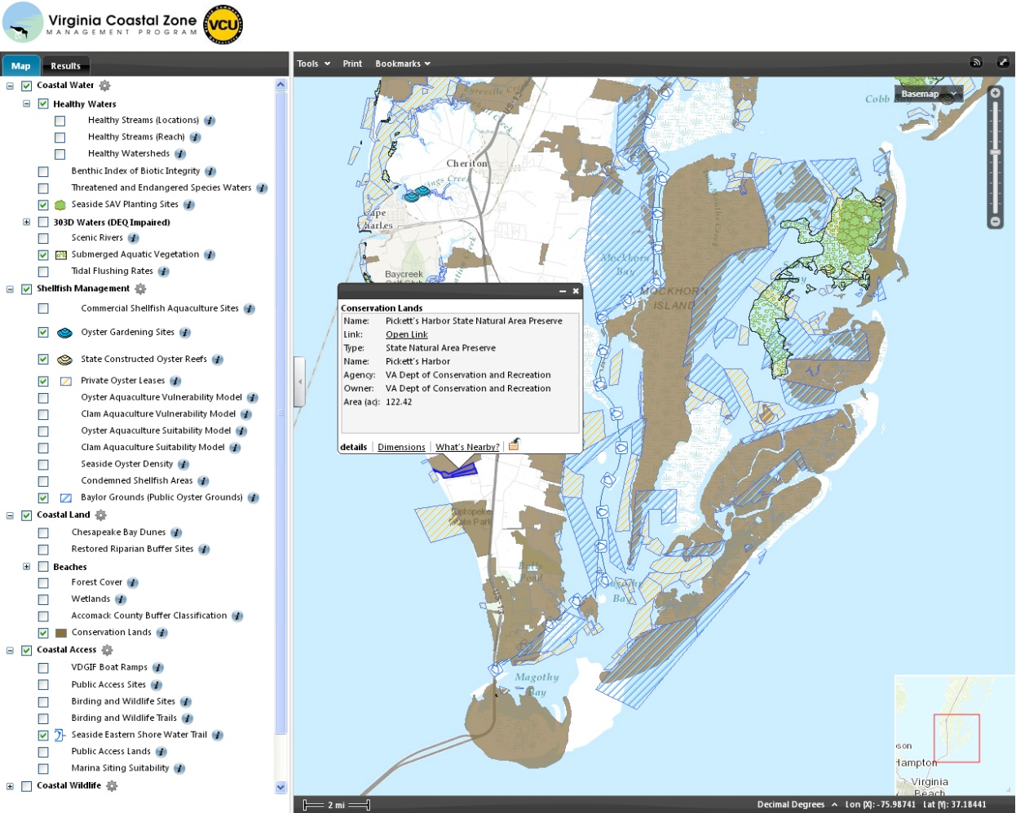

Figure 7.6-3 Coastal GEMS Screenshot

The development of Coastal GEMS was a large-scale, multi-partner effort to create a “vision” or map of the ecologically and economically significant aquatic (marine and freshwater) and terrestrial resources found within Virginia’s Coastal Zone. Although spatially displayed data for aquatic and terrestrial ecosystems are becoming more and more accessible through the Internet, often these data are sequestered in different agencies’ and organizations’ websites and are not joined into one central application to allow all users equal and efficient access. The vision was to build this type of access. Seeing the resources in one big picture could simplify the task of connecting local land use planning decisions to state and federal water use policies. A stronger understanding of how activities on the land and in the water affect one another would enable everyone to better protect and manage coastal resources in a logical and sustainable fashion - something critically needed in light of today’s increasing development pressures.

The data, which are being incorporated into Coastal GEMS, have been the result of collaborative discussions and data-sharing efforts between many state and local agencies with a vested interest in Virginia’s coastal zone and the Virginia CZM Program will continue to explore opportunities to include additional data layers from partner agencies as they are developed. The Virginia CZM Program has also funded many data development projects, which are represented in Coastal GEMS data layers.

The availability of adequate coastal resource data is essential to improving decision-making at the state and local level. By mapping the best remaining blue and green infrastructure in coastal Virginia, the Virginia CZM Program’s Coastal GEMS website provides an easy-to-access, visual reference for localities where vital coastal resources are located. The Virginia CZM Program continues to work closely with the Center for Environmental Studies at Virginia Commonwealth University and all its data-sharing partners to enhance the interface, tools, data, and information within Coastal GEMS. Coastal GEMS is now a dynamic Internet mapping application with aerial imagery, reference data layers such as roads and streams, and over 80 data layers of land and water coastal resources, models and examples for conservation planning. Unique selection tools allow you to generate tables of coastal resource information for a selected area and mapping tools allow you to easily investigate and navigate through the coastal zone and create maps that can be exported or printed for further use and analysis.

The divisions of state and local management of Virginia’s coastal resources are complex and difficult for the general public to understand. In addition to the mapping component of Coastal GEMS, the Virginia CZM Program created “fact sheets” for each data layer to break down the complexity of coastal resource management. The fact sheets provide brief information and links to in-depth information on:

* The value of the resource (ecological, economic, and social).
* Management of the resource (at local, state, and federal levels).
* Why and how the data was developed.
* How to directly download the data or who to contact to obtain the dataset.
* Future directions if the data is associated with a long-term funded project.
* Frequently asked questions received from the general public.

***Coastal GEMS Version 4 Now Available***

Since its inception, Coastal GEMS was always more than just a map. The launch of Coastal GEMS version 4 takes this concept to a new level. The mapping application is still the focus, and v4 includes an entirely new mapping interface with powerful new functionalities that we will cover later in this article. The v4 mapping application has a new home on the all-new Coastal GEMS landing page. Instead of going directly to the mapping application, navigating to [www.coastalgems.org](http://www.coastalgems.org) now takes you to the Coastal GEMS landing page, where you can launch the mapping application, explore our growing collection of story maps, or browse the new Coastal GEMS data library. Together these new products have transformed Coastal GEMS into a full-fledged data portal.

*Landing Page* **-** Built using ArcGIS Hub, the new landing page was designed to be a simple interface to access the suite of Coastal GEMS products. This platform leaves room for additional content in the future and can be quickly edited and updated by the CZM GIS Coordinator.

*Story Maps -* VA CZM has been creating story maps for several years, but until now there was not a single location where they could all be accessed. The story map page allows visitors to explore this growing collection of story maps associated with Coastal GEMS data layers and VA CZM initiatives.

*Data Library -*The all-new Coastal GEMS data library provides users with an alternative way to access the many data layers available through Coastal GEMS. The layers are browsed by category and include brief data abstracts and links to data sources, as well as the ability to view the full Coastal GEMS factsheets and open each layer in the Coastal GEMS map.

*Mapping Application -*The new Coastal GEMS web mapping application has a clean interface and several new features that allow users to perform GIS functions previously only possible using expensive desktop GIS software.

*Share Maps*

Just like v3, the v4 mapping application allows users to create map layouts that can be printed or shared in various image formats. The v4 application adds a clever new way to share maps though, with the fantastic “Share This Map!” widget. This tool creates a link that opens the application with the data layers and map extent already selected, allowing you to share interactive maps that recipients can continue to explore and add too. Hot tip: Working on something you might want to revisit? Send your self the link and pick up later where you left off!

*Add Outside Data*

Coastal GEMS still houses a lot of data, over 100 individual layers! Occasionally though, a user might want to add an additional layer from an outside source to their Coastal GEMS map, and with v4 that is now possible! Using the “Add Data” widget, it is possible to search and add data from ArcGIS online, add data hosted as a web service, or add data from your own computer in shapefile, kml, or CSV format.

*Access Attributes*

While v3 did allow Coastal GEMS users to see selected attribute information for individual features by clicking on them, it was not possible to view the full attribute table for each dataset. Coastal GEMS v4 allows users to harness the full potential of GIS datasets, both spatial and non-spatial data, by viewing, selecting, filtering, and even exporting attribute data.

*What’s Near You?*

In addition to filtering data by attributes, Coastal GEMS v4 users can also filter data by location in two ways. Attribute table data can be filtered by the current map extent, or you can use the new “What’s Near Me?” widget to define a search radius for any point and see the features from all of the Coastal GEMS layers that fall within that area!

*Schedule a Training*

To learn more about the all new Coastal GEMS, contact Nick Meade ([nick.meade@deq.virginia.gov](mailto:nick.meade@deq.virginia.gov)) for a training customized to your needs.

***Coastal Virginia Ecological Value Assessment (VEVA)***

Many years ago, the Virginia CZM Program envisioned a comprehensive planning tool that would streamline use of all state natural resource information into a single data set facilitating regional and local land-use management and conservation planning in the coastal zone. A collaborative effort led and funded by Virginia CZM culminated in FY 2010. This effort included key natural resource agencies and resulted in the Coastal Virginia Ecological Value Assessment (VEVA). Coastal VEVA integrates elements of more than 40 different data sets funded by the Virginia CZM Program alone, totaling approximately $1.3M.

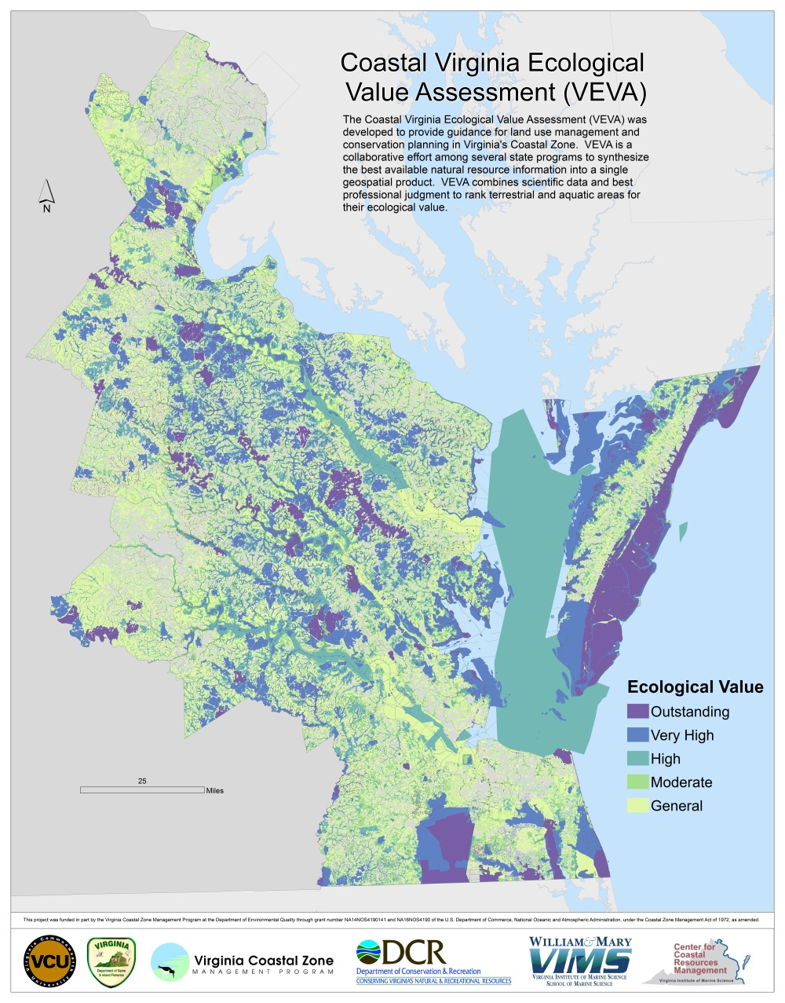

Figure 7.6-4 Coastal VEVA Screenshot

Research and data collection that ultimately became the foundation for VEVA began in 1988 with CZM funded conservation planning in Virginia’s Lower Peninsula. Following this effort and throughout the 1990’s, Virginia CZM funded natural heritage inventories in the lower Chickahominy watershed, Virginia Beach, the Albermarle-Pamlico Estuarine region and Northampton County as well as an interstate study of the Neotropical Migratory songbird corridor in New Jersey, Delaware, Maryland and Virginia.

The idea of creating a synthesis of the multitude of this and other contributing state natural resource data layers was brought up at a 2001 Coastal Partners Workshop. Participants agreed that the Virginia CZM Program should create a map of the best remaining coastal lands and waters, in other words the best remaining “green” and “blue” infrastructure. In response, the Virginia CZM Program crafted a Section 309 strategy beginning in FY 2003 that focused on data collection and data synthesis. Grants were awarded to DCR/Natural Heritage for priority conservation areas, to VCU for in-stream assessments, and to VIMS for blue infrastructure maps. In 2008 work began on synthesizing the blue and green infrastructure layers. The Virginia Department of Wildlife Resources (DWR), Virginia Department of Conservation and Recreation – Division of Natural Heritage (DCR-DNH), and Virginia Commonwealth University – Center for Environmental Studies (VCU-CES) collaborated to combine conservation information and priorities into a unified dataset of priority conservation areas. While the PCA assessed priorities on land, incorporating both stream and watershed health, it did not include all ecologically valuable regions within Virginia’s tidal waters. Coastal VEVA builds on the PCA and incorporates an assessment of estuarine natural resources recognizing that ecological value of Virginia’s coastal lands and waters are inextricably linked—with land use decisions on the upland ultimately affecting water quality and habitat health in receiving waters. The estuarine component was produced by VIMS College of William and Mary Center for Coastal Resource Management through a series of grants. Coastal VEVA is defined as lands, aquatic resources and surface waters identified as important for conservation of Virginia's wildlife, plants, and aquatic and natural communities. The identified lands, aquatic resources and waters can be used to prioritize areas for preservation, protection or specific management action.

An update to Coastal VEVA was completed in 2017 through Virginia CZM Program funding to DCR-DNH, DWR, and VCU CES. DCR-DNH updated their Virginia Natural Landscape Assessment (using the 2011 NLCD and much more extensive fragmentation layers) and DWR updated their Priority Wildlife Diversity Conservation Areas synthesis (including updates to their Anadromous Fish Use Waters and Unique Terrestrial and Aquatic Areas datasets as well as the inclusion of new Terrestrial and Aquatic Potential Habitats data from the North Atlantic Landscape Conservation Cooperative). VCU CES updated their Aquatic Resource Integrity Layer and worked with VIMS staff to update the Aquatic Priority Conservation Areas layer (including updated data for SAV, Shellfish Vulnerability, and Sea Turtle Nests). VCU CES then compiled all of the data and ran the VEVA model update. All partners agreed to retain the 30m resolution of the 2017 Coastal VEVA instead of 100m used in previous version. The 30m version does not reveal sensitive areas as previously thought and will be a more useful product for local scale conservation planning.

# Virginia Coastal Nonpoint Source Pollution Program

In 2001, Virginia became the sixth state to receive full approval of its *Coastal Nonpoint Pollution Control Program* from NOAA and EPA. Development of the program was initiated in the fall of 1992 in response to Section 6217 of the Coastal Zone Management Act Reauthorization Amendments of 1990. Section 6217 of the Act requires that states with an approved coastal zone management program, develop a Coastal Nonpoint Source Pollution Control Program. The statute is meant to restore and protect coastal water quality through the application of economically achievable "best management practices" implemented through enforceable state policies and mechanisms. The federal government defines state enforceable policies and mechanisms as state and local regulatory controls and/or non-regulatory incentive programs combined with state enforcement authority.

There are 56 management measures contained in the *Guidance Specifying Management Measures for Sources of Nonpoint Pollution in Coastal Waters*, a comprehensive technical document issued by EPA on methods to abate and control nonpoint pollution in coastal areas. The chapters include management measures in the following areas: agriculture, forestry, urban areas, marinas and recreational boating, and hydromodification (channelization and channel modification, dams and streambank and shoreline erosion). This document is available at [www.epa.gov/owow/nps/MMGI/](http://www.epa.gov/owow/nps/MMGI/).

In order to gain approval of its Coastal Nonpoint Pollution Control Program, Virginia was required to show that:

1) State programs include appropriate management measures (defined in the above guidance) to control NPS pollution;

2) The state has a means of implementing the management measures, and;

3) The state has sufficient statutory authority and enforcement capabilities to ensure implementation of management measures to reduce NPS pollution impacts on coastal resources.

With approval of its Coastal Nonpoint Pollution Control Program, Virginia remains eligible for full funding under the Coastal Zone Management Act and Section 319 of the Clean Water Act.

Following are some of the projects that contributed to the approval of Virginia’s Program:

* A series of workshops on the proper use of irrigation systems and development of informational material on irrigation best management practices;
* Development of a web-enabled database for use by local government to track erosion & sediment control activities; development of a model local stormwater ordinance; and an economic evaluation of incorporating BMPs into site design;
* Development of shore lands planning protocol for use by local governments to enhance planning capabilities for areas adjacent to shore lands;
* A statistical analysis of the impact of channelization activities and dams in Tidewater Virginia on in-stream & riparian habitat;
* A plasticulture guidebook for local government and farmers recommending practices to protect water quality for operations using plastic mulch;
* Development of the Virginia Clean Marina Program to provide technical assistance to marinas and recreational boaters.

Virginia’s Coastal Nonpoint Source (NPS) Program is facilitated through Virginia CZM, but implemented by DEQ with state and federal grants including Section 319 funding. Virginia CZM in particular focuses on pollution prevention and encourages efforts at a regional and local level, particularly improvements to land use planning and zoning practices to protect coastal water quality through its Section 309 Coastal Zone Enhancement Strategies (FY2016-2020 and FY2021-2025) and FY2020-2022 Focal Area grants. Additionally, CZM’s past (FY2016-2020) and current (FY2021-2025) Section 309 Marine Debris Strategies include initiatives to update and implement the Virginia Marine Debris Reduction Plan to better align with the Mid-Atlantic Marine Debris Reduction Plan. Major goals of the Plan include addressing Abandoned & Derelict Vessels, Derelict Fishing Gear, Consumer-Based Debris, and Microplastics/Microfibers. (See more details on marine debris reduction efforts below.)

The FY2020 Section 309 Project of Special Merit team (Virginia Coastal Policy Center, Virginia Institute of Marine Science, and DEQ) is working to provide guidance to localities on how to integrate adaptations to recurrent flooding with water quality improvements. The guidance will accompany recent regulatory changes to the Chesapeake Bay Preservation Act required by the 2020 General Assembly. The project’s anticipated completion is March 2022.

Another Component of the Virginia CZM’s Section 309 Cumulative and Secondary Impacts (CSI) Strategy for FY2016-2020 focused on addressing development pressure in the Lower Chickahominy River Watershed by bringing local governments and Virginia Indian Tribes together to foster dialogue about shared visions for land use, sustainable development, and cultural resource preservation. These entities are in the process of finalizing a Watershed Collaborative MOU to solidify consultation and coordination on the aforementioned issues. Virginia CZM staff will continue to support collaborative efforts going forward.

Since 2015, CZM has continued to provide funding to the Dept. of Conservation & Recreation (DCR) to administer and expand the Healthy Waters Program, which includes a delivery of tools and products from the DCR Natural Heritage Program (NHP) such as the Virginia Ecological Values Assessment (VEVA), Element Occurrences (EOs), Stream Conservation Units (SCUs), INSTAR data, Coastal GEMS, and ConservationVision Watershed Model. These expanded and updated datasets allow DCR staff to prioritize areas for restoration projects using Virginia CZM or other funds, while aligning with the Commonwealth’s new ConserveVirginia 2.0 program for land conservation, launched in 2019.

Since 2018, DEQ’s Stormwater Local Assistance Fund (SLAF) has provided matching funds for several localities for projects to improve stream habitat and reduce nutrient loads including:

* Fairfax County for the Flatlick Branch Stream Restoration Phase III (FY2018)
* Fairfax County for the Turkey Run Stream Restoration project (FY2019)
* Town of Vienna for the Pike Branch Stream Restoration project (FY2020)

Note that match funds for FY2015-2018 were provided by the state’s Water Quality Improvement Fund (WQIF), but were associated with wastewater treatment plants (WWTP), which are *point* sources of nutrient pollution.

*Locality Stormwater Management:* Since 2015, several coastal Planning District Commissions (PDCs) have continued to use Virginia CZM funding for FY2020 grants to convene quarterly meetings of locality stormwater managers and conduct outreach campaigns to educate the public on water quality issues associated with non-point source pollution.

*DEQ Regulatory Review:* Virginia CZM continued to review NPS pollution aspects of projects as part of their Federal consistency/EIR review process. This effort will continue in 2022.

**Increasing the Availability and Use of Virginia Native Plants**

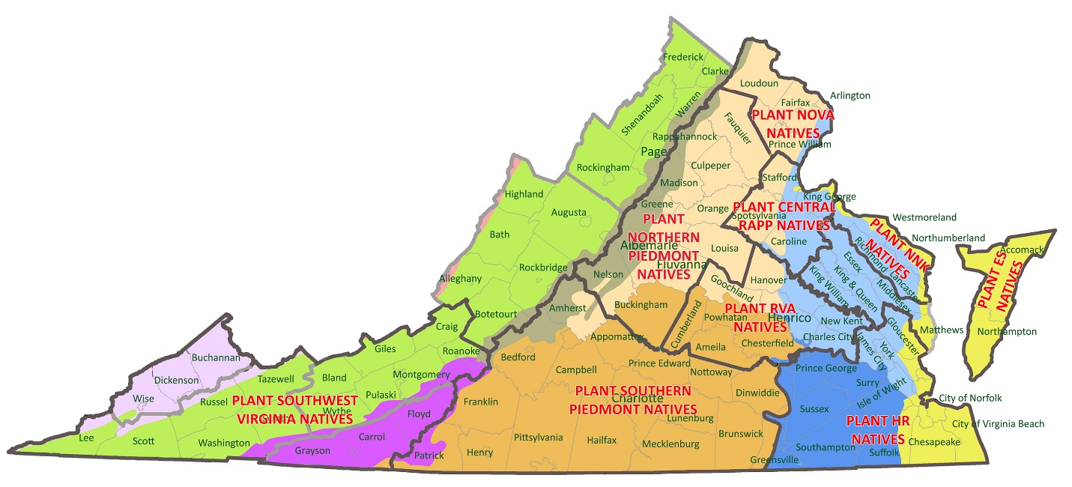

Figure 7.6-5 Map showing Boundaries of Existing Regional Native Plant Marketing Campaigns and Proposed Boundaries for Future Campaigns

Virginians are increasingly hearing that planting natives will help improve the environment – especially habitat for declining pollinator and bird populations as well as to improve water quality – but many are not sure where to start.

In 2021, the Plant Virginia Natives initiative offered a Landscaping with Virginia Natives webinar series with over 3,000 attendees across the state. Hundreds more have watched the recordings now available on [PlantVirginiaNatives.org](http://www.PlantVirginiaNatives.org).

Plant Virginia Natives is a collaborative network of partners engaged in state-wide and regional strategies to increase the knowledge, use and availability of native plants. The Virginia CZM Program, a network of state agencies and coastal localities, introduced, coordinates and has funded the initiative since 2008 (<https://www.deq.virginia.gov/coasts/virginia-native-plant-marketing>).

Plant Virginia Natives identifies opportunities to collaborate and partner on Virginia native plant communication and marketing efforts and form a cohesive and coordinated strategy to encourage the use of native plants coastal zone wide for their many benefits and help meet Virginia’s habitat restoration and water quality goals.

The Plant Virginia Natives initiative advances the shared goals of the partners, outlined in an Action Plan (downloadable from PlantVirginiaNatives.org):

**Goal 1:** Continue to encourage and increase collaboration and coordination among partners engaged in native plant education, communication and marketing. **Goal 2:** Enhance knowledge of the value of native plants.

**Goal 3:** Increase Virginia grown native stock, and consumer access to native plants.

**Goal 4:** Increase demand and use of plants native to Virginia by:

* Landscape and land use professions (including engineers, L.A.’s, anyone who specify for land development/use)
* Homeowners
* Landscaping and demonstration restoration projects on public and (state, federal) and also private (landowners or non-profit ownership)

One of the projects of the initiative are regional native plant marketing campaigns throughout the coastal zone, across the Piedmont and into the mountains. There are now nine regional campaigns in Virginia, engaging over 150 state, regional and local partners.

The regional native plant marketing campaigns help meet the goals of the initiative by focusing on helping landowners learn more about their property and the ecological benefits of a native plant landscape; and, recruiting local garden centers and other providers to promote and increase the supply and variety of the native plants they carry. The campaigns also work with local jurisdictions to strengthen policies that favor native plant landscaping. 

The regional native plant campaign model basically has three components. The campaigns work with local and regional native plant providers on point-of-sale materials to help customers find native plants such as signage and plant tags, which encourages both the demand and supply of native plants. Campaigns collect commitments or pledges to plant natives such as signatures during public events. A decal reminds people of their pledge. By displaying this decal in a publicly visible way, those who pledge also help spread the campaign’s message within their community. Finally, the campaigns use captivating communications to convey the benefits and to increase knowledge of native plants. Regional native plant guides have been the most popular resource. Seven guides have been published, including six coastal guides designed and funded by Virginia CZM - Eastern Shore, Northern Neck, Northern Virginia, Central Rappahannock, Virginia Capital region, Southeast Virginia - and a guide for the Northern Piedmont. Guides for the Southern Piedmont and Southwest Virginia are currently in production.

Over 100,000 full-color guides have been distributed. All guides are downloadable from [PlantVirginiaNatives.org](http://www.PlantVirginiaNatives.org), which is a growing hub for information about natives plants, linking visitors to all the partners have to offer.

Each of these full-color guides highlight 100 or so species of flowering perennials, ferns, vines, grasses, shrubs and trees with a photo, description, symbols for light and moisture requirements and wildlife value (butterfly, caterpillar, bird), and interesting facts. Indices list hundreds of additional species. The guides include sections on conservation landscaping; right plants for right places; native plant demonstration gardens; and, additional resources about native plants and landscaping with native plants. Each regional guide also highlights invasive plants of particular concern in the region and native alternatives.

Encouraging landowners and gardeners everywhere to choose plants native to Virginia reduces the risk of invasive plants escaping and impacting our forests, fields, parks, waterways, and backyards.

The benefits of working together is a proven strategy modeled by the Plant Virginia Natives initiative. Collaboration among many partners helps us reach into all corners of the state with our shared message about the numerous benefits of Virginia’s native plants.

# Virginia Coastal Needs Assessments and Strategies

# [Section 309 of the Coastal Zone Management Act (CZMA)](http://www.ocrm.nos.noaa.gov/czm/czmenhancement.html) establishes a match-free coastal zone enhancement grants program to encourage coastal states to develop new enforceable policies. The National Oceanic and Atmospheric Administration (NOAA) awards CZMA funds and requires that coastal states assess changes, progress and new issues in the nine areas below every five years.

1. wetlands
2. coastal hazards
3. public access
4. marine debris
5. cumulative and secondary impacts
6. special area management planning (SAMPs)
7. ocean resources
8. energy and government facility siting
9. aquaculture

After completion of a draft assessment, the Virginia CZM Program's [Coastal Policy Team](http://www.deq.virginia.gov/coastal/policytm.html) (CPT) meets to review and prioritize (high, medium or low priority) the nine assessment areas for the next five years of work and to develop strategies to address the priority areas. All of the projects undertaken to implement the strategies have either direct or indirect impacts to water quality.

*Virginia's 2015 Coastal Needs Assessment and FY2016 - FY2020 Strategies*

The Virginia CZM Program is focused its efforts on the following assessment areas and issues between 2016 and 2020.

* Coastal Hazards
  + Shoreline Plan and Policy Development
  + Community Resiliency Plans
* Cumulative and Secondary Impacts
  + Chickahominy River: Leveraging Economic Benefits of Land Conservation
  + Working Waterfronts
* Ocean Resources
  + Stakeholder Coordination
  + Sand Management
  + Ocean Data Collection/Synthesis or Tools
  + Marine Debris

*Virginia's 2020 Coastal Needs Assessment and FY2021 - FY2025 Strategies*

In the fall of 2019, based on NOAA guidance, the Virginia CZM Program conducted a Phase I Coastal Needs Assessment as the first step in identifying the areas or topics of highest priority for FY2021-2025 Coastal Strategies (Section 309) funding from NOAA.   
  
Virginia CZM Program posted the Phase I Assessment for public comments in March 2020.

Virginia CZM Program staff presented the Phase I Assessment and recommendations to the Virginia Coastal Policy Team (CPT) in January 2020. Based on the feasibility and importance of developing new enforceable policies, the members of the CPT, ranked the nine areas.   
  
Virginia CZM Program staff then conducted a Phase II Assessment of the four topics ranked highest priority:

1. Coastal Hazards
2. Cumulative & Secondary Impacts of Coastal Growth & Development
3. Ocean Resources
4. Marine Debris

Staff met with key stakeholders to complete the assessments as well as develop draft Coastal Strategies for coastal hazards, ocean resources, and marine debris.

The FY2020-2025 Coastal Needs Assessments and Strategies document was compiled by Virginia CZM Program staff and sent to NOAA for review. NOAA approved the strategies in February 2021. These strategies will be funded through the FY2021-2025 grant cycle (October 2021 - September 2026).

View the current and previous assessment and strategy reports and projects: <https://www.deq.virginia.gov/coasts/strategic-planning/coastal-needs-assessment-and-strategies>

**Virginia Marine Debris Reduction Efforts**

Since the Virginia CZM Program began working on the issue of marine debris back in 2013, the topic has gained momentum. Concerns among local and state government officials have increased dramatically, the media has covered the issue extensively and often, and public awareness has been elevated far beyond previous Section 309 cycles. Some, but of course, not all, of this attention can be traced to Virginia CZM’s Section 309 efforts and its major grantee, Clean Virginia Waterways. The VA CZM Program has been at the forefront of the issue and provided leadership in developing the first state marine debris reduction plan on the Atlantic Coast in 2014 – and recently a revised plan published in December 2021, based on input from a large and diverse group of stakeholders. The revised VMDRP aligns with the major goals of the Mid-Atlantic Marine Debris Action Plan. Virginia CZM also conducted likely the most in-depth monitoring, research and Community-Based Social Marketing campaign efforts to reduce balloon releases – one of the top most harmful forms of marine debris for wildlife (see more detail under question 35).

Virginia CZM was able to ensure that reducing marine debris was a key action in the 2016 Mid-Atlantic Ocean Action Plan, and the Virginia CZM Program Manager has led the Mid-Atlantic Marine Debris Work Group established under that plan since 2016. That group has gone on to secure additional funding from NOAA’s Marine Debris Program to expand Virginia’s balloon release reduction campaign to the entire Mid-Atlantic, including significant work by Virginia CZM staff on pre-campaign research, design of the campaign strategy and development of multi-media materials.

Examples of increased collaboration include the Virginia Marine Debris Summit in 2016 and the Mid-Atlantic Marine Debris Summit in 2019, the creation of a Virginia Abandoned and Derelict Vessel Work Group, a Virginia Plastic Pollution Prevention Network (which meets monthly), and annual Stormwater and Litter Workshops.

The 2021-2025 Virginia Marine Debris Reduction Plan can be downloaded from the Virginia CZM Program website at <https://www.deq.virginia.gov/coasts/marine-debris>.

Legislation and policies enacted in Virginia in 2020 and 2021 target some common and harmful sources of marine debris. (See more on the program’s marine debris reduction projects in question 18 below.)

* *Plastic bags:* H.B. 534 allows local governments to place a 5-cent tax on plastic

shopping bags.

* *Balloons:* H.B. 2159 bans the intentional release of helium-filled balloons.
* *Polystyrene containers:* H.B. 1902 phases out the use of single-use expanded polystyrene (EPS, and sometimes called Styrofoam), as food service containers. Certain chain restaurants have until July 1, 2023 to stop EPS use, and all other food vendors have until July 1, 2025.
* *Clam netting:* In 2021 the Virginia CZM Program Manager drafted an agreement for addressing derelict clam netting. The Virginia Marine Resources Commission, the Shellfish Growers of Virginia, the Virginia CZM Program and Clean Virginia Waterways signed the agreement. Only loose netting is to be collected so as not to disturb tiger beetle and nesting shorebird habitat.
* *Single-use plastics in universities and state agencies:* Executive Order 77, announced in March 2021, directs state universities and agencies, by July 2021, to stop buying, selling or distributing single-use bags, straws, cutlery, water bottles, and EPS food containers. In addition, all state agencies will develop a Plastic Pollution Reduction Plan to eliminate all non-medical single-use plastic and expanded polystyrene objects, and replace them with reusable, compostable or recyclable items. Phase Out Schedule for all non-medical single-use plastic:
  + 25 percent reduction by December 31, 2022
  + 50 percent reduction by December 31, 2023
  + 75 percent reduction by December 31, 2024
  + 100 percent reduction by December 31, 2025
* Virginia Litter Tax: In 2020, the Virginia Litter Tax was raised for the first time in 43 years – from $10 to $20 for businesses that manufacture, wholesale, distribute, or sell products from fourteen categories: food for human or pet consumption, groceries, tobacco products, soft drinks and carbonated water, alcoholic beverages, newspapers and magazines, motor vehicle parts, paper products, glass containers, metal containers, plastic or synthetic fibers, cleaning products, non-drugstore sundry products, and distilled spirits. An additional annual litter tax (for each location that manufactures, sells, or distributes groceries, soft drinks or beer) was raised from $15 to $30. Revenue from the Litter Tax (in addition to excise taxes on soft drinks, beer and wine coolers) are deposited into the Litter Control and Recycling Trust Fund, and distributed by the Virginia Litter Control and Recycling Fund Advisory Board. Awareness of the need to raise this tax came about as part of research done in the development of the Virginia Marine Debris Reduction Plan. A fact sheet was developed and disseminated to key policy makers and groups that were interested in lobbying for the change.

Having a Marine Debris Reduction Plan in place also helps Virginia meet one of its goals as a [member of the Mid-Atlantic Regional Council on the Ocean (MARCO)](http://www.deq.virginia.gov/Programs/CoastalZoneManagement/CZMIssuesInitiatives/OceanPlanning/VirginiaRoleonMidAtlanticCouncilontheOcean.aspx) ([www.midatlanticocean.org](http://www.midatlanticocean.org)). One of MARCO's water quality issues of concern is marine debris.

**Coastal Planning District Commissions**

Virginia's eight coastal planning district commissions (PDCs) play an integral role in the Virginia CZM Program. Coastal PDCs provide an important link between the state agencies and 86 localities that constitute Virginia's network of coastal resource managers. A representative from each PDC serves on the [Virginia CZM Program's Coastal Policy Team](http://www.deq.state.va.us/Programs/CoastalZoneManagement/DescriptionBoundary/VirginiaCoastalPolicyTeam.aspx) and all eight coastal PDCs meet quarterly with Virginia CZM staff. In addition, each PDC holds quarterly meetings for its local coastal resource managers.

The Virginia CZM Program supports each coastal PDC with an annual technical assistance grant and has provided assistance for a variety of regional and local coastal resource management projects sponsored by the PDCs. With this funding support, Virginia's coastal PDCs have been instrumental in the planning and implementation of a number of key water quality projects.

* [Accomack-Northampton Planning District Commission](http://a-npdc.org/)
* [Crater Planning District Commission](http://www.craterpdc.org/)
* [Hampton Roads Planning District Commission](http://www.hrpdcva.gov/)
* [Middle Peninsula Planning District Commission](http://www.mppdc.com/)
* [Northern Neck Planning District Commission](http://nnpdc.org/)
* [Northern Virginia Regional Commission](http://www.novaregion.org/)
* [George Washington Regional Commission](http://www.gwregion.org/)
* [Richmond Regional Planning District Commission](http://www.richmondregional.org/)