**CHAPTER 4.4 FRESHWATER PROBABILISTIC MONITORING**

### Summary

      Probabilistic Monitoring (ProbMon) employs random site selection to produce statistically unbiased estimates of water quality conditions proportional to their occurrence across the Commonwealth. The agency’s other water monitoring programs are focused on water quality at selected study sites, for example evaluating water quality at long-term trend stations or in specific watersheds, or assessing the effects of identified pollution sources or mitigation efforts. These programs are inappropriate for statistically estimating water quality on a statewide basis. ProbMon is a valuable tool for evaluating large-scale watershed management activities, for testing new monitoring and assessments methods in a variety of ecological settings and for supporting agency activities such as Total Maximum Daily Load (TMDL) studies and determining permit limits. The survey design, analysis, geovisualization, and reporting of ProbMon data uses open source software, which promotes the scientific transparency and reproducibility of this monitoring program[1].

      Since 2001, the DEQ ProbMon program has sampled 894 randomly selected wadeable sites (Figure 4.4-5) to provide statistically valid estimates of statewide biological condition and stressor extent. The robust dataset can provide insight into water quality status at US Level III ecoregion and river basin-specific scales. Nearly 250 sites were sampled during the 2022 assessment period (Figure 4.4-2). Based on the ProbMon data set, the majority of Virginia streams meet applicable numeric water quality criteria associated with aquatic life use. However, nearly 40% of Virginia streams fail to meet biological condition expectations, using a defined assessment threshold for aquatic organism (benthic) communities as indicators of stream health (VSCI/VCPMI). Additionally, many streams exceed screening values for parameters that have been shown in various studies to have the potential to act as stressors on aquatic life communities. These parameters, which include streambed sedimentation, habitat disturbance, and nutrients, are evaluated on a statewide basis using ProbMon data (Figure 4.4-1).

##### Figure 4.4-1. Percentage of stream miles with water quality parameters exceeding criteria, assessment thresholds or screening values. Orange bars indicate parameters with screening values only (no numeric water quality criteria or assessment thresholds) and green bars indicate parameters with numeric water quality criteria (pH, DO) or assessment thresholds (VSCI/VCPMI). Horizontal lines associated with each parameter illustrates 95% confidence limits. Figure represents data collected from 2015 - 2020.

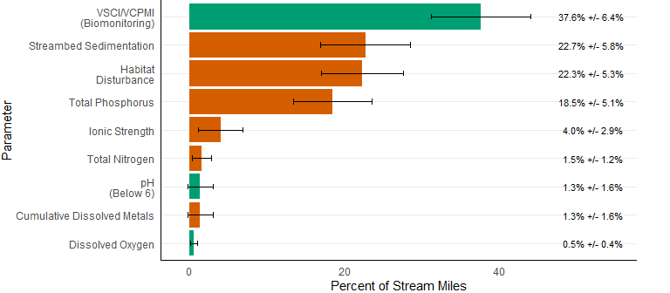

      ProbMon provides essential methodology for identifying potential aquatic life water quality stressors for which numeric criteria do not exist. For example, the agency uses ProbMon data to conduct benthic stressor analyses when developing TMDLs to determine the most probable water quality problems causing benthic impairments (i.e. the most probable stressors). These analyses often identify nutrients or sedimentation as the most probable stressors. The agency is also working in conjunction with the Water Quality Academic Advisory Committee to develop a screening approach for nutrient criteria. This strategy employs ProbMon data to evaluate the potential for impairment based not only on nutrient concentrations, but also on indirect evidence such as abnormal pH, dissolved oxygen, and degraded benthic macroinvertebrate communities. The unbiased, statewide approach to collecting water quality data employed in ProbMon provides an invaluable tool for developing and improving assessment methods. For example, methods for conducting genus-level (rather than the current family-level) macroinvertebrate bioassessments as well as fish-based bioassessments are in development. Development of these new tools, which should greatly improve the accuracy and precision of aquatic life use assessments in the Commonwealth, would not be possible without the extensive dataset produced from the ProbMon program.

      The agency has employed numerous watershed-scale restoration and protection efforts aimed at water quality parameters without numeric water quality criteria. For example, the Commonwealth has a long-standing commitment to achieve its share of the nutrient and sediment reductions needed to comply with the Chesapeake Bay TMDL (Bay TMDL). Virginia’s Chesapeake Bay Watershed Implementation Plan (submitted to EPA in August 2019) documents a mix of regulatory and non-regulatory programs aimed at reducing nutrients across all sources to comply with the Bay TMDL. Similar efforts are underway in a number of local TMDLs across Virginia. ProbMon is the most appropriate way to statistically evaluate the effectiveness of these management strategies for improving aquatic life use conditions and associated stressors in perennial freshwater streams across the Commonwealth.

### Introduction

      Probabilistic monitoring is designed to answer basic questions like: “What are the primary water quality problems in Virginia? How widespread are these problems, and what pollutants cause the greatest environmental stress to Virginia’s water resources?” In accordance with the Commonwealth’s Water Quality Monitoring, Information and Restoration Act, and the Federal Clean Water Act, the Virginia General Assembly, citizens, environmental stakeholders, and the United States Environmental Protection Agency (EPA) have encouraged the Virginia Department of Environmental Quality (DEQ) to answer these questions and to establish baseline water quality conditions for Virginia’s streams and rivers. ProbMon is the component of DEQ’s Water Quality Monitoring Strategy that can estimate water quality conditions statewide due to the statistically designed sampling network. This network is developed based on random site selection at a spatial density that allows for estimation of water quality conditions statewide on an annual basis.

      Extrapolating estimates of water quality conditions across large spatial areas requires the ProbMon sample design to differ from all other DEQ monitoring strategies. Typically, water quality monitoring stations are located at bridges, boat ramps or other public access points. These targeted monitoring stations comprise DEQ’s ambient monitoring network and have great utility for assessing water quality at watershed scales, identifying impaired waters, supporting TMDL and Implementation Plan modeling efforts, monitoring water quality trends over time, tracking local pollution events, and monitoring regulatory compliance of pollution sources. However, it is not appropriate to extrapolate results from these targeted stations to un-sampled watersheds. While ambient trend sites track the changes of several important chemical parameters over time on selected waterbodies (see chapter 4.7 of this Integrated Report), probabilistic surveys can estimate both status and changes over time for chemical, biological, and habitat parameters at various spatial scales.

      Additionally, ProbMon is the only agency water monitoring program that routinely monitors headwater systems in Virginia, which encompass over 65% of Virginia’s total stream miles. In contrast, DEQ’s ambient monitoring network focuses primarily on fourth and higher order streams (i.e. relatively large water bodies compared to the average stream or river in Virginia). Therefore, that network provides assessments for only a small portion of the Commonwealth’s streams and rivers on a biannual basis. Thus, data from statistically designed studies with randomly chosen sample locations are a critical component of assessing water quality conditions at various spatial and temporal scales.

      In Virginia, ProbMon sites are randomly selected using EPA’s probability survey design program (Stevens 1997; USEPA 2006; Kincaid & Olsen 2016; R Core Team 2019). The stratified sampling method controls for the propensity for smaller streams to dominate the sample sites chosen at random; however, there is no geographical bias to the sample frame. Intensification of sampling effort at finer spatial scales is possible in a probabilistic survey design, but Virginia has not expanded sampling efforts in any particular region of the Commonwealth. As such, accumulating enough samples in regions that are smaller across the landscape has taken a longer period of time. Temporal variability is shared among all samples of a given survey period despite the differences in raw sample numbers among different spatial groupings. Delays in reporting at finer spatial scales are necessary to ensure all subpopulations (data collected at a given scale) have the minimum number of samples to report statistically defensible estimates (Feller 1968). The number of sampling stations selected for a given area is in proportion to the density of streams in that area and these proportions are consistent from year to year.

      From 2001 to 2020, DEQ has evaluated 1419 stations and sampled 894 sites (Figure 4.4-5). In some cases, stations were evaluated, but not sampled for a variety of reasons including: the stream was not perennial, it was saltwater influenced, or the landowner denied access. DEQ typically samples 50 to 60 random stations per year throughout Virginia for a variety of chemical, biological, and habitat parameters. The number of stations sampled per year meet the minimum required to calculate an annual statewide estimate of water quality condition (Feller 1968). From January 1st, 2015 until December 31st, 2020 DEQ evaluated over 400 sites and sampled 248 stations (Figure 4.4-2). The amount of data collected in a six year Integrated Report window allows for the calculation of condition estimates across stream size and ecoregion, while combining all data from the advent of the program (2001 - 2020; 894 monitoring stations) allows for more data intensive calculations of basin-scale status estimates and relative risk. Analyses conducted over this larger time window are not meant to represent current conditions, rather they are meant to indicate what water quality conditions have been over the 20 year period. Figures 4.4-3 and 4.4-4 plot the 248 stations sampled from 2015 - 2020 with major river basins and US Level III Ecoregions, respectively. Temporal change analysis across the landscape will be possible with continued probabilistic monitoring effort.

Figure 4.4-2. Virginia probabilistic monitoring locations from 2015 - 2020 (n = 248).

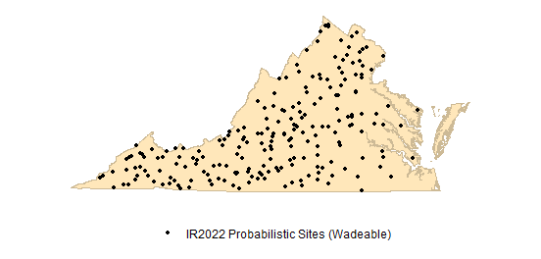

Figure 4.4-3. Virginia probabilistic monitoring locations from 2015 - 2020 with Virginia major river basins (n = 248).

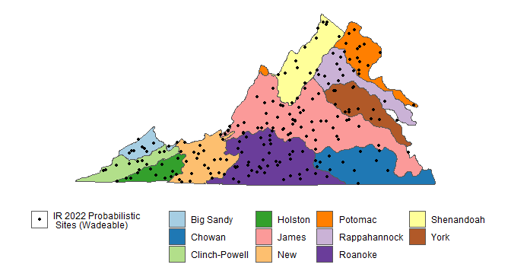

Figure 4.4-4. Virginia probabilistic monitoring locations from 2015 - 2020 with US Level III Ecoregions (n = 248).

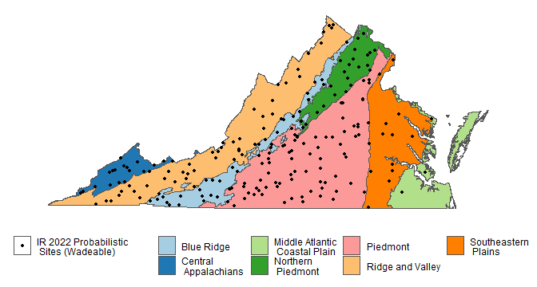

      Estimates of percent river miles not meeting water quality criteria are reported with 95% confidence intervals using a local area variance estimator statistical technique. For example, Figure 4.4-1 illustrates the percentage of stream miles in Virginia failing to meet biomonitoring criteria expectations are 37.6% +/- 6.4%, such that we are 95% confident that the true percentage of streams in Virginia failing to meet the VSCI/VCPMI criteria is between 31.2% and 44.1%. The sampling frame provided by EPA for Virginia streams and rivers includes 49,100 miles (derived from NHD 1:100,000 scale coverage[2]). It is important to note that the total amount of assessed river miles may vary to some extent by parameter. This number varies based on whether a monitoring tool was appropriate for the sampling location. For example, DEQ biological monitoring tools are not validated for streams without a defined channel, thus streams dominated by wetlands cannot be assessed (approximately 5,000 miles). The actual number of target stream miles (perennial, flowing freshwater) is much less because several thousands of stream miles are not perennial (e.g. the stream was dry when DEQ visited) or were found to be saltwater influenced. There is an estimated 1,200 miles of non-wadeable streams, which must be sampled using large river habitat and biological sampling methods (also referred to as boatable sites). Non-wadeable and wadeable sites, and associated watersheds, sampled since 2001 are presented in Figure 4.4-6. Large river data collection, using a non-wadeable (boatable) methodology, is underway and the condition will be included in future 303(d) / 305(b) Integrated Report chapters. The ProbMon chapter provides estimates for all perennial, non-tidal, wadeable stream and river miles, which equates to approximately 41,500 miles.

Figure 4.4-5. Virginia probabilistic monitoring wadeable locations from 2001 - 2020 (n = 894).

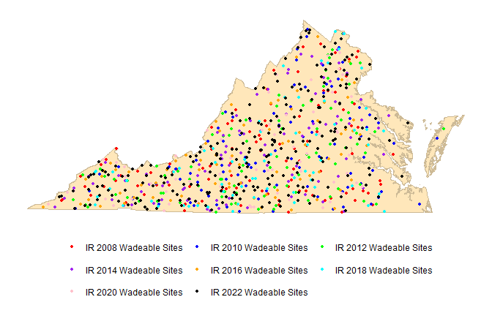

Figure 4.4-6. Virginia probabilistic monitoring wadeable and boatable sites from 2001 - 2020 (n = 969).

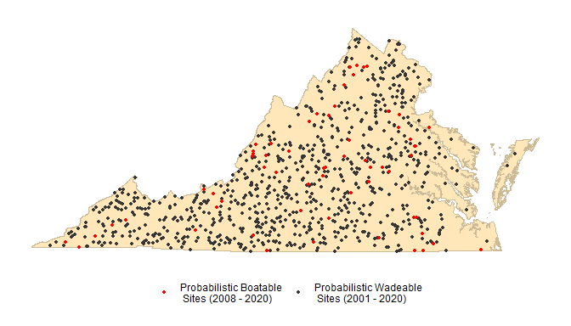

### Parameters with Water Quality Standards

      Dissolved oxygen, pH, temperature, metals, organic chemicals, and bacteria have applicable numeric water quality criteria. These regulatory criteria were developed to protect water quality conditions in support of swimming, fishing, and aquatic life designated uses. Overall results are summarized in Figure 4.4-1 and individual parameter results are discussed below. All results in the section “Parameters with Water Quality Standards” are based on data collected within the assessment period (2015 - 2020).

#### Dissolved Oxygen

      Dissolved oxygen (DO) is one of the most important measures of water quality for aquatic organisms. Adequate DO is a fundamental physiological requirement for aquatic life. In streams, the DO concentration may be altered by photosynthesis, respiration, nutrient input, re-aeration, and temperature, all of which have seasonal and daily cycles. This natural variability is reflected in the stream classification component of Virginia’s Water Quality Standards (Virginia Water Quality Standards 9VAC25-260-50). For example, a mountain stream that supports native trout is expected to have higher DO than a low-gradient, warm water stream. Although expectations for DO concentration vary, all waters (excluding swamps) in Virginia are required to have a DO concentration of 4 mg/L or above. DO standards can be determined on a case-by-case basis if DO deviates due to natural conditions as in swamps and other wetlands (Virginia Water Quality Standards 9VAC25-260-50). Pollution plays an important role in dissolved oxygen concentration. Human and animal wastes released into streams provide nutrients which cause excessive growth of algae and aquatic plants. As microbes break down this organic matter, their respiration can deplete the available DO and the aquatic biota may become stressed and die due to low DO concentration.

      ProbMon results indicate that DO conditions for the majority of Virginia’s streams and rivers are above the minimum DO criteria for specific water quality class designations (Table 4.4-1). Most stations with values below the appropriate criteria are located in coastal ecoregions where the DO is naturally lower due to swamp conditions. These sites with low DO need to be reviewed as candidates for site specific DO criteria. ProbMon results suggest that the majority of mountainous zone waters, stockable trout waters, and natural trout waters are meeting DO standards. Estimates are reflective of two sampling events from all perennial wadeable systems.

Table 4.4-1. Dissolved oxygen results (2015 - 2020, n=248) of percentage of streams below Virginia’s Water Quality Standard ( +/- confidence limits).

| Parameter | Below Standard ( 4 mg/L ) |
| --- | --- |
| Dissolved Oxygen | 0.5% ( +/- 0.4% ) |

#### pH

      Another primary parameter used to evaluate water quality is pH. pH measures the concentration of hydrogen ions in water or the amount of acidity present. Since the pH scale is logarithmic to base 10, a decline in pH by one unit indicates a tenfold decrease in hydrogen ions. At pH 7, a solution is neutral whereas pH values below 7 indicate acidic conditions and values above 7 indicate basic conditions.

      Stream pH depends on local geology, ecology, and anthropogenic influences. If a stream has poor buffering capacity as is the case for a stream flowing over granite or shale, it may be naturally acidic. In the case where inorganic acids such as sulfuric or nitric acid are introduced via rain, the low buffering capacity can be rapidly exhausted and the pH declines. The resulting low pH may be detrimental to aquatic biota unaccustomed to low pH. pH values harmful to aquatic life are below 6 or above 9. This range is reflected in Virginia’s Water Quality Standards, where most waters must fall within a pH range of between 6 and 9. Natural pH values of 5 or below occur in swamp waters and should not be considered harmful to the native fauna common to those ecosystems. pH standards can be determined on a case-by-case basis if pH deviates due to natural conditions as in swamps and other wetlands (Virginia Water Quality Standards 9VAC25-260-50).

      ProbMon results show that 1.3% of wadeable Virginia streams and rivers are estimated to have pH below 6 (Table 4.4-2). Two of three stations with pH less than 6 occurred at sites located in the coastal ecoregion where swamp waters are common. DEQ collects additional parameters, including Acid Neutralizing Capacity (ANC) and sulfate data at ProbMon stations to estimate the percent of streams impacted by acid rain and acid mine drainage. High sulfate values in low pH streams are indicative of acid mine drainage whereas streams with low ANC values are susceptible to episodic acidification from acid rain runoff (USEPA 2000). However, based on ProbMon data collected during the 2022 assessment period, DEQ found one occurrence of pH values below 6 in the mountain ecoregions. Estimates are reflective of an average of two data points, where data are available.

Table 4.4-2. pH results (2015 - 2020, n=245) of streams below or above Virginia’s Water Quality Standard ( +/- confidence limits).

| Parameter | Below Standard ( pH 6 ) | Above Standard ( pH 9) |
| --- | --- | --- |
| pH | 1.3% ( +/- 1.6% ) | 0.1% ( +/- 0.18% ) |

#### Temperature

      Temperature affects water quality by potentially imposing a heat burden on aquatic life and by limiting the level of dissolved oxygen in water. Temperature in streams varies in relation to seasonal and daily changes. Sunlight is the primary source of temperature change. Stream temperature is also influenced by the temperature of the stream bed, groundwater inputs, and air in contact with the water surface. Temperature is inversely related to bank vegetation cover as less cover results in more exposure to the sun and higher instream temperatures. Also, runoff from impervious surfaces in urban areas may increase water temperature. Finally, effluent that is discharged to a waterbody tends to have higher temperature than the receiving stream and may elevate instream water temperature.

      Stream temperature has a significant effect on aquatic organisms. It can directly influence the types of organisms found in an aquatic system as well as their growth, behavior, metabolism, reproduction and feeding habits. Virginia’s numeric temperature criteria reflect the upper limit for the support of different forms of aquatic life (Virginia Water Quality Standards 9VAC25-260-50). Criteria for temperature vary, notably in cold water fisheries, but as a general rule, all waters in Virginia are required to have a temperature at or below 31 or 32 degrees Celsius, based on appropriate water quality class designations.

      Overall, DEQ estimates that temperature criteria exceedances will be rare in Virginia’s wadeable streams (Table 4.4-3) during the spring and fall. However, it is important to note that ProbMon temperature data is seldom collected during the most stressful hydrologic and weather conditions. Estimates are reflective of an average of two data points, where data are available. In order to properly estimate temperature conditions, temperature data must be collected continuously. Continuous temperature data collection began in 2016 at twenty probabilistic trend sites.

Table 4.4-3. Temperature results (2015 - 2020, n= 245) above Virginia’s Water Quality Standard ( +/- confidence limits).

| Parameter | Above Standard (31/32 degrees Celsius) |
| --- | --- |
| Temperature | 0.0% ( +/- 0.0% ) |

#### Dissolved Metals

      Heavy metals have been identified as an important influence on benthic community structure in streams (Clements et al. 2000). Some taxa appear to be relatively tolerant to metals while other taxa are intolerant of heavy metals. Metals are most biologically available and toxic when dissolved in water. Toxicity of many metals is dependent on water hardness making it necessary to calculate site specific water quality criteria from hardness values. Table 4.4-4 lists the Virginia Water Quality Criteria for metals assuming a hardness (expressed as CaCO3) of 100 mg/L for most dissolved metals. The table also summarizes the number of sites that had detectable analytical results and the number of criterion exceedances based on site specific hardness values measured concurrently as part of the ProbMon program.

      All criteria are calculated using site-specific hardness measures. Two samples were measured above the acute sample criteria while two samples were measured above the acute sample criteria during the 2022 Integrated Report sample window (2015 - 2020). Results are shown in Table 4.4-4.

##### Table 4.4-4. Dissolved metals results (2015 - 2020, n=244) above Virginia’s Water Quality Standards ( +/- confidence limits). ppb1 = parts per billion.

| Metal | DEQ Acute Criteria (ppb1) | DEQ Chronic Criteria (ppb1) | # Above Criteria | % of Miles Above Criteria |
| --- | --- | --- | --- | --- |
| Arsenic | 340 | 150 | 0 | 0% (+/- 0%) |
| Cadmium | 3.9 CaCO3=100 | 1.1 CaCO3=100 | 0 | 0% (+/- 0%) |
| Chromium | 570 CaCO3=100 | 74 CaCO3=100 | 0 | 0% (+/- 0%) |
| Copper | 13 CaCO3=100 | 9 CaCO3=100 | 2 | 1.1% (+/- 1.7%) |
| Lead | 120 CaCO3=100 | 14 CaCO3=100 | 0 | 0% (+/- 0%) |
| Mercury | 1.4 | 0.77 | 0 | 0% (+/- 0%) |
| Nickel | 180 CaCO3=100 | 20 CaCO3=100 | 0 | 0% (+/- 0%) |
| Selenium | 20 | 5 | 0 | 0% (+/- 0%) |
| Silver | 3.4 CaCO3=100 | NA | 0 | 0% (+/- 0%) |
| Zinc | 120 CaCO3=100 | 120 CaCO3=100 | 0 | 0% (+/- 0%) |

#### Sediment Metals

      DEQ collected 492 sediment metals (arsenic, cadmium, chromium, copper, lead, mercury, nickel, silver, and zinc) samples from 2001 through 2012 and reported results in the 2008, 2010, 2012, and 2014 Integrated Reports. Sediment metals concentrations were below sediment screening values called Probable Effects Concentrations (PECs) and affected a low percentage of stream miles. Due to the low prevalence of metals above PECs in Virginia’s wadeable streams and high sampling costs, DEQ has suspended sediment metals sampling. Consequently, DEQ will not report on sediment in the 2022 assessment cycle. Integrated Report chapters from previous assessment cycles contain estimates of sediment metals in sediment.

      These chapters can be accessed at: <https://www.deq.virginia.gov/water/water-quality/monitoring/probabilistic-monitoring> under Reports and Data Sets.

#### Organic Chemicals in Sediment

      In 2001 and 2002, DEQ collected organic chemicals, organic pesticides, polychlorinated biphenyls, semi-volatile constituents, and herbicides in sediment but the data were not analyzed at a low enough detection limit to provide useful information. DEQ collected 209 organic chemical samples (total PCB, total PAH, heptachlor, chlordane, dieldrin, lindane, endrin, DDT, DDD, DDE, Total DDT, anthracene, chrysene, fluoranthene, naphthalene, phenanthrene, pyrene, benzoanthracene, benzo-a-pyrene) in sediment samples from 2003 through 2006 and reported results in the 2008 and 2010 Integrated Reports Probabilistic Monitoring chapters. A low percentage of wadeable stream miles had concentrations above PECs. Due to low prevalence of organic chemicals in sediment and high sampling costs, DEQ has suspended sediment sampling and will not report on organic chemicals during this assessment cycle. Integrated report chapters from previous assessment cycles contain estimates of organic chemicals in sediment.

      These chapters can be found online at: <https://www.deq.virginia.gov/water/water-quality/monitoring/probabilistic-monitoring> under Reports and Data Sets.

#### Bacteria

*Escherichia coli* (*E. coli*) bacteria are found in the intestines and fecal matter of warm-blooded animals. High counts of *E. coli* bacteria in a stream indicate that there is an elevated risk of illness from pathogenic organisms. According to Virginia’s Water Quality Standard for *E. coli*, a stream should not exceed a geometric mean of 126 colony forming units (cfu) per 100mL of water and shall not exceed a statistical threshold value (STV) of 410 counts/100 mL more than 10% of the time during the same period of up to 90 days (Virginia Water Quality Standards 9VAC25-260-170).

      DEQ bacterial impairment listing is determined based on a temporal data set where weekly bacteria samples are collected from a single site. Bacteria are only sampled once at each ProbMon site. Site specific bacteria problems are best characterized by repeated samples over consecutive weeks as is the approach in DEQ’s ambient monitoring program. For this reason, bacteria results from the freshwater ProbMon program and ambient monitoring program are not comparable and as such the results are not presented.

### Biological Monitoring

      Biological monitoring, or biomonitoring, of streams and rivers is an integral component of DEQ’s water quality monitoring program. Biomonitoring allows DEQ to assess the overall ecological condition of streams and rivers by evaluating stream condition with respect to suitability for support of aquatic communities. In Virginia, benthic macroinvertebrate communities are used as indicators of ecological condition and to address the question of whether a waterbody supports the aquatic life designated use.

      DEQ uses multimetric macroinvertebrate indices, specifically the Virginia Stream Condition Index (VSCI) and the Virginia Coastal Plain Macroinvertebrate Index (VCPMI), to assess the aquatic life use status of wadeable streams and rivers. The VSCI and the VCPMI are applied to biomonitoring data collected in freshwater non-coastal areas and freshwater coastal areas, respectively. These indices include several biological metrics that are regionally calibrated to the appropriate reference condition (DEQa 2006; DEQ 2013). Results are calculated into a single value, or score, that is sensitive to a wide range of stressors.

      VSCI and VCPMI scores were scaled for comparability so they could be utilized in all analyses (Table 4.4-5). Based on VSCI and VCPMI ProbMon results, VADEQ estimates that 37.6% of Virginia streams and rivers do not meet the aquatic life use standard (Table 4.4-6; DEQ, 2020). An estimate of statewide biological health by condition category is shown in Figure 4.4-7. VSCI scores less than 42 are considered severely ecologically stressed, scores between 42 and 60 are moderately stressed, while sites above 60 to 72 are thought to have good ecological condition and sites with VSCI scores above 72 are considered to have excellent water quality and habitat conditions (DEQ, 2006a). It is important to remember that biological indicators represent long-term water quality conditions and respond to a variety of stressors.

##### Table 4.4-5. Thresholds of condition classes for biological indicators.

| Response Parameters | Optimal | Suboptimal | Classification Reference |
| --- | --- | --- | --- |
| Virginia Stream Condition Index | > 60 | <50 | (DEQ 2006a) |
| Virginia Coastal Plain Macroinvertebrate Index | > 40 | <30 | (DEQ 2013) |

##### Table 4.4-6. VSCI/VCPMI (2015 - 2020, n=248) Scores below Virginia’s Assessment Thresholds ( +/- confidence limits).

| Parameter | Percentage of Stream Miles Below Threshold (+/- Confidence Limits) |
| --- | --- |
| VSCI/VCPMI | 37.6% (+/- 6.4% ) |

##### Figure 4.4-7. Biological stream condition index based on VSCI/VCPMI Scores (2015 - 2020, n = 248).

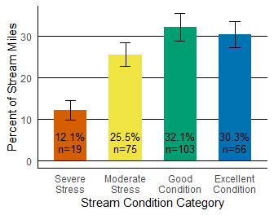

#### Statewide Status and Regional Condition Estimates

      The Probabilistic Monitoring program has generated a robust dataset comprised of 894 sites statewide since 2001, allowing the agency to estimate biological condition across the state at various spatial scales. In addition to the statewide estimate for the 2015 - 2020 assessment period covered in the 2022 Integrated Report, the program now has enough data to report condition estimates at river basin-specific scales in addition to larger stream size classes and ecoregional scales. Population estimates of biological condition may be calculated on datasets with more than 30 samples (Feller 1968). Previously, not all river basins had enough samples to extrapolate estimates of biological condition. Due to the random basis of the probabilistic sampling frame, it has taken 20 years to produce enough data in certain basins to meet the analytical requirements of river basin-scale analyses. Ongoing data collection will continue to reduce the variability around estimates in addition to allowing condition estimates at even finer spatial scales. The below analyses were conducted using the probabilistic monitoring dataset from 2001 to 2020 to illustrate the status of Virginia waterways across various environmental classification scales. Comparisons among the groupings (e.g. major river basins) represent the relative water quality condition among them as it has occurred over this time frame[3].

#### Biological Condition by Watershed Size

      Changes in biological community are evident by grouping streams based on their size. For this analysis, streams were categorized as small, medium, and large based on watershed area (Table 4.4-7). Figure 4.4-8 uses this watershed size classification to compare percent of stream miles at or below the biological stream condition assessment threshold for determining impairment. Nearly half of all small and medium streams have moderately to severely stressed biological conditions. Large streams are significantly different relative to their smaller counterparts with just under a quarter of large wadeable stream miles falling below the biological assessment threshold. This may suggest that, given a similar amount of stress, larger streams are more resilient to stress while smaller streams demonstrate a stronger response to stress.

##### Table 4.4-7 Stream size categories.

| Size Category | Stream Order (Strahler 1:100k NHD) | Watershed Area (sq miles) |
| --- | --- | --- |
| Small | 1,2,3 | < 10 |
| Medium | 2,3,4 | 10 - 50 |
| Large | 3,4,5 | > 50 |

Figure 4.4-8 VSCI/VCPMI status by stream size category. Percentile represents percent of stream miles below the biological assessment threshold, along with their 95% confidence limits. The number of samples collected from 2001 - 2020 in each category is identified as n.

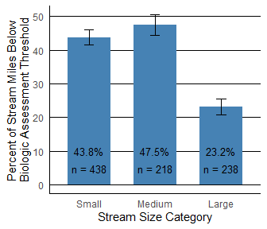

#### Biological Condition by US Level III Ecoregion

      Evaluating biological condition by US Level III Ecoregions offers a different perspective to analyze Virginia streams, grouping Virginia’s diverse geography based on similarities among environmental resources (Omernik 1987). Ecoregions are based on many factors including land use, land surface form, potential natural vegetation, and soils. An ecoregion is useful at the state level to understand the attainable ranges of aquatic ecosystems. Figure 4.4-9 illustrates the estimated percent of stream miles below the biological assessment threshold by Virginia ecoregions over the 2001 - 2020 data window. The Blue Ridge Mountain ecoregion demonstrates the lowest estimated percent of stream miles below the biological assessment threshold at 13.5% while the Central Appalachians and Southeastern Plains had the most at 62.7% and 59.9%, respectively.

Figure 4.4-9 VSCI/VCPMI status by US Level III Ecoregions. The estimated percent of stream miles below the biologic assessment threshold is listed on the y axis along with the associated 95% confidence limits. The number of samples collected from 2001 - 2020 in each ecoregion is identified as n. The Mid-Atlantic Coastal Plain Ecoregion was not included due to insufficient data.

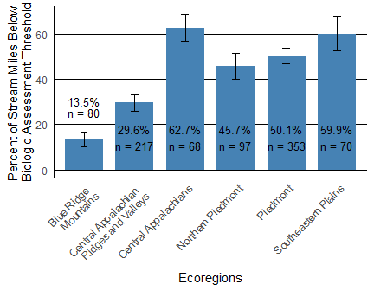

#### Biological Condition by Major River Basins

      Figure 4.4-10 illustrates the differences in biological condition across Virginia’s major river basins as the estimated percent of river miles below the biologic assessment threshold. Three of eleven major river basins in Virginia have well over 50% of stream miles under moderate to severe biological stress, including the Big Sandy River basin, Chowan River basin, and Rappahannock River basin. Most of the major river basins have between 25 to 50% of stream miles below the biological standard. The Holston River basin has the fewest stream miles with moderate to severe biological stress at only 14.1%.

Figure 4.4-10 VSCI status by major Virginia basins. The estimated percent of stream miles below the VSCI/VCPMI assessment threshold is listed on the y axis. The number of samples collected from 2001 - 2020 in each basin is identified as n.

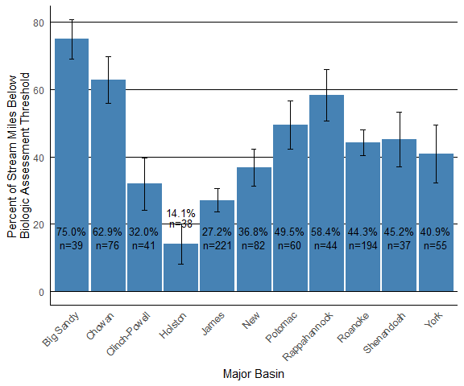

      Micromaps are employed in this chapter to visualize this spatially distributed dataset. Micromaps illustrate statistics while highlighting the geographic regions from which they are derived. Figure 4.4-11 offers a simplistic micromap, identifying VSCI/VCPMI by basin for explanatory purposes. By using a micromap and plotting the median estimated VSCI/VCPMI and interquartile range, we can visualize the range of biological condition in each major basin as well as compare these statistics among basins. VSCI and VCPMI scores were converted to a single biological scale for comparability in all analyses. Unconverted VCPMI scores are compared to a threshold score of 40; however, for the converted scores shown in 4.4-11 and subsequent micromaps, 60 is the biological threshold for both the VSCI and VCPMI scores.

      To understand Figure 4.4-11, begin at the top panel where the Holston, James, and New basins are highlighted. Moving from left to right, the n column specifies how many samples were collected in each basin. The number of samples per basin is consistent across all micromaps presented in this chapter. The dotplot identifies the median VSCI/VCPMI score in each basin with a solitary dot and the interquartile range, a measure of variability in the dataset between the 25th and 75th percentile, illustrated by a horizontal line spanning these percentiles. The dashed vertical line at 60 highlights the threshold for biological impairment. On the far right, a map illustrates which basins are described statistically in that panel with colors corresponding to the dot left of the basin name. Basins are grayed out in lower maps to indicate they are highlighted in a map above. Because the basins are ordered by median VSCI/VCPMI scores, basins at the top of the micromap have the best biological condition and basins at the bottom have the worst. The micromap illustrates the Chowan, Big Sandy, and Rappahannock generally have the lowest median VSCI/VCPMI scores in the state.

      The bottom-most panel highlights the differences in the populations of river basins with the lowest scoring median VSCI/VCPMI, the Big Sandy River and Rappahannock River basins. The proximity of the 50th and 75th percentiles in the Big Sandy River basin, both below 60 on the combined VSCI/VCPMI biological scale, indicate the tendency of the population to fall well below the biological assessment threshold. The median VSCI/VCPMI score of the Rappahannock River basin falls below the Big Sandy River basin median, but the sample population collected from the Rappahannock River basin incorporates a wider range of VSCI/VCPMI scores. Although the Rappahannock River basin median is lowest compared to basins statewide, the basin contains some higher scoring sites more in line with the rest of the basins statewide, whereas the Big Sandy River basin consistently exhibits scores below the biological assessment threshold. Continued sampling will likely further differentiate the biological condition of these two basins.

      Another interesting takeaway is the differences in the river basins that make up the Tennessee River basin drainage. The Holston and Clinch-Powell River basins plot at opposite ends of the biological condition scale in comparison to the Big Sandy River basin. The 25th percentiles of both the Holston and Clinch-Powell River basins plot at least 5 points above the 75th percentile of the Big Sandy River basin, indicating VSCI/VCPMI scores from the best sites in the Big Sandy River basin would be considered among the worst in the directly adjacent Holston and Clinch-Powell drainages.

Figure 4.4-11. VSCI/VCPMI status by basin. The vertical dashed line at 60 highlights the biologic assessment threshold. Data encompasses samples collected from 2001 - 2020.

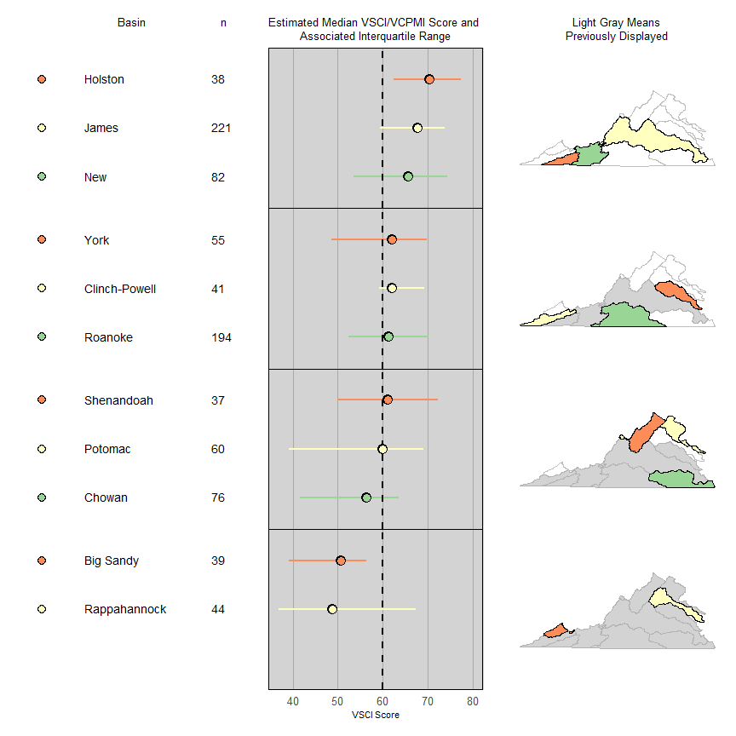

### Parameters without Water Quality Standards

      Stressors that increase the risk to benthic macroinvertebrate communities and do not have numeric water quality criteria or assessment thresholds include streambed sedimentation, habitat degradation, nutrients, ionic strength, and water column cumulative metals. Screening values for the aforementioned stressors, derived from literature values, are presented in Table 4.4-8. The ‘optimal’ classification represents water quality conditions that are not generally associated with degraded aquatic communities in the existing literature but does not provide a site-specific assessment value or an impairment threshold. Stressors classified as ‘suboptimal’ increase the likelihood of finding an impacted aquatic community. The condition class between optimal and suboptimal is termed ‘fair’ as the stress to the aquatic community is less certain.

Table 4.4-8. Thresholds of condition classes for stressor indicators[4].

| Stressor Parameters | Optimal | Suboptimal | Classification Reference |
| --- | --- | --- | --- |
| Total Nitrogen (mg/L) | < 1 | > 2 | (DEQ 2006a) |
| Total Phosphorus (mg/L) | < 0.02 | > 0.05 | (DEQ 2006a) |
| Habitat Degradation (unitless) | > 150 | < 120 | (USEPA 1999) |
| Streambed Sedimentation (unitless) | -0.5 to 0.5 | < -1.0 | (Kaufmann 1999) |
| Ionic Strength (TDS mg/L) | < 100 | > 350 | (DEQ 2006b) |
| Cumulative Dissolved Metals (unitless) | < 1 | > 2 | (Clements 2000) |

      In the following analyses, water quality parameters without numeric water quality criteria are presented using barplots and micromaps. Similar to previous Integrated Reports, the barplots represent estimates drawn from data in the 2022 assessment window (2015 - 2020). The micromaps utilize data from the entire probabilistic monitoring dataset (2001 - 2020) in order to present parameter estimates that are representative at a basin-specific scale. Thus, Virginia stream mile estimates are not identical between the micromap and barplot examples. The micromaps intend to highlight the extent to which these parameters affect major river basins across Virginia as well as the extent of stream miles categorized as suboptimal by distinct stressors. Because the same scale (percent of stream miles) is utilized across all of the following micromaps, one can efficiently compare the degree to which different parameters influence the percent of suboptimal stream miles across Virginia’s river basins.

      The biological information presented in the micromap beside each parameter is not intended to explain the biological impact that any one parameter imparts on a particular river basin[5]. Micromaps aid in visualization of spatial patterns of these potential stressors across basin in the Commonwealth. Utilizing micromaps to visualize potential individual stressors alongside biological condition helps identify stressors that may impart a stronger influence on aquatic life relative to other basins. To accentuate these storylines, a system of ranking basins based on the relative percent of stream miles that fall into the suboptimal category for each non regulated parameter is utilized. Accordingly, a basin with the highest rank (1) will have the most suboptimal stream miles for a particular stressor while a basin with the lowest rank (11) will have the least suboptimal stream miles for that respective parameter, relative to other basins statewide. Fewer suboptimal stream miles indicate a particular stressor is less likely to have widespread influence on benthic communities within a particular basin. Overlapping 95% confidence intervals decrease the certainty regarding the relative rankings of basins. For example, the exact rankings of basins 1-9, ranked based on habitat disturbance in Figure 4.4-13, are relatively uncertain because the confidence intervals mostly overlap. Non-overlapping confidence intervals of the lowest ranking (11) and highest ranking (1) basins for the majority of the stressors reinforce the significant differences among basins at either end of the ranking scale. The micromaps summarize biological and stressor data over a 20-year period at a basin scale. However, it should be noted that the co-occurrence of stream miles below the biological impairment threshold and stream miles below a suboptimal screening value for a potential stressor does not suggest in itself a causative relationship. Stressors impacting the benthic community at a targeted location must be evaluated using a site-specific stressor analysis to address an identified benthic impairment during the development of Total Maximum Daily Loads.

      At the end of the section, these results are summarized with a heatmap (Figure 4.4-24) that highlights the highest ranking basins for each potential stressor using darker colors. As the relative ranking decreases, indicating fewer suboptimal stream miles, the corresponding color shade lightens. Utilizing this schema, one can readily identify basins where multiple potential stressors exist, versus basins fewer potential stressors. The heatmap illustrates the prevalence of various potential stressors with respect to aquatic communities. By looking at the shading and relative rank assigned to each potential stressor in the basin column, one can visualize what potential stressors, or combinations of stressors, may have been negatively impacting aquatic communities over the 20-year data window. As stated above, these maps do not present conclusions about the probable stressors in specific waterbodies with benthic impairments, i.e. waters not supporting the aquatic life use.

#### Habitat Disturbance

      Habitat is defined as the area or environment where an organism resides. It encompasses its surroundings, both living and non-living. Fish, aquatic insects, and plants require certain types of habitat to thrive, so in-stream and riparian (stream bank) habitat is evaluated when a biomonitoring sample is collected. Because different organisms have diverse habitat requirements, a variety of available habitat types in a stream or river will support a diverse aquatic community. Habitat is scored by Rapid Bioassessment Protocol (RBP), which is a qualitative evaluation of ten habitat parameters summed together (total scores range from 0 to 200)(EPA 1999). Habitat scores above 150 indicate habitat conditions favorable for supporting a healthy aquatic community and are considered optimal. Scores lower than 120 are considered suboptimal and scores between 120 and 150 are fair (EPA 1999). Habitat disturbance is frequently identified in benthic TMDL stressor analyses as a potential or probable stressor. As indicated in Figure 4.4-12, DEQ estimates that slightly over 35% of stream and river miles have available habitat that is considered optimal.

Figure 4.4-12. Estimate of habitat condition in Virginia streams and rivers and associated 95% confidence interval. Data presented is from 2015 - 2020 (n = 247).

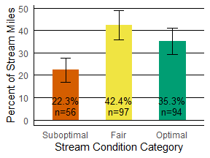

      Figure 4.4-13 is a micromap depicting the prevalence and scale of habitat disturbance across major basins statewide. The left barplot highlights the estimated percent of stream miles with suboptimal habitat scores, ordered from highest to lowest, with the corresponding statewide estimate of stream miles with suboptimal habitat scores (18.0% for 2001 - 2020) illustrated with a vertical dashed line. The right barplot shows the percent of stream miles below the biological assessment threshold for each basin, again with the Virginia estimate of stream miles below the biological impairment threshold represented by a dashed vertical line (42.6% for 2001 - 2020). No distinct spatial clustering appears when analyzing habitat disturbance with micromaps, indicating habitat degradation is a widespread problem across Virginia and is not limited to particular river basins or areas in the state. Ranking major river basins by decreasing estimates of habitat alteration, the Rappahannock, Clinch-Powell, Chowan, Potomac, New, and Roanoke River basins have suboptimal habitat condition above the statewide estimate[6].

Figure 4.4-13. Percent of stream miles with suboptimal habitat disturbance as measured by RBP habitat. From left to right, the vertical dashed lines represent the percent of stream miles across Virginia with suboptimal habitat disturbance and biologic condition below the assessment threshold, respectively. Data presented is from 2001 - 2020.

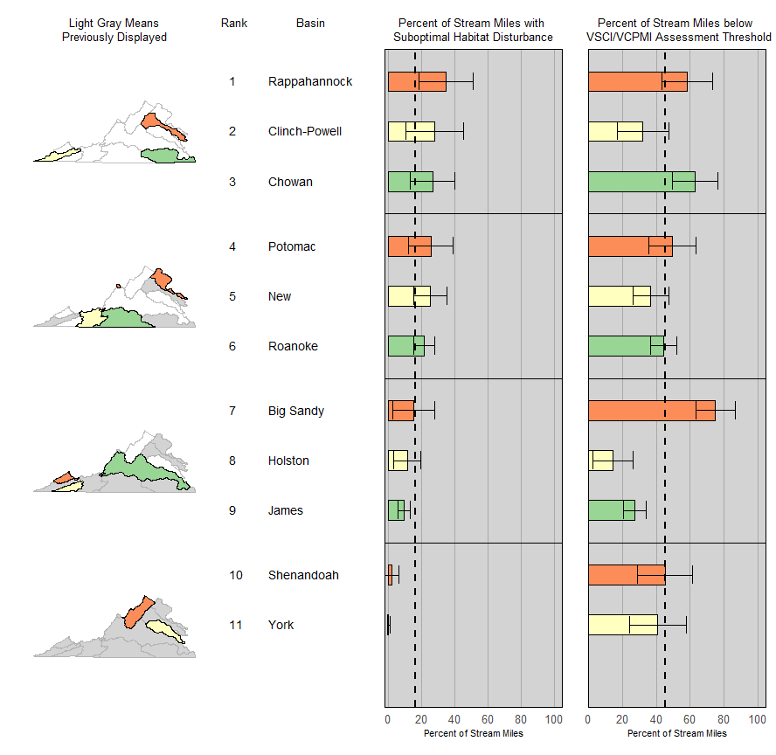

#### Streambed Sedimentation

      Excessive sedimentation is a component of habitat and has one of the most pronounced impacts on benthic communities. Excess sediment fills interstitial spaces in the stream substrates used by aquatic organisms, disturbs refuge areas, and can potentially smother the organisms. Until recently, tools for quantifying sedimentation impacts in streams have been inadequate. Methods existed for describing dominant instream particle size, but it was difficult to differentiate between natural conditions and man-made problems. Virginia has a variety of stream types; many are naturally sand/silt bed streams, so simply measuring the size of the sediment particles cannot differentiate natural and human-influenced sediment load.

      DEQ uses the relative bed stability (RBS) method for predicting the expected substrate size distribution for streams (Kaufmann 1999). RBS incorporates stream channel shape, slope, flow, and sediment supply. The method calculates a ‘stream power’ based on channel measurements to predict the expected sediment size distribution. The ratio of the observed sediment to the expected sediment is a measure of the RBS. A stream with a log RBS (LRBS) of less than -1 is carrying excess sediment (suboptimal), streams between -0.5 and 0.5 have a normal sediment load (optimal), and streams above 0.5 are excessively hardened (fair) (Kaufmann 1999 and USEPA 2000). Relative bed stability is frequently identified in benthic TMDL stressor analyses as a potential or probable stressor. Over 20% of Virginia’s stream and river miles have suboptimal sedimentation values (Figure 4.4-14).

Figure 4.4-14. Estimate of streambed sedimentation conditions in Virginia streams and rivers as defined by LRBS measures and 95% confidence interval. Data presented is from 2015 - 2020 (n = 229).

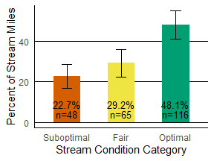

      Figure 4.4-15 illustrates the extent of stream miles affected by excess sedimentation is more prevalent in each of the major basins compared to overall habitat condition. All basins are estimated to have at least 12% of stream miles with suboptimal sedimentation levels. The Chowan and Roanoke basins are estimated to have more stream miles with suboptimal sedimentation levels than the overall estimate for stream miles in the Commonwealth (33% for 2001 - 2020). The basins with the highest percent of stream miles with suboptimal sedimentation are among the basins with the highest percent of stream miles below the VSCI/VCPMI assessment threshold. The micromap identifies the Big Sandy River and Shenandoah River basins as well below the statewide average for suboptimal streambed sedimentation but above the statewide average for benthic impaired stream miles. These basins are likely affected by other stressors in addition to streambed sedimentation, resulting in the percentage of stream miles with poor biological condition above the statewide estimate.

      Though the Potomac River basin has the lowest percentage of suboptimal stream miles for sedimentation, the estimate may not be fully reflective of sedimentation status in the basin. The Potomac River basin has a high prevalence of samples with LRBS scores above 0.5, indicating hardened stream bottoms likely due to hydrologic alteration. As such, the Potomac River basin may appear artificially stable due to more samples falling into the fair category (LRBS > 0.5) in comparison to other basins in Virginia[7].

Figure 4.4-15. Percent of stream miles with suboptimal streambed sedimentation as measured by LRBS. From left to right, the vertical dashed lines represent the statewide percent of stream miles across Virginia with suboptimal streambed sedimentation and biologic condition below the assessment threshold, respectively. Data presented is from 2001 - 2020.

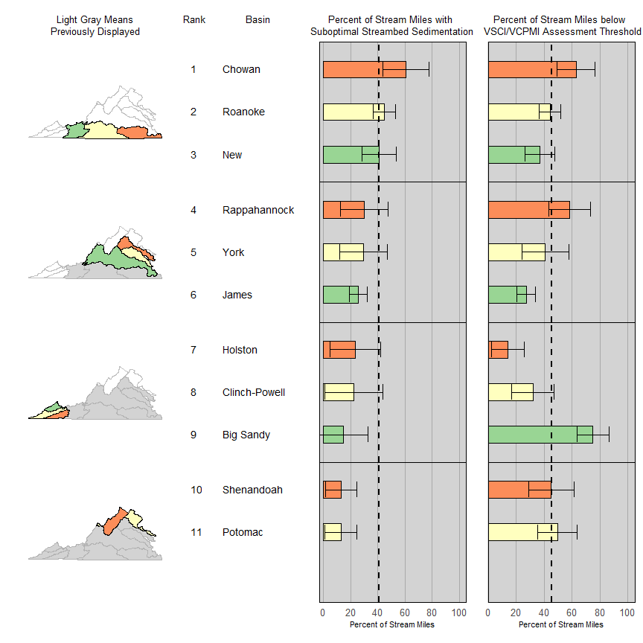

#### Nutrients

      Nutrients are substances assimilated by living organisms that promote growth. Nitrogen and phosphorus are the two most important nutrients in Virginia streams and rivers. Excess nutrients can stimulate in-stream plant and algal growth. Characteristics of nutrient enriched streams may include low dissolved oxygen, frequent fish kills, shifts in aquatic communities, and blooms of nuisance or harmful algae. Nutrients may come from fertilized lawns and cropland, failing septic systems, municipal and industrial discharges, and/or livestock manure.

      Total phosphorus above 0.05 mg/L and total nitrogen above 2 mg/L is considered suboptimal (Table 4.4-8) and can result in undesirable algae growth and shifts in aquatic communities (DEQ 2006a). Nutrients are sometimes identified in benthic TMDL stressor analyses as a potential or probable stressor. DEQ estimates that nearly 47% of streams and river miles are classified as optimal for total phosphorus while just under 87% of stream and river miles are considered optimal for total nitrogen (Figures 4.4-16 and 4.4-17).

Figure 4.4-16. Estimate of total phosphorus condition in Virginia streams and rivers and associated 95% confidence intervals. Data presented is from 2015 - 2020.

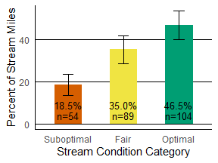

Figure 4.4-17. Estimate of total nitrogen condition in Virginia streams and rivers and associated 95% confidence intervals. Data presented is from 2015 - 2020.

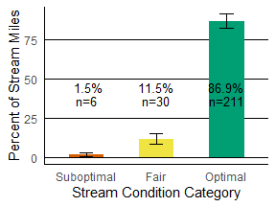

      Using micromaps to analyze nutrients by basin highlights spatial relationships in the dataset. Figure 4.4-18 ranks basins by percent of stream miles that fall into the suboptimal total phosphorus category (> 0.05 mg/L). The associated percent of stream miles below the biologic assessment threshold follows in the rightmost plot. The vertical lines on each barplot indicate the percent of stream miles throughout Virginia that fall into the suboptimal category for total phosphorus and below the biological impairment threshold, 17% and 43% for 2001 - 2020, respectively). The micromap displays the percent of stream miles deemed suboptimal due to total phosphorus, decreasing from east to west across the state. During the 20-year data window, basins with higher percentages of suboptimal stream miles due to phosphorus co-occur with higher percentages of stream miles below the biological assessment threshold. However, the percent of stream miles below the biological threshold cannot simply be attributed to one parameter, nor can it be assumed that the presence of potential stressors above a screening value results in an impaired aquatic life community[8].

Figure 4.4-18. Percent of stream miles with suboptimal total phosphorus. From left to right, the vertical dashed lines represent the percent of stream miles across Virginia with suboptimal total phosphorus and VSCI/VCPMI below the assessment threshold, respectively. Data presented is from 2001 - 2020.

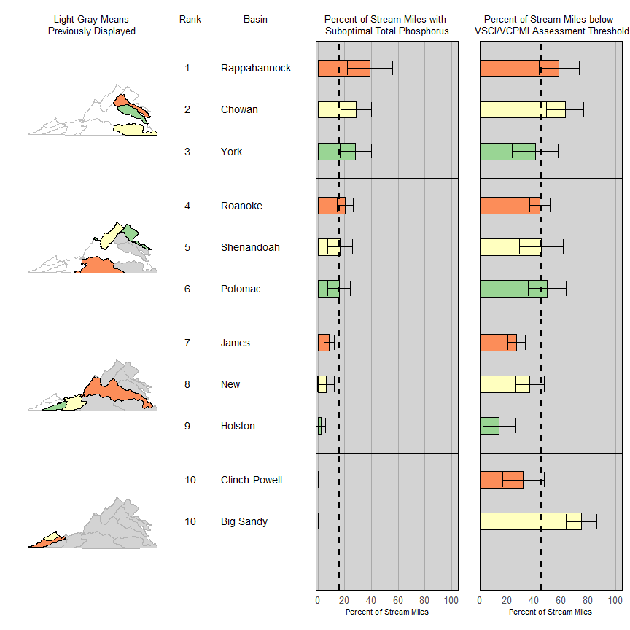

Figure 4.4-19 ranks the basins by the highest percentage of stream miles with total nitrogen > 2 mg/L. The Shenandoah, Rappahannock, Potomac, New, and Chowan River basins have the highest total nitrogen suboptimal stream miles and are above the statewide level (3.2%). These basins also display some of the highest percentages of stream miles below the VSCI/VCPMI assessment threshold. The Rappahannock, Potomac, Chowan, and Clinch-Powell River basins each display percentages of suboptimal stream miles above the statewide level for total nitrogen, total phosphorus, and VSCI/VCPMI[9].

Figure 4.4-19. Percent of stream miles with suboptimal total nitrogen. From left to right, the vertical dashed lines represent the percent of stream miles across Virginia with suboptimal total nitrogen and biologic condition below the assessment threshold, respectively. Data presented is from 2001 - 2020.

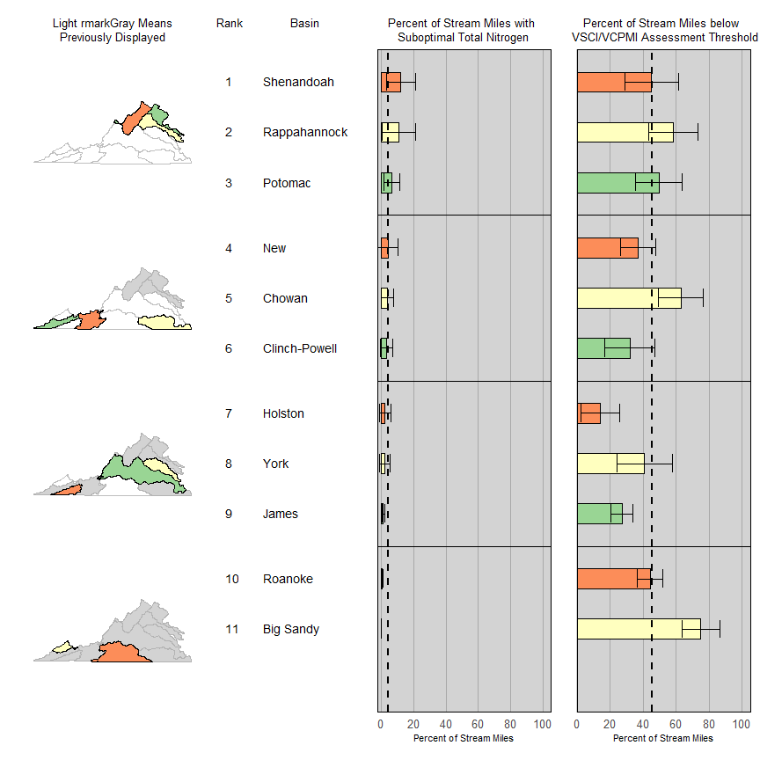

#### Ionic Strength (Total Dissolved Solids)

      Ionic strength varies with natural geology, but increases significantly in response to anthropogenic activities such as surface mining, road salts, or other industrial discharges. DEQ uses total dissolved solids (TDS) to measure ionic strength. Ionic strength is a measure of dissolved ions, dissolved metals, minerals, and organic matter in the water column. Water quality studies have consistently demonstrated that high levels of TDS in the water column impact aquatic life (DEQ 2006b). TDS levels above 350 mg/L increase the likelihood of having a degraded aquatic community and are considered suboptimal (Table 4.4-8). TDS has been identified as a potential or probable stressor in TMDL development. Results are shown in Figure 4.4-20; DEQ estimates that 4% of Virginia streams have TDS levels in the suboptimal range.

Figure 4.4-20. Estimate of ionic strength condition as measured by TDS in Virginia streams and rivers and associated 95% confidence intervals. Data presented is from 2015 - 2020.

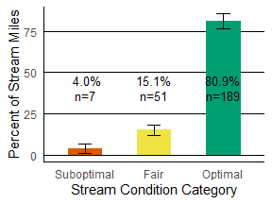

      A micromap offers a unique visualization tool to distinguish spatial trends in ionic strength across Virginia (Figure 4.4-21). The southwest corner of Virginia, where resource extraction has traditionally occurred, boasts the highest percentages of stream miles with suboptimal total dissolved solids. These basins include the Big Sandy, Clinch-Powell, and New. Additional basins at or above the Virginia estimate for stream miles with suboptimal total dissolved solids (2.4% for 2001 - 2020) are the Potomac and Shenandoah basins. These basins drain areas of the state with concentrated population centers where urban run-off and industrial processes could be contributing to higher instream ionic strength (Paul & Meyer 2001). Stream miles with suboptimal total dissolved solids are not widespread statewide and in the majority of basins total dissolved solids do not appear to be a major driver for the percentage of stream miles below the biological threshold[10].

Figure 4.4-21. Percent of stream miles with suboptimal ionic strength as measured by TDS. From left to right, the vertical dashed lines represent the percent of stream miles across Virginia with suboptimal total dissolved solids and moderately to severely stressed biological communities, respectively. Data presented is from 2001 - 2020.

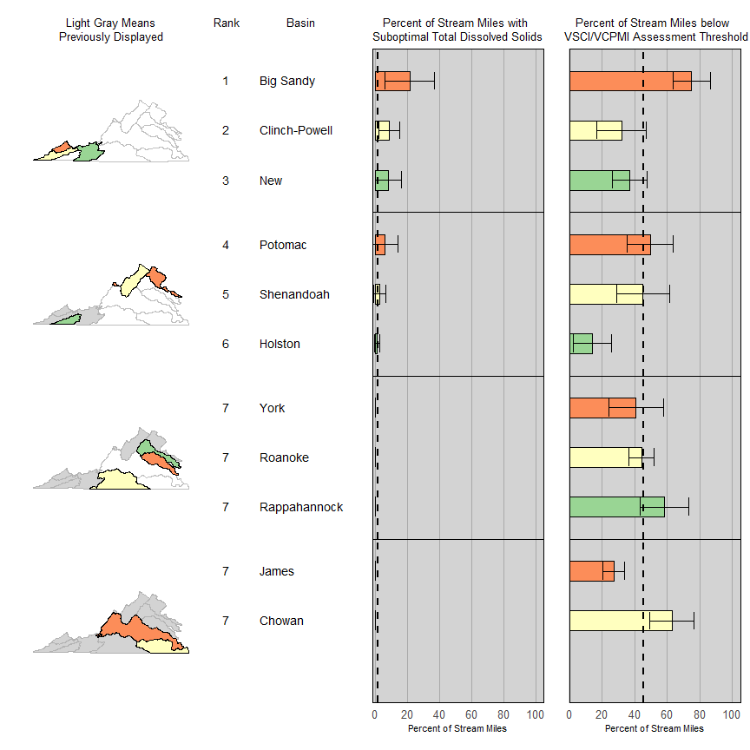

#### Cumulative Dissolved Metals (Cumulative Criterion Unit Metals Index)

      Heavy metals such as mercury, chromium, cadmium, arsenic, and lead in streams and rivers can be harmful to aquatic insects at low concentrations. The metals tend to accumulate in the gills and muscles of aquatic organisms. Dissolved metals have been identified as important predictors of stream health. Toxicity of many metals is dependent on water hardness, making it necessary to calculate site specific water quality criteria from hardness values.

      In the context of water quality criteria, dissolved metals are typically treated independently; however, there is strong evidence that metals have a cumulative effect (Clements 2000). Cumulative Criterion Units (CCU) account for this additive effect by standardizing each dissolved metal’s concentration. The metals are summed together and the result is the CCU Metals Index score. When the CCU Metals Index is above 2, the cumulative effect is considered likely to harm aquatic life (Clements 2000). CCU Metals has been identified as a potential or probable stressor in TMDL development. DEQ estimates that 1.3% of river miles in Virginia have Cumulative Criterion Units that are considered suboptimal (Figure 4.4-22; Table 4.4-8).

Figure 4.4-22. Estimate of Cumulative Criterion Unit Metals Index in Virginia streams and rivers and associated 95% confidence intervals. Data presented is from 2015 - 2020.

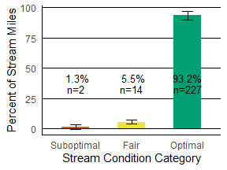

      Dissolved metals are not a widespread issue affecting many major basins across Virginia (Figure 4.4-23). The Rappahannock, Potomac, Chowan, and York River basins all demonstrate estimates of stream miles with suboptimal water column metals levels above the Virginia estimate (1.7% for 2001 - 2020). The majority of basins in Virginia do not have any stream miles that fall into the suboptimal category for water column metals[11].

Figure 4.4-23 Percent of stream miles with suboptimal levels of cumulative dissolved metals. From left to right, the vertical dashed lines represent the percent of stream miles across Virginia with suboptimal cumulative dissolved metals and moderately to severely stressed biological communities, respectively. Data presented is from 2001 - 2020.

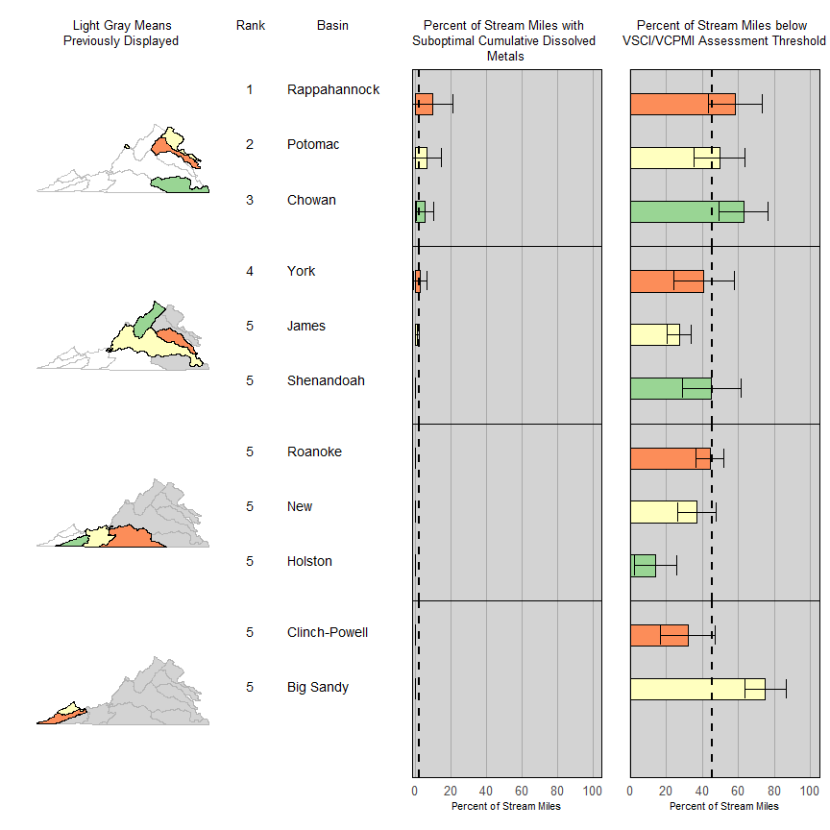

      Figure 4.4-24 combines the major river basin ranks from the previous micromaps to summarize the percent of stream miles that are suboptimal for each of the respective screening value parameters relative to the VSCI/VCPMI. Basins were ranked from one (1) to eleven (11) for each parameter, with a rank of 1 corresponding to the basin with the most stream miles in the suboptimal range and a rank of 11 where the fewest stream miles fall into the suboptimal range. Where basins displayed identical measures for a given parameter, many basins share a particular rank (e.g. Total dissolved solids and CCU metals). The condition estimate between ranks can be very close, resulting in minimal relative extent difference among basins, thus referencing the appropriate micromap is critical for understanding the stressor extent for each individual parameter.

      The summary heatmap graphic is also color coded by rank, scaling from dark blue to white as the percentage of suboptimal stream miles decreases from the highest to the lowest rank. Basins with the darkest boxes have the highest percentage of suboptimal stream miles due to the parameters listed in the left column. As evident by the numeric and color ranks, the Rappahannock and Chowan River basins have the most stream miles impacted by multiple parameters. Water bodies in these basins are potentially stressed by a combination of water quality parameters. The Holston River basin contains the fewest stream miles (e.g. ranks the lowest) considered suboptimal for the parameters analyzed in this section.

      By ranking basins from 1 to 11 according to the percent of stream miles that are below the biological assessment threshold (VSCI/VCPMI = 60), Figure 4.4-24 ranks the Big Sandy, Chowan, and Rappahannock River basins highest (rank 1, 2, and 3, respectively) and the Holston, James, and Clinch-Powell River basins lowest (rank 11 and 10, and 9, respectively). The Rappahannock and Chowan River basins hold the top three ranks for five of the six parameters detailed in this report. Multiple parameters may be driving the higher percentage of stream miles falling below the biological assessment threshold in the Chowan and Rappahannock River basins. Multiple stressors can interact in unpredictable ways and may present management challenges with efforts to improve aquatic health, for example in the identification of stressors and clean-up strategies.

Figure 4.4-24 Basin rank by parameters without water quality standards and VSCI/VCPMI. Basins with the most suboptimal stream miles for a particular parameter are ranked with highest (1). The color scales from dark blue to white as rank and level of disturbance decreases. Data summarized is from 2001 - 2020.

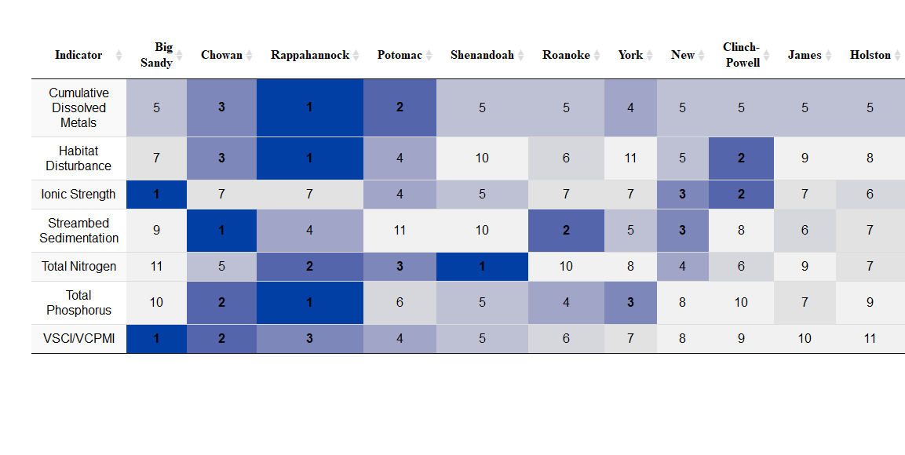

### 

### Stressor Extent and Relative Risks

      Two of the advantages of Virginia’s probabilistic datasets are the ability to calculate the relative risks (Figure 4.4-25) and stressor extent (Figure 4.4-26, Figure 4.4-27) that different environmental stressors have on the ecological health of rivers and streams across large regions. Since the stations are selected at random, DEQ can estimate water quality parameter values over the entire state with known confidence. EPA and other states have employed stressor extent and relative risk concepts extensively in their reports (ODEQ 2007; USEPA 2006; Van Sickle 2006; Van Sickle 2008).

      Relative risk is a term borrowed from the medical field and applied here to communicate the potential impact a stressor has on the aquatic environment. For example, it has been shown that an individual with total cholesterol above 240 mg/dl is at greater risk for heart disease than an individual whose cholesterol is below 200 mg/dl. When an individual has a cholesterol level above 240, their relative risk of having heart disease is higher than an individual with cholesterol level below 200.

      While stressor extent shows how prevalent or widespread a potential stressor is in Virginia streams (Figure 4.4-26), relative risk estimates the statistical likelihood of a degraded biological community given a stressor measured in a system at a certain value (Figure 4.4-25). Calculation of relative risk requires classification of water quality responses (e.g. the benthic macroinvertebrate indices – Table 4.4-5) and the water quality stressors (Table 4.4-8) into optimal and suboptimal categories. DEQ classified biological response parameters based on the biological assessment threshold used in the water quality assessment process. The stressor indicators in Table 4.4-8 were classified using screening values from peer reviewed literature studies. It is important to remember that the stressor screening values are not equivalent to numeric water quality criteria in the Commonwealth of Virginia. Like the river basin-scale analyses, relative risk and stressor extent are data-intensive statistical techniques requiring the entire probabilistic monitoring dataset (2001 - 2020) and do not suggest any water quality condition or specific potential or probable stressor at a specific location for a specific water body.

      The relative risks for aquatic stressors can be interpreted in a similar manner to the heart disease example. Figure 4.4-26 illustrates that the relative risk to the biological community due to habitat disturbance is 5.9; thus, the biological community is 5.9 times more likely to be considered suboptimal when habitat disturbance scores are below 120 (USEPA 1999). Relative risk values larger than 1 indicate an elevated risk to the biological community; consequently, only water quality stressors with a relative risk greater than 1 are reported in this chapter. pH was also evaluated for increased risk to the biological community but did not show significant relative risk to the biological community.

Figure 4.4-25. Relative Risk for major benthic macroinvertebrate stressors in all Virginia streams. The horizontal lines associated with the parameters illustrate the 95% confidence intervals. The vertical dashed line at 1 indicates significance; thus, all relative risk estimates and confidence intervals that exceed the dashed vertical are significant. Relative risk shows the number of times more likely a benthic macroinvertebrate community is to be scored in the suboptimal range if the parameter shown on the y-axis is degraded. Data encompasses samples collected from 2001 - 2020.

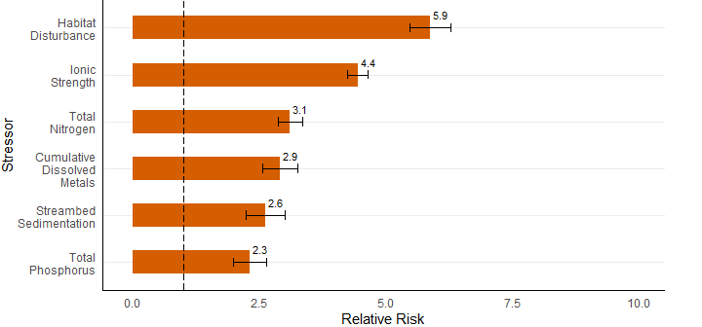

Figure 4.4-26. Stressor extent for major benthic macroinvertebrate stressors in Virginia streams. The horizontal lines associated with the parameters illustrate the 95% confidence intervals. Stressor extent shows the frequency of the stressor in all Virginia streams from data collected for the 2022 Integrated Report (2015 - 2020).

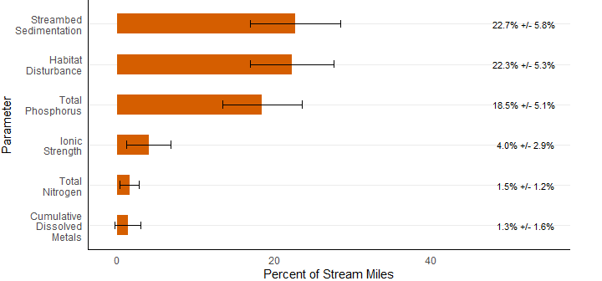

      The most common stressor across Virginia is streambed sedimentation. ProbMon data estimates streambed sedimentation is considered suboptimal in almost 23% of Virginia streams. When streambed sedimentation levels are suboptimal, relative risk analysis predicts they are 2.6 times more likely to have a suboptimal benthic community than streams with optimal sedimentation levels. Over 22% of Virginia streams have suboptimal habitat disturbance scores; suboptimal habitat disturbance scores increase the relative risk of a suboptimal aquatic community by a factor of 5.9.

      The two major nutrients found in Virginia streams are phosphorus and nitrogen; their relative risks are 2.3 and 3.1, respectively. Suboptimal phosphorus conditions occur in many more streams (18.5%) than elevated nitrogen (1.5%), but when nitrogen levels exceed 2 mg/L the relative risk to the aquatic community is greater than the risk of total phosphorus above 0.05 mg/L. Ionic strength (as measured by total dissolved solids) has a relative risk of 4.4, which is one of the highest relative risks in the analyses. However, suboptimal ionic strength conditions were only found in 4.0% of Virginia streams. Dissolved metal concentrations that may cause adverse biological condition were found in 1.3% of Virginia streams; however, elevated dissolved metal concentrations increase the relative risk of having a suboptimal benthic macroinvertebrate community by 2.9.

      Stressor extent presented in Figure 4.4-26 only focuses on the percent of stream miles deemed suboptimal by each of the major stressors to Virginia streams. Figure 4.4-27 encompasses the entire stream population for each stressor to relate a more complete narrative surrounding estimated stressor extents in Virginia. Streambed sedimentation has the highest extent of predicted stress in Virginia. As we have explored through previous visualization tools, streambed sedimentation, total phosphorus, and habitat disturbance are fairly widespread potential stressors statewide. Total nitrogen, water column metals, and ionic strength are fairly rare in Virginia with the majority of stream miles in the optimum category of their respective parameter. However, when any of total nitrogen, water column metals, or ionic strength parameters reach a suboptimal threshold, relative risk analyses estimate them among the most likely stressors to alter the biological community. Dissolved oxygen and pH do not have statistically significant relative risk in Virginia, thus they are not reported. Missing from this chapter are other known stressors, such as, hydrologic alteration and temperature stress in the critical time period, due to a lack of data to produce statistically significant estimates of relative risk[12].

Figure 4.4-27. Stressor extent for major benthic macroinvertebrate stressors in all Virginia streams (2015 - 2020) showing all condition classes (optimal, fair, and suboptimal). Optimal condition estimates are shown in green, fair condition estimates are yellow, and suboptimal conditions are shown in orange.

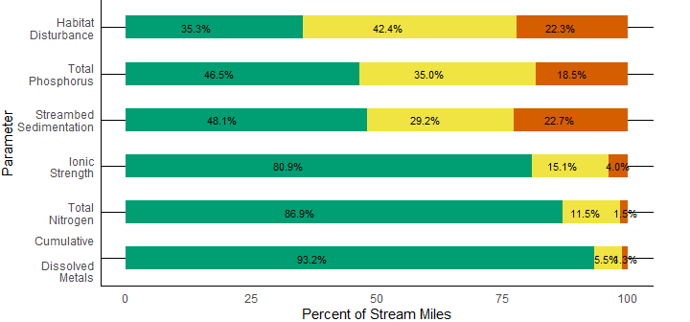

### Uses of Probabilistic Data

      In addition to estimating the condition of all streams and rivers compared to numeric water quality criteria, biological assessment thresholds or screening values, and identifying the major potential stressors to aquatic organisms, freshwater ProbMon data has many additional applications within water quality management programs. Examples of these uses are discussed below.

      ProbMon data is used in estimating both the natural and baseline conditions of Virginia streams. Specifically, ProbMon has helped identify minimally disturbed streams and understand their natural variability. This information is integral for DEQ to develop more regionally specific water quality expectations, define reference conditions, and select appropriate reference sites. Reference conditions and reference sites are used to estimate biological assemblage and water quality conditions that are expected to occur in minimally disturbed systems. These conditions provide the basis for developing appropriate biological assessment thresholds. ProbMon has also provided statistically defensible descriptions of stream conditions as of the beginning of this century. DEQ will find this baseline tremendously valuable for comparison in future assessments.

      ProbMon data are currently being used by the TMDL program for stressor identification in benthic TMDLs (DEQ 2017)[13]. Stressor analysis is the process whereby candidate causes of stress (or stressors) to benthic macroinvertebrate communities are evaluated. The report develops data collection recommendations and scientifically defensible screening values for categorizing potential stressors. ProbMon data are especially useful in describing statewide in-stream conditions for those parameters that do not currently have numeric water quality criteria but can still negatively impact benthic communities based on scientifically defensible screening values. Understanding existing conditions for those parameters provides perspective on parameter data and a way to evaluate potential stressors. Relative Bed Stability (RBS) and metals in water column cumulative criterion unit (metal CCU) are examples of new tools that are applicable to benthic TMDL stressor analysis. RBS is currently being utilized to evaluate sedimentation as a candidate stressor. ProbMon data are routinely used to develop stressor specific metrics to help identify stressor signals from impaired reaches and collect the appropriate water chemistry information during benthic TMDL stressor analysis and TMDL development.

      The collocation of biological, chemical, habitat, and landuse data at ProbMon sites also allows for the examination of multiple stressors such as dissolved metal CCUs. DEQ plans to explore the effects of multiple stressors in future reports. This information should aid TMDL development and provide insight into how biological communities and stressor parameters interact.

      ProbMon data are used as a test platform for new monitoring approaches such as periphyton and fish community data collection. The collection methodology was designed and tested in tandem with the EPA’s National Aquatic Resource Survey (NARS). Until DEQ participated in the NARS sampling, habitat and biological data collection, methodologies were not refined for large rivers. DEQ is now collecting complete ProbMon data sets for large rivers and plans to report on the condition of these valuable freshwater resources. Because ProbMon provides biological, chemical, physical habitat, and land use information at each site, the data set is indispensable for developing and improving biomonitoring tools.

      The ProbMon dataset provided crucial data needed to fill in gaps during the development of the VSCI and the validation of both the VSCI and Coastal Plain Macroinvertebrate Index (CPMI) (Maxted 2000). Following the validation, VSCI assessment results were included in the 2008 Integrated Report. DEQ used ProbMon data to validate the CPMI. Specifically, ProbMon data were utilized to identify new reference sites in the coastal plain, check ecoregion best standard values, and select potential metrics that would help the CPMI detect benthic macroinvertebrate community stresses created by human activity. The effort resulted in a new, robust tool for evaluating benthic macroinvertebrate communities in the coastal plain regions of the Commonwealth called the Virginia Coastal Plain Macroinvertebrate Index (VCPMI, DEQ 2013). The technical VCPMI document is online at: <https://www.deq.virginia.gov/home/showpublisheddocument/4315/637461491365370000> . ProbMon also aided in improving the biomonitoring program by identifying over 100 new biological references sites, thereby doubling the number of reference sites in the Virginia reference site database.

      ProbMon sites are the platform for building a genus-level macroinvertebrate database which will be used in developing a genus level benthic macroinvertebrate index beginning in 2020. ProbMon data may also be used to create a biological condition gradient for Virginia stream and rivers. The biological condition gradient is a descriptive model that illustrates how increasing stress alters ecological attributes (Davies and Jackson 2006). A biological condition gradient defines expected conditions, like benthic macroinvertebrate community structure, for streams by stream order and ecoregion. The biological condition gradient may help DEQ protect high-quality streams and provide stepwise interim goals for tracking water quality improvement.

      ProbMon data has been used to support water quality permitting decisions. DEQ establishes defensible background conditions in the dissolved metal permit model by using the statistically derived baseline metal estimates for watersheds across the Commonwealth. A workgroup has been formed to help deliver this information more broadly internally and externally.

      An important future application of ProbMon data is change analysis (Kincaid 2016). DEQ adjusted the experimental design of ProbMon by adding randomly selected sentinel sites in order to accelerate its ability to detect changes in population estimates. By revisiting a relatively small number of these randomly located sites each year, DEQ will be able to detect statewide and regional chemical, habitat, and biological changes. Perhaps the most important question a monitoring program addresses is: are management initiatives effective? The ability of ProbMon to detect broad shifts in data population estimates for chemical, biological and habitat water quality parameters is critical to the goal of statistically evaluating the effectiveness of water quality management programs at a state-wide or river basin scale.

      For example Virginia has gone to great effort recently to complete its Phase III Chesapeake Bay Watershed Implementation Plan (WIP) with the goal to achieve the nutrient and sediment reductions necessary to comply with the Chesapeake Bay Total Maximum Daily Load (Bay TMDL). Intensive, large-scale, multi-parameter monitoring which employs statistically valid, probabilistic site selection as is conducted in the ProbMon program, is an essential component of evaluating the effectiveness of programs such as the Phase III Chesapeake Bay WIP and complements more site-specific monitoring programs such as data collection at Virginia’s long-term trend stations, local TMDL and implementation monitoring stations, and the Chesapeake Bay monitoring program implemented by a number of partners throughout the Chesapeake Bay watershed.

### Conclusion

      DEQ analyzed a number of chemical, biological and habitat water quality parameters to develop probabilistic estimates of Virginia’s water quality conditions for the 2022 assessment period. Based on the analysis, only a small percentage of total stream miles, including small first and second-order streams, exceed numeric water quality criteria. This is an important finding because Virginia’s ambient monitoring program does not have the resources to evaluate the 65% of stream miles in those categories and this analysis allows for a general assessment of expected water quality conditions.

      Biological monitoring results indicate that under half of Virginia’s streams and rivers are estimated to have a score below the established biological assessment thresholds Benthic macroinvertebrate communities are estimated to be degraded in 37.6% of the wadeable streams and rivers in Virginia. Benthic macroinvertebrate communities are indicators of water quality problems because they represent the health of the aquatic life communities in Virginia waters. To further explore the relationships between the benthic macroinvertebrate communities and potential stressors across Virginia, the following six stressors would be expected to increase the risk to aquatic organisms: streambed sedimentation, habitat disturbance, total phosphorus, total nitrogen, total dissolved solids, and cumulative metals in water column. These parameters are discussed in the section “Parameters without water quality standards.” Although these six stressors do not currently have numeric water quality criteria, most are being addressed through a variety of strategies such as benthic TMDLs and TMDL implementation plans, nutrient management plans and best management practices. As the ProbMon program evolves and DEQ expands on the uses of ProbMon data, enhancement of the strategies for understanding, evaluating and restoring the Commonwealth’s streams and rivers will continue.

      The 2022 Integrated Report offers comparisons of ProbMon data among major river basins throughout the Commonwealth, based on a 20-year data set from 2001 to 2020. Over that time period, the Holston, James, and New River basins are estimated to have the least number of river miles falling into the suboptimal category for biological integrity, while the Chowan, Big Sandy, and Rappahannock River basins are estimated to have the most number of river miles falling into the suboptimal category for biological integrity. While the Big Sandy and Shenandoah River basins showed the highest estimates of suboptimal river miles statewide for a single stressor (ionic strength and total nitrogen, respectively), the Chowan and Rappahannock River basins have the highest statewide estimates for suboptimal river miles among multiple stressors, including habitat disturbance, streambed sedimentation, total phosphorus, and cumulative dissolved metals. In addition to presentations, posters, reports, and handouts about ProbMon, raw data and analytical procedures used to generate this report in open source code are available for viewing and download at the following website: <https://www.deq.virginia.gov/water/water-quality/monitoring/probabilistic-monitoring> under data sources.

### References

Clements, W.H., D.M. Carlisle, J.M. Lazorchak, and P.C. Johnson. 2000. Heavy Metals Structure Benthic Communities in Colorado Mountain Streams. Ecological Applications 10(2):626-638.

Virginia Water Quality Standards (9VAC25-260-00 et seq.). Department of Environmental Quality, Richmond, VA. <http://law.lis.virginia.gov/admincode/title9/agency25/chapter260/>.

Davies, S.P. and S.K. Jackson. 2006. The Biological Condition Gradient: a descriptive model for interpreting change in aquatic ecosystems. Ecological Applications 16 (4), 1251-1266.

Diaz-Ramos, S., D.L. Stevens, Jr., and A.R. Olsen 1996. EMAP Statistics Methods Manual. EPA/620/R-96/002. Corvallis, OR: U.S. Environmental Protection Agency, Office of Research and Development, National Health and Environmental Effects Research Laboratory. [see <http://www.epa.gov/nheerl/arm/> for downloadable file]

Feller, W. 1968. An Introduction to Probability Theory and Its Applications. Volume 1. 3rd Edition. New York. Wiley. p. 229.

Kaufmann, P. R., John M. Faustini, David P. Larsen, and Mostafa A. Shirazia. 2008. A roughness-corrected index of relative bed stability for regional stream surveys. Geomorphology. Volume 99, Issues 1-4, 1 July 2008, Pages 150-170.

Kaufmann, P. R., P. Levine, E. G. Robinson, C. Seeliger, and D. Peck. 1999. Quantifying physical habitat in wadeable streams. EPA/620/R-99/003, USEPA, Washington, D.C.

Kincaid, T. M. and Olsen, A. R. 2016. spsurvey: Spatial Survey Design and Analysis. R package version 3.3.

MacDonald, D.D. and C.G. Ingersoll, T.A. Berger. 2000. Development and Evaluation of Consensus-Based Sediment Quality Guidelines for Freshwater Ecosystems. Arch. Envorin. Contam. Toxicology 39:20-31.

Maxted, J. M. Barbour, J. Gerritsen, V. Poretti, N. Primrose, A. Silvia, D. Penrose, and R. Renfrow. 2000. Assessment framework for mid-Atlantic coastal plain streams using benthic macroinvertebrates. The North American Benthological Sociey 19(1), 128-144.

Omernik, James. 1987. Ecoregions of the Conterminous United States. Annuals of the Association of American Geographers. Volume 77, Issue 1, March 1987, Pages 118–125.

Oregon Department of Environmental Quality. 2007. Wadeable Stream Conditions in Oregon. Oregon Department of Environmental Quality, Laboratory Division, Watershed Assessment Section. DEQ07-LAB-0081-TR.

Paul, J.F. and M.E. McDonald. 2005. Development of Empirical, Geographically Specific Water Quality Criteria: A Conditional Probability Analysis Approach. Journal of the American Water Resources Association (JAWRA) 41(5):1211-1223.

Paul, M.J. and J.L. Meyer. 2001. Streams in the Urban Landscape. Annual Review of Ecology and Systematics. 32:333-365.

Quinn C. Payton, Michael G. McManus, Marc H. Weber, Anthony R. Olsen, and Thomas M. Kincaid. 2015. micromap: A Package for Linked Micromaps. Journal of Statistical Software, 63(2), 1-16. URL <http://www.jstatsoft.org/v63/i02/>.

R Core Team (2019). R: A language and environment for statistical computing. R Foundation for Statistical Computing, Vienna, Austria. URL <https://www.R-project.org/>.

Stevens, D.L, Jr. 1997. Variable Density Grid-Based Sampling Designs for Continuous Spatial Populations. Environmetrics 8:167-195.

USEPA. 2006. Wadeable Streams Assessment: A Collaborative Survey of the Nation’s Streams. EPA 841-B-06-002. Office of Research and Development, Office of Water, Washington, DC 20460.

USEPA. 2000. Mid-Atlantic Highlands Streams Assessment. EPA/903/R-00/015. United States Environmental Protection Agency, Region 3, Philadelphia, PA 19103.

USEPA. 1999. Rapid Bioassessment Protocols for Use in Wadeable Streams and Rivers. Office of Water. EPA/841/B-99/002.

Van Sickle, John and S.G. Paulsen. 2008. Assessing the attributable risks, relative risks, and regional extents of aquatic stressor. Journal of the North American Benthological Society. 27(4):920-931.

Van Sickle, John, J. Stoddard, S. Paulsen, A. Olsen. 2006. Using Relative Risk to Compare the Effects of Aquatic Stressors at a Regional Scale. Environ Manage 38:1020-1030.

Virginia Department of Environmental Quality. 2020. 2020 Water Quality Assessment Guidance Manual. <https://www.deq.virginia.gov/home/showpublisheddocument/2343/637436416905200000>.

Virginia Department of Environmental Quality. 2017. Stressor Analysis in Virginia: Data Collection and Stressor Thresholds. <https://www.deq.virginia.gov/home/showpublisheddocument/4313/637461491358800000>.

Virginia Department of Environmental Quality. 2013. The Virginia Coastal Plain Macroinvertebrate Index. Technical Bulletin. WQA/2013-002.Richmond, Virginia. <https://www.deq.virginia.gov/home/showpublisheddocument/4315/637461491365370000>.

Virginia Department of Environmental Quality. 2011. 2012 Water Quality Assessment Guidance Manual. <http://www.deq.state.va.us/waterguidance/pdf/112007.pdf>.

Virginia Department of Environmental Quality. 2006a.Using Probabilistic Monitoring Data to Validate the Non-Coastal Virginia Stream Condition Index. DEQ Technical Bulletin. WQA/2006-001. <https://www.deq.virginia.gov/home/showpublisheddocument/4319/637461491379900000>.

Virginia Department of Environmental Quality. 2006b. Fecal Bacteria and General Standard Total Maximum Daily Load Development for Straight Creek. Richmond, Virginia. DEQ TMDL Study. <http://www.deq.virginia.gov/tmdl/apptmdls/tenbigrvr/straight.pdf>.

Virginia Department of Environmental Quality. 2003. The Quality of Virginia Non-Tidal Streams: First Year Report. Richmond, Virginia. DEQ Technical Bulletin WQA/2002-001. <http://www.deq.virginia.gov/probmon/pdf/report1.pdf>.

Virginia Water Control Board. 1990. Comprehensive Review of Selected Toxic Substances – Environmental Samples in Virginia. Richmond, Virginia. Information Bulletin 583.

Yang, L., Jin, S., Danielson, P., Homer, C., Gass, L., Case, A., Costello, C., Dewitz, J., Fry, J., Funk, M., Grannemann, B., Rigge, M. and G. Xian. 2018. A New Generation of the United States National Land Cover Database: Requirements, Research Priorities, Design, and Implementation Strategies, p. 108–123.

1. All data and analysis scripts can be accessed at: <https://www.deq.virginia.gov/water/water-quality/monitoring/probabilistic-monitoring> under data sources.
2. The 1:100,000 scale coverage is appropriate for Probabilistic Monitoring site selection to ensure placement of sites along perennial waterbodies. This differs from the conventional statewide assessment which uses the 1:24,000 scale coverage, including 100,964 river miles.
3. It is important to note that the data represent a statistical picture of overall water quality conditions at the various spatial scales presented below, and across a 20-year data window. The analyses do not constitute a waterbody-specific water quality assessment. Additionally, the probabilistic monitoring data sets do not identify any specific stressors for the identified long-term biological conditions. Aquatic life use assessment status and stressors for individual waterbodies are determined on a case-by-case basis during the water quality assessment and Total Maximum Daily Load development processes.
4. The screening values presented in Table 4.4-8 do not represent water quality criteria nor are intended for establishing TMDL endpoints. The values represent an increase in the probability of stress to benthic communities as described in the section “Stressor Extent and Relative Risks.”
5. It is important to note that the data represent a statistical picture of overall water quality conditions at the various spatial scales presented below, and across a 20-year data window. The analyses do not constitute a waterbody-specific water quality assessment. Additionally, the probabilistic monitoring data sets do not identify any specific stressors for the identified long-term biological conditions. Aquatic life use assessment status and stressors for individual waterbodies are determined on a case-by-case basis during the water quality assessment and Total Maximum Daily Load development processes.
6. The co-occurrence of stream miles below the biological impairment threshold and stream miles below the suboptimal screening value does not suggest in itself a causative relationship, and potential stressors must be evaluated for each identified benthic impairment during TMDL development.
7. The co-occurrence of stream miles below the biological impairment threshold and stream miles below the suboptimal screening value does not suggest in itself a causative relationship, and potential stressors must be evaluated for each identified benthic impairment during TMDL development.
8. The co-occurrence of stream miles below the biological impairment threshold and stream miles below the suboptimal screening value does not suggest in itself a causative relationship, and potential stressors must be evaluated for each identified benthic impairment during TMDL development.
9. The co-occurrence of stream miles below the biological impairment threshold and stream miles below the suboptimal screening value does not suggest in itself a causative relationship, and potential stressors must be evaluated for each identified benthic impairment during TMDL development.
10. The co-occurrence of stream miles below the biological impairment threshold and stream miles below the suboptimal screening value does not suggest in itself a causative relationship, and potential stressors must be evaluated for each identified benthic impairment during TMDL development.
11. The co-occurrence of stream miles below the biological impairment threshold and stream miles below the suboptimal screening value does not suggest in itself a causative relationship, and potential stressors must be evaluated for each identified benthic impairment during TMDL development.
12. The co-occurrence of stream miles below the biological impairment threshold and stream miles below the suboptimal screening value does not suggest in itself a causative relationship, and potential stressors must be evaluated for each identified benthic impairment during TMDL development.
13. Stressor analysis report and all published results are available at: <https://www.deq.virginia.gov/water/water-quality/monitoring/probabilistic-monitoring> on the Resources pane.