# CHAPTER 4.3. INDIVIDUAL RIVER BASIN DESCRIPTION AND ASSESSMENTS

Individual basin summaries of the river miles, estuarine square miles, and lake/reservoir acres are presented in this chapter. The overall assessment of each waterbody was determined by examining the support of up to six designated uses, as appropriate, for each assessed waterbody. The assessment of a specific use depends on the types of data that are available. Additionally, not all uses may exist in a given water. For instance, the public water supply use only applies to the waters designated in Virginia’s water quality standards. The shellfishing use only exists in estuarine waters.

## Potomac and Shenandoah River Basin

The Potomac-Shenandoah River basin, as its name implies, is made up of the Shenandoah River sub-basin and the Potomac River sub-basin. It occupies the northern portion of Virginia and covers 5,681 square miles or 13 percent of the commonwealth’s total area.

In Virginia, the Potomac-Shenandoah basin is defined by both hydrologic and political boundaries. The James River and Rappahannock River basins bound the basin to the south. The West Virginia and Maryland State lines and the District of Columbia bound the northern and western perimeter of the basin.

The headwaters of the Shenandoah River sub-basin begin in Augusta County and flow in a northeasterly direction for approximately 100 miles to the West Virginia state line. The basin averages 30 miles in width and covers 3,384 square miles.

The topography of the Shenandoah River sub-basin is characterized by valleys and rolling hills bordered by the Appalachian Mountains to the west and the Blue Ridge Mountains to the east. The Massanutten Mountain Range divides the Shenandoah River into the North and South Forks. Tributaries of the Shenandoah River exhibit steep profiles as they drain the surrounding mountain ridge. The main stem of the Shenandoah exhibits a moderately sloping profile with occasional riffles and pools. Approximately 45 percent of the land is forested due to the large amount of federally owned land and the steep topography. Farmland and pasture account for 39 percent of the land area, while 16 percent is urban.

The Potomac River sub-basin headwaters begin in Highland County. The drainage area is 323 square miles for the headwaters. The river then flows in a northeasterly direction through West Virginia and Maryland before joining the Shenandoah at Harper’s Ferry, West Virginia. The Potomac River continues as the border between Maryland and Virginia. These waters flow approximately 200 miles in a southeasterly direction along Loudoun and Fairfax counties to its confluence with the Chesapeake Bay in Northumberland County. Approximately 2,298 of the 14,700 square miles of the Potomac River sub-basin drainage area lie in Virginia. The rest covers four states and the District of Columbia.

Gently sloping hills and valleys from Harpers Ferry to approximately 45 miles downriver characterize the topography of the upper Piedmont region of the Potomac River sub-basin. In the central Piedmont area, the profile is rather flat until it nears the fall line at Great Falls, where the stream elevation rapidly descends from over 200 feet to sea level. Tributaries in the central Piedmont exhibit moderate and near constant profiles. Their flat slope largely characterizes streams in the Coastal Plain area. Approximately 40 percent of the Potomac River basin is forested, 33 percent is farmland and pasture and an estimated 27 percent is urban.

The 2010 population for the Potomac-Shenandoah River basin was approximately 3,141,200. The majority of the population resides in urban Virginia surrounding Washington, D.C. All or part of the following jurisdictions lie within the basin: Counties – Arlington, Augusta, Clarke, Fairfax, Fauquier, Frederick, Highland, King George, Loudoun, Northumberland, Page, Prince William, Rockingham, Shenandoah, Stafford, Warren, and Westmoreland; Cities – Alexandria, Fairfax, Falls Church, Harrisonburg, Manassas, Manassas Park, Staunton, Waynesboro, and Winchester.

The Potomac-Shenandoah River basin is divided into eight USGS hydrologic units as follows: HUC 02070001- South Branch Potomac; HUC 02070004 - Conococheague-Opequon; HUC 02070005 - South Fork Shenandoah; HUC 02070006 - North Fork Shenandoah; HUC 02070007 - Shenandoah; HUC 02070008 - Middle Potomac-Catoctin; HUC 02070010 - Middle Potomac-Anacostia-Occoquan; HUC 02070011 - Lower Potomac. The eight hydrologic units are further divided into 92 waterbodies or watersheds and 183 6th order sub-watersheds.

Potomac and Shenandoah River basin assessment information is included in the following figures and tables.

Figure 4.3-1 Designated Use support summary for Potomac-Shenandoah River basin. (Note: Waters that have some data, but not enough to determine use support, are classified as having “Insufficient information”.)

**Size: All Sizes Rounded to Nearest Whole Number**

Rivers - 13,226 miles

Lakes - 4,242 acres

Estuaries - 59 sq. miles

1. Rivers Assessment (10,280 miles were not assessed)

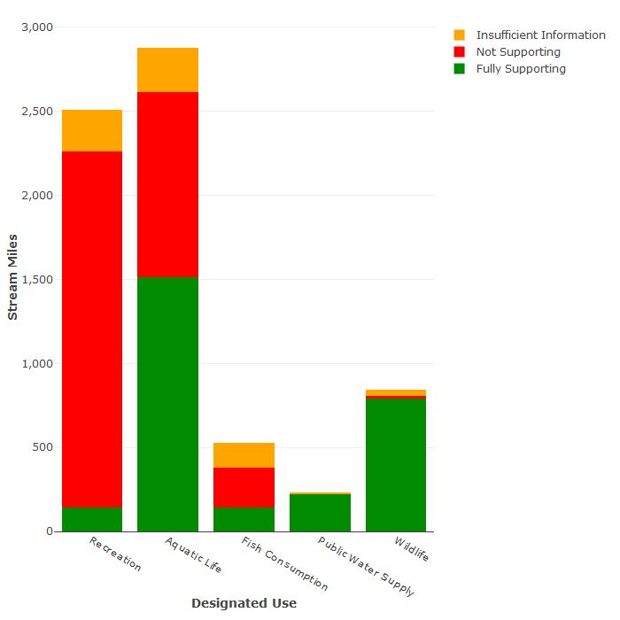

1. Lakes Assessment (650 acres were not assessed)

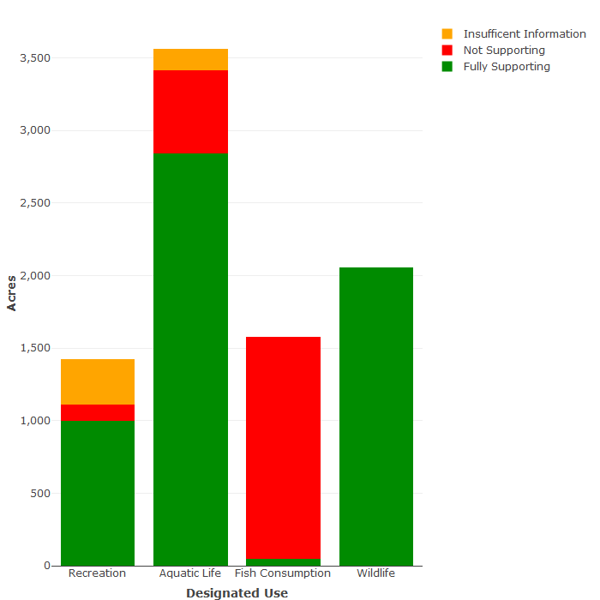

1. Estuaries assessment

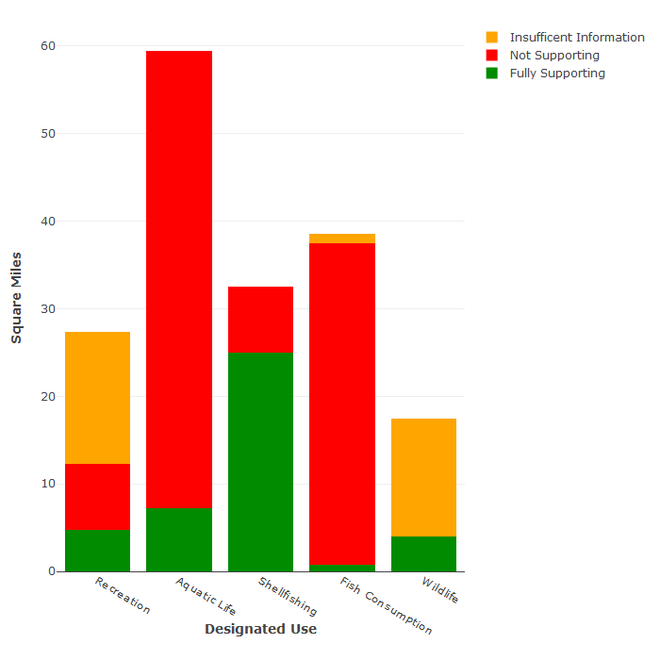

1. Assessment of Chesapeake Bay-specific designated uses (insufficient data exists to assess the Migratory fish spawning and nursery use)

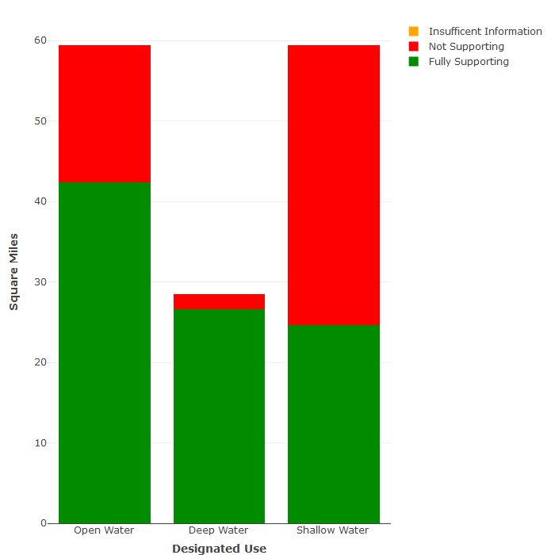

| ***Rivers*** | | ***Lakes*** | | ***Estuaries*** | |
| --- | --- | --- | --- | --- | --- |
| **Bacteria** | 85% | **PCBs in Fish Tissue** | 71% | **PCBs in Fish Tissue** | 62% |
| **Impaired Benthics** | 34% | **Dissolved Oxygen** | 14% | **Impaired Aquatic Plants** | 59% |
| **pH** | 8% | **Mercury in Fish Tissue** | 8% | **Dissolved Oxygen** | 32% |
| **Mercury in Fish Tissue** | 7% | **Temperature** | 8% | **Bacteria** | 20% |
| **PCBs in Fish Tissue** | 5% | **Bacteria** | 5% | **Impaired Benthics** | 4% |
| **Temperature** | 3% | **pH** | 4% | **pH** | 2% |

Table 4.3-1 Significant causes of designated use impairment in the Potomac-Shenandoah River basin, by waterbody type, ranked by percentage of impaired water size. (Note: Waters may have multiple pollutants.)

| ***Rivers*** | | ***Lakes*** | | ***Estuaries*** | |
| --- | --- | --- | --- | --- | --- |
| **Wildlife other than Waterfowl** | 65% | **Source Unknown** | 92% | **Sources Outside State Borders** | 88% |
| **Agriculture** | 57% | **Atmospheric Deposition (Toxics)** | 5% | **Agriculture** | 88% |
| **Non-Point Sources** | 56% | **Combined Sewer Overflows** | 5% | **Atmospheric Deposition (Nitrogen)** | 88% |
| **Livestock Grazing or Feeding Operations** | 44% | **Contaminated Sediments** | 5% | **Industrial or Municipal Point Source Discharges** | 88% |
| **On-site Septic Treatment Systems** | 32% | **Upstream Source** | 5% | **Internal Nutrient Recycling** | 88% |
| **Grazing in Riparian or Shoreline Zones** | 20% | **Grazing in Riparian or Shoreline Zones** | 5% | **Loss of Riparian Habitat** | 88% |

Table 4.3-2 Suspected sources of designated use impairment in the Potomac-Shenandoah River basin, by water body type, ranked by percentage of impaired water size. (Note: Waters may have multiple sources of pollution.)

**Benthic Chlorophyll-a Criteria development**

During the public comment periods for the 2012 and subsequent Integrated Reports, DEQ received comments from citizens regarding the presence of filamentous algae in the Shenandoah River and concern that the algae in the river impaired the recreation designated use. DEQ evaluated all available information submitted for the 2012 IR and each subsequent IR (including the 2022 IR) and identified five segments (approximately 25 river miles) along the North Fork and South Forks of the Shenandoah River as having an observed effect but lacking sufficient data to assess the attainment status of the recreation use (Category 3C). DEQ monitored these segments over the 2016 to 2019 period, developing and testing scientifically-based, defensible, and reproducible field methods for quantifying filamentous algae growth using benthic chlorophyll-a. DEQ staff also researched thresholds by other states for the purposes of determining when filamentous algae growth has reached a nuisance condition in freshwater streams. The result of this multi-year effort is a proposed special standard for inclusion in the Virginia Water Quality Standards for benthic chlorophyll-a designed to limit persistent, nuisance filamentous algae growth in large sections of the mainstem North Fork Shenandoah, South Fork Shenandoah, and Shenandoah Rivers. Information on this rulemaking as part of the 2021 Water Quality Standards Triennial Review is available on the [Virginia Town Hall website](https://townhall.virginia.gov/L/meetings.cfm). The proposed amendments provide two-month median and seasonal median criteria for benthic chlorophyll-a, both of which would apply during the recreation season (May 1 through October 31). On Aug. 25, the State Water Control Board (SWCB) approved revised water quality standards for the Commonwealth, including the new filamentous algae criteria for specific sections in the Shenandoah River basin. The rulemaking to finalize the amendments to the WQS regulation will need to complete executive review and also receive EPA approval before becoming effective.

**Additional efforts to reduce nutrients and sediment in the Shenandoah River basin**

DEQ recognizes that the presence of excess nutrients can be among the factors leading to algal growth, and continues to provide leadership in ongoing initiatives to reduce nutrients in the waters of the commonwealth. Two such efforts include the Chesapeake Bay TMDL/Virginia’s Bay Watershed Implementation Plan (WIP) and the development of waterbody-specific local TMDLs.

The entire Shenandoah basin is included in the watershed that is subject to the Chesapeake Bay TMDL and extensive controls on point and nonpoint source inputs of nitrogen, phosphorus and sediment are called for under the WIP. The Bay TMDL is the largest inter-state nutrient reduction regulatory program in the U.S., and the level of effort and dedication of resources supporting Virginia’s Bay Watershed Implementation Plan (WIP) is substantial. Implementation of the WIP for Chesapeake Bay restoration will also have the coincidental benefit of improving local water quality conditions in the headwater areas. Significant municipal and industrial point sources are required to either upgrade to near state-of-the-art nutrient reduction technology or make other arrangements (e.g., nutrient credit exchange) to reduce their nutrient discharges and meet assigned nutrient waste load allocations (WLAs); other smaller discharges are required to maintain “capped” loadings at their current design capacity. In 2011, the first year for compliance with Virginia’s Chesapeake Bay Nutrient Discharge Watershed General Permit, the Shenandoah basin’s significant dischargers achieved substantial nutrient reductions. The total nutrient loads discharged were well below their aggregate annual WLA -- Total Nitrogen (TN) was only 48 percent of the annual WLA and Total Phosphorus (TP) was just 67 percent of the annual WLA. In the past five years, four additional major facilities in the Shenandoah basin have upgraded to state-of-the-art nutrient removal technology.

The commonwealth updated the Watershed Implementation Plan (WIP) for the Chesapeake Bay TMDL in August 2019. That planning process included input on local implementation actions that can be used to meet the Bay nitrogen and phosphorus reduction goals. In the Shenandoah River watershed these nutrient reductions could amount to an additional 3.3 million pounds of nitrogen and 600,000 pounds of phosphorus removed from the river[1]. Since these pollutants may be closely related to the algae issues in the Shenandoah, it is likely that achieving the Bay TMDL reduction goals will significantly improve local water quality conditions. In fact, focusing implementation actions to cost effectively achieve multiple goals and co-benefits is a planning priority for the Bay WIP.

In addition to the extensive efforts to meet the targets of the Bay TMDL and WIP, numerous local TMDLs and TMDL implementation plans have been developed throughout the Shenandoah River Basin to restore water quality that is impaired for a variety of reasons. To date, EPA has approved 89 local TMDLs in the Shenandoah Basin, 31 for either nutrients or sediment. DEQ has also developed TMDL Implementation Plans for 33 watersheds in the Shenandoah Basin, 14 covering either nutrients or sediment. TMDL implementation plans, even those targeting sediment or bacteria reductions, rely on many of the same best management practices used to control nonpoint sources of nutrient loads. Implementation plans targeting bacteria and sediment have the coincidental benefit of reducing, to some extent, the nitrogen and phosphorus coming with the runoff.

**James River Basin**

The James River Basin occupies the central portion of Virginia and covers 10,265 square miles or approximately 24 percent of the commonwealth’s total land area. It is Virginia’s largest river basin and is made up of the Upper, Middle, and Lower James River sub-basins as well as the Appomattox River sub-basin.

The James River basin is defined by both hydrologic and political boundaries. The Potomac-Shenandoah River basin, the Rappahannock River basin and the York River basins bound the basin to the north. The southern boundary is made up of the New River basin, the Roanoke River basin and the Chowan River basin. Its headwaters originate along the Virginia/West Virginia state line.

The James River basin begins in the Alleghany Mountains and flows in a southeasterly direction to Hampton Roads where it enters the Chesapeake Bay. The James is formed by the confluence of the Jackson and Cowpasture Rivers and flows 242 miles to the Fall Line at Richmond and another 106 miles to the Chesapeake Bay.

The topography of the James River basin varies throughout the four physiographic provinces that it spans. The Valley and Ridge Province extends from the Appalachian Plateau in West Virginia to the Blue Ridge Province. The Blue Ridge Province, a remnant of a former highland, differs from the Valley and Ridge Province. It is a province of rugged terrain with steep slopes and narrow ridges in the north and broad moderate slopes in the south. The Piedmont Province extends to the Fall Line and has scattered hills and small mountains, gradually turning into gently rolling slopes and lower elevation in the eastern portion of the province. The Fall Zone separates the Coastal Plain Province from the Piedmont. The Fall Zone is a three-mile stretch of river running through Richmond where the river descends 84 feet as it flows from the resistant rocks of the Piedmont to the softer sediments of the Coastal Plain.

Over 65 percent of the James River basin is forested, with 19 percent in cropland and pasture. Approximately 12 percent is considered urban. The 2010 population for the James River basin was approximately 2,892,000. This population is concentrated in two metropolitan areas: Tidewater, with over one million people, and the Greater Richmond – Petersburg area with over 650,000. Two smaller population centers are the Lynchburg and Charlottesville areas, each with over 100,000 people. All or portions of the following 38 counties and 17 cities lie within the basin: counties – Albemarle, Alleghany, Amelia, Amherst, Appomattox, Augusta, Bath, Bedford, Botetourt, Buckingham, Campbell, Charles City, Chesterfield, Craig, Cumberland, Dinwiddie, Fluvanna, Giles, Goochland, Greene, Hanover, Henrico, Highland, Isle of Wight, James City, Louisa, Montgomery, Nelson, New Kent, Nottoway, Orange, Powhatan, Prince Edward, Prince George, Roanoke, Rockbridge, Surry, and York; cities – Buena Vista, Charlottesville, Chesapeake, Colonial Heights, Covington, Hampton, Hopewell, Lexington, Lynchburg, Newport News, Norfolk, Petersburg, Portsmouth, Richmond, Suffolk, Williamsburg, and Virginia Beach.

Average annual precipitation is 42.5 inches. Average annual snowfall amount ranges from over 30 inches in the mountains to less than 10 inches along the coast.

Major tributaries to the James River are Jackson River, Cowpasture River, Craig Creek, Maury River, Tye River, Rockfish River, Slate River, Rivanna River, Willis River, Appomattox River, Chickahominy River, Pagan River, Nansemond River, and the Elizabeth River.

The James River Basin is divided into eight USGS hydrologic units as follows: HUC 02080201 –Upper James, HUC 02080202 – Maury, HUC 02080203 – Upper Middle James, HUC 02080204 – Rivanna, HUC 02080205 – Lower Middle James, HUC 02080206 – Lower James, HUC 02080207 – Appomattox, and HUC 02080208 – the Elizabeth. The eight hydrologic units are further divided into 109 waterbodies or watersheds and 298 6th order sub-watersheds.

Basin assessment information is presented in the following tables and figures.

Figure 4.3-2 Designated Use support summary for the James River basin

**Size: All Sizes Rounded to Nearest Whole Number**

Rivers - 26,062 miles

Lakes - 18,564 acres

Estuaries - 265 sq. miles

1. Rivers Assessment (21,424 miles were not assessed)

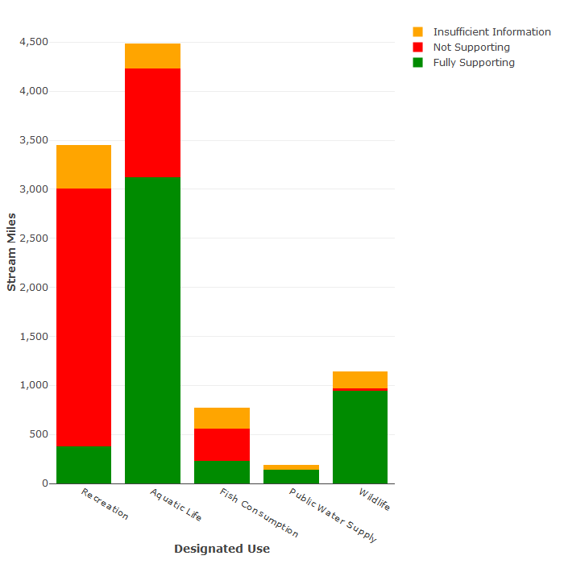

1. Lakes Assessment (157 acres were not assessed)

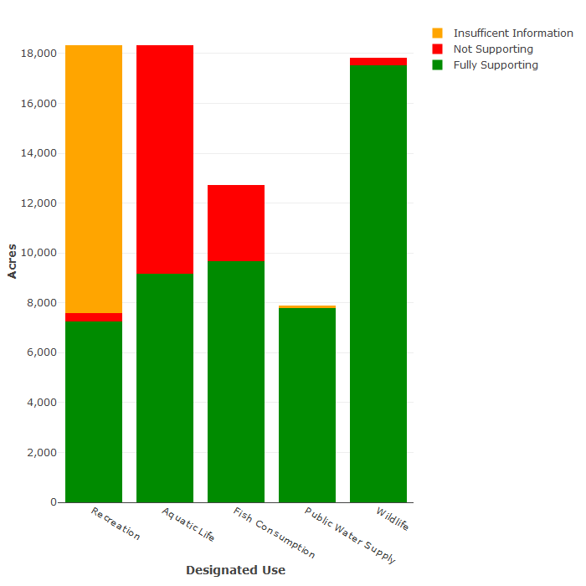

1. Estuaries assessment

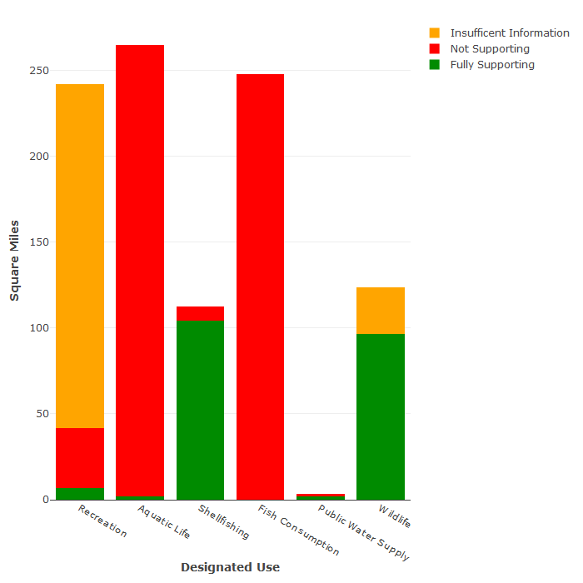

1. Assessment of Chesapeake Bay-specific designated uses (insufficient data exists to assess the Migratory fish spawning and nursery use)

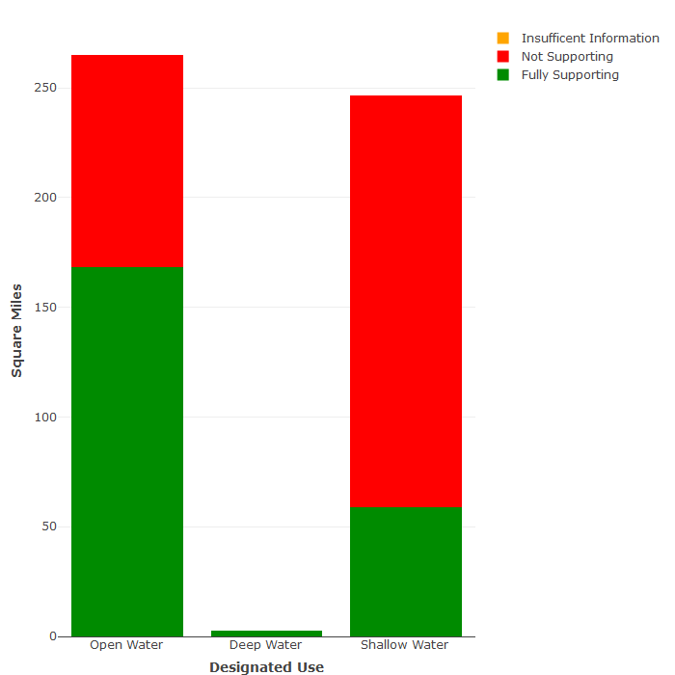

| ***Rivers*** | | ***Lakes*** | | ***Estuaries*** | |
| --- | --- | --- | --- | --- | --- |
| **Bacteria** | 79% | **Dissolved Oxygen** | 77% | **PCBs in Fish Tissue** | 94% |
| **Impaired Benthics** | 20% | **Mercury in Fish Tissue** | 27% | **Impaired Benthics** | 74% |
| **PCBs in Fish Tissue** | 9% | **Chlorophyll-a** | 4% | **Impaired Aquatic Plants** | 71% |
| **Dissolved Oxygen** | 8% | **pH** | 3% | **Chlorophyll-a** | 27% |
| **pH** | 7% | **Copper** | 3% | **Bacteria** | 14% |
| **Temperature** | 4% | **Bacteria** | 3% | **Dissolved Oxygen** | 8% |

Table 4.3-3 Significant causes of designated use impairment in the James River basin, by waterbody type, ranked by percentage of impaired water size. (Note: Waters can have multiple pollutants.)

| ***Rivers*** | | ***Lakes*** | | ***Estuaries*** | |
| --- | --- | --- | --- | --- | --- |
| **Agriculture** | 61% | **Source Unknown** | 53% | **Source Unknown** | 95% |
| **On-site Septic Treatment Systems** | 59% | **Dam or Impoundments** | 36% | **Agriculture** | 79% |
| **Non-Point Sources** | 58% | **Atmospheric Deposition (Toxics)** | 27% | **Industrial or Municipal Point Source Discharges** | 41% |
| **Urban Runoff/Storm Sewers** | 43% | **Natural Sources** | 16% | **Non-Point Sources** | 30% |
| **Wildlife other than Waterfowl** | 42% | **Non-Point Sources** | 8% | **Atmospheric Deposition (Nitrogen)** | 23% |
| **Source Unknown** | 25% | **Agriculture** | 3% | **Internal Nutrient Recycling** | 23% |

Table 4.3-4 Suspected sources of designated use impairment in the James River Basin, by water body type, ranked by percentage of impaired water size. (Note: Waters can have multiple sources of pollution.)

**Rappahannock River Basin**

The Rappahannock River basin is located in the northeastern portion of Virginia and covers 2,712 square miles or approximately 6 percent of the commonwealth’s total area.

The Rappahannock River basin is bordered by the Potomac-Shenandoah basin to the north and the York River basin and Chesapeake/Atlantic Coastal basin to the south and east. The headwaters lie in Fauquier and Rappahannock counties and flow in a southeasterly direction to its confluence with the Chesapeake Bay between Lancaster and Middlesex counties. The Rappahannock River basin is 184 miles in length and varies in width from 20 to 50 miles. The Rappahannock River basin’s major tributaries are the Hazel River, Thornton River, Mountain Run, Rapidan River, Robinson River, Cat Point Creek, and the Corrotoman River.

The topography of the Rappahannock River basin changes from steep slopes to flat land as it flows from the Blue Ridge Mountains to the Chesapeake Bay. About 51 percent of the basin land is forested, while pasture and cropland make up another 36 percent. Only about 6 percent of the land area is considered urban.

Most of the Rappahannock River basin lies in the eastern Piedmont and Coastal Plain areas of the commonwealth while its headwaters, located on the eastern slopes of the Blue Ridge, are considered to be in the northwestern Piedmont section.

The 2010 population of the Rappahannock River basin was approximately 483,770. The basin is mostly rural in character, with Fredericksburg, Spotsylvania, and Stafford as the main population centers. In recent years, the basin has seen increasing urban pressure from the influence of metropolitan Washington in the Fredericksburg and Fauquier areas of the basin. All or portions of the following 17 counties and one city lie within the basin: Albemarle, Caroline, Culpeper, Essex, Fauquier, Greene, King George, Lancaster, Madison, Middlesex, Northumberland, Orange, Rappahannock, Richmond, Spotsylvania, Stafford, and Westmoreland; City - Fredericksburg.

The Rappahannock River Basin is divided into two USGS hydrologic units as follows: HUC 02080103 – Rapidan – Upper Rappahannock; and HUC 02080104 – Lower Rappahannock. The two hydrologic units are further divided into 26 waterbodies or watersheds and 74 6th order sub-watersheds.

Basin assessment information is presented in the following figures and tables.

Figure 4.3-3 Designated use support summary for the Rappahannock River basin. (Note: Waters that have some data, but not enough to determine use support, are classified as having “Insufficient information”.)

**Size: All Sizes Rounded to Nearest Whole Numbers**

Rivers - 6,481 miles

Lakes - 1,486 acres

Estuaries - 155 sq. miles

1. Rivers Assessment (5,204 miles were not assessed)

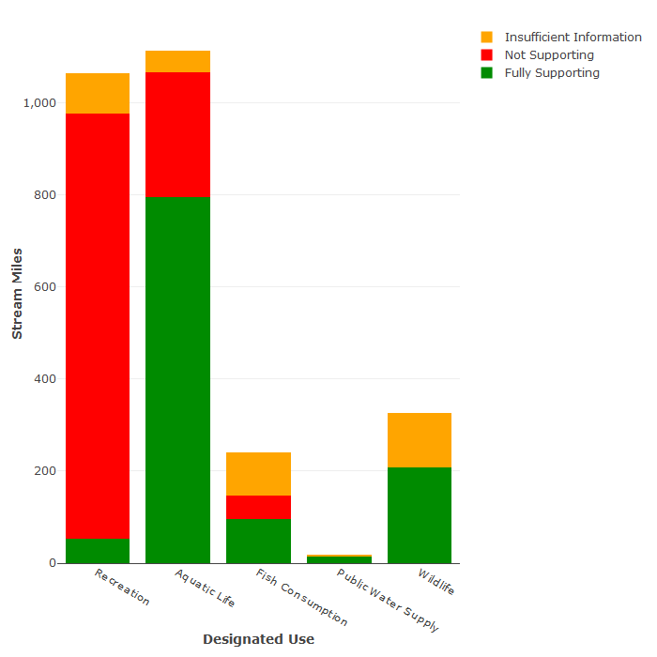

1. Lakes Assessment

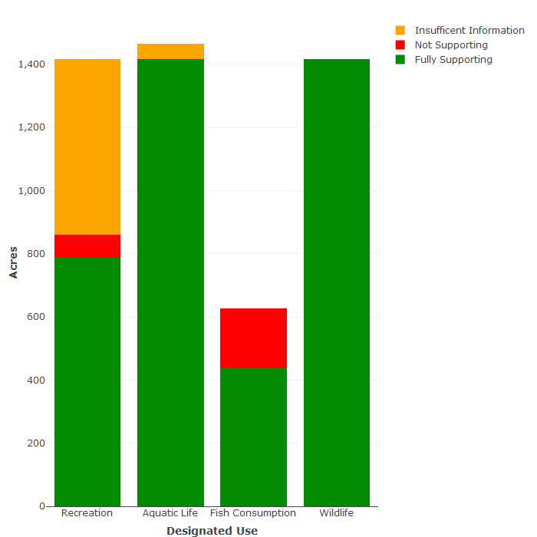

1. Estuaries assessment

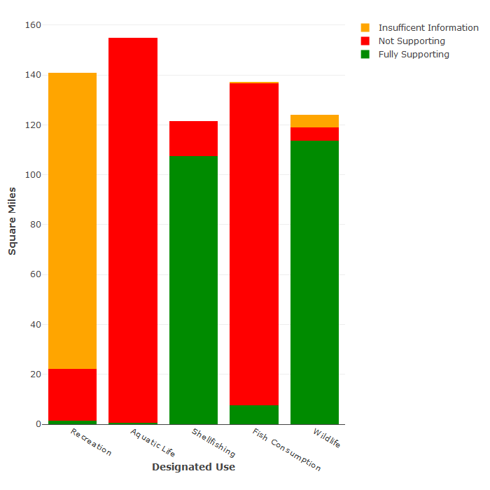

1. Assessment of Chesapeake Bay-specific designated uses (insufficient data exists to assess the Migratory fish spawning and nursery use)

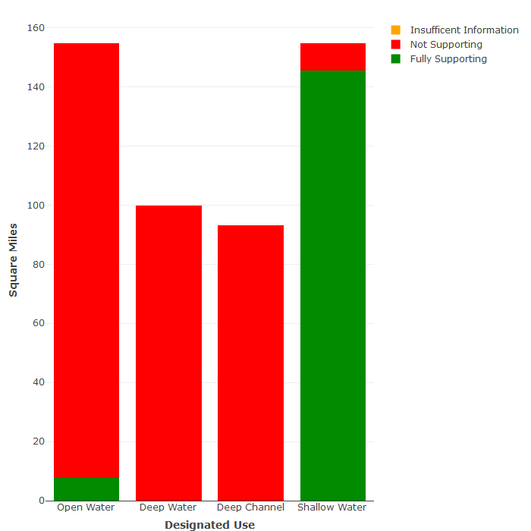

| ***Rivers*** | | ***Lakes*** | | ***Estuaries*** | |
| --- | --- | --- | --- | --- | --- |
| **Bacteria** | 92% | **Mercury in Fish Tissue** | 72% | **Dissolved Oxygen** | 95% |
| **Impaired Benthics** | 14% | **Bacteria** | 28% | **PCBs in Fish Tissue** | 84% |
| **pH** | 9% | **--** | -- | **Impaired Benthics** | 82% |
| **Dissolved Oxygen** | 5% | **--** | -- | **Bacteria** | 21% |
| **PCBs in Fish Tissue** | 4% | **--** | -- | **Impaired Aquatic Plants** | 6% |
| **Temperature** | 2% | **--** | -- | **Chloride** | 3% |

Table 4.3-5 Significant causes of designated use impairment in the Rappahannock River basin, by waterbody type, ranked by percentage of impaired water size. (Note: Waters can have multiple pollutants.)

| ***Rivers*** | | ***Lakes*** | | ***Estuaries*** | |
| --- | --- | --- | --- | --- | --- |
| **On-site Septic Treatment Systems** | 72% | **Source Unknown** | 72% | **Agriculture** | 98% |
| **Livestock Grazing or Feeding Operations** | 58% | **Non-Point Sources** | 28% | **Municipal Point Source Discharges** | 98% |
| **Waterfowl** | 58% | **Atmospheric Deposition (Toxics)** | 19% | **Sources Outside State Borders** | 95% |
| **Wildlife other than Waterfowl** | 58% | **--** | -- | **Internal Nutrient Recycling** | 95% |
| **Waste From Pets** | 55% | **--** | -- | **Loss of Riparian Habitat** | 95% |
| **Urban Runoff/Storm Sewers** | 38% | **--** | -- | **Atmospheric Deposition (Nitrogen)** | 95% |

Table 4.3-6 Suspected sources of designated use impairment in the Rappahannock River basin, by water body type, ranked by percentage of impaired water size. (Note: Waters can have multiple sources of pollution.)

**Roanoke River Basin**

The Roanoke River basin covers 6,393 square miles or approximately 15 percent of the commonwealth’s total area. In addition to the Roanoke itself, the basin also contains the Yadkin, Dan, Smith, Staunton, and Banister Rivers and numerous other sub-basins.

The Virginia portion of the Roanoke River basin is defined by both hydrologic and political boundaries. The basin is bound by the James River basin on the north, to the east by the Chowan River basin, and to the west by the New River basin. The southern boundary of the basin is the Virginia/North Carolina state line.

The topography of the Roanoke River basin ranges from steep slopes and valleys in the Valley and Ridge Province to gently sloping terrain east of the mountains in the Piedmont Province.

The Roanoke River basin headwaters begin in the mountainous terrain of eastern Montgomery County and flow in a southeasterly direction to the Virginia/North Carolina state line. The Roanoke basin passes through three physiographic provinces- the Valley and Ridge Province to the northwest, and the Blue Ridge and Piedmont Provinces to the southeast.

The Roanoke watershed is large enough to accommodate two major reservoirs, Smith Mountain and Leesville Lakes to the north and Kerr Reservoir and Lake Gaston located at the junction of the Roanoke River and the North Carolina state line. These reservoirs range in size from the 33,300 acre Kerr Reservoir to the 2,600-acre Leesville Lake. These impoundments are used for both recreation and hydroelectricity. Major tributaries in the northern section of the basin are the Little Otter and Big Otter Rivers along with the Blackwater and Pigg Rivers. Major tributaries in the southern portion include the Dan River, Smith River, and Banister River. Over 62 percent of the Roanoke River Basin is forested, while nearly 25 percent is in cropland and pasture. Approximately 10 percent is considered urban.

The 2010 population for the Roanoke River Basin was approximately 943,200. All or portions of the following 17 counties and 4 cities lie within the basin: counties – Appomattox, Bedford, Botetourt, Brunswick, Campbell, Carroll, Charlotte, Floyd, Franklin, Grayson, Halifax, Henry, Mecklenburg, Montgomery, Patrick, Pittsylvania, and Roanoke; cities – Danville, Martinsville, Roanoke, and Salem.

The Roanoke River basin is divided into seven USGS hydrologic units as follows: HUC 03010101 – Upper Roanoke; HUC 03010102 – Middle Roanoke; HUC 03010103 – Upper Dan; HUC 03010104 – Lower Dan; HUC 03010105 – Banister; HUC 03010106 – Roanoke Rapids and HUC 03040101 – Upper Yadkin. The seven hydrologic units are further divided into 87 waterbodies or watersheds and 202 6th order sub-watersheds.

Basin assessment information is presented in the following figures and tables.

Figure 4.3-4 Designated use support summary for the Roanoke River basin. (Note: Waters that have some data, but not enough to determine use support, are classified as having “Insufficient information”.)

**Size: All Sizes Rounded to Nearest Whole Number**

Rivers - 17,279 miles

Lakes - 66,785 acres

Estuaries - 0 sq. miles

1. Rivers Assessment (14,560 miles were not assessed)

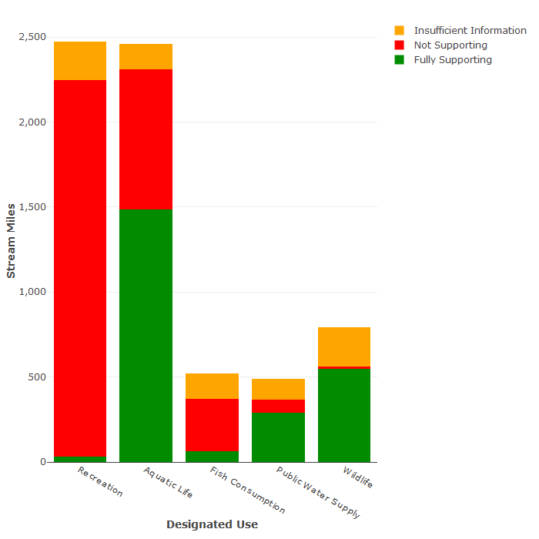

1. Lakes Assessment (1,600 acres were not assessed)

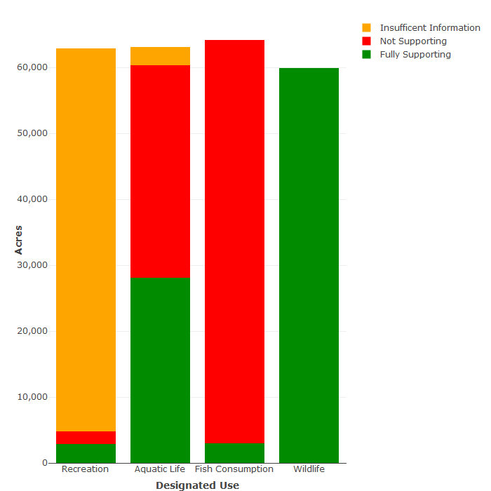

| ***Rivers*** | | ***Lakes*** | |
| --- | --- | --- | --- |
| **Bacteria** | 93% | **PCBs in Fish Tissue** | 90% |
| **Impaired Benthics** | 29% | **Mercury in Fish Tissue** | 76% |
| **Mercury in Fish Tissue** | 11% | **Dissolved Oxygen** | 50% |
| **PCBs in Fish Tissue** | 11% | **Temperature** | 5% |
| **Temperature** | 5% | **Bacteria** | 3% |
| **Dissolved Oxygen** | 2% | **Chlorophyll-a** | <1% |

Table 4.3-7 Significant causes of designated use impairment in the Roanoke River basin, by waterbody type, ranked by percentage of impaired water size. (Note: Waters can have multiple pollutants.)

| ***Rivers*** | | ***Lakes*** | |
| --- | --- | --- | --- |
| **Wildlife other than Waterfowl** | 88% | **Source Unknown** | 79% |
| **Livestock Grazing or Feeding Operations** | 87% | **Atmospheric Deposition** | 31% |
| **Unspecified Domestic Waste** | 87% | **Industrial Point Source Discharges** | 31% |
| **Waste from Pets** | 52% | **Contaminated Sediments** | 31% |
| **On-Site Septic Treatment Systems** | 37% | **On-site Septic Treatment Systems** | 2% |
| **Source Unknown** | 30% | **Wildlife other than Waterfowl** | 1% |

Table 4.3-8 Suspected sources of designated use impairment in the Roanoke River basin, by water body type, ranked by percentage of impaired water size. (Note: Waters can have multiple sources of pollution.)

**Chowan River-Dismal Swamp Basin**

The Chowan River and Dismal Swamp basin is located in the southeastern portion of Virginia and covers 4,220 square miles or approximately 10 percent of the commonwealth’s total area.

The basin extends eastward from Charlotte County to the Chesapeake Bay. The Chowan River-Dismal Swamp basin in Virginia is defined by both hydrologic and political boundaries - the James River basin to the north, the Chesapeake/Atlantic and Small Coastal River basins to the east, the Roanoke River basin to the west and the Virginia/North Carolina State line to the south. The basin is approximately 145 miles in length and varies from 10 to 50 miles in width. The Chowan River-Dismal Swamp basin flows through the Piedmont and Coastal Plain Physiological Provinces. The Chowan portion flows 130 miles from west to east, crossing both the Piedmont and Coastal Plain, while the Dismal Swamp lies entirely within the Coastal Plain. The Piedmont portion is characterized by rolling hills, steeper slopes and somewhat more pronounced stream valleys. The Coastal Plain, in contrast, is nearly flat with a descending series of terraces.

The Chowan River-Dismal Swamp basin is mostly rural with approximately 64 percent of its land covered by forest. Cropland and pasture make up another 28 percent, while only about 6 percent is classified as urban.

The 2010 population for the Chowan River-Dismal Swamp basin was approximately 597,900. All or portions of the following 13 counties and 6 cities lie within the basin: counties – Brunswick, Charlotte, Dinwiddie, Greensville, Isle of Wight, Lunenburg, Mecklenburg, Nottoway, Prince Edward, Prince George, Southampton, Surry, and Sussex; Cities – Chesapeake, Emporia, Franklin, Petersburg, Suffolk, and Virginia Beach.

Major tributaries of the Chowan River are the Meherrin, the Nottoway and the Blackwater. The Nottoway and the Blackwater join at the Virginia/North Carolina state line to form the Chowan River. The Dismal Swamp portion is mostly flat with many swamp and marshland areas.

The Chowan River-Dismal Swamp basin is divided into five USGS hydrologic units as follows: HUC 03010201 – Nottoway; HUC 03010202 – Blackwater; HUC 03010203 – Chowan; HUC 03010204 – Meherrin; and HUC 03010205 – Albemarle Sound. The five hydrologic units are further divided into 42 waterbodies or watersheds and 127 6th order sub-watersheds.

Basin assessment information is presented in the following figures and tables.

Figure 4.3-5 Designated use support summary for the Chowan River-Dismal Swamp basin. (Note: Waters that have some data, but not enough to determine use support, are classified as having “Insufficient information”.)

**Size: All Sizes Rounded to Nearest Whole Number**

Rivers - 10,934 miles

Lakes - 4,700 acres

Estuaries - 39 sq. miles

1. Rivers Assessment (7,342 miles were not assessed)

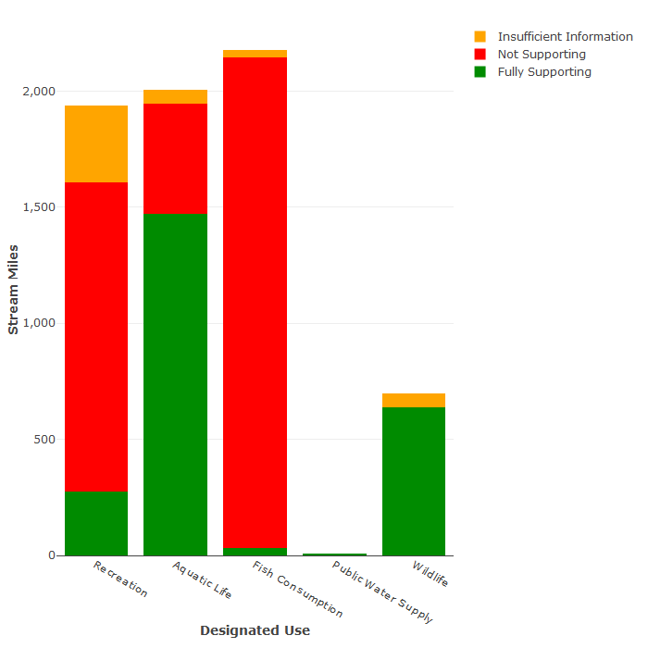

Note: 5 miles of the public water supply use were assessed as fully supporting

1. Lakes Assessment (275 acres were not assessed)

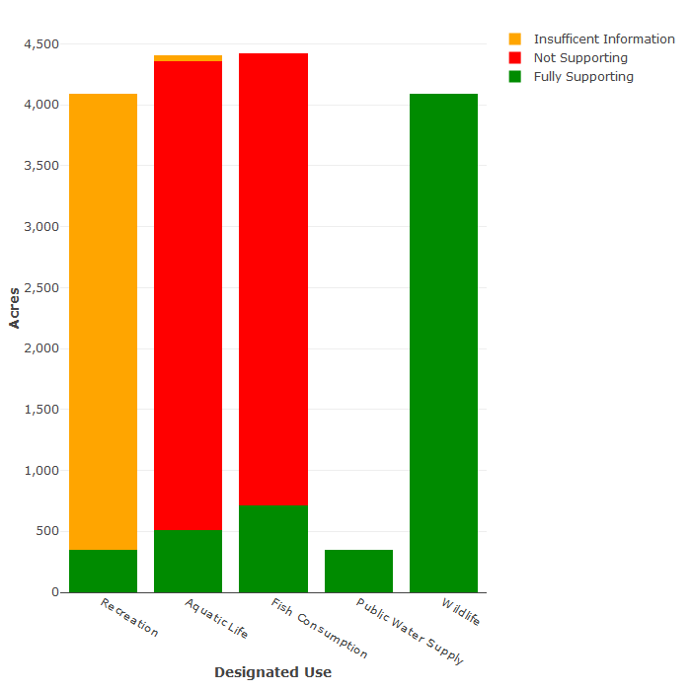

1. Estuaries assessment

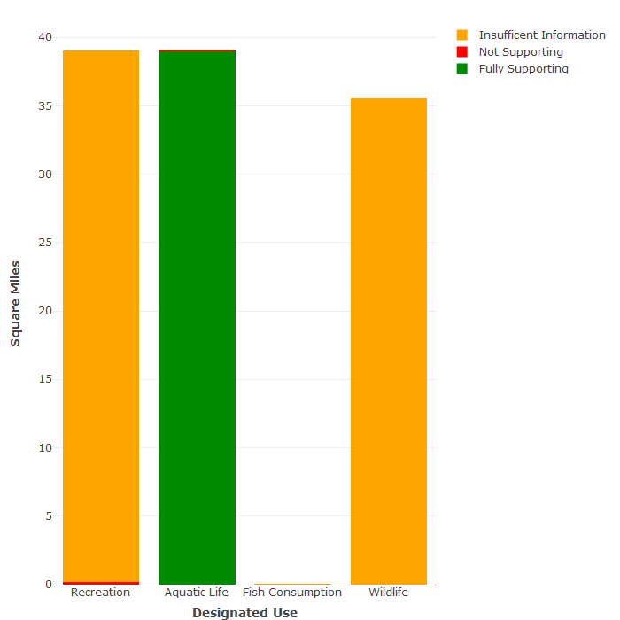

| ***Rivers*** | | ***Lakes*** | | ***Estuaries*** | |
| --- | --- | --- | --- | --- | --- |
| **Mercury in Fish Tissue** | 67% | **Mercury in Fish Tissue** | 89% | **Bacteria** | 100% |
| **Bacteria** | 43% | **pH** | 77% | **Dissolved Oxygen** | 45% |
| **Impaired Benthics** | 8% | **Dissolved Oxygen** | 14% | **--** | -- |
| **Dissolved Oxygen** | 7% | **Total Phosphorus** | 8% | **--** | -- |
| **pH** | 2% | **Chlorophyll-a** | 4% | **--** | -- |
| **PCBs in Fish Tissue** | 1% | **--** | -- | **--** | -- |

Table 4.3-9 Significant causes of designated use impairment in the Chowan River-Dismal Swamp basin, by waterbody type, ranked by percentage of impaired water size. (Note: Waters can have multiple pollutants.)

| ***Rivers*** | | ***Lakes*** | | ***Estuaries*** | |
| --- | --- | --- | --- | --- | --- |
| **Source Unknown** | 85% | **Source Unknown** | 94% | **On-Site Septic Treatment Systems** | 73% |
| **Atmospheric Deposition (Toxics)** | 29% | **Natural Conditions** | 80% | **Municipal Point Source Discharges** | 72% |
| **Agriculture** | 26% | **Natural Sources** | 10% | **Urban Runoff/Storm Sewers** | 63% |
| **Urban Runoff/Storm Sewers** | 26% | **Atmospheric Deposition (Toxics)** | 6% | **Agriculture** | 54% |
| **On-Site Septic Treatment Systems** | 25% | **Agriculture** | 4% | **Livestock Grazing or Feeding Operations** | 28% |
| **Non-Point Sources** | 20% | **--** | -- | **Source Unknown** | 25% |

Table 4.3-10 Suspected sources of designated use impairment in the Chowan River-Dismal Swamp basin, by water body type, ranked by percentage of impaired water size. (Note: Waters can have multiple sources of pollution.)

**Tennessee-Big Sandy River Basin**

The segment of the Tennessee and Big Sandy River basin which lies in Virginia is made up of the Holston, Clinch-Powell, and Big Sandy River sub-basins. These sub-basins are located in the extreme southwest portion of Virginia and cover 4,132 square miles or approximately 10 percent of the commonwealth’s total land area.

The Virginia portion of the Tennessee-Big Sandy River basin is defined by both hydrologic and political boundaries. The West Virginia state line lies to the north, Kentucky to the west, and Tennessee to the south. The New River basin makes up the eastern boundary.

While numerous southwestern Virginia streams feed the Tennessee and Big Sandy Rivers, neither river forms within the commonwealth itself. The Big Sandy sub-basin contains the Levisa and Tug Forks that flows northward into Kentucky forming the Big Sandy River. The southwestward flowing Holston, Clinch, and Powell tributaries form the Tennessee River in Tennessee. Both of the major river sub-basins eventually empty into the Gulf of Mexico via the Ohio and Mississippi Rivers.

The Tennessee-Big Sandy River basin spans three physiographic provinces: Appalachian Plateau, Valley and Ridge, and the Blue Ridge. The Big Sandy portion of the basin lies within the Appalachian Plateau. This province is characterized as rugged, with mountainous terrain and steep valleys. Parallel valleys and ridges running in a northeast to southwest direction characterize the Tennessee portion, lying in the Valley and Ridge Province. A small portion of the basin, located in the Blue Ridge Province, is more like a plateau with no single, prominent ridge that characterizes the province to the southeast.

Within Virginia, approximately 48 percent of the Tennessee River basin is forested, while cropland and pasture make up another 39.7 percent. The Big Sandy portion of the basin is approximately 86 percent forest, with only about 5 percent in cropland and pasture. Urban areas make up only a small percentage of the total land area.

The 2010 population for the Tennessee-Big Sandy River Basin was approximately 458,700. All or parts of the following jurisdictions lie within the basin: counties – Bland, Buchanan, Dickenson, Grayson, Lee, Russell, Scott, Smyth, Tazewell, Washington, Wise, and Wythe; Cities – Bristol and Norton.

The Tennessee-Big Sandy River basin is divided into six USGS hydrologic units as follows: HUC 05070201 – Tug Fork; HUC 05070202 – Upper Levisa; HUC 06010101 – North Fork Holston; HUC 06010102 - South and Middle Fork Holston; HUC 06010205 – Upper Clinch; and HUC 06010206 – Powell River. The six hydrologic units are further divided into 56 waterbodies or watersheds and 135 6th order sub-watersheds.

Basin assessment information is presented in the following figures and tables.

Figure 4.3-6 Designated use support summary for the Tennessee-Big Sandy River basin. (Note: Waters that have some data, but not enough to determine use support, are classified as having “Insufficient information”.)

**Size: All Sizes Rounded to Nearest Whole Number**

Rivers - 10,669 miles

Lakes - 3,857 acres

Estuaries - 0 sq. miles

1. Rivers Assessment (8,369 miles were not assessed)

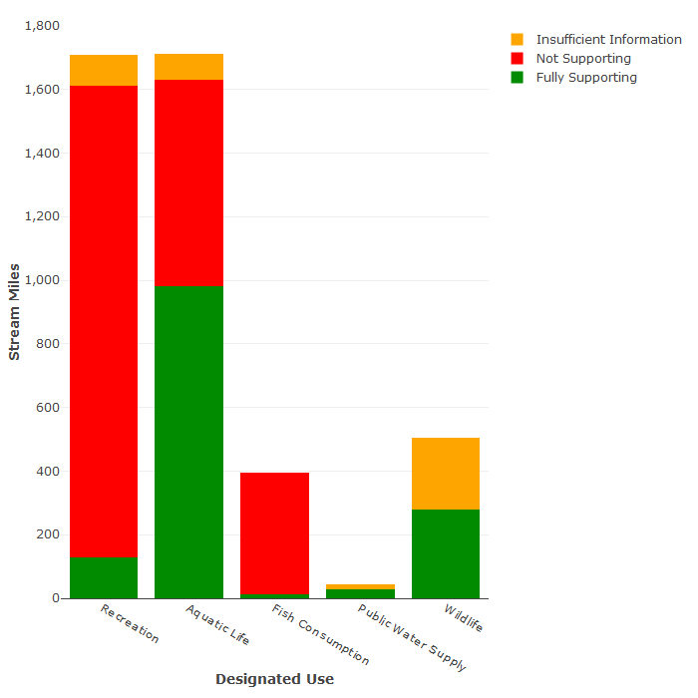

1. Lakes Assessment (116 acres were not assessed)

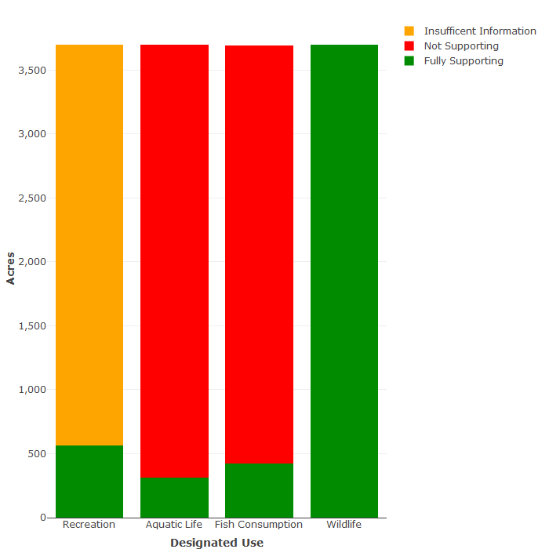

| ***Rivers*** | | ***Lakes*** | |
| --- | --- | --- | --- |
| **Bacteria** | 76% | **Mercury in Fish Tissue** | 90% |
| **Impaired Benthics** | 30% | **Dissolved Oxygen** | 81% |
| **PCBs in Fish Tissue** | 18% | **PCBs in Fish Tissue** | 47% |
| **Mercury in Fish Tissue** | 5% | **Temperature** | 13% |
| **Temperature** | 4% | **--** | -- |
| **pH** | 1% | **--** | -- |

Table 4.3-11 Significant causes of designated use impairment in the Tennessee-Big Sandy River basin, by waterbody type, ranked by percentage of impaired water size. (Note: Waters can have multiple pollutants.)

| ***Rivers*** | | ***Lakes*** | |
| --- | --- | --- | --- |
| **Unrestricted Cattle Access** | 47% | **Source Unknown** | 82% |
| **Rural Residential Areas** | 46% | **Atmospheric Deposition (Toxics)** | 42% |
| **Source Unknown** | 20% | **Natural Conditions** | 13% |
| **Sewage Discharges in Unsewered Areas** | 19% | **Natural Sources** | 1% |
| **Coal Mining** | 14% | **--** | -- |
| **Surface Mining** | 9% | **--** | -- |

Table 4.3-12 Suspected sources of designated use impairment in the Tennessee-Big Sandy River basin, by water body type, ranked by percentage of impaired water size. (Note: Waters can have multiple sources of pollution.)

**Chesapeake Bay/Atlantic Ocean and Small Coastal Basins**

The Chesapeake Bay/Atlantic Ocean and small coastal basins are located in the eastern part of Virginia and covers 3,592 square miles or approximately 8 percent of the commonwealth’s total land area. The combined basins encompass the small bays, river inlets, islands and shoreline immediately surrounding the Chesapeake Bay and the southern portion of the Delmarva Peninsula. These basins also include the Chesapeake Bay itself.

The Chesapeake Bay/Atlantic Ocean and small coastal basins are defined by both hydrologic and political boundaries. The Potomac River, the Rappahannock River, the York River, the James River, and the Chowan River-Dismal Swamp basins border the small coastal basins to its west. The Eastern Shore portion is bordered on the west by the Chesapeake Bay, on the north by Maryland, and on the east by the Atlantic Ocean.

The topography of the Chesapeake Bay/Atlantic Ocean and small coastal basins does not vary much. The basins lie within the Coastal Plain Physiographic Province where elevations average no more than a few feet above sea level. More significant elevation occurs along the central spine of the Eastern Shore portion, which forms a plateau about 45 feet above sea level. Much of these basins consist of marshland. About 30 percent of the Chesapeake Bay/Atlantic Ocean and small coastal basins are forested, while nearly 22 percent is in cropland and pasture. Approximately 24 percent is considered urban.

The 2010 population for the Chesapeake Bay/Atlantic Ocean and small coastal basins was approximately 741,800. All or portions of the following jurisdictions lie within these basins: Counties – Accomack, Essex, Gloucester, King and Queen, Lancaster, Matthews, Middlesex, Northampton, Northumberland, and York; Cities – Hampton, Newport News, Norfolk, Poquoson, and Virginia Beach.

Tributaries in the Chesapeake Bay/coastal basins drain into the Chesapeake Bay or the Atlantic Ocean. Major tributaries flowing into the Chesapeake Bay from the western shore are the Great Wicomico River, Piankatank River, Fleets Bay, Mobjack Bay including the East, North, Ware, and Severn Rivers, Poquoson River, Back River and Lynnhaven River. Tributaries in the Eastern Shore portion that drain into the Bay are Pocomoke River, Onancock, Pungoteague, Occohannock, and Nassawadox Creeks. Machipongo River, Assawoman Creek, Parker Creek, Folly Creek, and Finney Creek drain east directly into the Atlantic Ocean.

The Chesapeake Bay/Atlantic Ocean and small coastal basins are divided into seven USGS hydrologic units as follows: HUC 02060009 – Pocomoke; HUC 02060010 – Chincoteague; HUC 02080101 – Lower Chesapeake Bay; HUC 02080102 – Great Wicomico-Piankatank; HUC 02080108 – Lower Lynnhaven-Poquoson; HUC 02080109 – Western Lower Delmarva; and HUC 02080110 – Tangier. The seven hydrologic units are further divided into 24 waterbodies or watersheds and 73 6th order sub-watersheds.

Basin assessment information is presented in the following figures and tables.

Figure 4.3-7 Designated use support summary for the Chesapeake Bay/Atlantic Ocean and small coastal basins. (Note: Waters that have some data, but not enough to determine use support, are classified as having “Insufficient information”.)

**Size: All Sizes Rounded to Nearest Whole Number**

Rivers - 1,878 miles

Lakes - 2,150 acres

Estuaries - 2,243 sq. miles

1. Rivers Assessment (1,714 miles were not assessed)

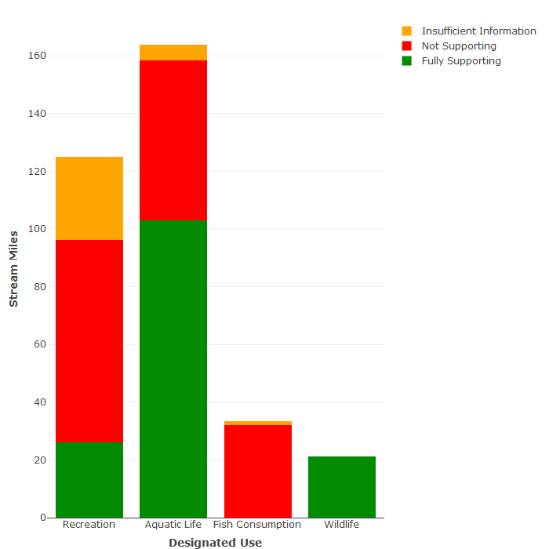

1. Lakes Assessment (956 acres were not assessed)

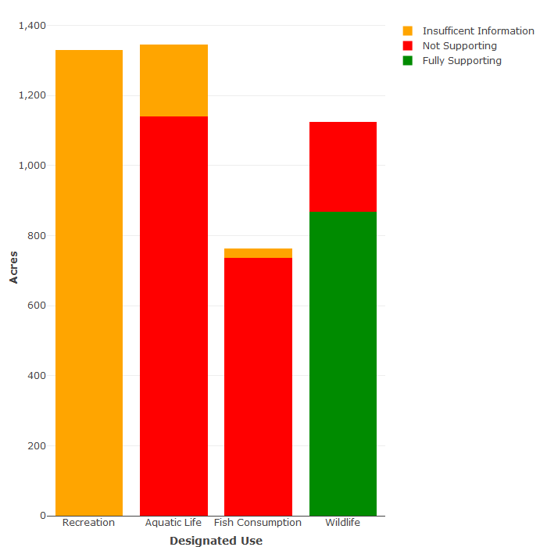

1. Estuaries assessment

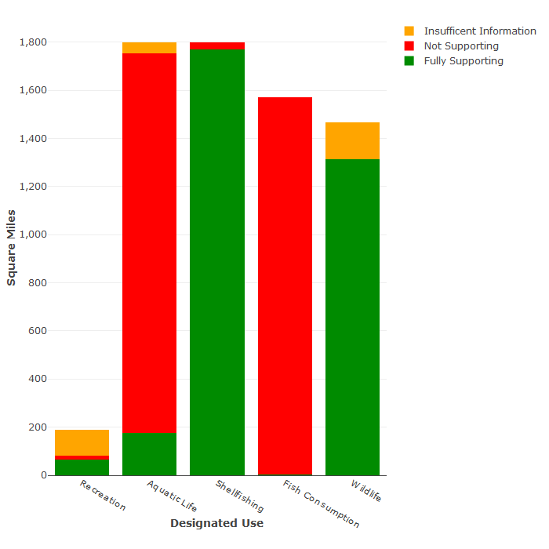

1. Assessment of Chesapeake Bay-specific designated uses (insufficient data exists to assess the Migratory fish spawning and nursery use)

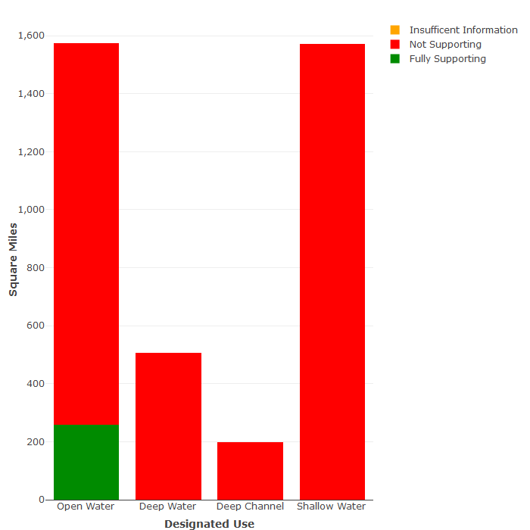

| ***Rivers*** | | ***Lakes*** | | ***Estuaries*** | |
| --- | --- | --- | --- | --- | --- |
| **Bacteria** | 56% | **Chlorophyll-a** | 73% | **Impaired Aquatic Plants** | 100% |
| **Impaired Benthics** | 28% | **Total Phosphorus** | 73% | **PCBs in Fish Tissue** | 99% |
| **Mercury in Fish Tissue** | 26% | **Dissolved Oxygen** | 63% | **Dissolved Oxygen** | 85% |
| **Dissolved Oxygen** | 18% | **PCBs in Fish Tissue** | 62% | **Bacteria** | 3% |
| **pH** | 8% | **Mercury in Fish Tissue** | 45% | **Impaired Benthics** | 2% |
| **--** | -- | **Copper** | 22% | **Mercury in Fish Tissue** | <1% |

Table 4.3-13 Significant causes of designated use impairment in the Chesapeake Bay/Atlantic Ocean and small coastal basins, by waterbody type, ranked by percentage of impaired water size. (Note: Waters can have multiple pollutants.)

| ***Rivers*** | | ***Lakes*** | | ***Estuaries*** | |
| --- | --- | --- | --- | --- | --- |
| **Source Unknown** | 72% | **Source Unknown** | 100% | **Source Unknown** | 100% |
| **Urban Runoff/Storm Sewers** | 40% | **--** | -- | **Agriculture** | 100% |
| **On-site Septic Treatment Systems** | 39% | **--** | -- | **Clean Sediments** | 100% |
| **Agriculture** | 38% | **--** | -- | **Internal Nutrient Recycling** | 100% |
| **Non-Point Sources** | 31% | **--** | -- | **Loss of Riparian Habitat** | 100% |
| **Atmospheric Deposition (Toxics)** | 26% | **--** | -- | **Sources Outside State Borders** | 100% |

Table 4.3-14 Suspected sources of designated use impairment in the Chesapeake Bay/Atlantic Ocean and small coastal basins, by water body type, ranked by percentage of impaired water size. (Note: Waters can have multiple sources of pollution.)

**York River Basin**

The York River basin lies in the central and eastern section of Virginia and covers 2,674 square miles or 6 percent of the commonwealth’s total area. It is defined by hydrologic boundaries. The basin is bound by the Rappahannock River basin to the north, the James River basin to the south and west and the Chesapeake Bay/Atlantic Ocean and small coastal basins to the east.

The headwaters of the York River begin in Orange County and flow in a southeasterly direction for approximately 220 miles to its mouth at the Chesapeake Bay. The basin’s width varies from five miles at the mouth to 40 miles at its headwaters.

The basin is comprised of the York River and its two major tributaries, the Pamunkey and the Mattaponi Rivers. The York River itself is only about 30 miles in length. The Pamunkey River’s major tributaries are the North and South Anna Rivers and the Little River, while the major Mattaponi tributaries are the Matta, Po, and Ni Rivers.

Lying in the Piedmont and Coastal Plain physiographic provinces, the basin’s topography is characterized by slightly rolling hills at the headwaters or extreme western portion, to gently sloping hills and flat farmland near its mouth. Tributaries in the central Piedmont exhibit moderate and near constant profiles. Their flat slope largely characterizes streams in the Coastal Plain. Approximately 65 percent of the land area is forest. Farmland and pasture account for approximately 20 percent of the land area. Approximately 10 percent of the river basin land area is urban.

The 2010 population for the York River basin was approximately 435,400. The majority of the population is rural and is evenly distributed throughout the basin. The only major city that falls within this basin is a portion of Williamsburg. All or portions of the following thirteen counties lie within the basin: Albemarle, Caroline, Fluvanna, Gloucester, Goochland, Hanover, James City, King and Queen, King William, Louisa, New Kent, Orange, Spotsylvania, and York.

The York River basin is divided into three USGS hydrologic units as follows: HUC 02080105 – Mattaponi; HUC 02080106 - Pamunkey and HUC 02080107 - York. The three hydrologic units are further divided into 27 waterbodies or watersheds and 69 6th order sub-watersheds.

Basin assessment information is presented in the following figures and tables.

Figure 4.3-8 Designated use support summary for the York River basin. (Note: Waters that have some data, but not enough to determine use support, are classified as having “Insufficient information”.)

**Size: All Sizes Rounded to Nearest Whole Number**

Rivers - 6,704 miles

Lakes - 11,338 acres

Estuaries - 82 sq. miles

1. Rivers Assessment (5,809 miles were not assessed)

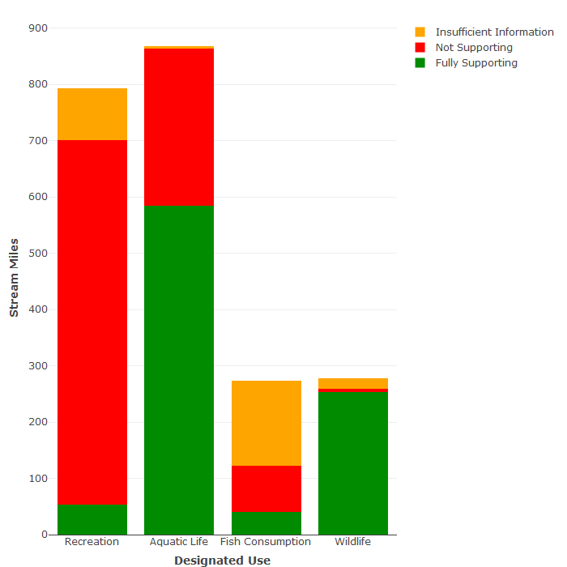

1. Lakes Assessment (520 acres were not assessed)

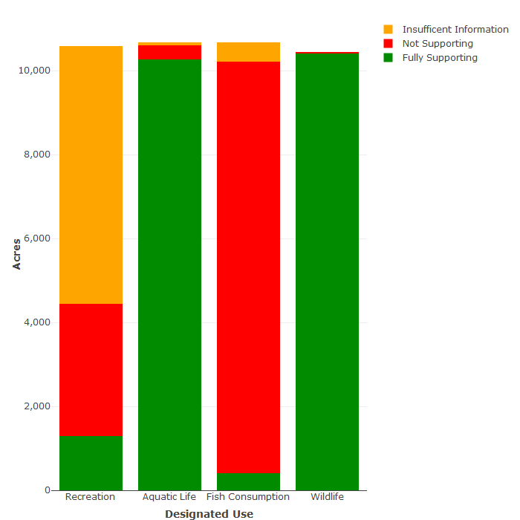

1. Estuaries assessment

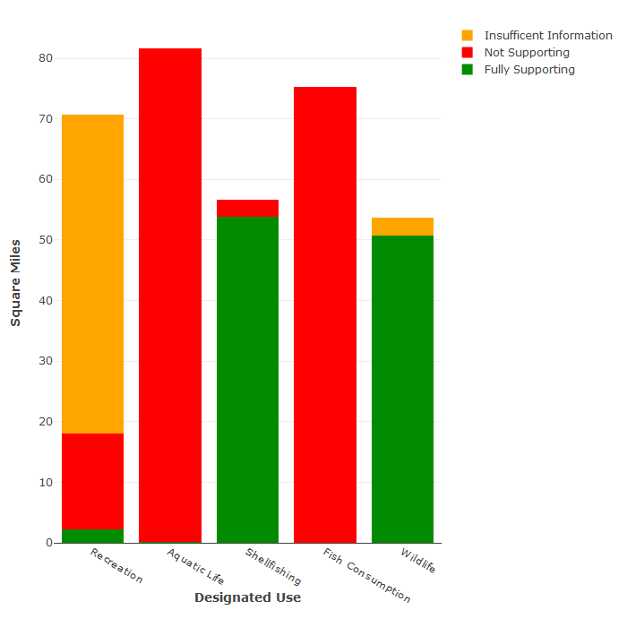

1. Assessment of Chesapeake Bay-specific designated uses

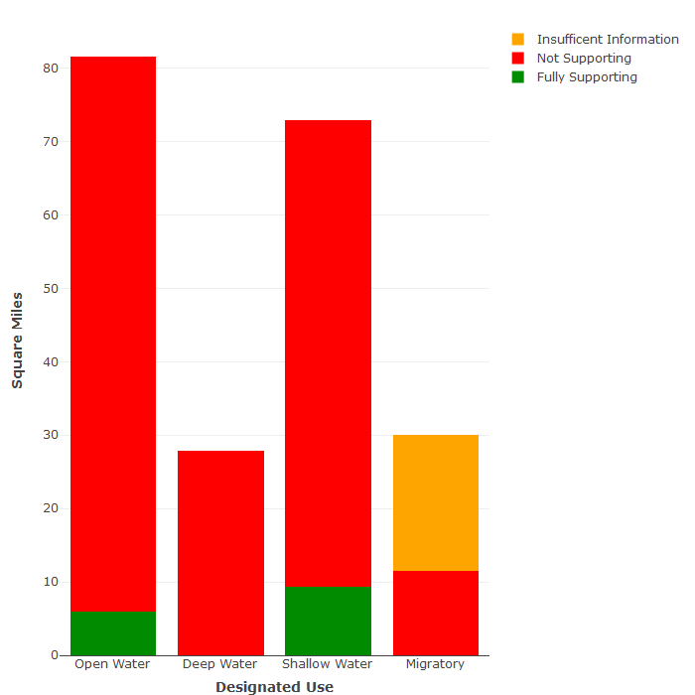

| ***Rivers*** | | ***Lakes*** | | ***Estuaries*** | |
| --- | --- | --- | --- | --- | --- |
| **Bacteria** | 87% | **PCBs in Fish Tissue** | 95% | **Dissolved Oxygen** | 100% |
| **Impaired Benthics** | 16% | **Harmful Algal Blooms** | 31% | **PCBs in Fish Tissue** | 92% |
| **pH** | 15% | **Mercury in Fish Tissue** | 18% | **Impaired Aquatic Plants** | 78% |
| **Dissolved Oxygen** | 8% | **PCBs in Water Column** | 12% | **Impaired Benthics** | 73% |
| **PCBs in Fish Tissue** | 8% | **Dissolved Oxygen** | 2% | **Bacteria** | 22% |
| **Mercury in Fish Tissue** | 6% | **pH** | 2% | **Mercury in Fish Tissue** | 21% |

Table 4.3-16 Significant causes of designated use impairment in the York River basin, by waterbody type, ranked by percentage of impaired water size. (Note: Waters can have multiple pollutants.)

| ***Rivers*** | | ***Lakes*** | | ***Estuaries*** | |
| --- | --- | --- | --- | --- | --- |
| **Grazing in Riparian or Shoreline Zones** | 50% | **Source Unknown** | 99% | **Industrial or Municipal Point Source Discharges** | 100% |
| **Sewage Discharges in Unsewered Areas** | 50% | **Natural Conditions** | 1% | **Sources Outside State Borders** | 100% |
| **Waterfowl** | 50% | **Inactive Abandoned Mine Lands** | <1% | **Agriculture** | 100% |
| **Wildlife other than Waterfowl** | 50% | **--** | -- | **Atmospheric Deposition (Nitrogen)** | 100% |
| **Livestock Grazing or Feeding Operations** | 50% | **--** | -- | **Internal Nutrient Recycling** | 100% |
| **Runoff from Forest/**  **Grassland/**  **Parkland** | 50% | **--** | -- | **Loss of Riparian Habitat** | 100% |

Table 4.3-17 Suspected sources of designated use impairment in the York River basin, by water body type, ranked by percentage of impaired water size. (Note: Waters can have multiple sources of pollution.)

**New River Basin**

The New River basin is located in southwest Virginia and covers 3,068 square miles or approximately 7 percent of the commonwealth’s total land area. The New River flows from its headwaters in Watauga County, North Carolina in a northeasterly direction to Radford, Virginia, and then in a northwesterly direction to Glen Lyn, where it exits into West Virginia. There it flows to the confluence of the Gauley River forming the Kanawha River, a tributary to the Ohio River.

The New River basin in Virginia is defined by both hydrologic and political boundaries. It is bordered by the James River basin and Roanoke River basin to the east, and the Tennessee and Big Sandy River basin to the west. The southern boundary of the Virginia portion is the North Carolina state line and its northwest boundary is the West Virginia state line.

The New River basin runs 115 miles in length from Blowing Rock, North Carolina to Bluestone Dam near Hinton, West Virginia with a maximum basin width of 70 miles near Rural Retreat, Virginia. The Virginia portion of the New River basin is 87 miles in length.

The topography of the New River basin is generally rugged; the upper reaches of its tributaries are extremely steep. High mountains, narrow valleys and steep ravines characterize the basin. There are ten tributaries in the Upper New River basin each having more than 100 square miles in drainage area and many others with forty or more square miles.

The New River basin is the least densely populated of the commonwealth’s major river basins. The higher elevations of the basin have steep slopes and are thickly forested, while the mount bases are mostly used for agriculture. Approximately 59 percent of its land is forested. Cropland and pasture make up another 35 percent, with approximately 3 percent considered urban.

The 2010 population for the New River basin was approximately 412,900. All or portions of the following jurisdictions lie within the basin: Counties - Bland, Carroll, Craig, Floyd, Giles, Grayson, Montgomery, Pulaski, Smyth, Tazewell, Wythe; Cities - Galax and Radford.

The New River basin is divided into two USGS hydrologic units as follows: HUC 05050001 – Upper New; and HUC 05050002 – Middle New. The two hydrologic units are further divided into 38 waterbodies or watersheds and 90 6th order watersheds.

Basin assessment information is presented in the following figures and tables.

Figure 4.3-9 Designated use support summary for the New River basin. (Note: Waters that have some data, but not enough to determine use support, are classified as having “Insufficient information”)

**Size: All Sizes Rounded to Nearest Whole Number**

Rivers - 7,750 miles

Lakes - 4,661 acres

Estuaries - 0 sq. miles

1. Rivers Assessment (6,499 miles were not assessed)

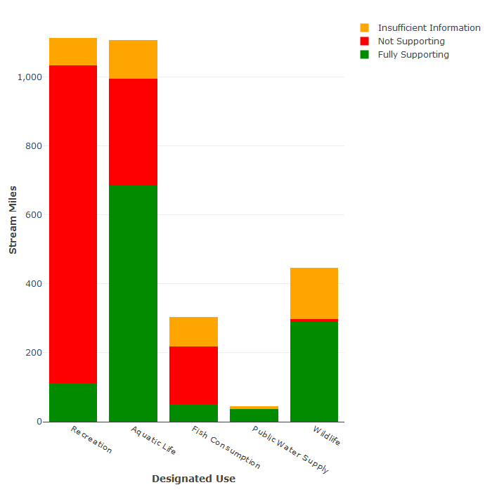

Note: 27 miles of the public water supply use were assessed as fully supporting

1. Lakes Assessment (34 acres were not assessed)

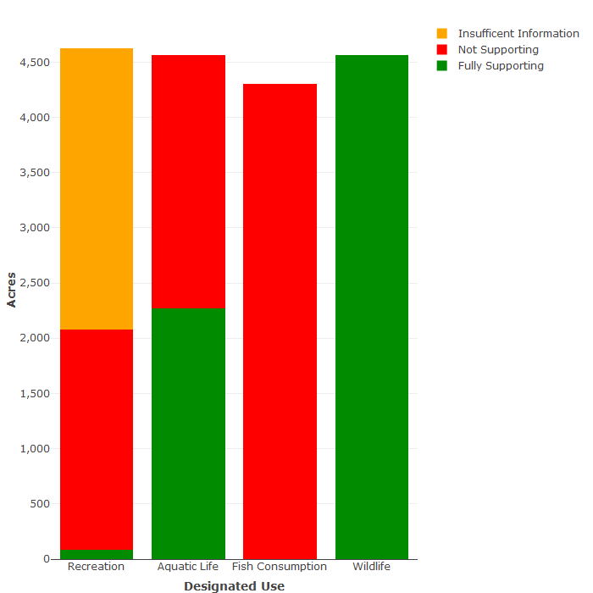

| ***Rivers*** | | ***Lakes*** | |
| --- | --- | --- | --- |
| **Bacteria** | 88% | **PCBs in Fish Tissue** | 99% |
| **Temperature** | 17% | **Dissolved Oxygen** | 53% |
| **Impaired Benthics** | 16% | **Bacteria** | 46% |
| **PCBs in Fish Tissue** | 11% | **--** | **--** |
| **Mercury in Fish Tissue** | 3% | **--** | -- |
| **PCBs in Water Column** | 2% | **--** | -- |

Table 4.3-17 Significant causes of designated use impairment in the New River basin, by waterbody type, ranked by percentage of impaired water size. (Note: Waters can have multiple pollutants.)

| ***Rivers*** | | ***Lakes*** | |
| --- | --- | --- | --- |
| **Livestock Grazing or Feeding Operations** | 55% | **Atmospheric Deposition** | 99% |
| **On-site Septic Treatment Systems** | 32% | **Contaminated Sediments** | 99% |
| **Unrestricted Cattle Access** | 31% | **Industrial Point Source Discharges** | 99% |
| **Unspecified Domestic Waste** | 31% | **Natural Sources** | 53% |
| **Source Unknown** | 30% | **Source Unknown** | 44% |
| **Wildlife other than Waterfowl** | 28% | **Livestock Grazing or Feeding Operations** | 1% |

Table 4.3-18 Suspected sources of designated use impairment in the New River basin, by water body type, ranked by percentage of impaired water size. (Note: Waters can have multiple sources of pollution.)

1. Chesapeake Bay Program, 2017. Chesapeake Assessment and Scenario Tool (CAST) Version 2017d. Chesapeake Bay Program Office, Last accessed [11/2018]