## CHAPTER 4.2. WATER QUALITY ASSESSMENT SUMMARY

The overall water quality for Virginia is determined based on whether the condition of the waterbody being assessed allows citizens to safely enjoy its designated uses as described in Virginia’s water quality standards. Table 4.2-1 briefly describes the primary designated uses and the parameters used in this assessment to demonstrate their attainment. Several additional aquatic life sub-uses have been adopted for the Chesapeake Bay and the tidal tributaries. Additional information about the Bay sub-uses can be found in Chapter 4.6.

| **DESIGNATED USE** | **USE DESCRIPTION/INDICATORS** |
| --- | --- |
| **Aquatic Life Use,**  **Chesapeake Bay sub-uses** | Description: The propagation, growth, and protection of a balanced indigenous population of aquatic life that may be expected to inhabit a waterbody |
| Indicators: Dissolved oxygen, pH, temperature, chlorophyll a*, nutrients*, water column and sediment toxics, toxicity tests, benthics, submerged aquatic vegetation |
| **Fish Consumption Use** | Description: Game and marketable fish species that are safe for human health |
| Indicators: VDH notices, fish tissue toxics, water column toxics |
| **Shellfishing Use** | Description: Marketable shellfish (clams, oysters, mussels) that are safe for human health |
| Indicators: VDH notices |
| **Recreation (Swimming) Use** | Description: Swimming, boating, and other recreational activities |
| Indicators: VDH notices for bacteria and harmful algal blooms, bacteria |
| **Public Water Supply Use** | Description: Drinking water safe for human health |
| Indicators: VDH notices, water column toxics |
| **Wildlife Use** | Description: The propagation, growth, and protection of associated wildlife |
| Indicators: Water column toxics |

Table 4.2-1 Designated use descriptions and indicators

The six-year assessment begins with an analysis of all quality assurance/quality control (QA/QC) approved data from DEQ ambient water quality, biological, sediment and fish tissue monitoring, special studies and/or other non-DEQ water quality data, including citizen monitoring data. Non-agency monitoring data is evaluated for use in the assessment using a process outlined in Part VI of the 2022 Assessment Guidance Manual. The results of these comprehensive data analyses are compared to both numeric and narrative criteria related to the designated uses established by Virginia’s water quality standards, which are provisions of state and/or federal regulations. A description of the assessment methodology can be found in Chapter 4.1, as well as the 2022 Assessment Guidance Manual.

Statewide summaries of the river miles, estuarine square miles, and lake/reservoir acres within and bordering Virginia are presented in Tables 4.2-2 through 4.2-5. The overall assessment of each waterbody was determined by examining the support of up to six designated uses (see Figure 4.2-1), as appropriate, for each assessed waterbody. The assessment of a specific use depends on the types of data that are available. Additionally, not all uses may exist in a given water. For instance, the public water supply use only applies to the waters designated in Virginia’s water quality standards. The shellfishing use only exists in estuarine waters.

Additional geographical re-indexing and use of the National Hydrologic Database (NHD) has altered the actual number of stream miles within the state from previous reports. The stream mile delineation guidance has provided basic guidelines to the regional assessment staff for associating the mileage assessed, relative to a specific sampling station. This is especially important where there are no easily identifiable changes in watershed characteristics. In some cases, the stream miles associated with a sampling station have been conservatively reduced or in other cases, slightly expanded from previous assessment reports. In many cases, additional monitoring stations have been added in the watershed and may increase the size of some impaired segments depending on the additional data collected and assessed. The stream mile delineations found in this report are only reflective of the 2022 assessment period but follow closely with the monitoring efforts reported in previous reports.

A total of 100,983 miles of rivers, 2,843 square miles of estuarine waters, and 117,753 acres of reservoir/lakes was determined to be available for assessment this cycle. Approximately 65% of Virginia’s rivers are headwater systems, and are not monitored by the DEQ ambient monitoring network. These waters are routinely monitored via the Freshwater Probabilistic Monitoring program (Chapter 4.4) and are also included in watershed cleanup plans.

|  | **Rivers (mi)** | **Lakes (acres)** | **Estuaries (sq mi)** |
| --- | --- | --- | --- |
| **Non-Impaired (% total)** | 3,577 (4%) | 12,303 (10%) | 312 (11%) |
| **Impaired (% total)** | 16,205 (16%) | 101,172 (86%) | 2,138 (75%) |
| **Not Assessed (% total)** | 81,201 (80%)[1] | 4,308 (4%) | 393 (14%) |
| **TOTAL** | 100,983 | 117,783 | 2,843[2] |

| ***IR Assessment Results - comparison*** | | | | | | |
| --- | --- | --- | --- | --- | --- | --- |
|  | ***Rivers (mi)*** | | ***Lakes (acres)*** | | ***Estuaries (sq mi)*** | |
| ***Assessment Cycle*** | **2020** | **2022** | **2020** | **2022** | **2020** | **2022** |
| ***% Non-Impaired*** | 6% | 4% | 16% | 10% | 11% | 11% |
| ***% Impaired*** | 16% | 16% | 80% | 86% | 75% | 75% |

Table 4.2-2: Summary of overall assessment results for Virginia’s rivers, lakes and estuaries as reported in the 2022 IR, and comparison of the 2020 and 2022 IR assessment results.

| **Degree of Use Support** | **Water Type** | **Total Miles *(Rounded to the Nearest Whole Number)*** | **(%)**  **Total** |
| --- | --- | --- | --- |
| Fully Support All Designated Uses **(EPA Category 1)** | River (mi.) | **1** | 0.0% |
| *Virginia Subcategory 1A* |  | 0 |  |
| Fully Support Some Uses but Insufficient Data to Assess All Uses **(EPA Category 2)** | River (mi.) | **3,576** | 3.5% |
| *Virginia Subcategory 2A* |  | 3,024 |  |
| *Virginia Subcategory 2B* | 469 |
| *Virginia Subcategory 2C* | 83 |
| Insufficient Data to Determine if any Uses are Being Met **(EPA Category 3)** | River (mi.) | **81,201[3]** | 80.4% |
| *Virginia Subcategory 3A* |  | 80,460 |  |
| *Virginia Subcategory 3B* | 296 |
| *Virginia Subcategory 3C* | 244 |
| *Virginia Subcategory 3D* | 200 |
| Waters are Impaired or Threatened but do not need a TMDL **(EPA Category 4)** | River (mi.) | **7,778** | 7.7% |
| *EPA Subcategory 4A* |  | 7,710 |  |
| *EPA Subcategory 4B* | 0 |
| *EPA Subcategory 4C* | 69 |
| Waters are Impaired or Threatened and need a TMDL **(EPA Category 5)** | River (mi.) | **8,427** | 8.3% |
| *Virginia Subcategory 5A* |  | 4,978 |  |
| *Virginia Subcategory 5B* | 0 |
| *Virginia Subcategory 5C* | 340 |
| *Virginia Subcategory 5D* | 3,013 |
| *Virginia Subcategory 5E* | 0 |
| *Virginia Subcategory 5F* | 72 |
| *Virginia Subcategory 5R* | 23 |
| **Total Size** | River (mi.) | **100,983** | 100% |

Table 4.2-3 Assessment Results for Rivers

| **Degree of Use Support** | **Water Type** | **Total Acres *(Rounded to the Nearest Whole Number)*** | **(%)**  **Total** |
| --- | --- | --- | --- |
| Fully Support All Designated Uses **(EPA Category 1)** | Lakes (acres) | **0** | 0.0% |
| *Virginia Subcategory 1A* |  | 0 |  |
| Fully Support Some Uses but Insufficient Data to Assess All Uses **(EPA Category 2)** | Lakes (acres) | **12,303** | 10.4% |
| *Virginia Subcategory 2A* |  | 4,813 |  |
| *Virginia Subcategory 2B* | 7,490 |
| *Virginia Subcategory 2C* | 0 |
| Insufficient Data to Determine if any Uses are Being Met **(EPA Category 3)** | Lakes (acres) | **4,308** | 3.7% |
| *Virginia Subcategory 3A* |  | 2,407 |  |
| *Virginia Subcategory 3B* | 348 |
| *Virginia Subcategory 3C* | 199 |
| *Virginia Subcategory 3D* | 1,354 |
| Waters are Impaired or Threatened but do not need a TMDL **(EPA Category 4)** | Lakes (acres) | **15,804** | 13.4% |
| *EPA Subcategory 4A* |  | 15,757 |  |
| *EPA Subcategory 4B* | 0 |
| *EPA Subcategory 4C* | 46 |
| Waters are Impaired or Threatened and need a TMDL **(EPA Category 5)** | Lakes (acres) | **85,368** | 72.5% |
| *Virginia Subcategory 5A* |  | 75,459 |  |
| *Virginia Subcategory 5B* | 0 |
| *Virginia Subcategory 5C* | 801 |
| *Virginia Subcategory 5D* | 9,108 |
| *Virginia Subcategory 5E* | 0 |
| *Virginia Subcategory 5F* | 0 |
| *Virginia Subcategory 5R* | 0 |
| **Total Size** | Lakes (acres) | **117,783** | 100% |

Table 4.2-4 Assessment Results for Lakes/Reservoirs

| **Degree of Use Support** | **Water Type** | **Total Square Miles *(Rounded to the Nearest Whole Number)*** | **(%)**  **Total** |
| --- | --- | --- | --- |
| Fully Support All Designated Uses **(EPA Category 1)** | Estuary (sq. mi.) | 0 | 0% |
| *Virginia Subcategory 1A* |  | 0 |  |
| Fully Support Some Uses but Insufficient Data to Assess All Uses **(EPA Category 2)** | Estuary (sq. mi.) | **312** | 11% |
| *Virginia Subcategory 2A* |  | 227 |  |
| *Virginia Subcategory 2B* | 82 |
| *Virginia Subcategory 2C* | 3 |
| Insufficient Data to Determine if any Uses are Being Met **(EPA Category 3)** | Estuary (sq. mi.) | **393** | 14% |
| *Virginia Subcategory 3A* |  | 393 |  |
| *Virginia Subcategory 3B* | 0 |
| *Virginia Subcategory 3C* | 0 |
| *Virginia Subcategory 3D* | 0 |
| Waters are Impaired or Threatened but do not need a TMDL **(EPA Category 4)** | Estuary (sq. mi.) | **78** | 3% |
| *EPA Subcategory 4A* |  | 78 |  |
| *EPA Subcategory 4B* | 0 |
| *EPA Subcategory 4C* | 0 |
| Waters are Impaired or Threatened and need a TMDL **(EPA Category 5)** | Estuary (sq. mi.) | **2,060** | 72% |
| *Virginia Subcategory 5A* |  | 4 |  |
| *Virginia Subcategory 5B* | 0 |
| *Virginia Subcategory 5C* | 0 |
| *Virginia Subcategory 5D* | 2,050 |
| *Virginia Subcategory 5E* | 0 |
| *Virginia Subcategory 5F* | 7 |
| *Virginia Subcategory 5R* | 0 |
| **Total Size** | Estuary (sq. mi.) | **2,843[4]** | 100% |

Table 4.2-5 Assessment Results for Estuarine Waters

Figure 4.2-1 Designated use support summary. (Note: Waters that have some data, but not enough to determine use support, are classified as having “Insufficient information”)

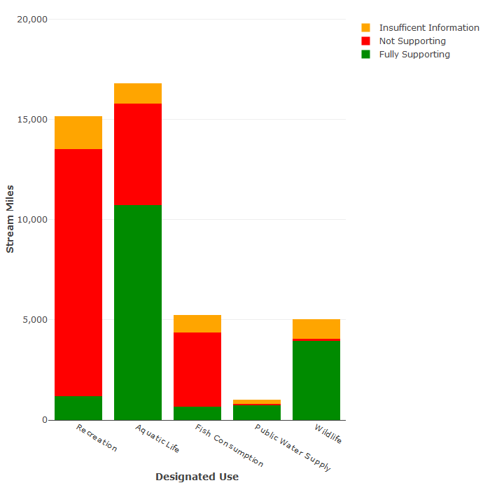

1. Rivers Assessment for 100,983 total river miles

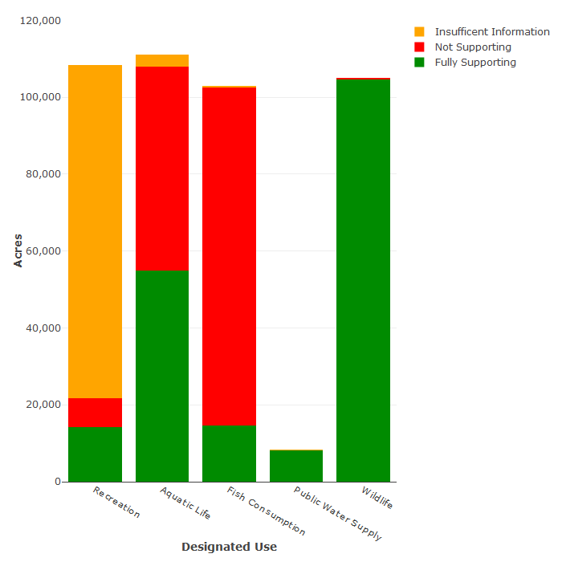

1. Lakes Assessment for 117,783 total lake acres[5]

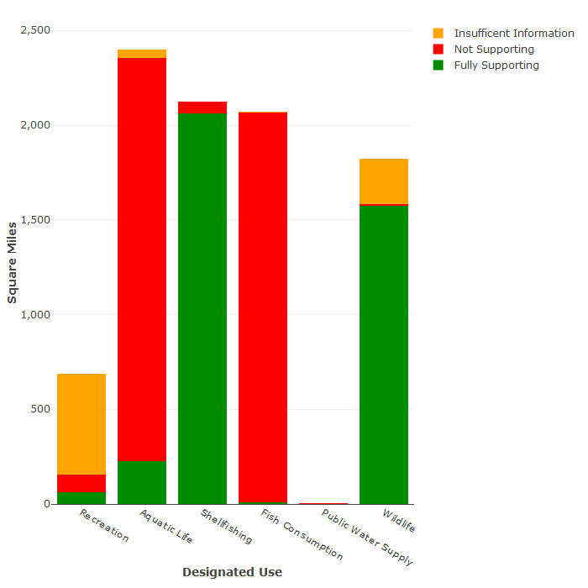

1. Estuaries assessment for 2,843 total estuarine square miles[6]

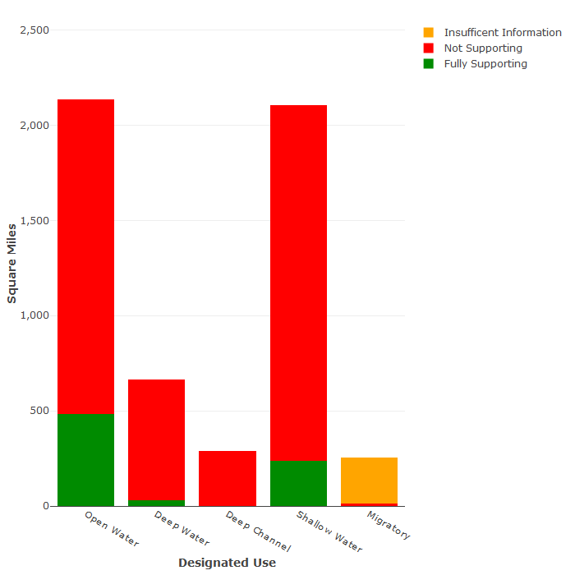

1. Assessment of Chesapeake Bay-specific designated uses

**Results**

Figures 4.2-2 and 4.2-3 lists the major causes of impairment for those waters not attaining full support for at least one designated use. Table 4.2-5 lists potential sources that correlate to these impairments. Impairment causes and/or sources can be a “major impact”, defined as that which causes a significant impairment to the waterbody, or moderate and minor impacts individually or in combination. Normally a major impact would be from a sole source with a large pollutant(s) contribution. Moderate and/or minor impacts have a slight to moderate effect on the waters and may be from a single moderate contributor or a combination of several minor contributors. It is important to note that moderate and minor impacts can, under certain conditions, work in conjunction to cause a major impact. Assessors take into consideration such factors as land use and co-occurring impairments when determining likely sources of pollution for a particular waterbody.

The major cause of impairment of the recreation and shellfishing uses is excessive bacteria. *Escherichia coli* (*E. coli*) is the pathogenic indicator used in freshwater, while enterococci is used in estuarine/coastal waters. These bacteria are associated with the fecal matter of warm-blooded animals. Bacteria and other microorganisms are found naturally in water, but can become harmful to human health in high concentrations. Exposure to water-borne pathogens can cause various gastrointestinal, skin, neurological, and other serious diseases. Stormwater runoff often carries domestic and livestock animal wastes, and it is a major source of impairment. Inadequate sewage treatment, combined sewer and separate sanitary sewer overflows, and straight-pipes are other major sources of bacteria contamination. Many rivers are covered by watershed plans to address bacteria impairments across the state.

Mercury and polychlorinated biphenyls (PCBs) are the major causes of impairment of the fish consumption and public water supply uses. Mercury, specifically in the form of methylmercury, causes damage to the human central nervous system and brain. The metal can be found naturally, but its appearance in the environment is often due to anthropogenic reasons. Mercury commonly enters water through atmospheric deposition. Air particles can travel vast distances, so locating a single source is not possible in most cases. Some anthropogenic sources of atmospheric mercury are coal combustion, waste incineration, and metal processing. PCBs are another common cause of impairment. While the toxicity of individual PCBs depends on the specific form (or congener), this class of organic compounds contains endocrine disruptors, neurotoxins, and carcinogens. Like methylmercury, PCBs accumulate in fish tissues. The production of PCBs, used mainly as coolants and insulating fluids, was banned in the US in the late 1970s. However, PCBs are still ubiquitous, frequently appearing as “legacy contaminants” in soils close to where dischargers once used PCBs in industrial processes. These soils can then enter nearby water sources through stormwater runoff.

One major cause of impairment of the aquatic life use is low dissolved oxygen concentration. Sixty percent of lake acres assessed for dissolved oxygen showed impairment this cycle, including portions of Kerr Reservoir, Lake Chesdin and Leesville Lake. This increase in impairments is in part due to several previously impaired or borderline-impaired lakes crossing the impairment threshold this cycle. All aquatic life depends on oxygen, and when it is depleted to the point where aquatic life is no longer sustainable, a waterbody is said to be hypoxic. Hypoxia can result from natural processes, such as in slow-moving swamp waters that have large amounts of decaying plant material. It can also naturally occur in lakes/reservoirs when the water column becomes thermally stratified. However, chronic hypoxia often occurs for anthropogenic (human-caused) reasons. Nutrient pollution can cause hypoxia by promoting the growth of algae blooms. Excessive algae produce floating mats on the water surface which keep light from reaching rooted vegetation, therefore limiting its growth. Moreover, as algae die and settle to the bottom, decay processes reduce oxygen levels and create unfavorable conditions for other aquatic organisms. Fish kills often result from hypoxic conditions. Stormwater runoff, which often carries lawn/agricultural fertilizers and nutrient-rich animal wastes, is a major contributor of nitrogen and phosphorus pollution.

As evident in the figures below, the commonwealth has made substantial progress by completing TMDL plans for many impairments, including bacteria, benthics, and dissolved oxygen, whereas other impairments, such as toxics in fish tissue, still require TMDLs. The Chesapeake Bay TMDL addresses many of the estuarine aquatic life impairments, including dissolved oxygen and submerged aquatic vegetation or SAV. DEQ currently has TMDL projects underway to address toxics in fish tissue in the tidal and non-tidal James River basin, Mountain Run of the Rappahannock River basin, and has initiated a TMDL study with West Virginia for the Bluestone River of the New River basin. The studies in the James and Rappahannock basins are scheduled to be completed by 2024 and the multistate Bluestone River study should be completed in 2025. Chapter 7.2 provides more information on the prioritization process for TMDL development through 2022.

Figure 4.2-2. Summary of impaired waters as reported in the 2022 and 2020 Integrated Reports. Differences between reporting periods reflect both delistings and new impairment listings. Blue shading indicates the size of the waterbody that does not require a TMDL because one has been developed, other pollution controls are in place or the condition in considered natural (category 4). Red shading indicates that a TMDL is required (category 5).

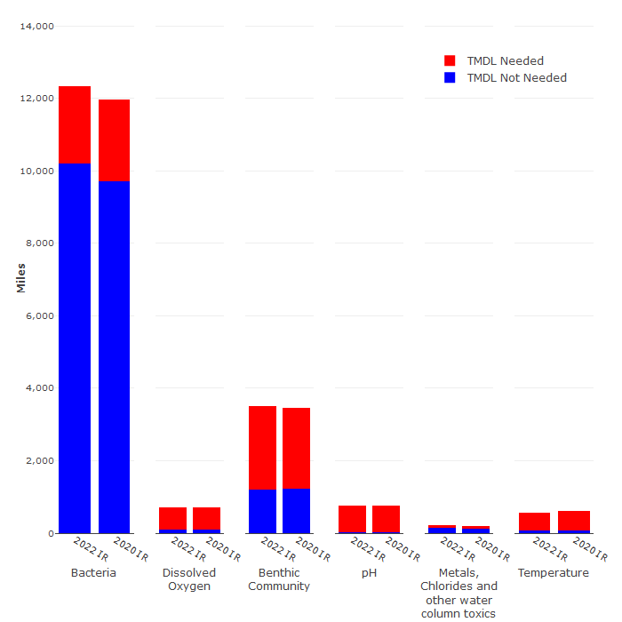

1. Summary of impaired river miles

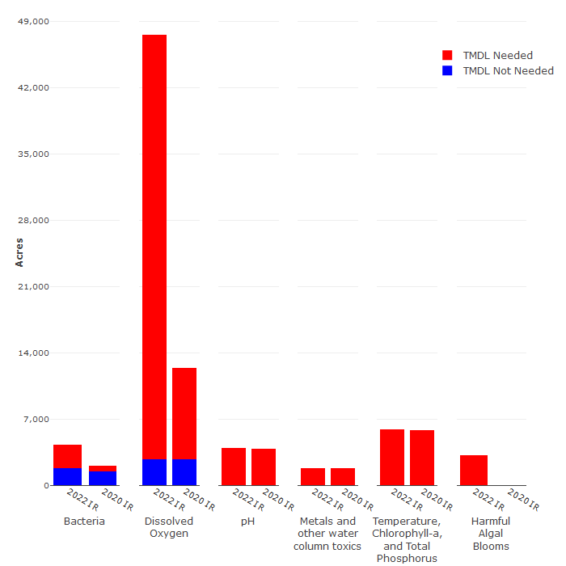

1. Summary of impaired lake acres [7]

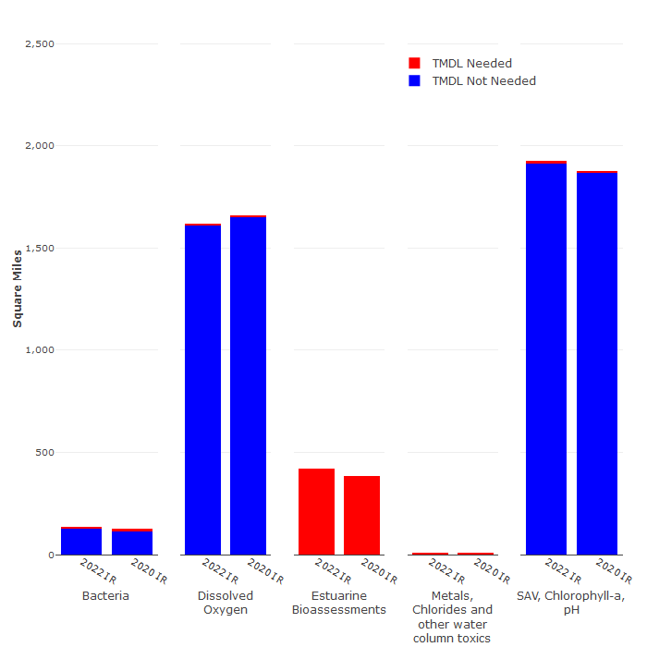

1. Summary of impaired estuarine square miles[8]

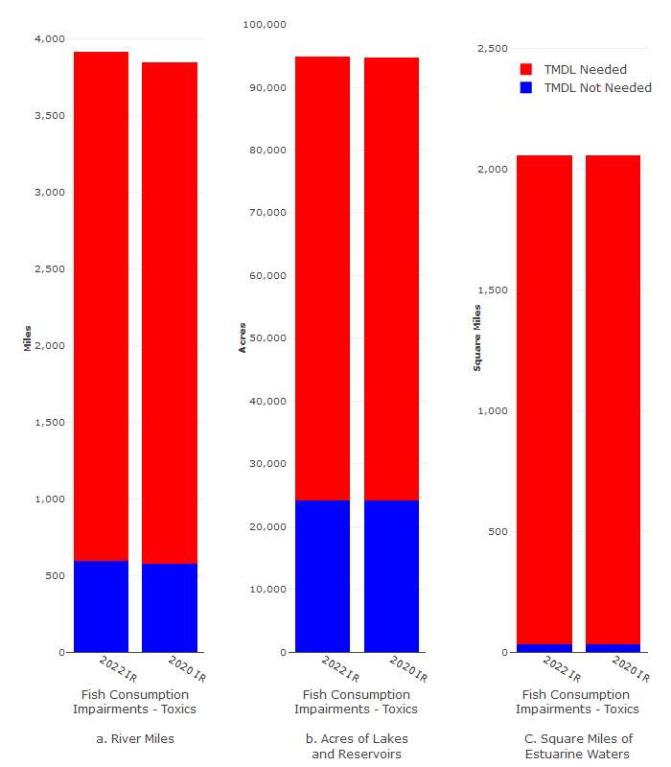

Figure 4.2-3. Summary of waters with fish consumption impairments as reported in the 2022 and 2020 Integrated Reports. The overwhelming majority of toxics impairments in rivers, lakes and estuaries are due to exceedances of thresholds for PCBs and Mercury in fish tissue. TMDL: Total Maximum Daily Load; see text for further discussion.

| Leading Causes of Impairment in Virginia Waters | | | |
| --- | --- | --- | --- |
|  | River (mi) | Lakes (acres) | Estuaries (sq mi) |
| Total Impaired | 16,205 | 101,172 | 2,138 |
| Bacteria | 12,346 | 4,304 | 140 |
| Toxics in Fish Tissue | 3,702 | 87,849 | 2,058 |
| Dissolved Oxygen | 704 | 47,590 | 1,612 |

Table 4.2-6 Leading causes of impairments by water body type.

| Rivers | | Lakes | | Estuaries | |
| --- | --- | --- | --- | --- | --- |
| Wildlife other than Waterfowl | 41% | Source Unknown | 78% | Agriculture | 97% |
| Source Unknown | 37% | Industrial Point Source Discharges | 24% | Source Unknown | 96% |
| On-site Septic Systems | 36% | Atmospheric Deposition | 24% | Industrial Point Source Discharges | 92% |
| Livestock Grazing or Feeding Operations | 35% | Contaminated Sediments | 24% | Sources Outside State Borders | 89% |
| Agriculture | 31% | Atmospheric Deposition (Toxics) | 5% | Atmospheric Deposition (Nitrogen) | 89% |
| Non-Point Sources | 30% | Natural Conditions | 5% | Internal Nutrient Recycling | 89% |

Table 4.2-7 Suspected sources of designated use impairment, by water body type, ranked by percentage of impaired water size. (Note: Waters can have multiple sources of pollution.)

1. ~65% of Virginia’s rivers are headwaters systems not monitored by DEQ’s ambient network. These waters are routinely monitored via Probabilistic Monitoring.
2. Updates to Virginia's portion of the National Watershed Boundary Dataset (NWBD) with the release of Version 5 in summer 2016, resulted in the removal of 6 square miles of ocean water.
3. Conversion to the high resolution (1:24,000) National Hydrography Dataset (NHD) resulted in a significant increase in stream mileage, and, consequently, a higher percentage of waters considered “not assessed” due to the inclusion of previously unmapped waterways—mostly small unnamed tributaries. DEQ’s freshwater probabilistic monitoring program, described in chapter 4.4, includes coverage of small unnamed tributaries as part of the randomly generated station locations. ProbMon data is used to answer questions about statewide and regional water quality conditions, and to identify problem areas for follow-up monitoring.
4. Updates to Virginia's portion of the National Watershed Boundary Dataset (NWBD) with the release of Version 5 in summer 2016, resulted in the removal of 6 square miles of ocean water.
5. The 2022 IR is first cycle in which waterbodies can be listed as impaired as a result of Virginia Department of Health recreational advisories based on the presence of Harmful Algal Blooms (HABs). Also note that the 2022 IR reflects changes in the recreation designated use assessments, as the Commonwealth began implementing the revised bacteria criteria. DEQ has updated the monitoring strategy to implement the new criteria, and, as a result, many lakes and estuarine segments moved to “unassessed” this cycle.
6. The 2022 IR reflects changes in the recreation designated use assessments, as the Commonwealth began implementing the revised bacteria criteria. DEQ has updated the monitoring strategy to implement the new criteria, and, as a result, many lakes and estuarine segments moved to “unassessed” this cycle.
7. Dissolved oxygen impairments increased this cycle. This increase in impairments is in part due to several previously impaired or borderline-impaired lakes— including portions of Kerr Reservoir, Lake Chesdin and Leesville Lake—crossing the impairment threshold this cycle. Additionally, the 2022 IR is first cycle in which waterbodies can be listed as impaired as a result of Virginia Department of Health recreational advisories based on the presence of Harmful Algal Blooms (HABs).
8. 6 Metals, chlorides and other water column toxics impair less than 10 square miles of Virginia’s estuarine waters.