

2022 Annual Report

Virginia Ambient Air Monitoring

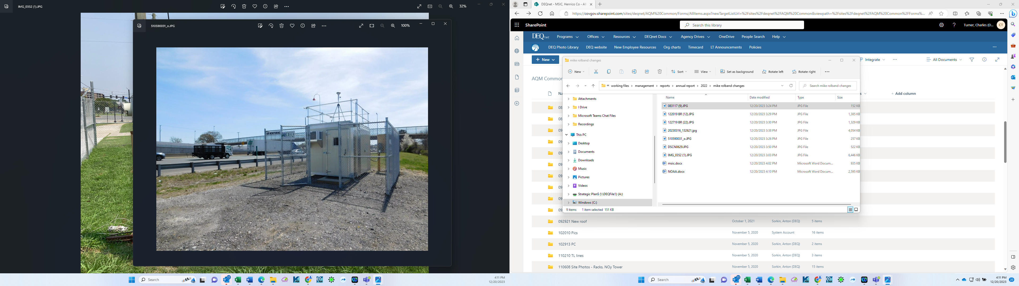
Northern Regional Office Springfield Near Road Site

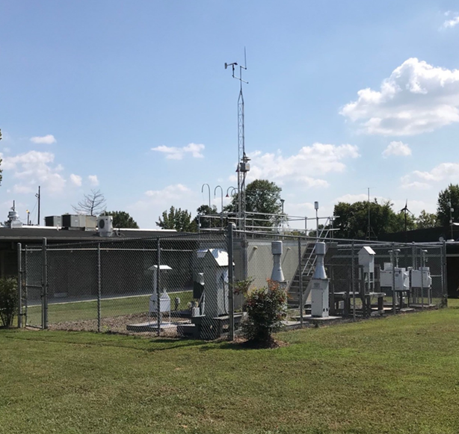
Piedmont Regional Office MathScience Center Site

Commonwealth of Virginia
Department of Environmental Quality

Office of Air Quality Monitoring
4949-C Cox Road
Glen Allen, VA 23060

This Ambient Air Monitoring Data Report includes data gathered during the time period from
Jan. 1, 2022, to Dec. 31, 2022.

Special Thanks to:

Michael Rolband, Director
Virginia Department of Environmental Quality

and to

Michael Dowd
Director, Division of Air Quality

For their support of the publication of this document.

Acknowledgements:

The DEQ Office of Air Quality Monitoring Team would also like to thank Dan Salkovitz, Julie Raimondi and the DEQ Communications Office for their assistance in the development of this document.

Published, December 2023

2022 Annual Report prepared by:
DEQ-AQM Data Team
TABLE OF CONTENTS

GENERAL INFORMATION:
Introduction 2
Virginia’s Office of Air Quality Monitoring 3
Frequently Asked Questions 4

CRITERIA POLLUTANTS:
PM_{2.5} (Particulate Matter equal to or less than 2.5 microns)
Description 8

PM₁₀ (Particulate Matter equal to or less than 10 microns)
Description 14

CO (Carbon Monoxide)
Description 17
Graphs 19
SO₂ (Sulfur Dioxide)
Description 22
Graphs 25
NO₂ (Nitrogen Dioxide)
Description 28
Graphs 31
OZONE
Description 34
Eight-Hour Graphs 40

LEAD
Description 43

ACID RAIN:
Acid Precipitation Monitors 46
VOLATILE ORGANIC COMPOUNDS (VOCs):
Air Toxics Monitoring Network 47
AQI (Air Quality Index) 59
APPENDIX A:
Abbreviation Table 70
Regional Site List and Monitoring Network 71
Data Capture Criteria 77
National Ambient Air Quality Standards 78
Number of Criteria Pollutant Monitoring Sites 79

APPENDIX B:
Air Quality Internet Links 81
References 82

INTRODUCTION

The 2022 Virginia Ambient Air Monitoring Data Report is a compilation of air pollutant measurements made by the Virginia Department of Environmental Quality (DEQ), the U.S. Department of Agriculture - Forest Service, the National Park Service, and the Environmental Protection Agency (EPA). Ambient air quality was measured at 36 locations within Virginia during 2022. Included in this total are: (1) one sulfur dioxide monitor that is maintained by an industrial company located in Giles County as required by EPA’s Data Requirements Rule, (2) two CASTNet sites operated by EPA, and (3) one nitrogen dioxide site operated in Pittsylvania County by Williams Transco. All monitoring sites were established in accordance with EPA’s siting criteria contained in 40 CFR Part 58, Appendices D and E. Monitoring network operations conformed to EPA guidance documents and accepted air quality monitoring practices. All data reported for these monitoring sites were quality assured in accordance with requirements contained in 40 CFR Part 58, Appendix A.

Generally, calendar year 2022 was a good year in Virginia from the perspective of air quality. In 2022, ambient concentrations of carbon monoxide, nitrogen dioxide, and PM10 were within the EPA’s national ambient air quality standards (NAAQS). For sulfur dioxide the industrial monitor in Giles County reported a 2022 design value that exceeded NAAQS, all other sulfur dioxide sites demonstrated compliance with the NAAQS. Virginia experienced a good 2022 ozone season. There was one ozone exceedance day in Northern Virginia, one ozone exceedance day in the Richmond area, and one exceedance day in the Hampton Roads area. For the three-year period from 2020 through 2022, all ozone sites demonstrated compliance with the 0.070 ppm NAAQS for ozone. For 2022, there was one exceedance day in Northern Virginia where an exceedance of the 35 micrograms per cubic meter (µg/m3) 24-hour standard for PM2.5 was recorded. The 2020–2022 design values for all sites in Virginia for both the 24-hour and annual standards for PM2.5 are below the NAAQS standard.

Some significant changes that impacted the air quality monitoring network in 2022 are:

- A new continuous PM2.5 FEM analyzer was installed at the Tidewater Office Site (AQS No. 51-810-0008) and the Charles City County site (AQS No. 51-036-0002).

- The Automated Gas Chromatograph at the DEQ Photochemical Assessment Monitoring Site (PAMS) was activated June 1, 2022, and operated throughout the three-month PAMS season with a data capture rate of 73%.

- Williams Transco shut down the source specific nitrogen dioxide monitoring site on Dec. 31, 2022.

OFFICE OF AIR QUALITY MONITORING

The Office of Air Quality Monitoring (AQM) is responsible for seeing that the Virginia ambient air monitoring network is maintained and operated in accordance with state and federal guidelines. Staff from DEQ regional offices, the City of Alexandria, and the National Park Service conduct the daily operations at these sites. AQM supports these operations by:

- calibrating air monitoring instrumentation and associated support equipment on a set schedule
- auditing instrumentation to ensure that it is operating within standards
- troubleshooting instrumentation problems reported by the regional operators
- supplying field operators with necessary items so they can perform their job properly
- repairing malfunctioning sampling instrumentation and ancillary equipment

AQM’s other functions include:

- responding to regional and locality requests for special sampling such as emergency response or to answer citizen complaints
- coordinate efforts with the regional offices and localities to determine new air monitoring site locations
- conduct AQM-generated special sampling projects to characterize a community's air quality
- furnish ambient air data to the regional offices, localities, Central Office, EPA, and the EPA database AQS
- answer Freedom of Information Act requests for ambient air monitoring data
- work with regions and localities to meet area monitoring needs, work with EPA to meet necessary state and federal monitoring needs support SESARM (Southeastern States Air Resource Managers, Inc.) and MARAMA (Mid-Atlantic Regional Air Management Association of the Southeast) on routine and special projects

Criteria Pollutant Monitoring:

A portion of the air monitoring network is made up of instruments that sample for criteria air pollutants. Sulfur dioxide, nitrogen dioxide, carbon monoxide, ozone, lead and particulate matter (PM10 & PM2.5) can injure health, harm the environment, and cause property damage.Criteria air pollutants are regulated by EPA using health-based criteria (science-based guidelines) as the basis for setting permissible limits. One set of limits (primary standard) protects health; another set of limits (secondary standard) is intended to prevent environmental and property damage.

Special Monitoring:

In addition to overseeing the air sampling network for criteria air pollutants, AQM conducts routine and short-term sampling for VOCs (volatile organic compounds), carbonyls, toxic metals, and NOy (total reactive nitrogen). Sampled VOCs are made up of 58 HAPs (Hazardous Air Pollutants) and 56 Hydrocarbon Ozone Precursors.

FREQUENTLY ASKED QUESTIONS

1. What is the Clean Air Act?

The Clean Air Act is a federal law that provides for the protection of human health and the environment. The original Clean Air Act was passed in 1963, and the 1970 version of the law resulted in the creation of EPA, which was charged with setting and enforcing ambient air quality standards. The law was amended in 1977, and most recently in 1990. Most of the activities of DEQ’s Air Division come from mandates of the Clean Air Act and are overseen by EPA.

2. What is a criteria air pollutant?

The Clean Air Act names six air pollutants that are commonly found in the air throughout the United States. They can injure humans by causing respiratory and cardiovascular problems, and harm the environment by impairing visibility and causing damage to animals, crops, vegetation, and buildings. EPA has developed health-based criteria for these pollutants through scientific studies and has established regulations setting permissible levels of these pollutants in the air. The criteria pollutants are: carbon monoxide, sulfur dioxide, nitrogen dioxide, ozone, particulate matter, and lead. The limits that have been set for them are the National Ambient Air Quality Standards (NAAQS). The Clean Air Act mandates that EPA review the NAAQS every five years.

3. What is the difference between a primary and secondary National Ambient Air Quality Standard?

The National Ambient Air Quality Standards are divided into two types. The first type, the primary standard, is designed to protect human health, especially those who are most vulnerable such as children and the elderly, and people suffering from asthma, emphysema, chronic bronchitis, and heart ailments. The second type, the secondary standard, is designed to prevent damage to property and the environment. For a list of the primary and secondary National Ambient Air Quality Standards, see NAAQS table or page 78 of this report.

4. How is the location of an air monitoring station decided?

Generally, the deciding factor in all Virginia air monitoring sampling is to determine where the highest pollutant concentrations will occur, and place the sampler as near as possible to that location. A wind rose is a meteorological map showing the frequency and strength of winds from different directions at a specific location. A wind rose is typically used to determine the prevailing wind direction for an area and identify the downwind direction from a probable source.

For typical criteria pollutant monitoring, the federal guidelines contained in Appendices D and E of Part 58 of Title 40 of the Code of Federal Regulations are followed. These guidelines not only encourage siting in areas with free airflow and a minimum number of obstructions, but they also give the height requirements for the sample inlet and the desired separation distances from obstructions such as tree lines, localized sources such as oil furnace flues, and other influences that can skew the data.

FREQUENTLY ASKED QUESTIONS

Other determining factors for placing air monitoring stations include:
- security of the site
- safety of the operator
- availability of electric power and communication service
- accessibility of the site

For more specific information, consult EPA's Quality Assurance Handbook for Air Pollution Measurement Systems, Volume II, Section 6.

5. How large of an area does an air monitoring station represent?

The sampling area of a monitoring site is dependent on the parameters selected for representation, such as:
- type of pollutants being sampled
- rural vs. urban sampling
- source oriented, population oriented, or background oriented
- sampling for pollution transported from outside Virginia

Many sites are also dependent on topography and meteorology of an area, which play an important role. Federal guidelines spell out the general area of representation. Some examples of varied air sampling sites include:
- A background research site in central Virginia may represent an area with a radius of 50 to 100 kilometers.
- An ozone or fine particulate site in the Shenandoah Valley may represent an elongated area with an axis running with the valley and is a hundred kilometers long but only twenty-five kilometers wide.
- A carbon monoxide sampling site in an urban street canyon setting may represent an area of only a few blocks in radius.
- A source-oriented site in south-central Virginia may represent an area from 0.5 to 4 kilometers in radius.

6. What is a “nonattainment” area?

A nonattainment area is a geographic area that has been determined by EPA as not meeting the air quality standards for one or more pollutants. Typically, an area is declared nonattainment based on data collected at one or more ambient air monitoring sites within the area. However, sometimes the nonattainment designation can be made based on the use of air quality models that use monitoring data from other areas. In Virginia, nonattainment areas are designated for ozone.

7. How can I find out if I live in a nonattainment area?

EPA maintains a list of all nonattainment areas in the country in their Green Book and website.

FREQUENTLY ASKED QUESTIONS

8. What are the impacts of a nonattainment designation?

To demonstrate how they plan to achieve federal air quality standards, states must draft a State Implementation Plan (SIP). This plan lists specific actions that the state will undertake to improve and maintain acceptable air quality, and a time frame for accomplishing these goals. The SIP may require new factories to install the newest and most effective air pollution control technologies. Other actions could include requiring older factories to retrofit their smokestacks with better pollution control devices, requiring an area to sell only reformulated gasoline during the summer months, requiring vapor recovery systems on gasoline pumps, and requiring vehicle exhaust emission checks. SIP development is a lengthy process and involves negotiation between the state and EPA until it is finalized.

9. What is a maintenance area?

A maintenance area is an area that has formerly been designated nonattainment but is now recognized by EPA as meeting the NAAQS. A maintenance area must have an approved “maintenance plan” to meet and maintain air quality standards.

10. What is a design value?

A design value is a statistic that describes the air quality status of a given area relative to the level of the NAAQS. Design values are typically used to classify nonattainment areas, assess progress towards meeting the NAAQS, and develop control strategies. Design values are expressed as concentrations in the ambient air and are calculated according to regulatory specifications to determine the highest monitored concentration in an attainment or non-attainment area.

11. How can I get current or historical air quality data?

Current AQI and air quality forecasts can be obtained from the DEQ public website and EPA's AirNow website. Summary air quality data for PM2.5 and ozone, and prior annual monitoring data reports for DEQ, can be found at Air Monitoring Publications. EPA also provides monitoring and emissions data, as well as maps, on the web at their AirData and Air Emissions Inventories webpages. Detailed data for monitoring sites in Virginia can also be obtained by contacting the DEQ Office of Air Quality Monitoring, or from EPA’s Data Mart.

12. What do I do if I have a complaint about air quality in my neighborhood?

Contact the DEQ regional office in your area by phone, or make a report online. For a list of regional offices and phone numbers, see Appendix A of this report, or visit DEQ's locations page.

13. Who can I call about an indoor air quality problem, such as mold or radon gas?

Your local health department may be able to assist you with some indoor air quality problems, such as mold or radon gas. See Virginia Department of Health Local Districts for the health department office in your area. Other excellent sources of information on indoor air quality can be found on EPA's Indoor Air Quality website and through the American Lung Association.

CRITERIA POLLUTANTS

PM2.5 Monitoring Network

PM_{2.5} is particulate matter (PM) that is less than or equal to 2.5 micrometers (a micrometer is one millionth of a meter) in aerodynamic diameter. These particles are often called “fine particles” because of their small size. Fine particles originate from a variety of man-made stationary and mobile sources, such as factory smokestacks and diesel engines, as well as from natural sources, such as forest fires and dust storms. These particles may be emitted directly into the air, or they may be formed by chemical reaction in the atmosphere from gaseous emissions of sulfur dioxide (SO2), nitrogen oxides (NOx), volatile organic compounds (VOCs), and other chemicals.

Scientific research has linked fine particle pollution to human health problems. The particles are easily inhaled deep into the lungs and can enter the bloodstream. Particle pollution is of particular concern to people with heart or lung disease, such as coronary artery disease, congestive heart failure, asthma, or chronic obstructive pulmonary disease (COPD). Older adults are at risk because they may have underlying, undiagnosed heart or lung problems. Young children are also at risk because their lungs are still developing, they are more likely to have asthma or acute respiratory disease, and they tend to spend longer periods of time at high activity levels, causing them to inhale more particles than someone at rest. Even otherwise healthy people may suffer short-term symptoms such as eye, nose, and throat irritation, coughing, and shortness of breath during episodes of high particulate levels.

PM_{2.5} air quality standards were implemented by EPA in 1997 to protect against the health effects of fine particle pollution. On Dec. 14, 2012, EPA strengthened the nation’s air quality standards for fine particle pollution to improve public health protection by revising the primary annual PM2.5 standard to 12.0 μg/m³ and retaining the 24-hour fine particle standard of 35 μg/m³.
In addition to health problems, fine particle pollution contributes to haze that causes deterioration of visibility in scenic areas, and deposits harmful compounds on the soil and water. Unlike ozone, which is a seasonal pollutant in most areas of the country, particle pollution can occur year-round, and is monitored throughout the year in Virginia. The DEQ PM_{2.5} monitoring network uses three different types of samplers to monitor fine particulate in the state:

PM_{2.5} 24-hour Mass Sampler: This Federal Reference Method (FRM) sampler collects particulate matter on a stretched Teflon filter media. The samplers collect 24-hour samples on a one-in-three-day schedule. The filters are retrieved from the field and shipped via courier to the Virginia Division of Consolidated Laboratory Services in Richmond. At the laboratory, the filters are equilibrated for a minimum of 24 hours prior to the final weighing.

PM2.5 Monitoring Network

PM_{2.5} 24-hour Speciation: Speciated PM_{2.5} data are collected at one site in Virginia, the MathScience Innovation Center in Henrico County, as part of the national .Samples are collected using two co-located samplers that operate simultaneously. One sampler, the MetOne Super SASS, collects particulate matter on two filters, one nylon and the other Teflon. The second sampler, the URG 3000N carbon sampler, uses a quartz filter to collect particulate matter. The samplers run for 24 hours, on a one-in-three-day sampling schedule. After the completion of a sample run, the instrument operator removes the exposed filters and ships them via refrigerated container to an EPA contract lab, where the filters are analyzed for the following:

- Teflon filter: 33 trace elements including aluminum, antimony, arsenic, bromine, calcium, iron, lead, silicon, titanium, vanadium, and zirconium
- Nylon filter: cations (ammonium, potassium, sodium) and anions (nitrate, sulfate chloride)
- Quartz filter: carbons (elemental carbon, organic carbon, total carbon)
The resulting data provide a “chemical fingerprint” of air masses moving through the Richmond area. This data, in conjunction with historical data from other speciation sites, including those outside Virginia, gives a representative picture of the constituents of the air samples, which help identify sources of high values and show how the air masses move over a broad area.

PM_{2.5} Continuous: Unlike the PM_{2.5} 24-hour sampler, these instruments collect particulate samples on a continuous basis, and data can be compiled into hourly and 24-hour averages. PM_{2.5} continuous samplers are operated in Henrico , Roanoke , Fairfax Co, Frederick , and Albemarle counties, Shenandoah National Park, and the Cities of Richmond and Hampton. Some of these continuous monitors are designated as Federal Equivalent Method (FEM) monitors, meaning that they may be used to determine NAAQS compliance and report the AQI.

The purpose of each of the PM_{2.5} samplers is determined by the type and designation of the sampler. The FRM and the FEM samplers collect data that are used to determine if the state is complying with the NAAQS for particulate matter. The speciation sampler collects data about the composition of particulate matter in Virginia and is useful for identifying potential sources of air pollution both within and outside the state boundaries. The FRM and speciation monitors are manual, filter-based methods, and the samples they collect must be transported to a laboratory for processing. Consequently, they are not useful for reporting real-time air quality conditions. The continuous particulate monitors provide real-time data on fine particulate levels. The hourly average data are polled by a central computer, and then posted on the DEQ Air Monitoring webpage. The data are also simultaneously sent to EPA’s national air quality website at Airnow.

PM2.5 Monitoring Network

In addition to the PM_{2.5} network operated by DEQ, the National Park Service and the USDA Forest Service operate PM_{2.5} samplers at Big Meadows in Shenandoah
National Park, and in Rockbridge County as part of the IMPROVE (Interagency Monitoring of Protected Visual Environments) network. This network employs different sampling
methods than those used by DEQ.

PM2.5 Monitoring Network
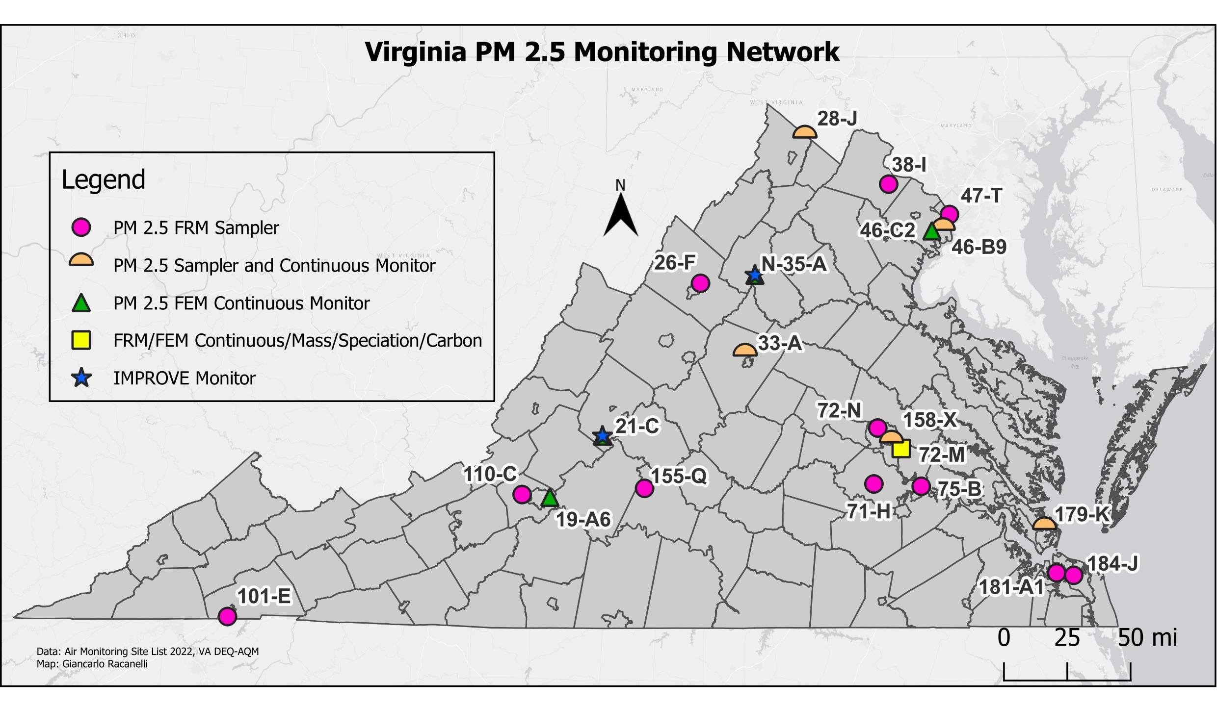

Site ID | County/City | Station Location
28-J | Frederick | Woodbine Road, Lester Building Systems
38-I | Loudoun | Broad Run High School, Ashburn
47-T | Arlington | Aurora Hills Visitors Center. 18th and Hayes Streets
46-C2 | Fairfax | Park and Ride, 6831 Backlick Rd
46-B9 | Fairfax | Lee District Park, Telegraph Road
26-F | Rockingham | Rockingham VDOT
N-35 | Madison | Big Meadows, Shenandoah National Park
33-A | Albemarle | Albemarle High School
21-C | Rockbridge | USDA Forest Service, Natural Bridge Station
155-Q | Lynchburg | Leesville Hwy. & Greystone Dr., City Water Tower
110-C | Salem | Salem High School
19-A6 | Vinton | Herman L. Horn Elementary School, Ruddell Road
101-E | Bristol | Highland View Elementary School
72-N | Henrico | DEQ Piedmont Office, Glen Allen
158-X | Richmond City | Joseph Bryan Park
72-M | Henrico | MathScience Innovation Center, 2401 Hartman St.
75-B | Charles City Co. | Rt. 608, Shirley Plantation
71-H | Chesterfield | Beach Road VDOT
179-K | Hampton | NASA Langley Research Center
181-A1 | Norfolk | NOAA Storage Facility, 2nd Street and Woodis Avenue
184-J | Virginia Beach City | DEQ Tidewater Regional Office

PM2.5 Monitoring Network

NAAQS

Primary Standard for PM_{2.5}:
- Annual Arithmetic Mean – the three-year average of the weighted annual mean PM_{2.5} concentration must not exceed 12.0 μg/m³.
- 24-Hour concentration – the three-year average of the annual 98th percentile of 24-hour concentrations must not exceed 35 μg/m³.

Secondary Standard for PM_{2.5}:
- Annual Arithmetic Mean – the three-year average of the weighted annual mean PM_{2.5} concentration must not exceed 15.0 μg/m³.

2020-2022 PM_{2.5} 24-hour Averages, 98th Percentile Values (μg/m³, LC)
Site | 2020 | 2021 | 2022 | 3-Year Average
(101-E) Bristol | 13.7 | 16.2 | 13.0 | 14.3
(26-F) Rockingham Co. | 14.0 | 18.3 | 13.0 | 15.1
(28-J) Frederick Co. | 16.2 | 21.2 | 19.2 | 18.9
(33-A) Albemarle Co. | 12.3 | 17.9 | 15.0 | 15.1
(19-A6) Roanoke Co. | 14.7 | 19.7 | 15.7 | 16.7
(110-C) Salem | 13.5 | 18.8 | 12.6 | 15.0
(155-Q) Lynchburg | 11.7 | 17.5 | 11.5 | 13.6
(71-H) Chesterfield Co. | 11.4 | 18.9 | 11.9 | 14.1
(72-M) Henrico Co. | 14.5 | 18.0 | 15.9 | 16.1
(72-N) Henrico Co. | 12.7 | 17.2 | 11.1 | 13.7
(75-B) Charles City Co. | 11.5 | 17.0 | 12.9 | 13.8
(158-X) Richmond | 15.7* | 17.6* | 16.4 | 16.6
(179-K) Hampton | 12.8 | 15.5 | 13.0 | 13.8
(181-A1) Norfolk | 12.1* | 15.4 | 12.8 | 13.4
(184-J) Va. Beach | 15.1* | 15.1 | 13.6 | 14.6
(38-I) Loudoun Co. | 19.3* | 16.0 | 13.0 | 16.1
(47-T) Arlington Co. | 17.7 | 17.1 | 13.5 | 16.1
(46-B9) Franconia, Fairfax Co. | 14.6 | 17.6 | 14.0 | 15.4
(46-C2) Springfield, Fairfax Co. | 16.3 | 19.9* | 15.7 | 17.3

* Annual value did not meet completeness criteria

PM2.5 Monitoring Network

NAAQS

Primary Standard for PM_{2.5}:
- Annual Arithmetic Mean – the three-year average of the weighted annual mean PM_{2.5} concentration must not exceed 12.0 μg/m³.
- 24-Hour concentration – the three-year average of the annual 98th percentile of 24-hour concentrations must not exceed 35 μg/m³.

Secondary Standard for PM_{2.5}:
- Annual Arithmetic Mean – the three-year average of the weighted annual mean PM_{2.5} concentration must not exceed 15.0 μg/m³.

2020-2022 PM_{2.5} Weighted Annual Arithmetic Means (μg/m³, LC)
Site | 2020 | 2021 | 2022 | 3-Year Average
(101-E) Bristol | 6.0 | 7.3 | 6.2 | 6.5
(26-F) Rockingham Co. | 6.1 | 7.4 | 6.5 | 6.7
(28-J) Frederick Co. | 6.6 | 8.6 | 7.7 | 7.6
(33-A) Albemarle Co. | 6.5 | 7.7 | 7.7 | 7.3
(19-A6) Roanoke Co. | 6.7 | 8.3 | 7.4 | 7.5
(110-C) Salem | 5.9 | 7.1 | 6.4 | 6.5
(155-Q) Lynchburg | 5.4 | 6.6 | 5.7 | 5.9
(71-H) Chesterfield Co. | 5.5 | 7.0 | 5.8 | 6.1
(72-M) Henrico Co. | 6.9 | 8.3 | 7.7 | 7.6
(72-N) Henrico Co. | 5.6 | 7.2 | 6.0 | 6.3
(75-B) Charles City Co. | 5.6 | 7.0 | 5.8 | 6.1
(158-X) Richmond | 6.9* | 8.3* | 8.0 | 7.7
(179-K) Hampton | 5.9 | 7.0 | 6.8 | 6.6
(181-A1) Norfolk | 6.0* | 7.2 | 6.3 | 6.5
(184-J) Va. Beach | 6.2* | 7.3* | 6.5 | 6.7
(38-I) Loudoun Co. | 6.2* | 7.4 | 6.4 | 6.7
(47-T) Arlington Co. | 6.6 | 7.9 | 6.7 | 7.1
(46-B9) Franconia, Fairfax Co. | 6.6 | 7.9 | 7.2 | 7.2
(46-C2) Springfield, Fairfax Co. | 7.9 | 9.1* | 8.1 | 8.4

* Annual value did not meet completeness criteria.

PM10 Monitoring Network

PM₁₀ is particulate matter comprised of solid particles or liquid droplets with an aerodynamic diameter of less than or equal to 10 micrometers and is sometimes referred to as “coarse particles.” PM₁₀ particles are larger than PM_{2.5} but are still in a size range that can pose health problems. They can be inhaled and retained in the human respiratory system, causing breathing difficulties, and eye, nose, and throat irritation. In addition to the health effects, these particles can impair visibility, contribute to climate change, and result in acidic dry deposition. Acidic dry deposition occurs when particles containing acidic compounds fall to the ground. The acidic particles can corrode surfaces that they settle on and can increase the acidity of the soil and water.

The NAAQS for particulate matter were revised in September 2006. EPA changed the existing standards for PM₁₀ by revoking the annual standard of 50 micrograms per cubic meter, because current scientific evidence did not support a link between long-term exposure to coarse particles and health problems. However, the 24-hour PM₁₀ standard was retained to protect citizens from effects of short-term exposures.
DEQ uses different methods to measure PM₁₀ in ambient air. The traditional filter-based manual method employs a sampler that uses a particle size discrimination inlet on top of a base, where a quartz fiber filter is placed before each sampling event. The inlet is designed so that particles in the size range of 10 micrometers or below stay suspended in the air stream that is drawn across the filter, while larger particles settle out before reaching the filter. The PM₁₀ concentration is determined by dividing the change in filter massfrom pre- and post-weighing by the volume of sampled air. The resulting PM₁₀ concentration is reported as micrograms per cubic meter (μg/m³). The normal sampling schedule for the manual samplers is once every sixth day from midnight to midnight.
A newer, continuous technology was introduced at several Virginia sites in 2021. The newer method uses scattered light spectrometry instead of filters, and the data are available 24 hours a day. The advantage of the new method is that there is no need for regular site visits to collect and process filters, and data is available in near real-time. In 2022, continuous PM₁₀ samplers were operating at the following sites: Frederick, Fairfax, and Henrico counties, and the City of Hampton.
PM10 Monitoring Network

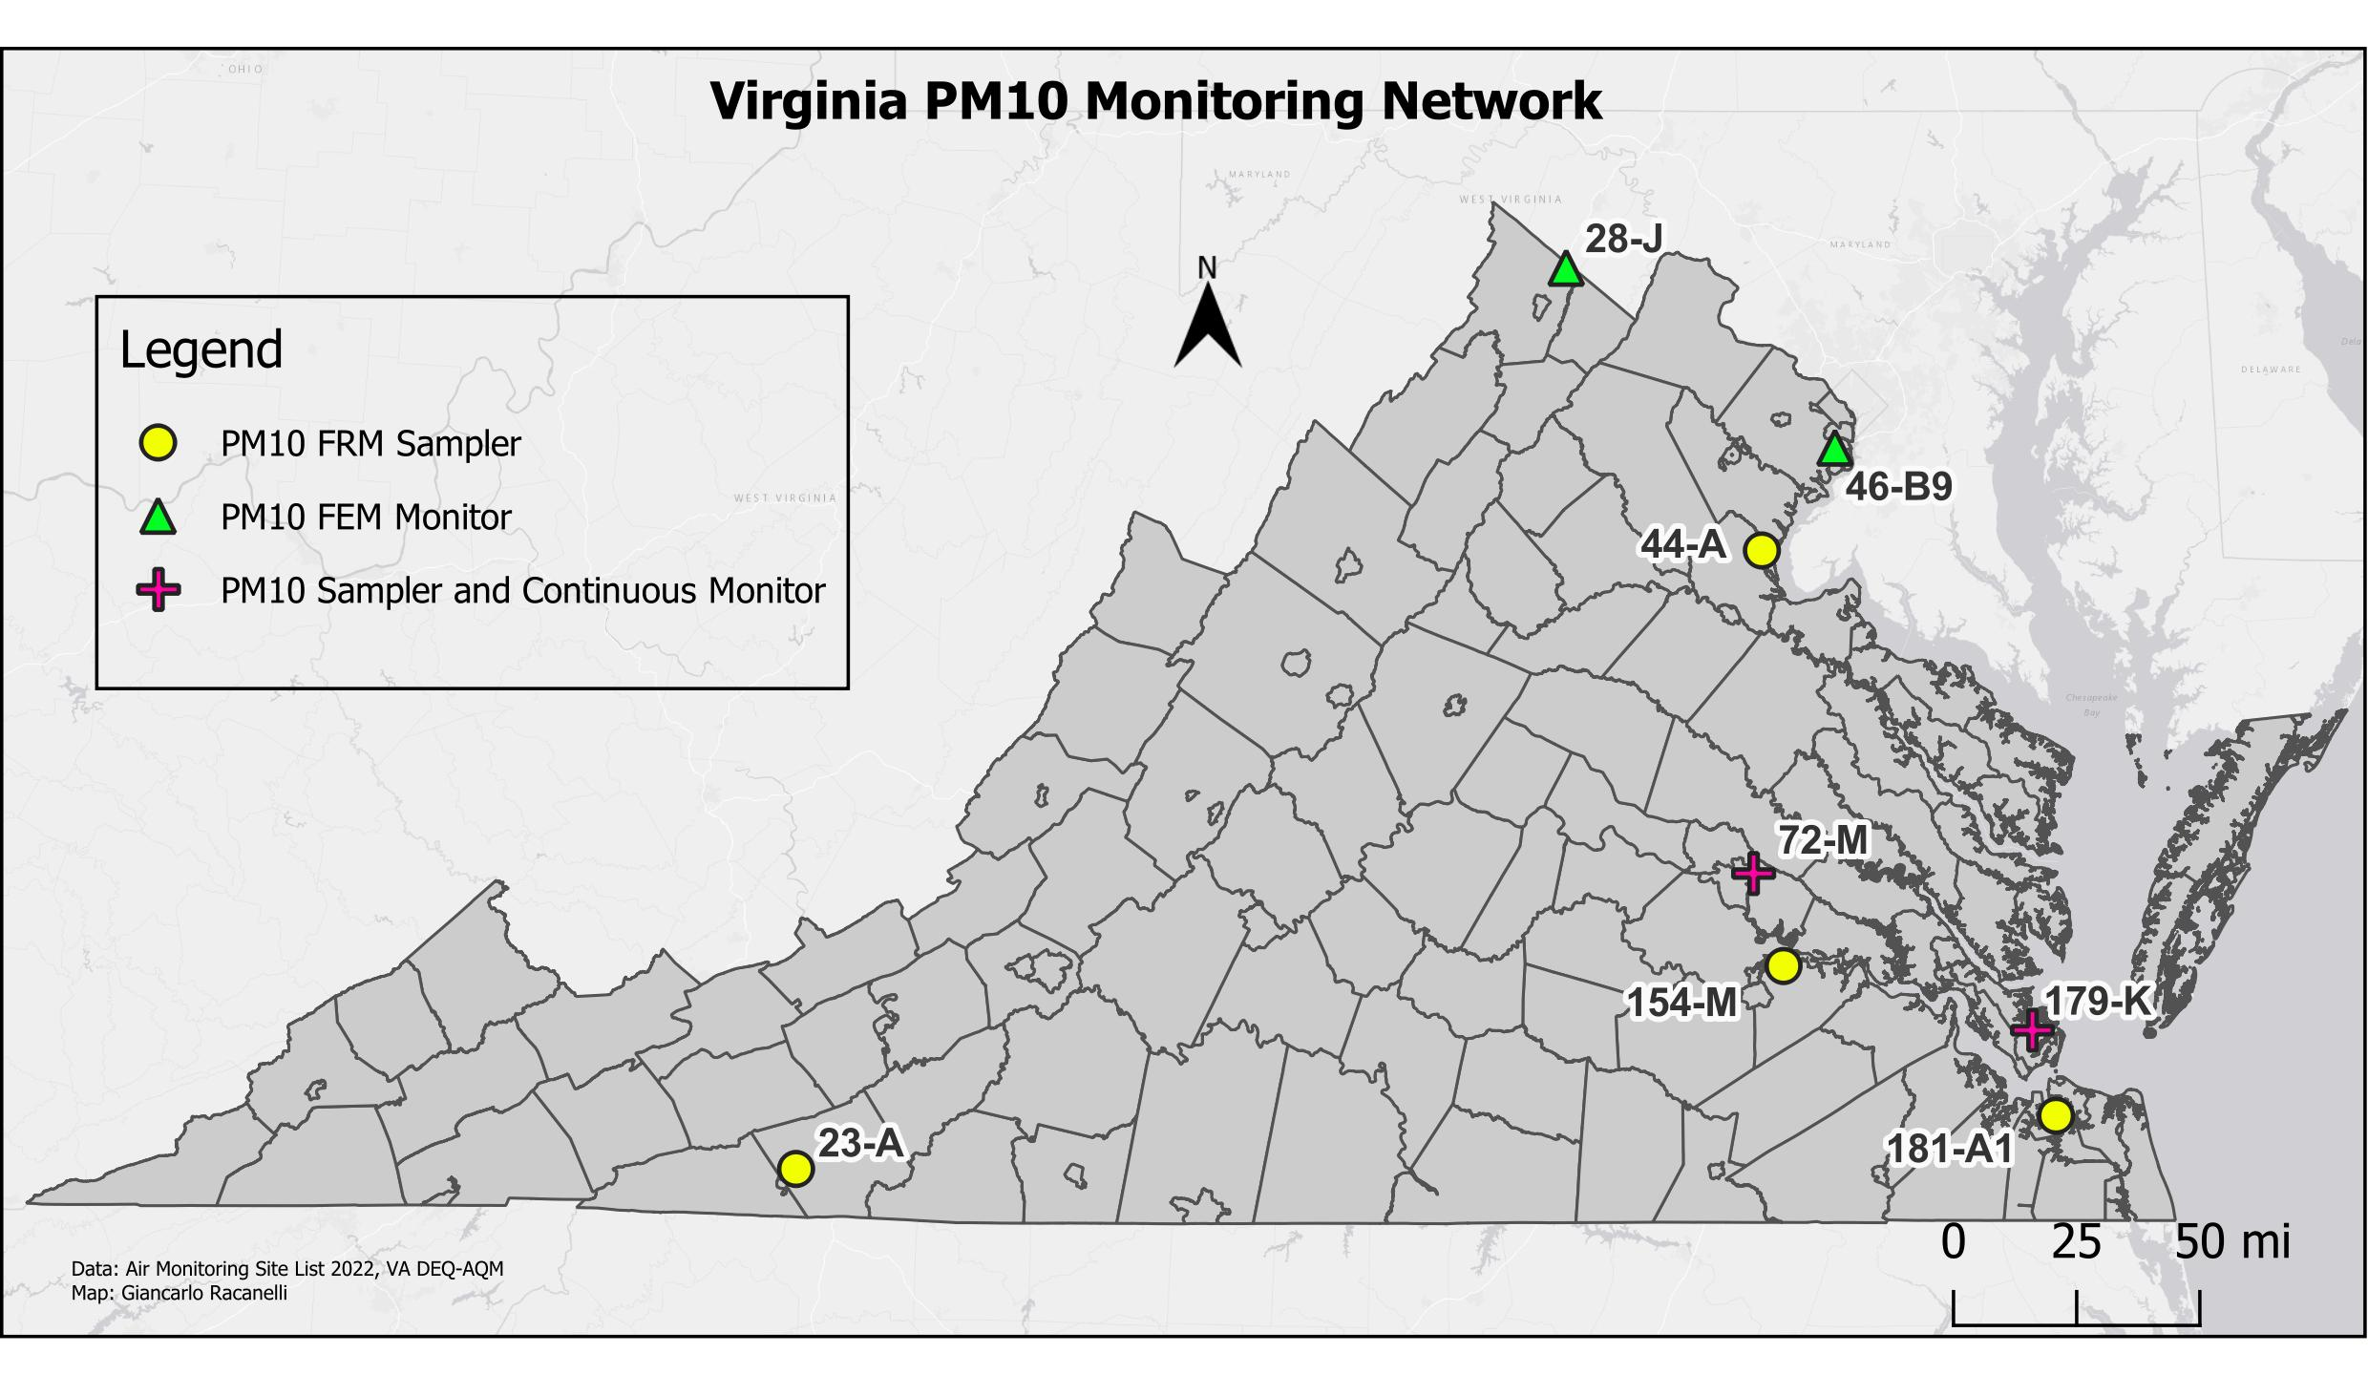

Site ID | County/City | Station Location
23-A | Carroll | Gladeville Elementary School
28-J | Frederick | Woodbine Road, Lester Building Systems
44-A | Caroline | U.S.G.S. Geomagnetic Center, Corbin
46-B9 | Fairfax | Lee District Park, Telegraph Road
72-M | Henrico | MathScience Innovation Center, 2401 Hartman St.
154-M | Hopewell | Carter Woodson Middle School, Hopewell
179-K | Hampton | NASA Langley Research Center
181-A1 | Norfolk | NOAA Storage Facility, 2nd Street and Woodis Avenue

PM10 Monitoring Network

(NAAQS)

Primary Standard for PM₁₀:
- 24-hour concentration not to exceed 150 μg/m³ more than once per year averaged over three years. An exceedance means a 24-hour average value that is above the level of the 24-hour standard after rounding to the nearest 10 μg/m³.

Secondary Standard for PM₁₀:
- Same as Primary.

2020-2022 PM₁₀ 24-Hour Average Concentrations (units in μg/m³ STD)
Site | 2020 |  | 2021 |  | 2022 |  | >150 μg/m³
 | 1st Max | 2nd Max | 1st Max | 2nd Max | 1st Max | 2nd Max
(23-A) Carroll Co. | 16 | 15 | 36 | 27 | 25 | 22 | 0
(28-J) Frederick Co.* | - | - | 51 | 46 | 45 | 42 | 0
(44-A) Stafford Co. | 24 | 16 | 34 | 30 | 18 | 13 | 0
(46-B9) Fairfax Co.* | 17 | 16 | 45 | 27 | 30 | 23 | 0
(72-M) Henrico Co. | 16 | 15 | 39 | 23 | 29 | 27 | 0
(154-M) Hopewell@ | 16 | 15 | 34 | 19 | 25 | 16 | 0
(179-K) Hampton* | 13 | 10 | 17 | 14 | 28 | 26 | 0
(181-A1) Norfolk | 29 | 20 | 24 | 21 | 22 | 20 | 0

* Continuous monitoring started in 2022
@ Did not meet 4th quarter data completeness criteria in 2022
- No data

CO Monitoring Network

Carbon monoxide (CO) is a colorless, odorless gas that is produced by incomplete burning of carbon compounds in fossil fuels (gasoline, natural gas, coal, oil, etc.). Over half of the CO emissions in the country come from motor vehicle exhaust. Other sources include construction equipment, boats, lawnmowers, woodstoves, forest fires, and industrial manufacturing processes.

CO concentrations are higher in the vicinity of heavily traveled highways and drop rapidly the further the distance from the road. Ambient levels of carbon monoxide tend to be higher in the colder months due to thermal inversions that trap pollutants close to the ground. A thermal inversion occurs when the temperature of the air next to the ground is colder than air above it. When this happens, the air resists vertical mixing that can help the pollutants to disperse, forming a layer of smog close to the ground.

Carbon monoxide is harmful because it reacts in the bloodstream, reducing the amount of oxygen that is supplied to the heart and brain. CO can be harmful at lower levels to people who suffer from cardiovascular disease, like angina, arteriosclerosis, or congestive heart failure. At high levels, CO can impair brain function, cause vision problems, reduce manual dexterity, and reduce ability to perform complicated tasks. At very high levels, carbon monoxide can be deadly.

Carbon monoxide in the ambient air is measured continuously with an electronic instrument that uses non-dispersive infrared (NDIR) photometry, and is based on the principle that the concentration of CO in a sample of air is related to the amount of infrared (IR) light that is absorbed when a beam of IR radiation is passed through the sample. The CO analyzer calculates the concentration by measuring the IR absorption that takes place within a sample chamber containing ambient air, and then outputs the concentration in the form of a voltage signal that goes from the instrument to an external data logger via ethernet connection.

CO Monitoring Network

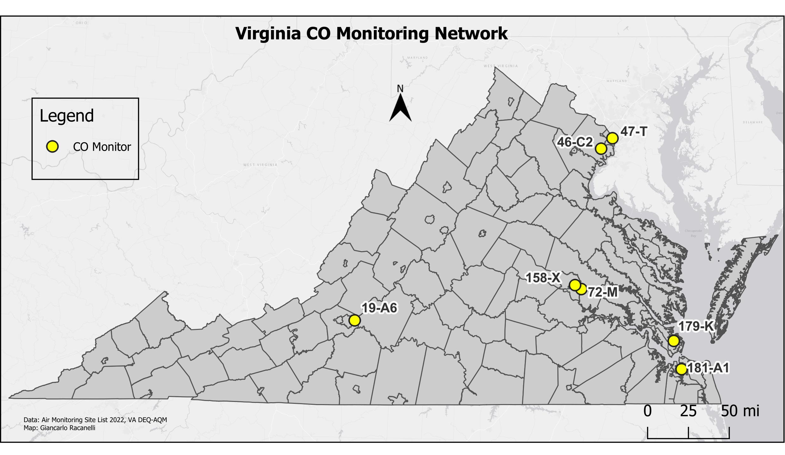
Site ID | County | Station Location
47-T | Arlington | Aurora Hills Visitors Center. 18th and Hayes Streets
46-C2 | Fairfax | Park and Ride, 6831 Backlick Rd
19-A6 | Vinton | Herman L. Horn Elementary School, Ruddell Road
158-X | Richmond City | Joseph Bryan Park
72-M | Henrico | MathScience Innovation Center, 2401 Hartman St.
179-K | Hampton | NASA Langley Research Center
181-A1 | Norfolk | NOAA Storage Facility, 2nd Street and Woodis Avenue

CO Monitoring Network

NAAQS

Primary Standard for CO:
- Eight-hour average not to exceed 9 ppm more than once per year.
- One-hour average not to exceed 35 ppm more than once per year.

There are no Secondary Standards for CO because it does not harm vegetation or buildings.

Site | 2022
 | 1-Hour Avg. (ppm) |  | 8-Hour Avg. (ppm)
 | 1st Max. | 2nd Max. | 1st Max. | 2nd Max.
(19-A6) Roanoke Co. | 0.9 | 0.8 | 0.6 | 0.6
(72-M) Henrico Co. | 1.2 | 1.1 | 0.9 | 0.9
(158-X) Richmond | 1.3 | 1.2 | 0.9 | 0.9
(179-K) Hampton | 0.9 | 0.9 | 0.7 | 0.7
(181-A1) Norfolk | 1.4 | 1.4 | 1.0 | 0.9
(46-C2) Fairfax Co. | 1.9 | 1.7 | 1.1 | 1.0
(47-T) Arlington Co. | 1.5 | 1.4 | 1.2 | 1.2

Eight Hour Averages stated as Ending Hour

SO2 Monitoring Network

Sulfur dioxide (SO₂) is a colorless gas that has a strong odor. It results from burning of fuels containing sulfur (such as coal and oil), petroleum refining, and smelting (extracting metals from ore), and it also occurs naturally from volcanic eruptions. SO₂ can dissolve in water vapor to produce sulfuric acid, and it can also interact with other gases and particles in the air to produce sulfate aerosols that can travel long distances in the atmosphere.

EPA has developed primary and secondary air quality standards for SO₂. The primary standards are designed to protect people from the health effects of sulfur dioxide gas, which include respiratory problems for people with asthma and for those who are active outdoors. Long-term exposure to high concentrations of sulfur dioxide gas can cause respiratory illness and aggravate existing heart conditions. Sulfate particles that are formed from SO₂ gas can be inhaled and are associated with increased respiratory symptoms and disease.

Secondary standards for sulfur dioxide protect against damage to vegetation and buildings, and against decreased visibility. The acids that can form from SO₂ and water vapor contribute to acid deposition (commonly called “acid rain”) which causes damage to the leaves of plants and trees, making them vulnerable to disease, and can increase the acidity of lakes and streams, making them unsuitable for aquatic life. Acid deposition also causes deterioration of materials on buildings, monuments, and sculptures. Finally, small sulfate particles, formed when SO₂ gas reacts with other gases and particles in the air, contribute to haze that causes decreased visibility in many areas of the country.

Sulfur dioxide is monitored continuously with an electronic instrument using ultraviolet fluorescence detection. The instrument pulls outside air into a sample chamber containing a high intensity ultraviolet (UV) light. Any SO₂ molecules in the sample air absorb some of the UV light, become excited, and then fluoresce, releasing light characteristic of SO₂. The fluorescence is detected with a photomultiplier tube (a tube that detects very small amounts of light and multiplies the signal many times), and the resulting voltage signal, which corresponds to the amount of SO₂ in the sample, is sent to a data logger and stored as the SO₂ concentration.
SO2 Monitoring Network

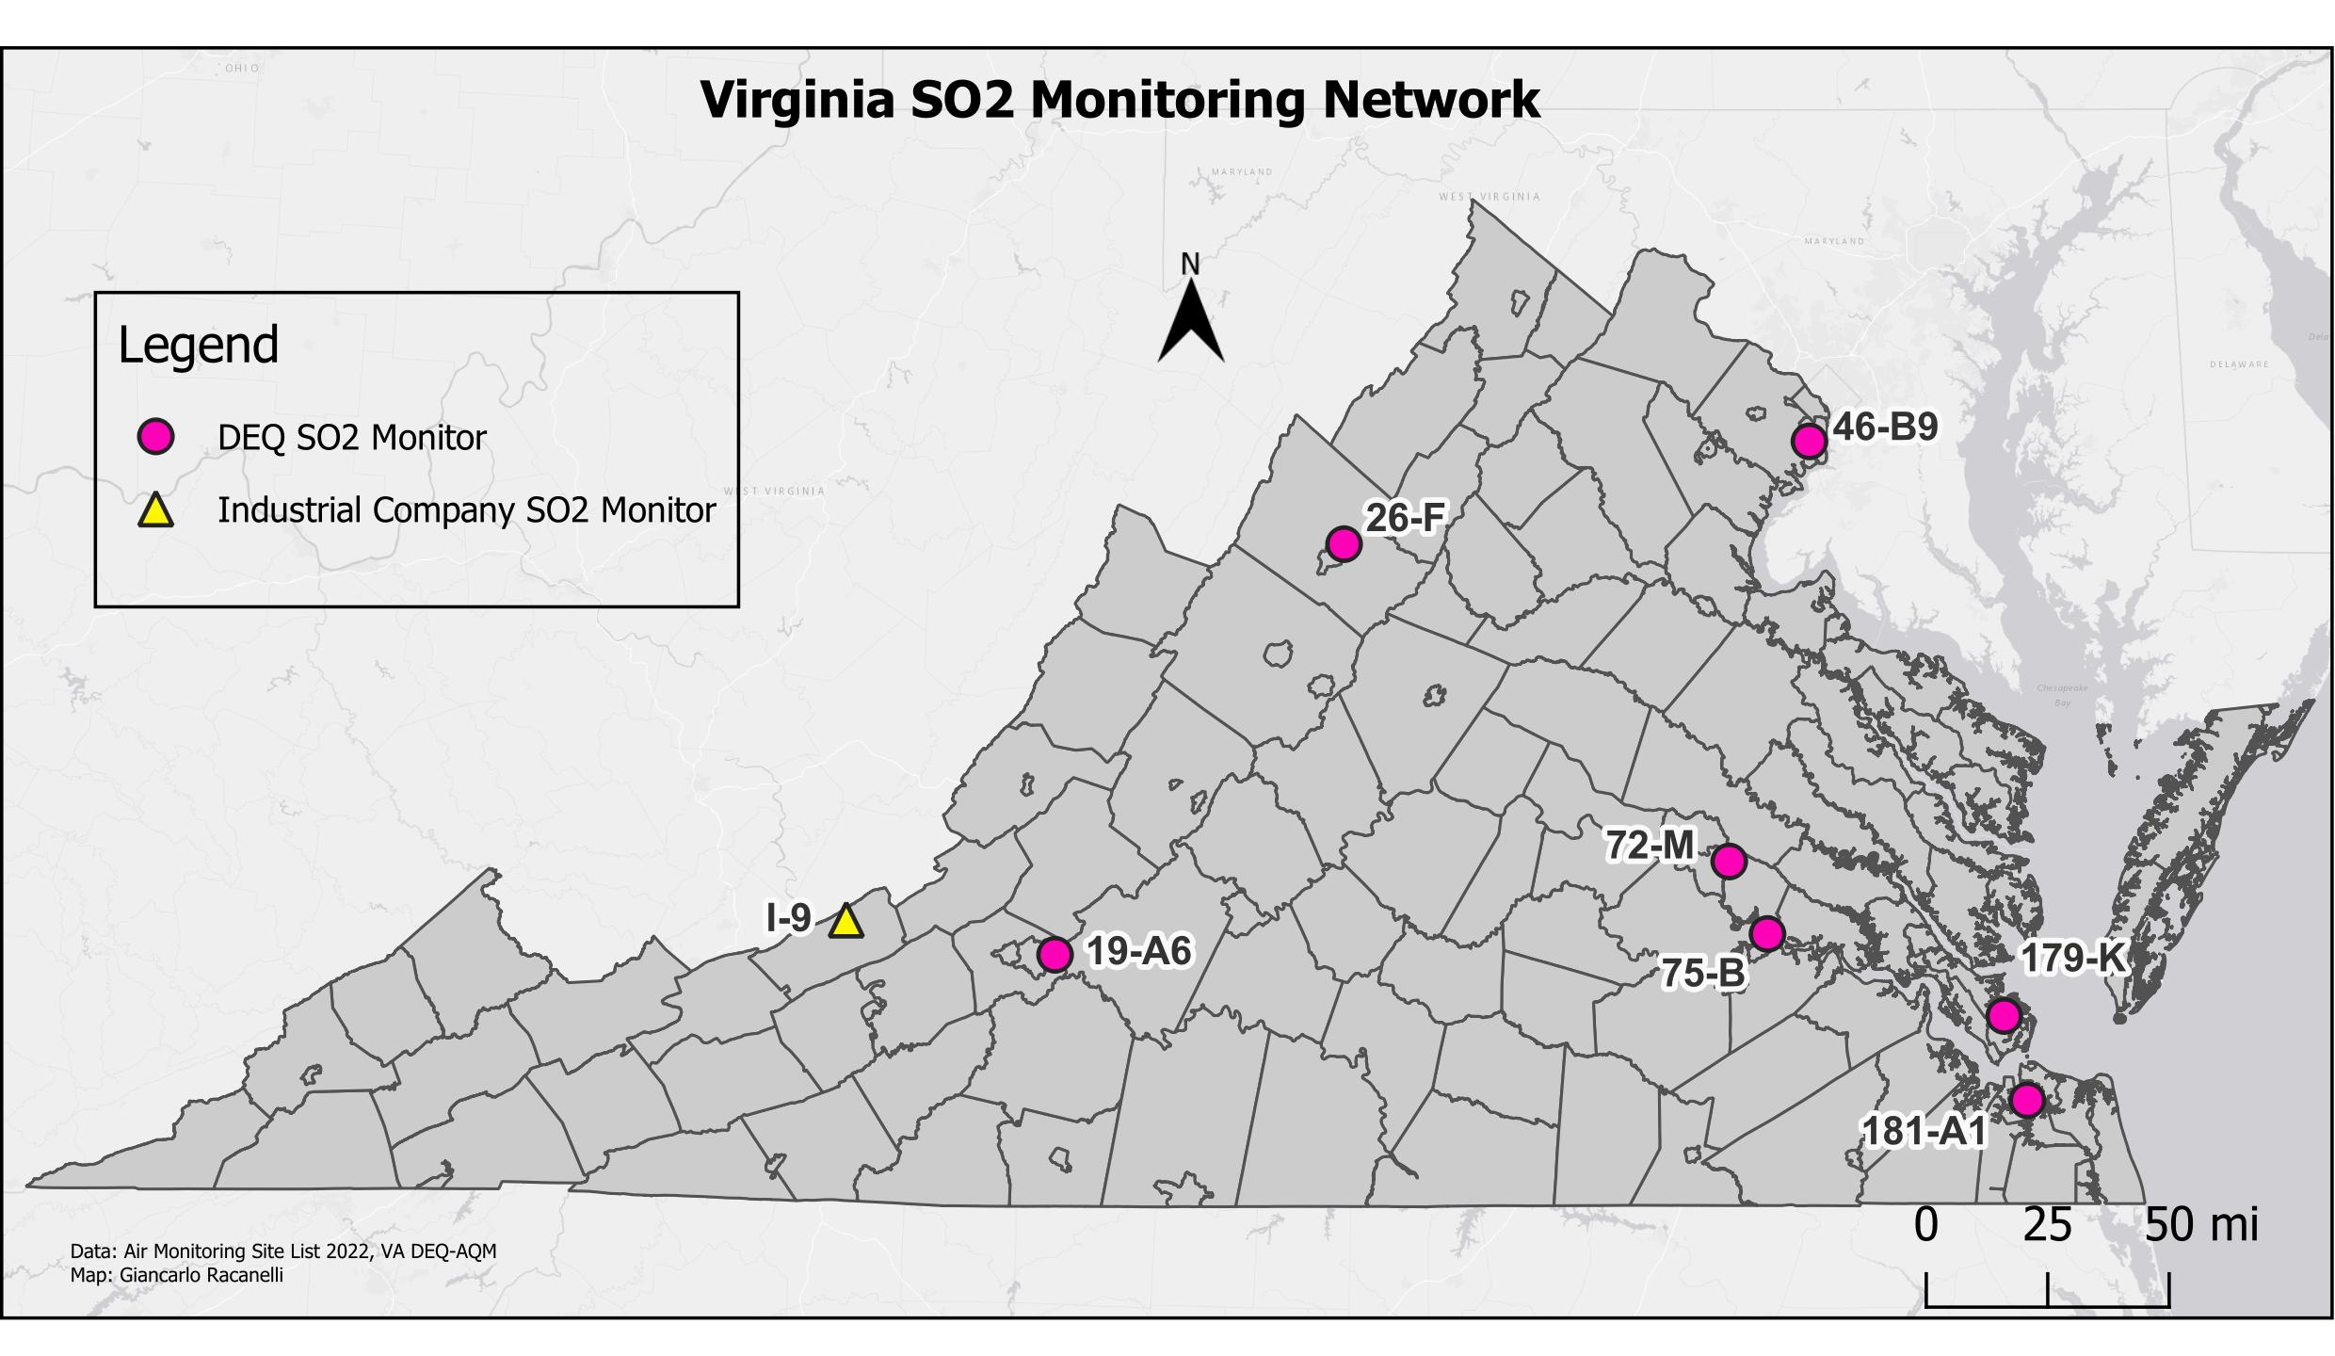

Site ID | County/City | Station Location
26-F | Rockingham | Rockingham VDOT
46-C9 | Fairfax | Lee District Park, Telegraph Road
19-A6 | Vinton | Herman L. Horn Elementary School, Ruddell Road
72-M | Henrico | MathScience Innovation Center, 2401 Hartman St.
75-B | Charles City Co. | Rt. 608, Shirley Plantation
179-K | Hampton | NASA Langley Research Center
181-A1 | Norfolk | NOAA Storage Facility, 2nd Street and Woodis Avenue

SO2 Monitoring Network

NAAQS

Primary Standard for SO₂:
- Three-year average of the annual 99th percentile one-hour daily maximum values not to exceed 75 ppb.

Secondary Standard for SO₂:
- Three-hour concentration not to exceed 0.5 ppm (500 ppb) more than once per year.

Sulfur Dioxide 99th Percentile 1-Hour Daily Maximum Values (ppb)
Site ID | City/County | 2020 | 2021 | 2022 | 3-Yr Avg Design Value  2020-2022
26-F | Rockingham Co. | 2.0 | 1.8 | 1.7 | 1.8
19-A6 | Roanoke Co. | 3.3 | 3.4 | 2.9* | 3.4
72-M | Henrico Co. | 2.2 | 1.5 | 2.8 | 2.2
75-B | Charles City Co. | 2.6 | 2.7 | 3.9 | 3.1
179-K | Hampton | 3.7 | 3.1 | 3.1 | 3.3
181-A1 | Norfolk | 1.7 | 1.9 | 2.4 | 2.0
46-B9 | Fairfax Co. | 2.4 | 2.7 | 2.5 | 2.5
* Did not meet completeness criteria for 2022.

Sulfur Dioxide 3-Hour Block Average Maximum Values (ppb)
Site ID | City/County | 2020 | 2021 | 2022 | Number Obs. > 500 ppb
26-F | Rockingham Co. | 2.2 | 1.7 | 1.8 | 0
19-A6 | Roanoke Co. | 2.7 | 4.1 | 3.2 | 0
72-M | Henrico Co. | 2.8 | 3.0 | 3.0 | 0
75-B | Charles City Co. | 2.1 | 4.2 | 3.4 | 0
179-K | Hampton | 3.2 | 3.1 | 2.9 | 0
181-A1 | Norfolk | 1.7 | 2.1 | 2.0 | 0
46-B9 | Fairfax Co. | 2.4 | 3.3 | 2.2 | 0

NO2 Monitoring Network

Nitrogen dioxide (NO₂) is one in a group of gases referred to as oxides of nitrogen (NO_{X}). NO_{X} gases, including NO₂ which is characterized by a reddish-brown color and pungent odor, , results from high temperature burning of fossil fuels in automobiles, power plants, and other industrial, commercial, and residential sources. NO_{X} can also occur naturally from lightning, forest fires, and bacterial processes that take place in soil.

NO_{X} pollution contributes to a wide range of problems in the environment. Ground-level ozone, a major component of “smog”, forms when NO_{X} and volatile organic compounds (VOCs) react in the presence of sunlight. NO_{X} also reacts with other gases and particles in the air to form acids that contribute to acid deposition, and to form small particles that can be inhaled into the lungs. NO_{X} contributes to water quality deterioration by depositing nitrogen into water bodies, upsetting the nutrient balance and causing oxygen depletion in the water so that fish and other aquatic life cannot survive. Nitrate particles and nitrogen dioxide also contribute to visibility impairment by blocking light transmission.

EPA has established primary and secondary air quality standards for NO₂ because it can cause lung irritation and respiratory problems in humans. Small particles formed from reaction of NO_{X} gases with other compounds can be inhaled deep into the lungs and cause or worsen respiratory conditions such as emphysema and bronchitis and can aggravate existing heart conditions.

Nitrogen dioxide is measured traditionally with electronic instruments using the gas phase chemiluminescence method, where the instrument measures the light produced from the chemiluminescence reaction of nitric oxide (NO) to NO₂. This method of NO₂ detection is indirect and accomplished in two steps; first, the analyzer must convert any NO₂ in the sample air to NO, and second, it measures NO from the chemiluminescence produced by the reaction of NO with ozone (O₃) to produce NO₂.

A newer technology is becoming widely used, and DEQ has deployed these new instruments at most of its NO₂ sites. This new technology is called CAPS (cavity-attenuated phase-shift spectroscopy), and measures NO₂ directly by measuring the optical absorption of NO₂ at 450 nanometers, in the UV light spectrum. This method is faster than the chemiluminescence method and requires fewer components and steps. NO₂ measurements produced by both types of instruments are sent to an external data logger via ethernet connection.

NO2 Monitoring Network

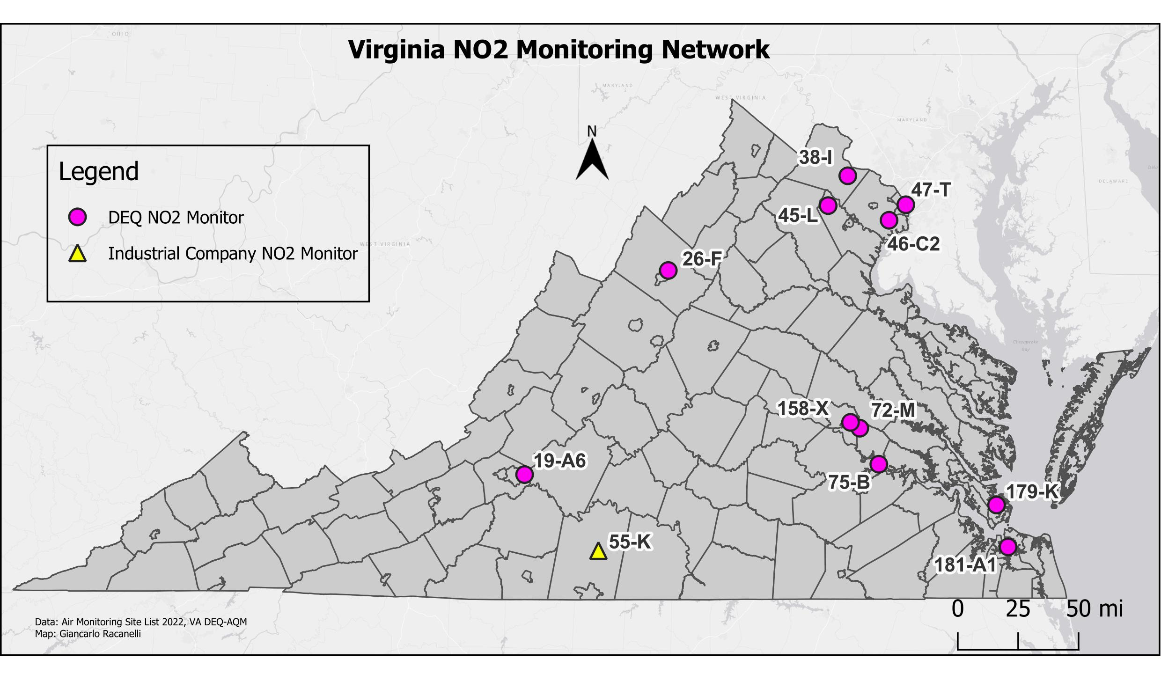

Site ID | County/City | Station Location
38-I | Loudoun | Broad Run High School, Ashburn
47-T | Arlington | Aurora Hills Visitors Center. 18th and Hayes Streets
46-C2 | Fairfax | Park and Ride, 6831 Backlick Rd
45-L | Prince William | Long Park, Route 15
26-F | Rockingham | Rockingham VDOT
19-A6 | Vinton | Herman L. Horn Elementary School, Ruddell Road
158-X | Richmond City | Joseph Bryan Park
72-M | Henrico | MathScience Innovation Center, 2401 Hartman St.
75-B | Charles City Co. | Rt. 608, Shirley Plantation
179-K | Hampton | NASA Langley Research Center
181-A1 | Norfolk | NOAA Storage Facility, 2nd Street and Woodis Avenue

NO2 Monitoring Network

NAAQS

Primary Standard for NO₂:
- Three-year average of the 98th percentile one-hour daily maximum values not to exceed 100 ppb.
- Annual Arithmetic Mean not to exceed 53 ppb (.053 ppm).

Secondary Standard for NO₂:
- Annual Arithmetic Mean not to exceed 53 ppb (.053 ppm).

Nitrogen Dioxide 98th Percentile 1-Hour Daily Maximum Values (ppb)
Site  City/County | 2020 | 2021 | 2022 | 3-Yr Avg. Design Value 2020-2022
(26-F) Rockingham Co. | 34.4 | 36.2 | 36.3 | 36
(19-A6) Roanoke Co. | 30.5 | 33.0 | 32.7 | 32
(72-M) Henrico Co. | 28.6 | 31.2 | 35.4 | 32
(75-B) Charles City Co. | 26.0 | 31.5 | 25.5 | 28
(158-X) Richmond | 40.5 | 47.8 | 48.6 | 46
(179-K) Hampton | 21.0 | 22.4 | 20.4 | 21
(181-A1) Norfolk | 34.8 | 39.6 | 40.9 | 38
(38-I) Loudoun Co. | 30.7 | 31.3 | 33.7 | 32
(45-L) Prince William Co. | 21.3 | 22.5 | 21.5 | 22
(46-C2) Fairfax Co. | 42.5 | 45.9 | 46.3 | 45
(47-T) Arlington Co. | 37.9 | 40.4 | 41.1 | 40

Site | Annual Arithmetic Mean (ppb)
 | 2020 | 2021 | 2022
(26-F) Rockingham Co. | 8 | 9 | 8
(19-A6) Roanoke Co. | 5 | 5 | 5
(72-M) Henrico Co. | 5 | 7 | 7
(75-B) Charles City Co. | 3 | 3 | 4
(158-X) Richmond | 12 | 13 | 14
(179-K) Hampton | 3 | 3 | 3
(181-A1) Norfolk | 7 | 7 | 7
(38-I) Loudoun Co. | 5 | 5 | 5
(45-L) Prince William Co. | 3 | 4 | 3
(46-C2) Fairfax Co. | 14 | 15 | 15
(47-T) Arlington Co. | 7 | 8 | 9

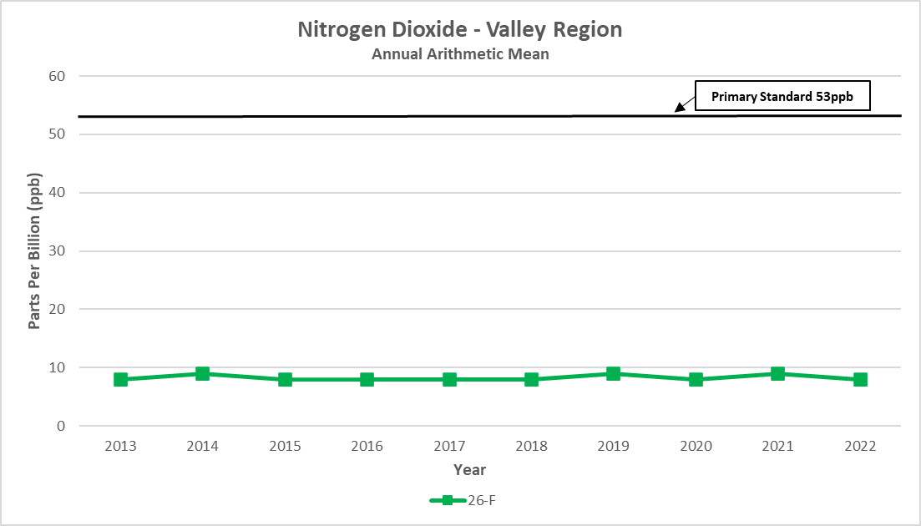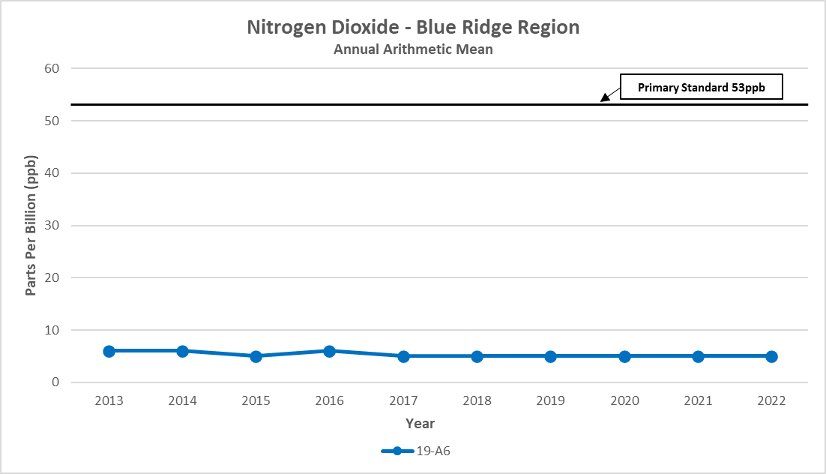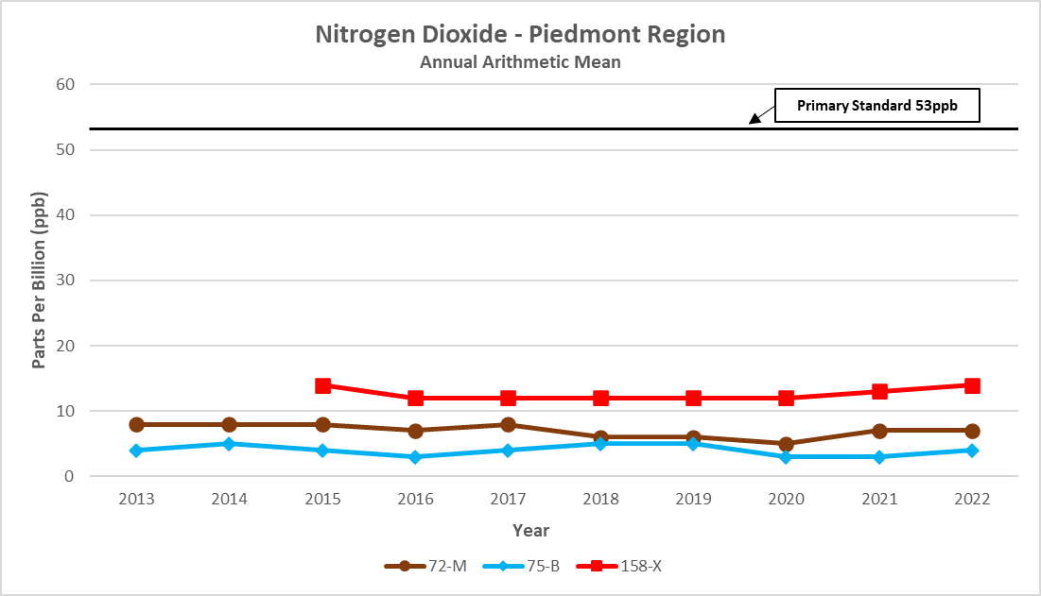
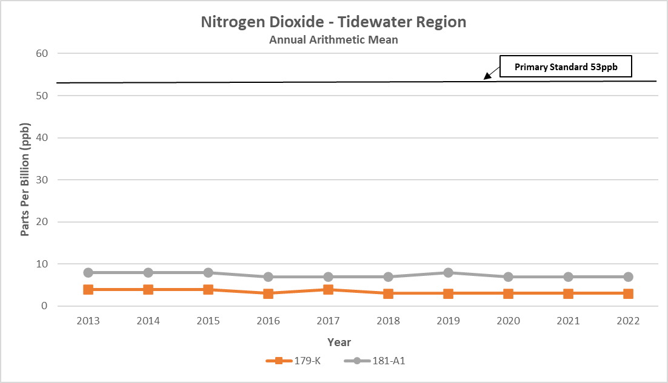
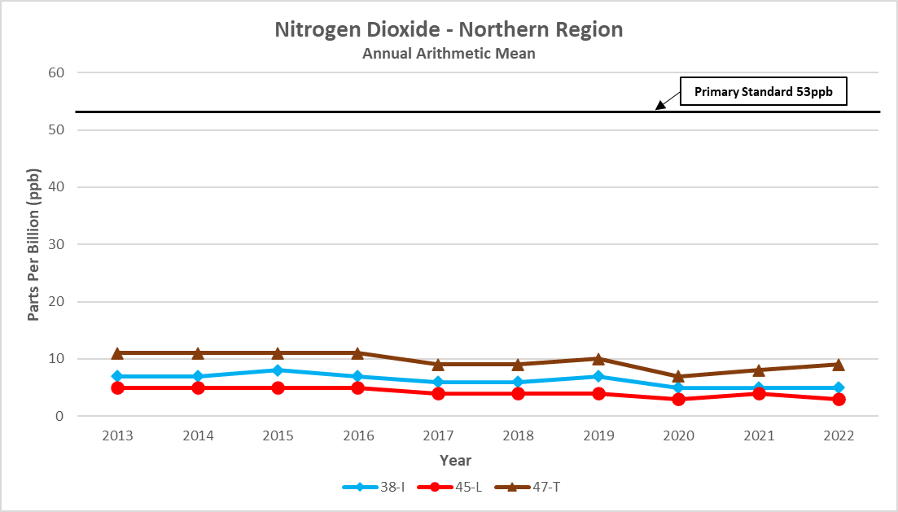
Ozone Monitoring Network

Ozone (O₃) is a gas comprised of three oxygen atoms. It is unstable, a strong oxidizing agent, and will react readily with other compounds to decay to the more stable diatomic oxygen (O₂).

Ozone is a gas that occurs both in the Earth's upper atmosphere and at ground level. Ozone can be "good" or "bad" for people's health and for the environment, depending on its location in the atmosphere. “Good” ozone occurs naturally in the stratosphere, about 10-30 miles above the earth’s surface, where it forms a layer that filters the sun’s ultraviolet rays before they reach the surface where they can cause harm to people, animals, and plants. “Bad” ozone, or ground-level ozone, occurs when chemicals found in the atmosphere at earth’s surface react in the presence of intense sunlight. Ozone at ground level is harmful because it can cause a variety of health problems, as well as damage to plants and materials. Since ground-level ozone is not emitted directly, it is called a “secondary” pollutant. The chemicals needed to form ozone, NOx and hydrocarbons (also called VOCs), can come from motor vehicle exhaust, power plants, industrial emissions, gasoline vapors, chemical solvents, and natural sources such as lightning, forest fires, and plant decomposition. Ozone, and the chemicals that produce ozone, can travel hundreds of miles from their sources, so that even rural areas with few pollutant emissions can occasionally experience high ozone levels. Efforts to control ground-level ozone involve limiting emissions of NOx and VOCs, or “ozone precursors,” that are necessary for ozone production.

Ground-level ozone is a seasonal pollutant, and the length of the ozone season varies across the country. In some areas, the season may last most of the year, but in Virginia it is usually only a problem during the late spring to summer months when the sunlight is most intense. Virginia is required to operate its ozone monitors from the months of March to October. In addition to the seasonal pattern, ozone also has a strong diurnal (daily) pattern at low altitudes, so that it is usually depressed at night, but begins to build during the day after the sun rises.

EPA has created primary and secondary air quality standards for ground-level ozone because of its adverse effects on public health and welfare. In humans, ozone can irritate lung airways, causing sunburn-like inflammation, and can induce symptoms such as wheezing, coughing, and pain when taking a deep breath. Although people with existing respiratory problems, such as asthma and emphysema, are most vulnerable, young children and otherwise healthy people can also suffer respiratory problems from ozone exposure. Scientific studies have shown that even at low levels, ozone can trigger breathing problems for sensitive individuals. In addition to human health problems, ozone can damage the leaves of plants and trees, making them susceptible to disease, insects, and harsh weather. Ozone can also cause rubber to harden and crack, and some painted surfaces to fade more quickly.

Ozone Monitoring Network

Ozone is measured continuously with electronic instruments using UV absorption photometry. The method is based on the principle that ozone strongly absorbs UV light at 254 nanometers (one billionth of a meter). The ozone monitor draws ambient air into a sample cell, passes UV light through the air at one end of the cell, and a detector measures the light intensity in the sample cell at the other end. When more ozone is present in the sample air, less light reaches the detector. The instrument calculates the ozone concentration of the ambient air based on the light intensity measured by the detector, which is output as a voltage and sent via ethernet connection to an external data logger.

Daily ozone forecasts for selected metropolitan areas and hourly ozone values for all Virginia ozone monitoring sites can be viewed for the months of March to October on the DEQ web page. In addition, animated ozone maps for Virginia and other parts of the United States are available at EPA's AirNow website.

Ozone Monitoring Network

The National Park Service operated one ozone monitor at Big Meadows in Shenandoah National Park in 2022. Daily data from this site is available at the DEQ website, and historical data may be obtained on the internet at NPS Gaseous Pollutant and Meteorological Data or at EPA’s AirData website. EPA also maintains ozone monitoring sites in Giles and Prince Edward counties as part of the CASTNET (Clean Air Status and Trends Network) program. Data from these sites is available for download at the CASTNET website

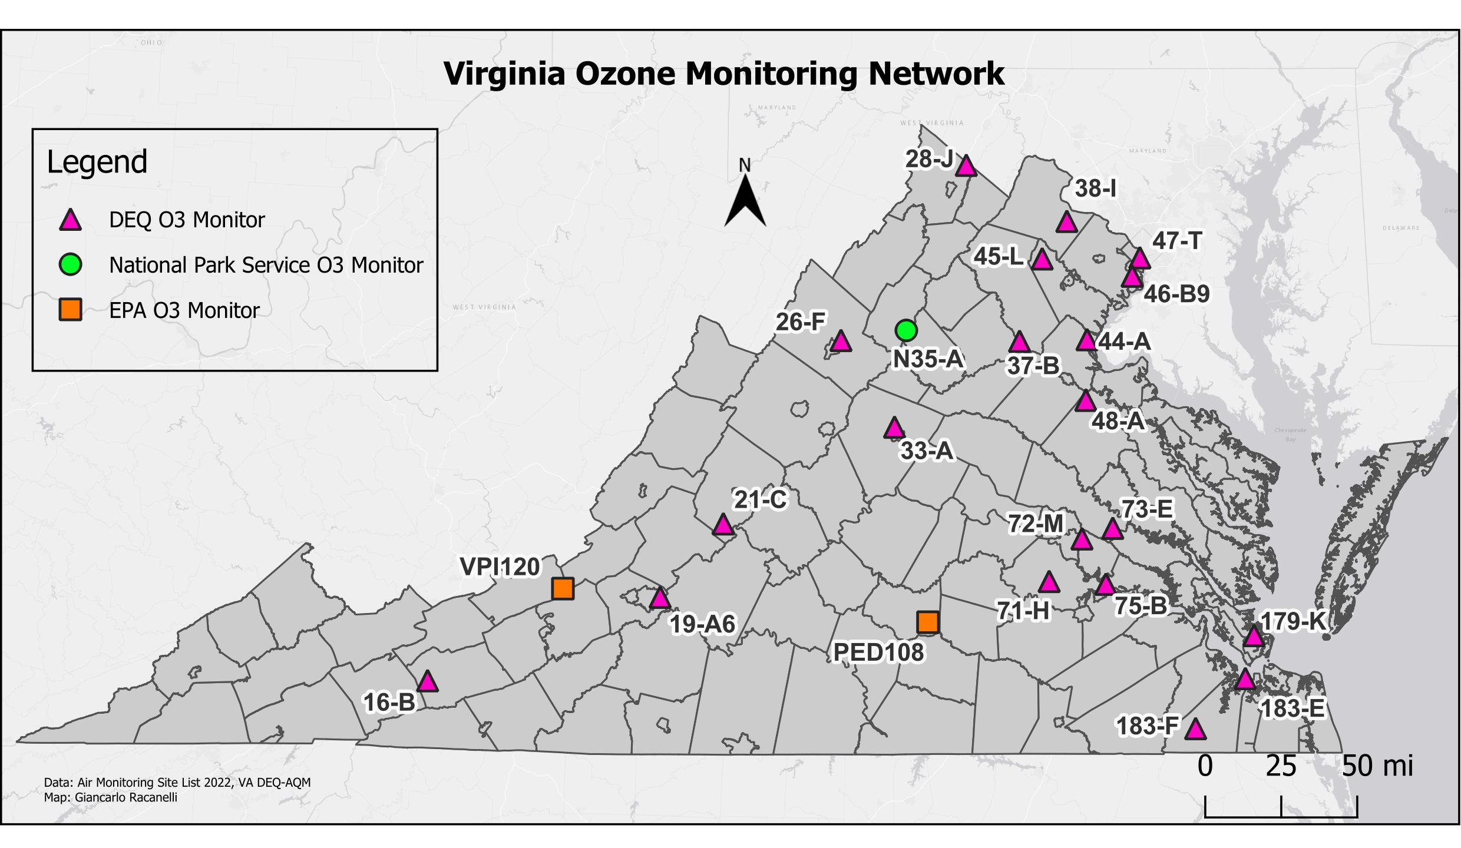
Site ID | County/City | Station Location
28-J | Frederick | Woodbine Road, Lester Building Systems
38-I | Loudoun | Broad Run High School, Ashburn
47-T | Arlington | Aurora Hills Visitors Center. 18th and Hayes Streets
46-B9 | Fairfax | Lee District Park, Telegraph Road
45-L | Prince William | Long Park, Route 15
26-F | Rockingham | Rockingham VDOT
N35-A | Madison | Big Meadows, Shenandoah National Park
37-B | Fauquier | Chester Phelps Wildlife Area, Route 61
44-A | Stafford | Widewater Elementary School, Den Rich Rd.
48-A | Caroline | U.S.G.S. Geomagnetic Center, Corbin
21-C | Rockbridge | USDA Forest Service, Natural Bridge Station
33-A | Albemarle | Albemarle High School
72-M | Henrico | MathScience Innovation Center, 2401 Hartman St.
73-E | Hanover | McClellan Road
16-B | Wythe | Sewage Disposal Plant, Rural Retreat
VPI 120 | Giles | Blue Grass Trail
19-A6 | Roanoke | Herman L. Horn Elementary School, Ruddell Road
PED108 | Prince Edward | Burkeville
71-H | Chesterfield | Beach Road VDOT
75-B | Charles City Co. | Rt. 608, Shirley Plantation
179-K | Hampton | NASA Langley Research Center
183-F | Suffolk | Tidewater Research Station, Holland
183-E | Suffolk | Tidewater Community College

Ozone Monitoring Network

NAAQS

Primary Standard for O₃:
- Maximum eight-hour average concentration of 0.070 ppm, effective Oct. 1, 2015, based on three-year average of the annual fourth highest daily maximum eight-hour averages.

- Secondary Standard for O₃:
Same as primary.

The standard is attained at a monitoring site when the three-year average of the fourth highest daily maximum eight-hour average for each of the three most recent years is less than or equal to 0.070 ppm.

Site | Days Exceeded 0.070 ppm | 2022
 |  | Highest Daily Maximum 8-Hour Avg.
 |  | 1st Max. | 2nd Max. | 3rd Max. | 4th Max.
(16-B) Wythe Co. | 0 | .063 | .059 | .059 | .059
(26-F) Rockingham Co. | 0 | .062 | .058 | .057 | .056
(28-J) Frederick Co. | 0 | .062 | .060 | .056 | .055
(33-A) Albemarle Co. | 0 | .060 | .059 | .056 | .055
(19-A6) Roanoke Co. | 0 | .064 | .064 | .060 | .058
(21-C) Rockbridge Co. | 0 | .061 | .060 | .055 | .054
(71-H) Chesterfield Co. | 0 | .064 | .059 | .058 | .058
(72-M) Henrico Co. | 0 | .074 | .064 | .063 | .061
(73-E) Hanover Co. | 0 | .063 | .062 | .061 | .061
(75-B) Charles City Co. | 0 | .062 | .062 | .060 | .060
(179-K) Hampton | 0 | .063 | .060 | .060 | .060
(183-E) Suffolk | 0 | .058 | .057 | .056 | .056
(183-F) Suffolk | 0 | .075 | .063 | .060 | .057
(37-B) Fauquier Co. | 0 | .061 | .058 | .056 | .056
(38-I) Loudoun Co. | 0 | .074 | .062 | .061 | .061
(44-A) Stafford Co. | 0 | .062 | .060 | .060 | .058
(45-L) Prince William Co. | 0 | .068 | .064 | .059 | .058
(46-B9) Fairfax Co. | 0 | .066 | .062 | .062 | .062
(47-T) Arlington Co. | 0 | .070 | .069 | .065 | .061
(48-A) Caroline Co. | 0 | .060 | .059 | .056 | .056

2020-2022 Fourth-Highest Daily Maximum 8-Hour Ozone Averages
(units parts per million)

Areas | Monitor Location  (County/City) | 2020 | 2021 | 2022 | 3-Year Average  (NAAQS = .070 ppm)
Richmond Maintenance Area | Chesterfield Co. | .054 | .062 | .058 | .058
 | Henrico Co. | .055 | .062 | .061 | .059
 | Hanover Co. | .053 | .061 | .061 | .058
 | Charles City Co. | .054 | .059 | .060 | .058
Hampton Roads Maintenance Area | Hampton City | .053 | .061 | .060 | .058
 | Suffolk City (TCC) | .054 | .055 | .056 | .055
 | Suffolk City (Holland) | .052 | .059 | .057 | .056
Fredericksburg Maintenance Area | Stafford Co. | .056 | .062 | .058 | .059
Northern Virginia Nonattainment Area | Loudoun Co. | .060 | .066 | .061 | .062
 | Prince William Co. | .057 | .062 | .058 | .059
 | Arlington Co. | .062 | .070 | .061 | .064
 | Fairfax Co. (Lee Park) | .057 | .068 | .062 | .062
Shenandoah National Park Maintenance Area | Madison Co.  (Big Meadows) | .053 | .061 | .061 | .058
Areas Currently Designated Attainment | Wythe Co. | .054 | .059 | .059 | .057
 | Rockbridge Co. | .051 | .055 | .054 | .053
 | Rockingham Co. | .053 | .062 | .056 | .057
 | Frederick Co. | .052 | .059 | .055 | .055
 | Albemarle Co. | .055 | .061 | .055 | .057
 | Roanoke Co. | .054 | .059 | .058 | .057
 | Fauquier Co. | .049 | .060 | .056 | .055
 | Caroline Co. | .053 | .066 | .056 | .058

A 3-year average greater than .070 ppm exceeds the 8-hour NAAQS for ozone.

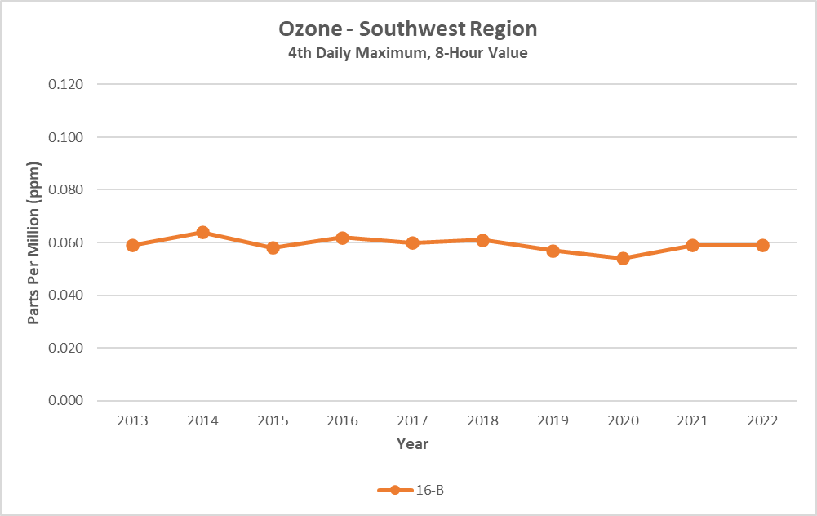

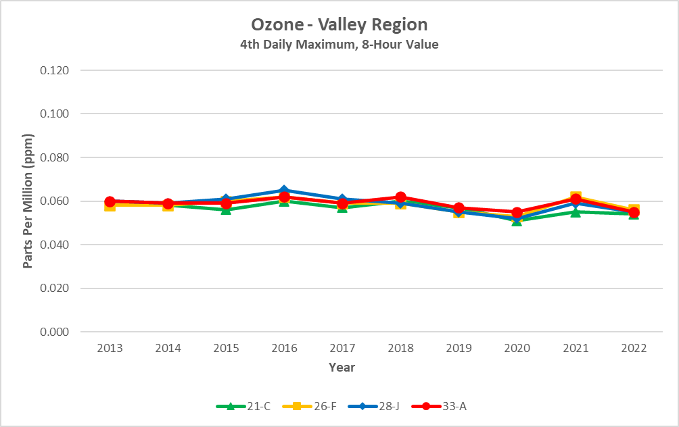

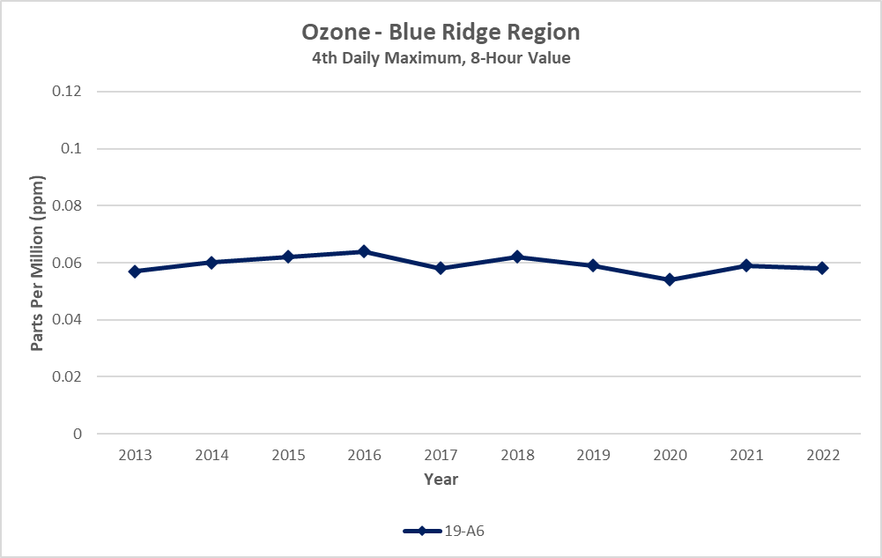

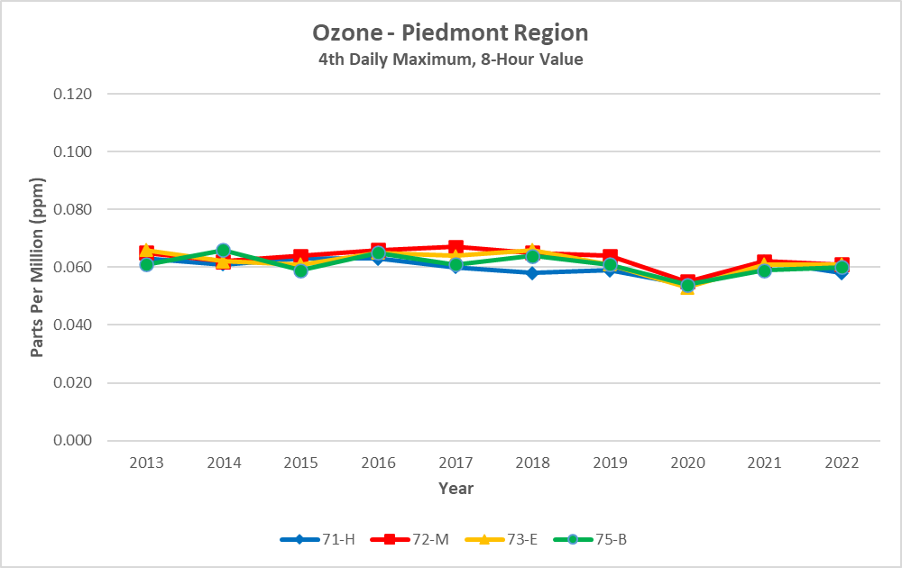

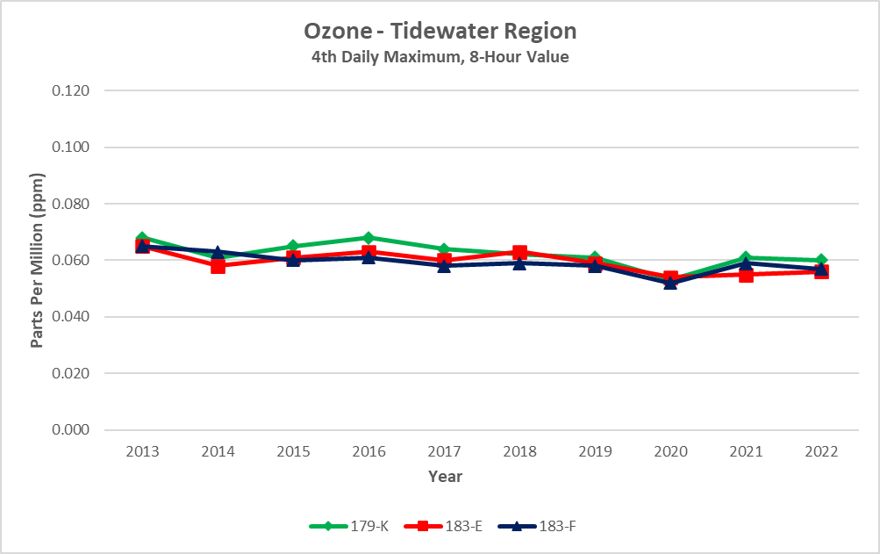

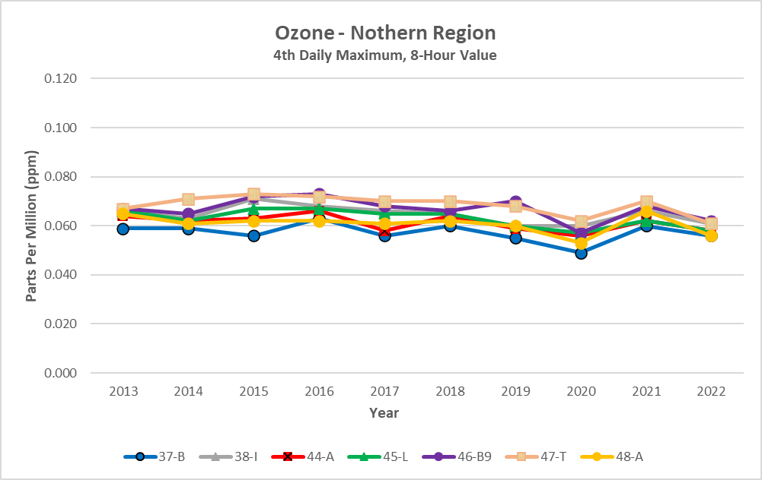

Lead Monitoring Network

Lead (Pb) is a metal found naturally in the environment as well as in manufactured products. In the past, emissions from cars and trucks using leaded gasoline were the primary sources of lead in the atmosphere. Efforts by EPA to remove lead from motor vehicle gasoline resulted in dramatic reductions of lead in the ambient air from 1980 to 1999. Now the major sources of lead in the air are ore, metals processing, and piston-engine aircraft operating on leaded aviation gasoline.
Particles containing lead can be inhaled, or lead can be ingested from drinking water or through contaminated food because of deposition of leaded particles onto the ground or in the water. In the body, lead can accumulate in the bones, affect the nervous system, kidney function, immune system, reproductive and developmental systems and the cardiovascular system. Young children are particularly vulnerable to the effects of lead, where it can contribute to behavioral problems and learning deficits. Lead can stay in the environment for a long time, causing adverse effects to plants and animals.
The NAAQS for lead were revised in October 2008. At that time, EPA reduced the level of the standard from 1.5 micrograms per cubic meter to 0.15 micrograms per cubic meter. The secondary standard was also reduced to the level of the new primary standard. DEQ received a waiver from EPA in 1997 to discontinue lead monitoring because Virginia had no major lead sources. However, when the new standards were promulgated, the emission threshold that agencies were required to use for determining if a lead monitor was needed near a source also changed. As a result, Virginia had to resume monitoring for lead in a few areas, and AQM began installing the lead monitors in late 2009 and completed installation in October 2010.

To measure lead, ambient air is drawn into a high-volume sampler. The sample air flows across an 8 by 10-inch glass fiber filter at a rate of 39-60 cubic feet per minute for a 24-hour period. The filter is sent to the Division of Consolidated Laboratories, where a small portion of it is analyzed using inductively coupled plasma-mass spectrometry (ICP-MS). The resulting lead concentration is reported as micrograms per cubic meter (μg/m³). The normal sampling schedule is once every sixth day from midnight to midnight. DEQ maintains one lead monitoring site in Radford. This site is the source-specific monitoring site for the Radford Army Arsenal Plant.

Lead Monitoring Network

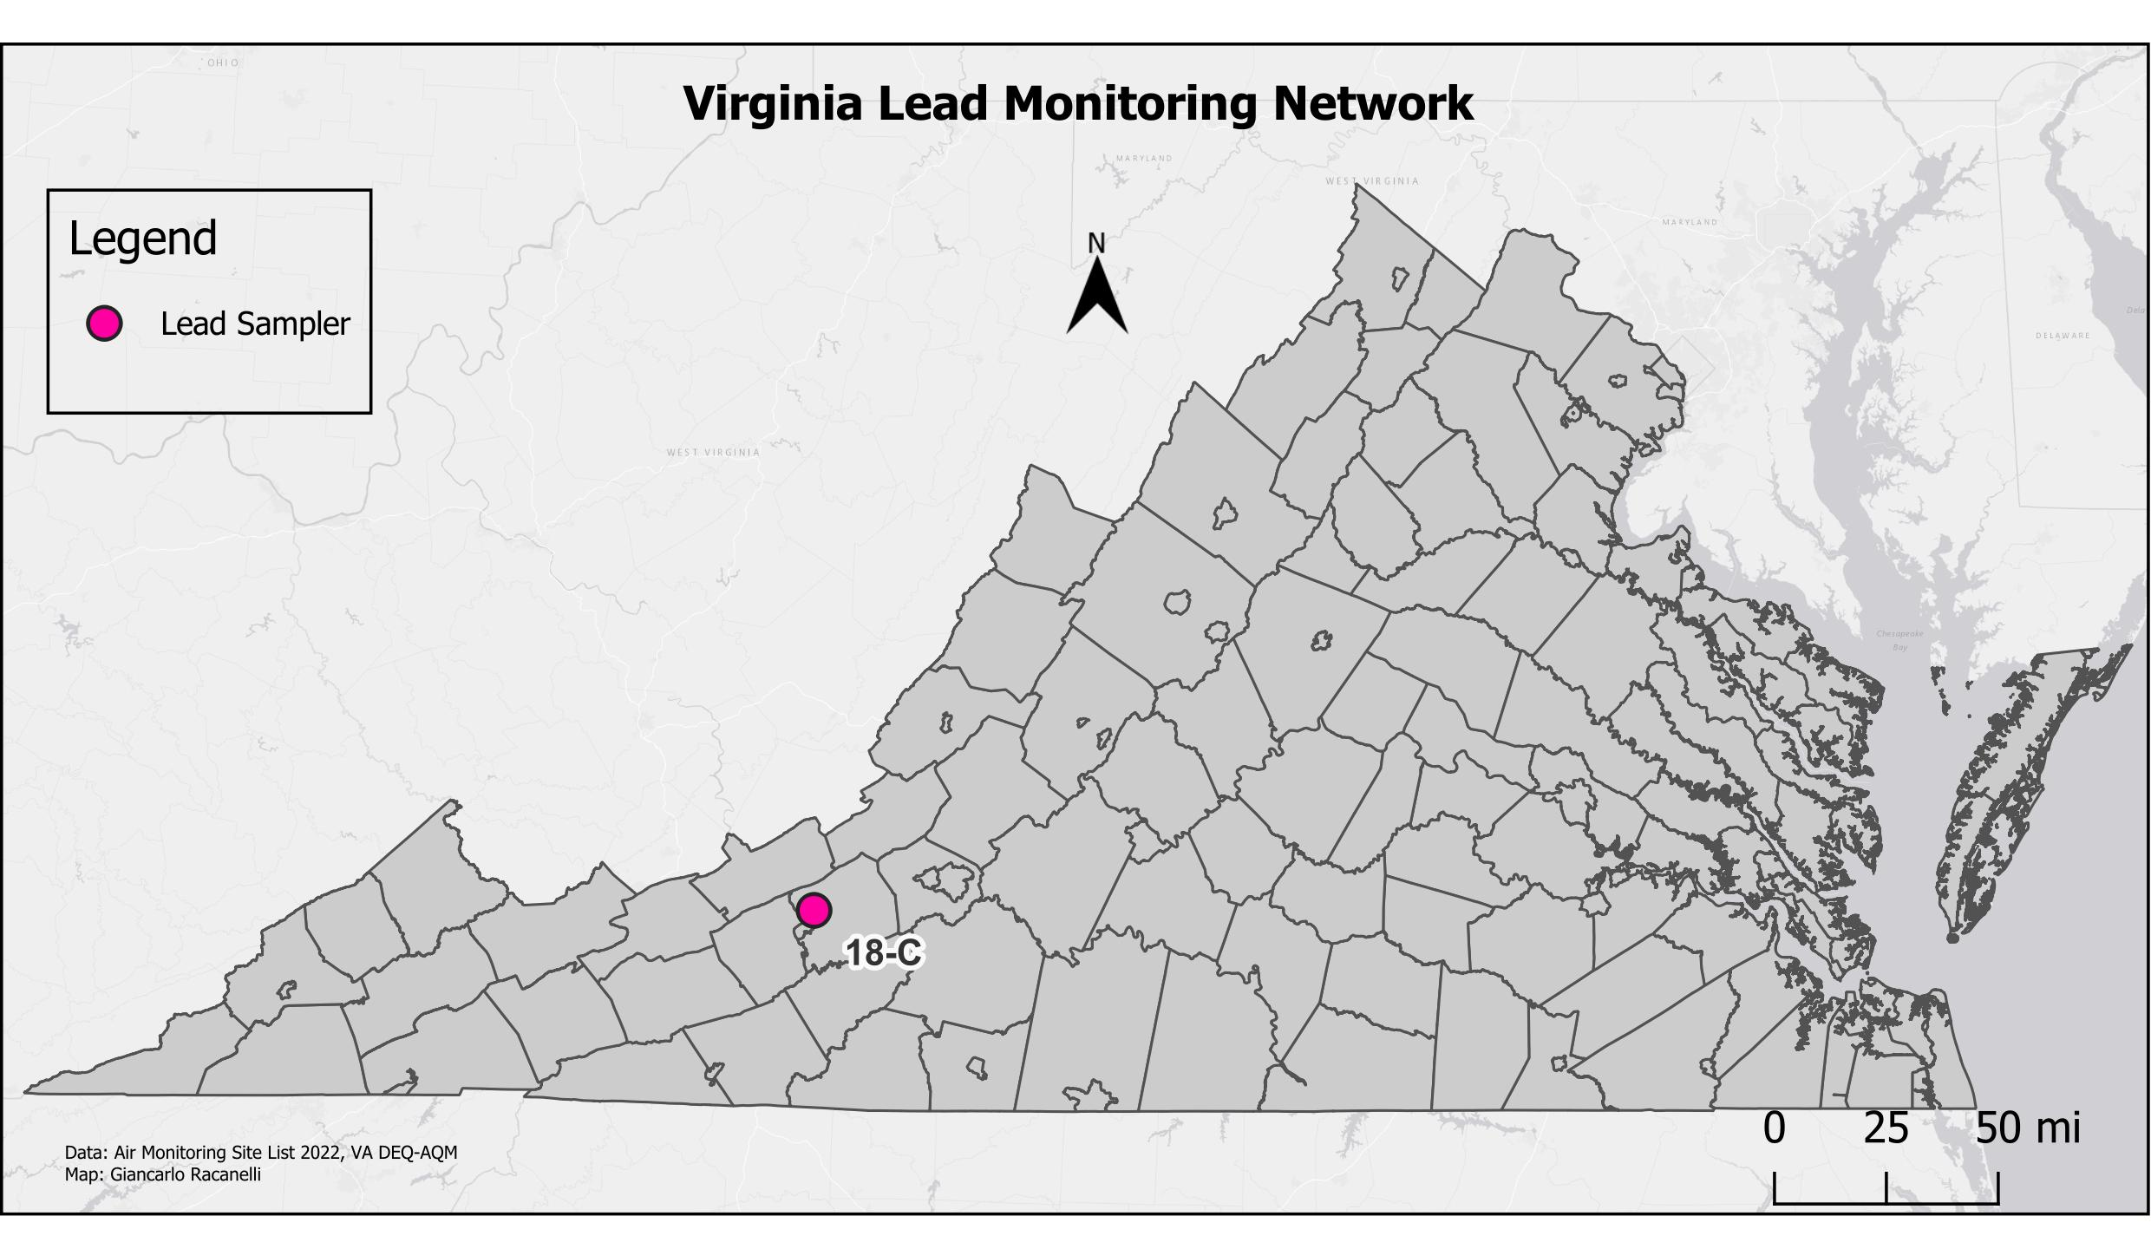
Site ID | County/City | Station Location
18-C | Montgomery | Stroubles Creek Wastewater Treatment Plant, Radford

NAAQS

Primary Standard for Pb:
- 0.15 μg/m³ three-month rolling average

Secondary Standard for Pb:
- Same as Primary

2022 Pb 3-Month Averages (units in μg/m³, LC )

Site | No. Samples Collected | 1st Max | 2nd Max | >0.15 μg/m³
(18-C) Montgomery Co. | 59 | 0.016 | 0.009 | 0

Acid Precipitation Network

Air Toxics Monitoring Network

Acid Precipitation Network

The National Acid Deposition Program (NADP) had five monitoring sites in Virginia in 2021: Big Meadows (Shenandoah National Park), Blue Grass Trail (Giles County), Charlottesville, Prince Edward County, and Natural Bridge Station (Rockbridge County).
There was one NADP Mercury Deposition Network (MDN) site in Virginia: Big Meadows (Shenandoah National Park).
There were two NADP Ammonia Monitoring Network (AMoN) sites in Virginia: Prince EdwardCounty and Blue Grass Trail (Giles County). AMoN site information and data are available on-line at Ammonia Monitoring Network.

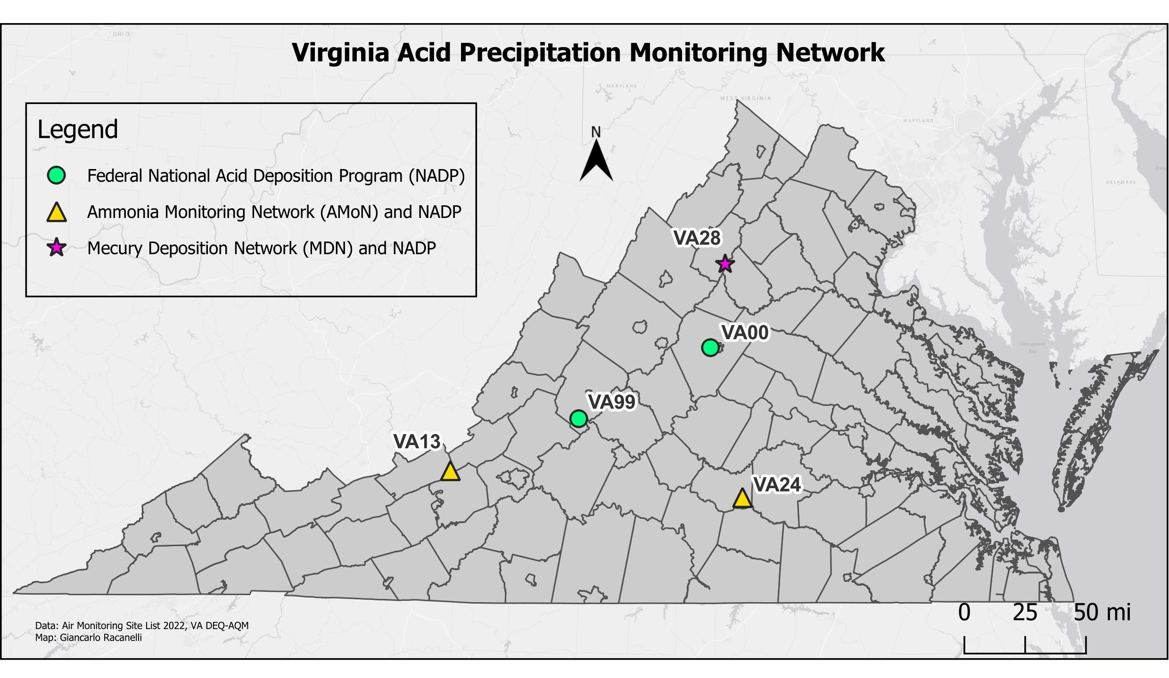
Site ID (NTN) | County/City | Station Location
VA28 | Madison | Big Meadows, Shenandoah National Park
VA00 | Albemarle | Charlottesville
VA99 | Rockbridge | USDA Forest Service, Natural Bridge Station
VA13 | Giles | Blue Grass Trail
VA24 | Prince Edward | Burkeville

Air Toxics Monitoring Network

In 2022, AQM operated an Air Toxics Monitoring Network (ATMN). The ATMN consists of two separate monitoring programs: the Urban Air Toxics Monitoring Program (UATM), and the National Air Toxics Trend Stations Program (NATTS).

The UATM program operated a site located at the Carter G. Woodson Middle School in Hopewell. Sampling at this site consisted of VOCs, Carbonyls, and Total Suspended Particulate (TSP) Metals. Each of the UATM sites had a sampling schedule consisting of 24-hour samples collected every 6th day. Data from these sites will be used to characterize air toxics concentrations in the respective urban areas.

AQM used the manual method for collecting ambient air samples for VOC analysis. Whole air samples were collected using evacuated Silco^{T} or SUMMA^{T} canisters and RMESI (RM Environmental Systems, Inc.) air samplers. DCLS analyzed samples using a Gas Chromatograph equipped with a Mass Selective Detector and employed method TO-15. Carbonyls were collected on DNPH (2,4-Dinitrophenylhydrazine) treated sorbent tubes using ATEC 8000 cartridge samplers. Samples taken were analyzed by the DCLS, using a Liquid Chromatographic procedure designated as method TO-11A. Metals samples were collected using a high volume Total Suspended Particulate (TSP) sampler and were analyzed by the DCLS. Analysis utilized inductively coupled plasma mass spectrometry (ICP-MS) using method IO-3.1 and IO-3.5.

The NATTS program operated one station located at the Math Science Innovation Center in Henrico County. The NATTS site had a sampling schedule consisting of 24-hour samples collected every 6th day (in accordance with the EPA Sampling Schedule). Data from this site will be evaluated along with data from all the NATTS sites nationally. AQM used the manual method for collecting ambient air samples for VOC analysis. Whole air samples were collected using evacuated Silco^{T} canisters and ATEC 2200 canister air samplers. Each sample was analyzed by the DCLS, using a Gas Chromatograph equipped with a Mass Selective Detector, utilizing method TO-15. Carbonyls were collected on DNPH (2,4-Dinitrophenylhydrazine) treated sorbent tubes using ATEC 8000 cartridge samplers. Carbonyls samples were analyzed by DCLS using a Liquid Chromatographic procedure, and the TO-11a method. The PM10-metals samples were collected using a high volume PM10 sampler and analyzed by the DCLS. Analysis utilized Inductively Coupled Plasma Mass Spectrometry (ICP-MS) using method IO-3.1 and IO-3.5. The Polycyclic Aromatic Hydrocarbons (PAH) samples are collected using polyurethane foam sampling cartridges and analyzed using EPA method TO-13a. The TO-13a analysis is performed by EPA’s contract laboratory ERG.

Air Toxics Monitoring Network

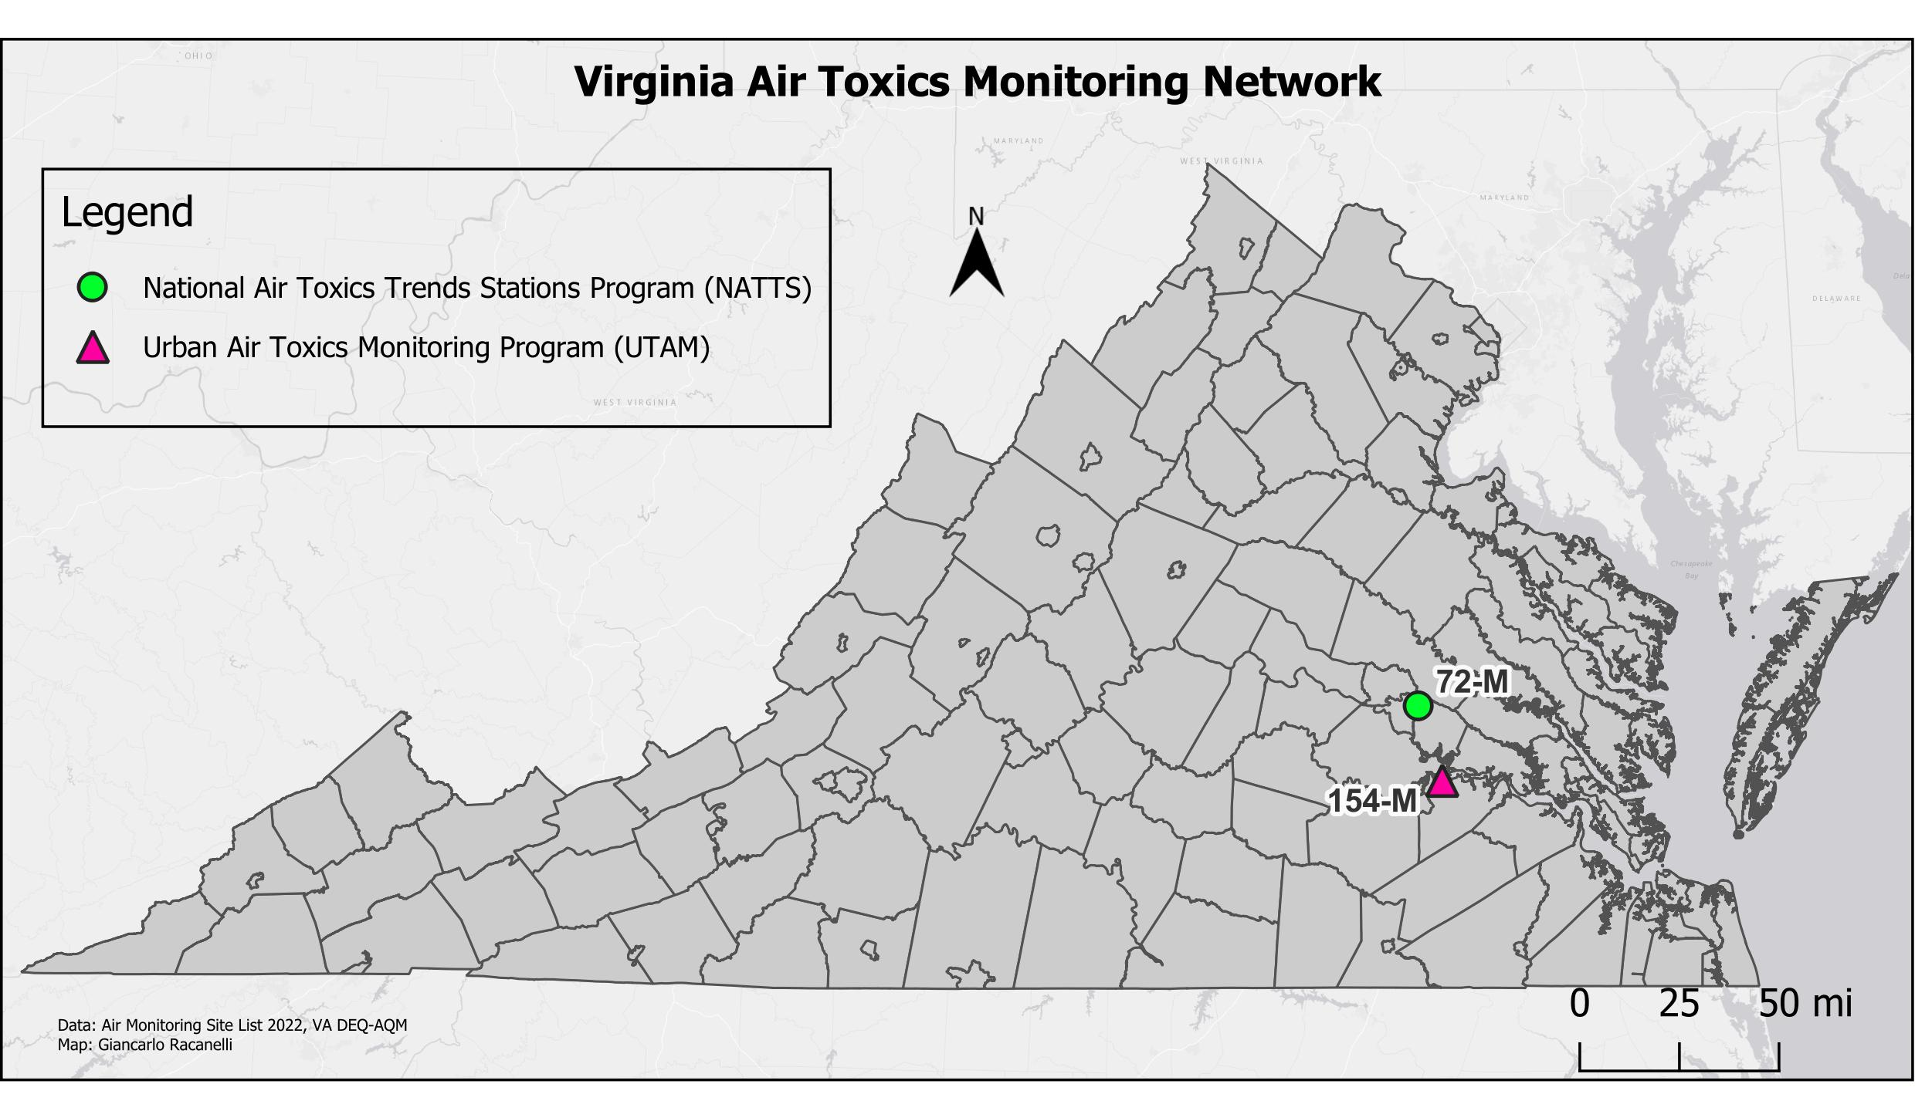

Site ID | County/City | Station Location
72-M | Henrico | MathScience Innovation Center, 2401 Hartman St.
154-M | Hopewell | Carter Woodson Middle School

The NATTS site in Richmond collects ambient air samples for air toxics, also called HAPs (Hazardous Air Pollutants), which are regulated under the 1990 amendments of the Clean Air Act. There are 188 HAPs regulated by CAA Section 112, however 62 have been identified as “Analytes of Principal Interest” for the NATTS program by EPA. These HAPS are typically classified as either VOC (measured with method TO-15), carbonyls (method TO-11a), metals (method IO-3.5) or PAHs (method TO-13a). The analytes are divided into Tier I or Tier II based on their cancer risk and non-cancer hazard quotient and 18 of these are identified as Tier I analytes by EPA. The table below provides a list of the Tier I analytes of interest with their analytes class, and their measurement method.

HAP | Analyte class | Measurement method | NATTS required MDL (ug/m3)
Acrolein | VOC | TO-15 | 0.09
Tetrachloroethylene | VOC | TO-15 | 0.17
Benzene | VOC | TO-15 | 0.13
Carbon tetrachloride | VOC | TO-15 | 0.17
Chloroform | VOC | TO-15 | 0.50
Trichloroethylene | VOC | TO-15 | 0.20
1,3-butadiene | VOC | TO-15 | 0.10
Vinyl chloride | VOC | TO-15 | 0.11
Formaldehyde | carbonyl | TO-11a | 0.08
Acetaldehyde | carbonyl | TO-11a | 0.45
Naphthalene | PAH | TO-13a | 0.029
Benzo(a)pyrene | PAH | TO-13a | 0.00091
Arsenic | PM10 metal | IO-3.5 | 0.00023
Beryllium | PM10 metal | IO-3.5 | 0.00042
Cadmium | PM10 metal | IO-3.5 | 0.00056
Manganese | PM10 metal | IO-3.5 | 0.005
Lead | PM10 metal | IO-3.5 | 0.015
Nickel | PM10 metal | IO-3.5 | 0.0021

Detectable VOC in 24-Hour Canister Samples
GC/MSD - MathScience Innovation Center (NATTS Site), Henrico County
Jan. 1 - Dec. 31, 2022 Concentrations are in ppbV
(non-detects are counted as zeros for statistical purposes)

Parameter | Parameter Name | Count | Min | Max | Median | Average | StDev
43205 | Propylene | 43 | 0.00 | 0.50 | 0.00 | 0.015 | 0.080
43207 | Freon 113 | 43 | 0.06 | 0.10 | 0.07 | 0.073 | 0.008
43208 | Freon 114 | 43 | 0.00 | 0.00 | 0.00 | 0.000 | 0.000
43209 | Ethyl Acetate | 43 | 0.00 | 0.09 | 0.02 | 0.026 | 0.026
43218 | 1,3-butadiene | 60 | 0.00 | 0.09 | 0.00 | 0.001 | 0.011
43231 | Hexane | 43 | 0.03 | 0.27 | 0.09 | 0.105 | 0.056
43232 | Heptane | 43 | 0.00 | 0.15 | 0.05 | 0.057 | 0.036
43248 | Cyclohexane | 43 | 0.00 | 0.06 | 0.00 | 0.010 | 0.015
43372 | MTBE | 60 | 0.00 | 0.00 | 0.00 | 0.000 | 0.000
43441 | Methyl Methacrylate | 60 | 0.00 | 0.03 | 0.00 | 0.000 | 0.003
43505 | Acrolein | 60 | 0.00 | 0.92 | 0.22 | 0.310 | 0.227
43702 | Acetonitrile | 60 | 0.00 | 2.02 | 0.56 | 0.644 | 0.410
43704 | Acrylonitrile | 60 | 0.00 | 0.00 | 0.00 | 0.000 | 0.000
43801 | Chloromethane | 43 | 0.49 | 0.79 | 0.60 | 0.611 | 0.075
43802 | Dichloromethane | 60 | 0.00 | 0.40 | 0.16 | 0.185 | 0.077
43803 | Chloroform | 60 | 0.00 | 0.04 | 0.02 | 0.023 | 0.008
43804 | Carbon Tetrachloride | 60 | 0.00 | 0.09 | 0.07 | 0.064 | 0.020
43806 | Bromoform | 60 | 0.00 | 0.02 | 0.00 | 0.001 | 0.005
43811 | Trichlorofluoromethane | 43 | 0.16 | 0.39 | 0.22 | 0.225 | 0.033
43812 | Chloroethane | 43 | 0.00 | 0.00 | 0.00 | 0.000 | 0.000
43813 | 1,1-Dichloroethane | 43 | 0.00 | 0.00 | 0.00 | 0.000 | 0.000
43814 | Methyl chloroform | 43 | 0.00 | 0.00 | 0.00 | 0.000 | 0.000
43815 | Ethylene dichloride | 43 | 0.00 | 0.03 | 0.00 | 0.009 | 0.010
43817 | Tetrachloroethylene | 60 | 0.00 | 0.09 | 0.01 | 0.014 | 0.013
43818 | 1,1,2,2-Tetrachloroethane | 60 | 0.00 | 0.02 | 0.00 | 0.001 | 0.004
43819 | Bromomethane | 43 | 0.00 | 0.02 | 0.00 | 0.000 | 0.003
43820 | 1,1,2-Trichloroethane | 60 | 0.00 | 0.02 | 0.00 | 0.001 | 0.004
43823 | Dichlorodifluoromethane | 43 | 0.18 | 0.62 | 0.49 | 0.480 | 0.071
43824 | Trichloroethylene | 60 | 0.00 | 0.02 | 0.00 | 0.001 | 0.003
43826 | 1,1-Dichloroethylene | 43 | 0.00 | 0.00 | 0.00 | 0.000 | 0.000
43828 | Bromodichloromethane | 43 | 0.00 | 0.00 | 0.00 | 0.000 | 0.000
43829 | 1,2-Dichloropropane | 43 | 0.00 | 0.00 | 0.00 | 0.000 | 0.000
43830 | trans-1,3-Dichlopropylene | 60 | 0.00 | 0.00 | 0.00 | 0.000 | 0.000
43831 | cis-1,3-Dichlopropylene | 60 | 0.00 | 0.01 | 0.00 | 0.000 | 0.001
43832 | Dibromochloromethane | 43 | 0.00 | 0.01 | 0.00 | 0.000 | 0.002
43838 | Trans-1,2-Dichloroethene | 43 | 0.00 | 0.00 | 0.00 | 0.000 | 0.000
43839 | cis-1,2-Dichloroethene | 43 | 0.00 | 0.01 | 0.00 | 0.000 | 0.001
43843 | Ethylene Dibromide | 43 | 0.00 | 0.04 | 0.00 | 0.002 | 0.008
43844 | Hexachlorobutadiene | 60 | 0.00 | 0.02 | 0.00 | 0.001 | 0.003
43860 | Vinyl Chloride | 60 | 0.00 | 0.00 | 0.00 | 0.000 | 0.000
45109 | m/p-Xylene | 60 | 0.02 | 0.32 | 0.13 | 0.128 | 0.071
45201 | Benzene | 60 | 0.00 | 0.27 | 0.00 | 0.080 | 0.091
45202 | Toluene | 60 | 0.05 | 0.57 | 0.24 | 0.244 | 0.121
45203 | Ethylbenzene | 43 | 0.01 | 0.14 | 0.04 | 0.045 | 0.028
45204 | o-Xylene | 60 | 0.01 | 0.13 | 0.05 | 0.052 | 0.028
45207 | 1,3,5-Trimethylbenzene | 43 | 0.00 | 0.09 | 0.02 | 0.018 | 0.016
45208 | 1,2,4-Trimethylbenzene | 43 | 0.00 | 0.30 | 0.05 | 0.061 | 0.054
45213 | p-Ethyltoluene | 43 | 0.00 | 0.17 | 0.02 | 0.031 | 0.035
45220 | Styrene | 60 | 0.00 | 0.65 | 0.03 | 0.056 | 0.100
45801 | Chlorobenzene | 60 | 0.00 | 0.07 | 0.00 | 0.009 | 0.016
45805 | 1,2-Dichlorobenzene | 43 | 0.00 | 0.17 | 0.04 | 0.054 | 0.057
45806 | 1,3-Dichlorobenzene | 43 | 0.00 | 0.22 | 0.09 | 0.077 | 0.075
45807 | 1,4-Dichlorobenzene | 60 | 0.00 | 0.28 | 0.07 | 0.073 | 0.076
45810 | 1,2,4-Trichlorobenzene | 60 | 0.00 | 0.71 | 0.00 | 0.066 | 0.137
46401 | Tetrahydrofuran | 43 | 0.00 | 0.10 | 0.00 | 0.017 | 0.029

Detectable VOC in 24-Hour Canister Samples
GC/MSD - Carter G. Woodson Middle School (UATM Site), Hopewell
Jan. 1 - Dec. 31, 2022 - Concentrations are in ppbV
(Non-detects are considered zeros for statistical purposes. Results below MDLs and/or Reporting Limits are reported.)

Parameter | Parameter Name | Count | Min | Max | Median | Average | StDev
43205 | Propylene | 41 | 0.00 | 1.32 | 0 | 0.045 | 0.220
43207 | Freon 113 | 41 | 0.06 | 0.31 | 0.08 | 0.094 | 0.050
43208 | Freon 114 | 41 | 0 | 0 | 0 | 0.000 | 0.000
43209 | Ethyl Acetate | 41 | 0 | 0.15 | 0.03 | 0.039 | 0.041
43218 | 1,3-butadiene | 58 | 0 | 0.14 | 0 | 0.002 | 0.018
43231 | Hexane | 41 | 0.02 | 0.3 | 0.08 | 0.092 | 0.057
43232 | Heptane | 41 | 0.01 | 0.45 | 0.07 | 0.090 | 0.090
43248 | Cyclohexane | 41 | 0 | 0.05 | 0 | 0.013 | 0.015
43372 | MTBE | 58 | 0 | 0 | 0 | 0.000 | 0.000
43441 | Methyl Methacrylate | 58 | 0 | 0.07 | 0 | 0.002 | 0.011
43505 | Acrolein | 58 | 0 | 0.88 | 0.255 | 0.317 | 0.193
43702 | Acetonitrile | 58 | 0 | 3.57 | 0.255 | 0.388 | 0.644
43704 | Acrylonitrile | 58 | 0 | 0.05 | 0 | 0.001 | 0.007
43801 | Chloromethane | 41 | 0.49 | 0.77 | 0.62 | 0.623 | 0.073
43802 | Dichloromethane | 58 | 0.07 | 0.21 | 0.1 | 0.102 | 0.024
43803 | Chloroform | 58 | 0 | 0.05 | 0.03 | 0.025 | 0.010
43804 | Carbon Tetrachloride | 58 | 0 | 0.08 | 0.065 | 0.059 | 0.020
43806 | Bromoform | 58 | 0 | 0.05 | 0 | 0.003 | 0.009
43811 | Trichlorofluoromethane | 41 | 0.15 | 0.26 | 0.22 | 0.221 | 0.024
43812 | Chloroethane | 41 | 0 | 0.05 | 0 | 0.001 | 0.008
43813 | 1,1-Dichloroethane | 41 | 0 | 0 | 0 | 0.000 | 0.000
43814 | Methyl chloroform | 41 | 0 | 0 | 0 | 0.000 | 0.000
43815 | Ethylene dichloride | 41 | 0 | 0.03 | 0 | 0.009 | 0.010
43817 | Tetrachloroethylene | 58 | 0 | 0.06 | 0.01 | 0.015 | 0.014
43818 | 1,1,2,2-Tetrachloroethane | 58 | 0 | 0.03 | 0 | 0.002 | 0.006
43819 | Bromomethane | 41 | 0 | 0.02 | 0 | 0.001 | 0.005
43820 | 1,1,2-Trichloroethane | 58 | 0 | 0.03 | 0 | 0.001 | 0.005
43823 | Dichlorodifluoromethane | 41 | 0.36 | 0.59 | 0.49 | 0.486 | 0.052
43824 | Trichloroethylene | 58 | 0 | 0.02 | 0 | 0.001 | 0.003
43826 | 1,1-Dichloroethylene | 41 | 0 | 0 | 0 | 0.000 | 0.000
43828 | Bromodichloromethane | 41 | 0 | 0 | 0 | 0.000 | 0.000
43829 | 1,2-Dichloropropane | 41 | 0 | 0.02 | 0 | 0.000 | 0.003
43830 | trans-1,3-Dichlopropylene | 58 | 0 | 0.02 | 0 | 0.001 | 0.003
43831 | cis-1,3-Dichlopropylene | 58 | 0 | 0.02 | 0 | 0.000 | 0.003
43832 | Dibromochloromethane | 41 | 0 | 0.02 | 0 | 0.002 | 0.005
43838 | Trans-1,2-Dichloroethene | 41 | 0 | 0 | 0 | 0.000 | 0.000
43839 | cis-1,2-Dichloroethene | 41 | 0 | 0 | 0 | 0.000 | 0.000
43843 | Ethylene Dibromide | 41 | 0 | 0.05 | 0 | 0.006 | 0.014
43844 | Hexachlorobutadiene | 58 | 0 | 0.02 | 0 | 0.001 | 0.004
43860 | Vinyl Chloride | 58 | 0 | 0 | 0 | 0.000 | 0.000
45109 | m/p-Xylene | 58 | 0.02 | 0.72 | 0.105 | 0.119 | 0.111
45201 | Benzene | 58 | 0.05 | 0.72 | 0.12 | 0.150 | 0.108
45202 | Toluene | 58 | 0.04 | 0.89 | 0.205 | 0.224 | 0.158
45203 | Ethylbenzene | 41 | 0 | 1.42 | 0.03 | 0.067 | 0.218
45204 | o-Xylene | 58 | 0 | 0.29 | 0.04 | 0.049 | 0.046
45207 | 1,3,5-Trimethylbenzene | 41 | 0 | 0.21 | 0.01 | 0.016 | 0.032
45208 | 1,2,4-Trimethylbenzene | 41 | 0 | 0.7 | 0.03 | 0.055 | 0.107
45213 | p-Ethyltoluene | 41 | 0 | 0.23 | 0.02 | 0.026 | 0.039
45220 | Styrene | 58 | 0 | 0.17 | 0.02 | 0.035 | 0.046
45801 | Chlorobenzene | 58 | 0 | 0.09 | 0 | 0.010 | 0.023
45805 | 1,2-Dichlorobenzene | 41 | 0 | 0.25 | 0.02 | 0.070 | 0.078
45806 | 1,3-Dichlorobenzene | 41 | 0 | 0.3 | 0.11 | 0.097 | 0.092
45807 | 1,4-Dichlorobenzene | 58 | 0 | 0.38 | 0.035 | 0.081 | 0.098
45810 | 1,2,4-Trichlorobenzene | 58 | 0 | 0.63 | 0 | 0.059 | 0.138
46401 | Tetrahydrofuran | 41 | 0 | 0.06 | 0 | 0.007 | 0.015

24-Hour Carbonyl Sampling 2022 Summary Statistical Analysis
Concentrations are in ug/m³
(Non-detects are counted as zeros for statistical purposes)

Site | Parameter | Parameter Name | Num | Minimum | Maximum | Median | Average | StDev
Carter G.  Woodson  Middle School | 43502 | Formaldehyde | 58 | 0.74 | 17.34 | 1.91 | 2.547 | 2.304
 | 43503 | Acetaldehyde | 58 | 0.47 | 3.66 | 1.07 | 1.076 | 0.485
 | 43504 | Propionaldehyde | 58 | 0.0 | 0.32 | 0.12 | 0.127 | 0.063
 | 43552 | Methyl Ethyl Ketone | 58 | 0.07 | 0.67 | 0.26 | 0.258 | 0.119
 | 43560 | Methyl Isobutyl Ketone | 58 | 0.00 | 0.07 | 0.02 | 0.025 | 0.060

NATTS Carbonyl Sampling 2022 Summary Statistical Analysis
Concentrations are in ug/m³
(Non-detects are counted as zeros for statistical purposes)

Site | Parameter | Parameter Name | Num | Minimum | Maximum | >MDL | Average | StDev
MathScienceInnovation  Center | 43502 | Formaldehyde | 60 | 0.91 | 6.65 | 60 | 2.732 | 1.398
 | 43503 | Acetaldehyde | 60 | 0.64 | 2.01 | 60 | 1.173 | 0.332
 | 43504 | Propionaldehyde | 60 | 0.01 | 0.35 | 60 | 0.201 | 0.065
 | 43551 | Acetone | 60 | 0.96 | 4.42 | 60 | 2.383 | 0.988
 | 43552 | Methyl Ethyl Ketone | 59 | 0.11 | 0.79 | 59 | 0.334 | 0.136
 | 43560 | Methyl Isobutyl Ketone | 54 | 0.00 | 0.14 | 27 | 0.031 | 0.030

NATTS PAH Sampling 2022 Summary Statistical Analysis
Site: MathScience Innovation Center, Richmond

Parameter | Parameter Name | 2018 | 2019 | 2020 | 2021 | 2022
 |  | Annual Mean (nanograms/m³)
17141 | Naphthalene | 47.820 | 56.341 | 38.355 | 44.444 | 46.888
17147 | Acenaphthene | 2.815 | 3.353 | 2.073 | 1.978 | 2.221
17148 | Acenaphthylene | 0.245 | 0.246 | 0.139 | 0.121 | 0.130
17149 | Fluorene | 2.966 | 3.138 | 2.142 | 2.636 | 2.211
17150 | Phenanthrene | 6.124 | 6.137 | 4.528 | 5.581 | 5.118
17151 | Anthracene | 0.101 | 0.090 | 0.085 | 0.089 | 0.090
17201 | Fluoranthene | 1.418 | 1.357 | 0.920 | 1.098 | 1.014
17204 | Pyrene | 0.640 | 0.546 | 0.448 | 0.501 | 0.463
17208 | Chrysene | 0.115 | 0.098 | 0.067 | 0.000 | 0.059
17212 | Perylene | 0.007 | 0.004 | 0.001 | 0.009 | 0.000
17215 | Benzo[a]anthracene | 0.044 | 0.036 | 0.025 | 0.044 | 0.030
17220 | Benzo[b]fluoranthene | 0.141 | 0.131 | 0.091 | 0.239 | 0.062
17223 | Benzo[k]fluoranthene | 0.039 | 0.036 | 0.025 | 0.041 | 0.029
17224 | Benzo[e]pyrene | 0.069 | 0.073 | 0.049 | 0.067 | 0.052
17231 | Dibenzo[a,h] anthracene | 0.012 | 0.009 | 0.004 | 0.008 | 0.002
17237 | Benzo[g,h,i]perylene | 0.068 | 0.066 | 0.057 | 0.073 | 0.062
17242 | Benzo[a]pyrene | 0.045 | 0.044 | 0.025 | 0.067 | 0.035
17243 | Indeno[1,2,3-cd]pyrene | 0.072 | 0.075 | 0.046 | 0.074 | 0.042

TSP Metals Sampling 2022 Summary Statistical Analysis
Site: Carter G. Woodson Middle School, Hopewell
Concentrations are in ng/m³
(Non-detects are counted as zero for statistical purposes)

Parameter | Parameter Name | No. Samples Collected | Min | Max | Median | Average | Std Dev
12103 | Arsenic | 61 | 0.24 | 5.19 | 0.60 | 0.830 | 0.840
12105 | Beryllium | 61 | 0.00 | 0.03 | 0.01 | 0.07 | 0.007
12110 | Cadmium | 61 | 0.00 | 0.46 | 0.07 | 0.076 | 0.061
12112 | Chromium | 61 | 1.14 | 3.77 | 1.59 | 1.721 | 0.474
12128 | Lead | 61 | 0.50 | 3.79 | 1.70 | 1.810 | 0.756
12132 | Manganese | 61 | 1.53 | 94.38 | 7.05 | 9.909 | 11.880
12136 | Nickel | 61 | 0.34 | 5.40 | 0.58 | 0.840 | 0.826

NATTS PM10 Metals Sampling 2022 Summary Statistical Analysis
Site: MathScience Innovation Center, Richmond
Concentrations are in ng/m³
(non-detects are counted as zero for statistical purposes)

Parameter | Compound Name | Number of Samples | Min | Max | Median | Average | Std Dev
85103 | Arsenic | 60 | 0.156 | 2.580 | 0.543 | 0.641 | 0.412
85105 | Beryllium | 60 | 0.000 | 0.023 | 0.003 | 0.005 | 0.006
85110 | Cadmium | 60 | 0.020 | 0.852 | 0.081 | 0.110 | 0.116
85112 | Chromium | 60 | 1.203 | 3.502 | 1.615 | 1.609 | 0.363
85128 | Lead | 60 | 0.691 | 25.115 | 1.489 | 2.034 | 3.092
85132 | Manganese | 60 | 0.510 | 5.061 | 2.142 | 2.294 | 1.042
85136 | Nickel | 60 | 0.288 | 1.087 | 0.498 | 0.506 | 0.126

Trend of VOCs at the NATTS site

Trend of carbonyls and PAHs at the NATTS site

Trend of PM10-metals at NATTS site

AQI (Air Quality Index)



What is the AQI?

The air quality index (AQI) is a measurement designed to indicate how clean the air is in an area, and it also provides information about health effects associated with air pollution. The index is reported daily, or in some cases continuously, and calculated from measured concentrations of five major pollutants regulated by the Clean Air Act: ground-level ozone, particulate matter, carbon monoxide, sulfur dioxide, and nitrogen dioxide. EPA has established national ambient air quality standards (NAAQS) for each of these pollutants to protect public health, and the index is derived from the NAAQS. State and local agencies are required to report the AQI in areas where the population is 350,000 or more, although it is often reported in additional areas as a public service.

How does the AQI work?

The AQI range is from 0 to 500, with the low numbers representing good air quality and the high numbers indicating unhealthy or even hazardous air quality. The index is divided into six categories with coordinating color codes. In addition, each category has a health-related message associated with it, to inform the public of possible health effects that may arise as a result of breathing polluted air.

Generally, an index of 100 corresponds to the national air quality standard for the pollutant, which is the level that EPA has established to protect public health. Levels below 100 are considered satisfactory, while numbers above 100 are considered unhealthy, first for sensitive groups, and then for the general public as the index value increases.

How is the AQI calculated?

The AQI is calculated from air pollution measurements collected at monitoring sites across the country. The reporting agency must calculate an index for each pollutant from the measured concentrations at all monitoring sites in an area using a standard formula developed by EPA. The pollutant with the highest index is reported as the “primary pollutant”, and the highest index is reported as the AQI for the area. If the AQI is above 100, then the agency must report which groups may be sensitive to the primary pollutant. If two or more pollutants have indexes above 100, then the agency must report all groups that may be affected by those pollutants.

How do I find the AQI for my area?

DEQ reports the air quality index for Roanoke, Winchester, Richmond, Hampton Roads, and Northern Virginia on its Air Quality Index webpage. Air quality forecasts and current air quality data can be obtained at the DEQ site, as well as links to other air quality websites. EPA also reports air quality conditions for the United States at AirNow.

In addition to the internet, current and forecasted AQI levels are broadcast on local television and radio weather reports in many areas, as well as printed in newspapers. By reaching out to the public using these different media, individuals can plan their activities to reduce exposure during episodes of poor air quality, and they can also take steps to reduce pollution.

For detailed information about the AQI, and on health effects of the pollutants that are included in the AQI, visit AirNow.

Air Quality Index  (0-500) | Levels of Health Concern | Meaning
(0-50) | Good | Air quality is considered satisfactory, and air pollution poses little or no risk.
(51-100) | Moderate | Air quality is acceptable; however, for some pollutants there may be a moderate health concern for a very small number of people who are unusually sensitive to air pollution.
(101-150) | Unhealthy for  Sensitive Groups | Members of sensitive groups may experience health effects. The general public is not likely to be affected.
(151-200) | Unhealthy | Everyone may begin to experience health effects; members of sensitive groups may experience more serious health effects.
(201-300) | Very Unhealthy | Health warnings of emergency conditions. The entire population is more likely to be affected.
(301-500) | Hazardous | Health alert: everyone may experience more serious health effects.

Note: Values above 500 are considered Beyond the AQI. Follow recommendations for the "Hazardous category." Additional information on reducing exposure to extremely high levels of particle pollution is available “here”

OZONE
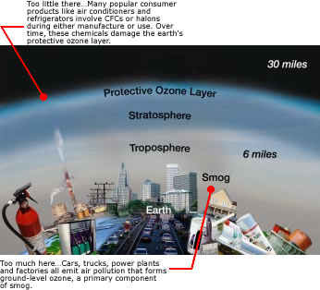

What is ozone?
Ozone is a gas that occurs both in the Earth's upper atmosphere and at ground level. Ozone can be "good" or "bad" for your health and the environment, depending on its location in the atmosphere.

How Can Ozone Be Both Good and Bad?
Ozone occurs in two layers of the atmosphere. The layer closest to the Earth's surface is the troposphere. Here, ground-level or "bad" ozone is an air pollutant that is harmful to breathe and it damages crops, trees and other vegetation. It is a main ingredient of urban smog. The troposphere generally extends to a level about 6 miles up, where it meets the second layer, the stratosphere. The stratosphere or "good" ozone layer extends upward from about 6 to 30 miles and protects life on Earth from the sun's harmful ultraviolet (UV) rays.

What is Happening to the "Good" Ozone Layer?
Ozone is produced naturally in the stratosphere. But this "good" ozone is gradually being destroyed by man-made chemicals referred to as ozone-depleting substances (ODS), including chlorofluorocarbons (CFCs), hydrochlorofluorocarbons (HCFCs), halons, methyl bromide, carbon tetrachloride, and methyl chloroform. These substances were formerly used and sometimes still are used in coolants, foaming agents, fire extinguishers, solvents, pesticides, and aerosol propellants. Once released into the air these ozone-depleting substances degrade very slowly. In fact, they can remain intact for years as they move through the troposphere until they reach the stratosphere. There they are broken down by the intensity of the sun's UV rays and release chlorine and bromine molecules, which destroy the "good" ozone. Scientists estimate that one chlorine atom can destroy 100,000 "good" ozone molecules.
Even though we have reduced or eliminated the use of many ODSs, their use in the past can still affect the protective ozone layer. Research indicates that depletion of the "good" ozone layer is being reduced worldwide. Thinning of the protective ozone layer can be observed using satellite measurements, particularly over the Polar Regions.

How Does the Depletion of "Good" Ozone Affect Human Health and the Environment?
Ozone depletion can cause increased amounts of UV radiation to reach the Earth which can lead to more cases of skin cancer, cataracts, and impaired immune systems. Overexposure to UV is believed to be contributing to the increase in melanoma, the most fatal of all skin cancers. Since 1990, the risk of developing melanoma has more than doubled.
UV can also damage sensitive crops, such as soybeans, and reduce crop yields. Some scientists suggest that marine phytoplankton, which are the base of the ocean food chain, are already under stress from UV radiation. This stress could have adverse consequences for human food supplies from the oceans.

What is Being Done About the Depletion of "Good" Ozone?
The United States, along with over 180 other countries, recognized the threats posed by ozone depletion and in 1987 adopted a treaty called the Montreal Protocol to phase out the production and use of ozone-depleting substances.
EPA has established regulations to phase out ozone-depleting chemicals in the United States. Warning labels must be placed on all products containing CFCs or similar substances and nonessential uses of ozone-depleting products are prohibited. Releases into the air of refrigerants used in car and home air conditioning units and appliances are also prohibited. Some substitutes to ozone-depleting products have been produced and others are being developed. If the United States and other countries stop producing ozone-depleting substances, natural ozone production should return the ozone layer to normal levels by about 2050.

What Causes "Bad" Ozone?
Ground-level or "bad" ozone is not emitted directly into the air, but is created by chemical reactions between oxides of nitrogen (NOx) and volatile organic compounds (VOC) in the presence of sunlight. Emissions from industrial facilities and electric utilities, motor vehicle exhaust, gasoline vapors, and chemical solvents are some of the major sources of NOx and VOC.
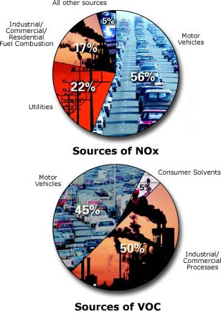
At ground level, ozone is a harmful pollutant. Ozone pollution is a concern during the summer months because strong sunlight and hot weather result in harmful ozone concentrations in the air we breathe. Many urban and suburban areas throughout the United States have high levels of "bad" ozone. But many rural areas of the country are also subject to high ozone levels as winds carry emissions hundreds of miles away from their original sources.

How Does "Bad" Ozone Affect Human Health and the Environment?
Breathing ozone can trigger a variety of health problems including chest pain, coughing, and throat irritation. It can worsen bronchitis, emphysema, and asthma. "Bad" ozone also can reduce lung function and inflame the linings of the lungs. Repeated exposure may permanently scar lung tissue.
Healthy people also experience difficulty breathing when exposed to ozone pollution. Because ozone forms in hot weather, anyone who spends time outdoors in the summer may be affected, particularly children, older people, outdoor workers and people exercising. Millions of Americans live in areas where the national ozone health standards are exceeded.
Ground-level or "bad" ozone also damages vegetation and ecosystems. It leads to reduced agricultural crop and commercial forest yields, reduced growth and survivability of tree seedlings, and increased susceptibility to diseases, pests and other stresses such as harsh weather. In the United States alone, ground-level ozone is responsible for an estimated $500 million in reduced crop production each year. Ground-level ozone also damages the foliage of trees and other plants, affecting the landscape of cities, national parks and forests, and recreation areas.

What Is Being Done About "Bad" Ozone?
Under the Clean Air Act, EPA has set protective health-based standards for ozone in the air we breathe. EPA, state, and cities have instituted a variety of multi-faceted programs to meet these health-based standards. Throughout the country, additional programs are being put into place to cut NOx and VOC emissions from vehicles, industrial facilities, and electric utilities. Programs are also aimed at reducing pollution by reformulating fuels and consumer/commercial products, such as paints and chemical solvents, that contain VOC. Voluntary programs also encourage communities to adopt practices, such as carpooling, to reduce harmful emissions.
High-Altitude "Good" Ozone
- Protect yourself against sunburn. When the UV Index is "high" or "very high": Limit outdoor activities between 10 am and 4 pm, when the sun is most intense. Twenty minutes before going outside, liberally apply a broad-spectrum sunscreen with a Sun Protection Factor (SPF) of at least 15. Reapply every two hours or after swimming or sweating. For UV Index forecasts, check local media reports or visit: sun safety
- Use approved refrigerants in air conditioning and refrigeration equipment. Make sure technicians that work on your car or home air conditioners or refrigerator are certified to recover the refrigerant. Repair leaky air conditioning units before refilling them.

Ground-Level "Bad" Ozone
- Check the air quality forecast in your area. At times when the Air Quality Index (AQI) is forecast to be unhealthy, limit physical exertion outdoors. In many places, ozone peaks in mid-afternoon to early evening. Change the time of day of strenuous outdoor activity to avoid these hours, or reduce the intensity of the activity. For AQI forecasts, check your local media reports or visit: http://epa.gov/airnow
- Help your local electric utilities reduce ozone air pollution by conserving energy at home and the office. Consider setting your thermostat a little higher in the summer. Participate in your local utilities' load-sharing and energy conservation programs.
- Reduce air pollution from cars, trucks, gas-powered lawn and garden equipment, boats and other engines by keeping equipment properly tuned and maintained. During the summer, fill your gas tank during the cooler evening hours and be careful not to spill gasoline. Reduce driving, carpool, use public transportation, walk, or bicycle to reduce ozone pollution, especially on hot summer days.
- Use household and garden chemicals wisely. Use low VOC paints and solvents. And be sure to read labels for proper use and disposal.

For more information, please visit these sites:
Airnow
Air Topics



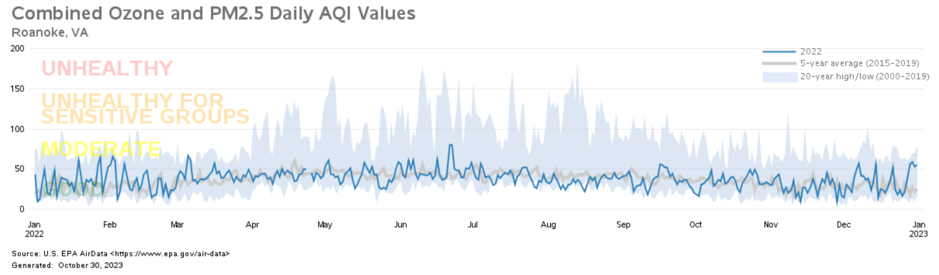

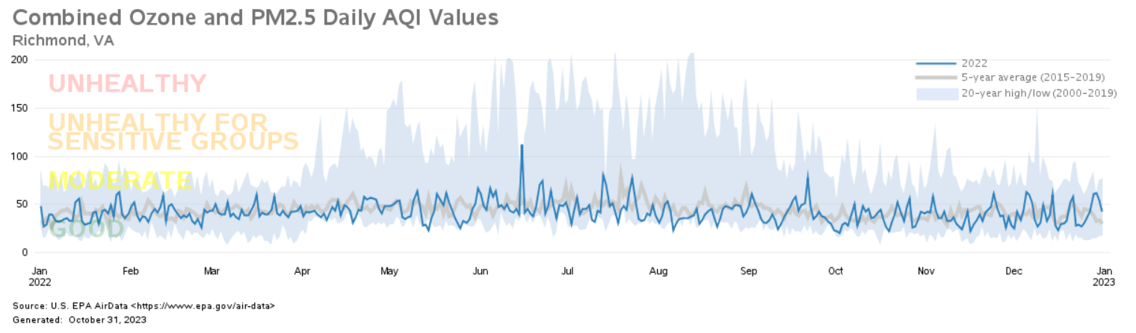

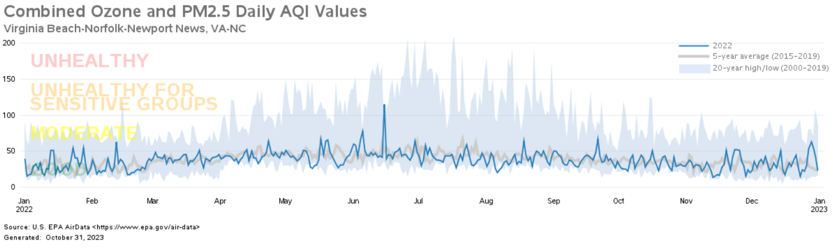

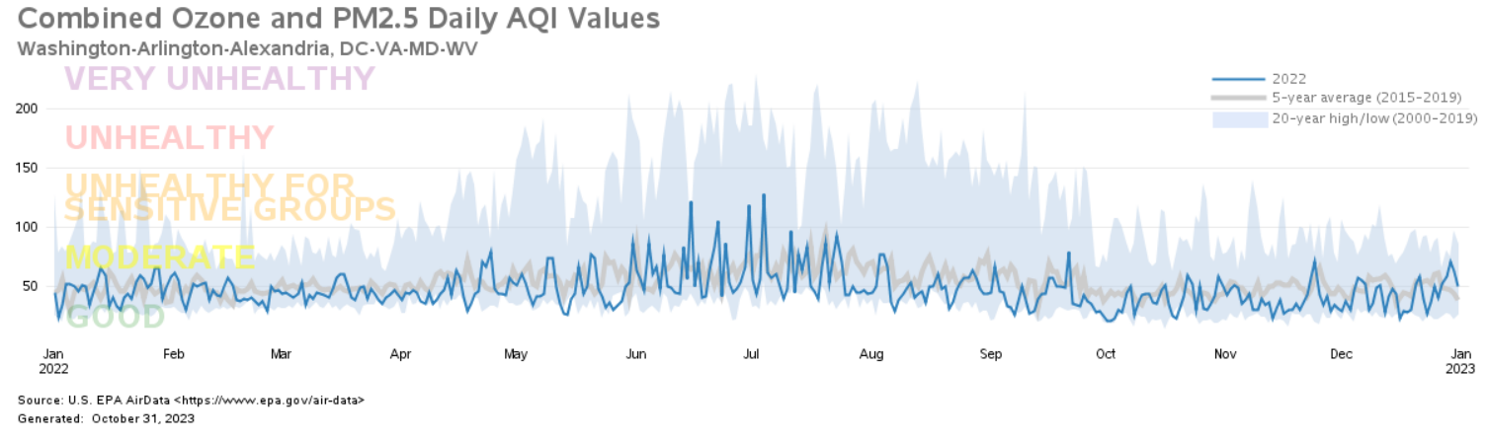

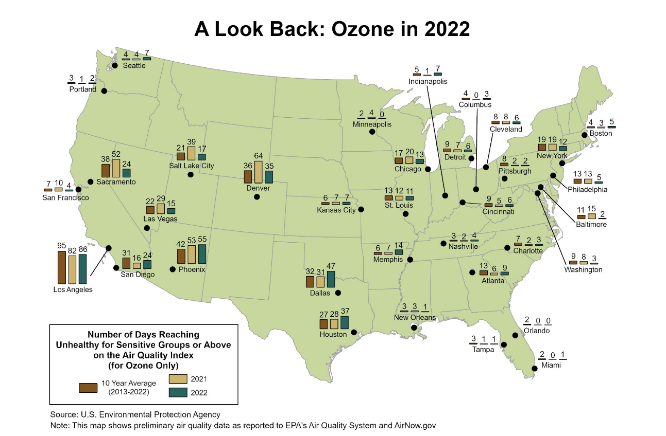
A number of factors influence ozone formation, including emissions from cars, trucks,
buses, power plants, and industries, along with weather conditions. Weather is especially favorable for ozone formation when it’s hot, dry and sunny, and winds are calm and light. Federal and state regulations, including regulations for power plants, vehicles and fuels, are helping reduce ozone pollution nationwide.
For the 35 metropolitan areas in this story map, the graphic below shows the total number of unhealthy days for ozone pollution since the year 2000.

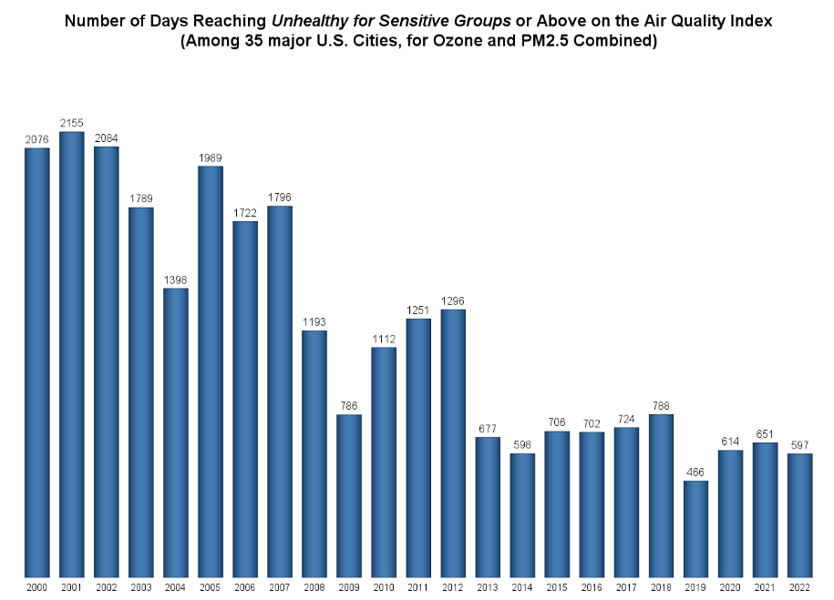

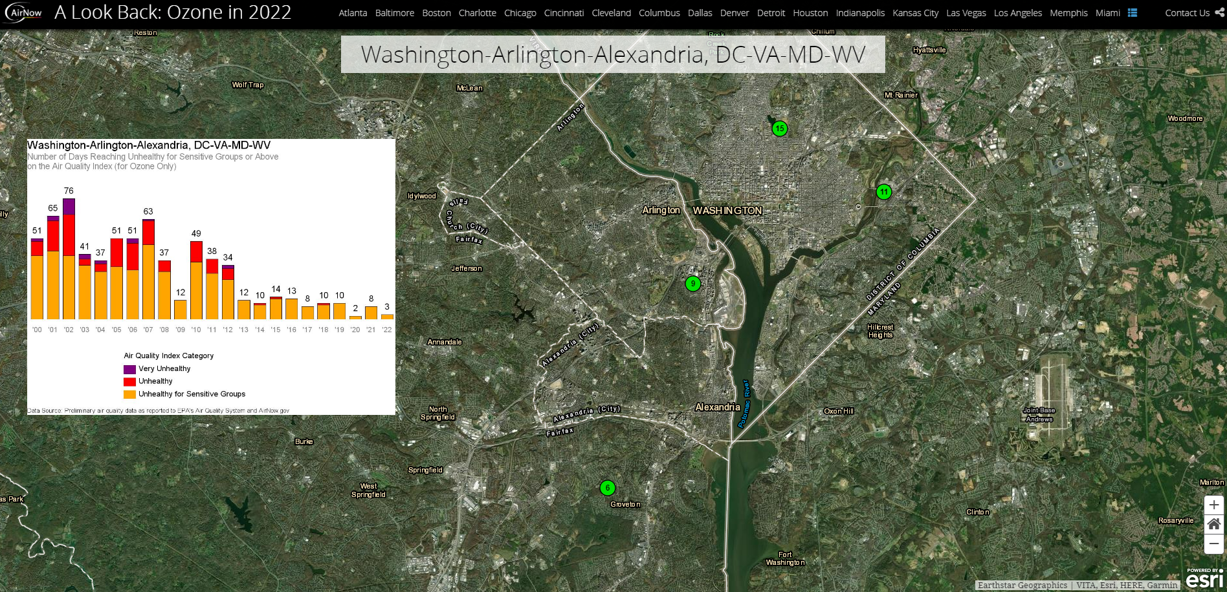
For more information, please visit these EPA sites:

A Look Back in 2022
National Air Quality: Status and Trends of Key Air Pollutants

Appendix A

Abbreviation Table

AMoN Ammonia Monitoring Network
AQM Air Quality Monitoring
AQCR Air Quality Control Region
ATMN Air Toxics Monitoring Network
Avg. Average
CAMP Community Air Toxics Assessment Monitoring Program
CASTNET Clean Air Status and Trends Network
CO Carbon Monoxide
DEQ Department of Environmental Quality
FEM Federal Equivalent Method
EPA Environmental Protection Agency
FRM Federal Reference Method
IMPROVE Interagency Monitoring of Protected Visual Environments
LAT Latitude
LC Local Conditions
LONG Longitude
MARAMA Mid-Atlantic Regional Air Management Association
MDL Minimum Detectable Limit
MDN Mercury Deposition Network
MET. Meteorological Instrumentation
MSA Metropolitan Statistical Area
NA Not Available
NADP National Acid Deposition Program
NAMS National Air Monitoring Stations
NATTS National Air Toxics Trend Stations
NMOC Non-Methane Organic Compounds
NO₂ Nitrogen Dioxide
NUM Number of Samples
O₃ Ozone
PAMHC Total PAMS Hydrocarbon
PAMS Photochemical Assessment Monitoring Station
PM₁₀ Particulate Matter with an aerodynamic diameter less than or equal to 10 microns
PM_{2.5} Particulate Matter with an aerodynamic diameter less than or
equal to 2.5 microns
POLLUT. Pollutant
ppbC Part Per Billion of Carbon
ppbv Part Per Billion by volume
ppm Part Per Million
SESARM Southeastern States Air Resource Managers, Inc.
SLAMS State and Local Air Monitoring Station
SO₂ Sulfur Dioxide
STD Standard
STDEV Standard Deviation
TEOM Tapered Element Oscillating Microbalance (a method for
continuously measuring PM_{2.5} in ambient air)
TNMOC Total Nonmethane Organic Compound
UATM Urban Air Toxics Monitoring Program
µg/m³ Micrograms per cubic meter
VOC Volatile Organic Compounds

Southwest Monitoring Network

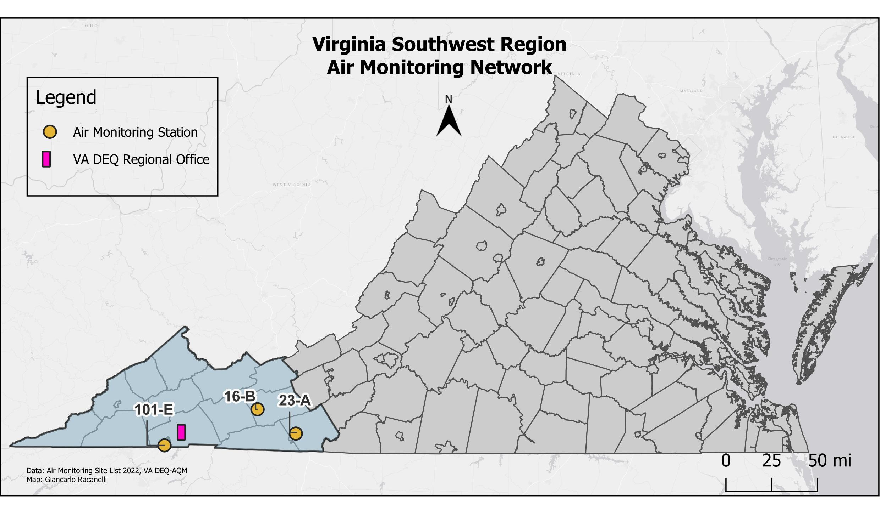

STATION  NUMBER | POLLUT. | LOCATION | EPA ID | CITY/COUNTY | LAT/LONG
16-B | O₃ | Sewage Disposal Plant | 51-197-0002 | Rural Retreat  Wythe Co. | 36.89117  -81.25423
23-A | PM₁₀ | Gladeville Elementary School | 51-035-0001 | Galax  Carroll Co. | 36.70067  -80.87978
101-E | PM_{2.5} | Highland View Elementary School | 51-520-0006 | Bristol | 36.60800  -82.16410

Contact Information for this Region:
Southwest Regional Office
Jeffery Hurst, Director
355-A Deadmore Street
Abingdon, VA 24210
(276) 676-4800

Valley Monitoring Network

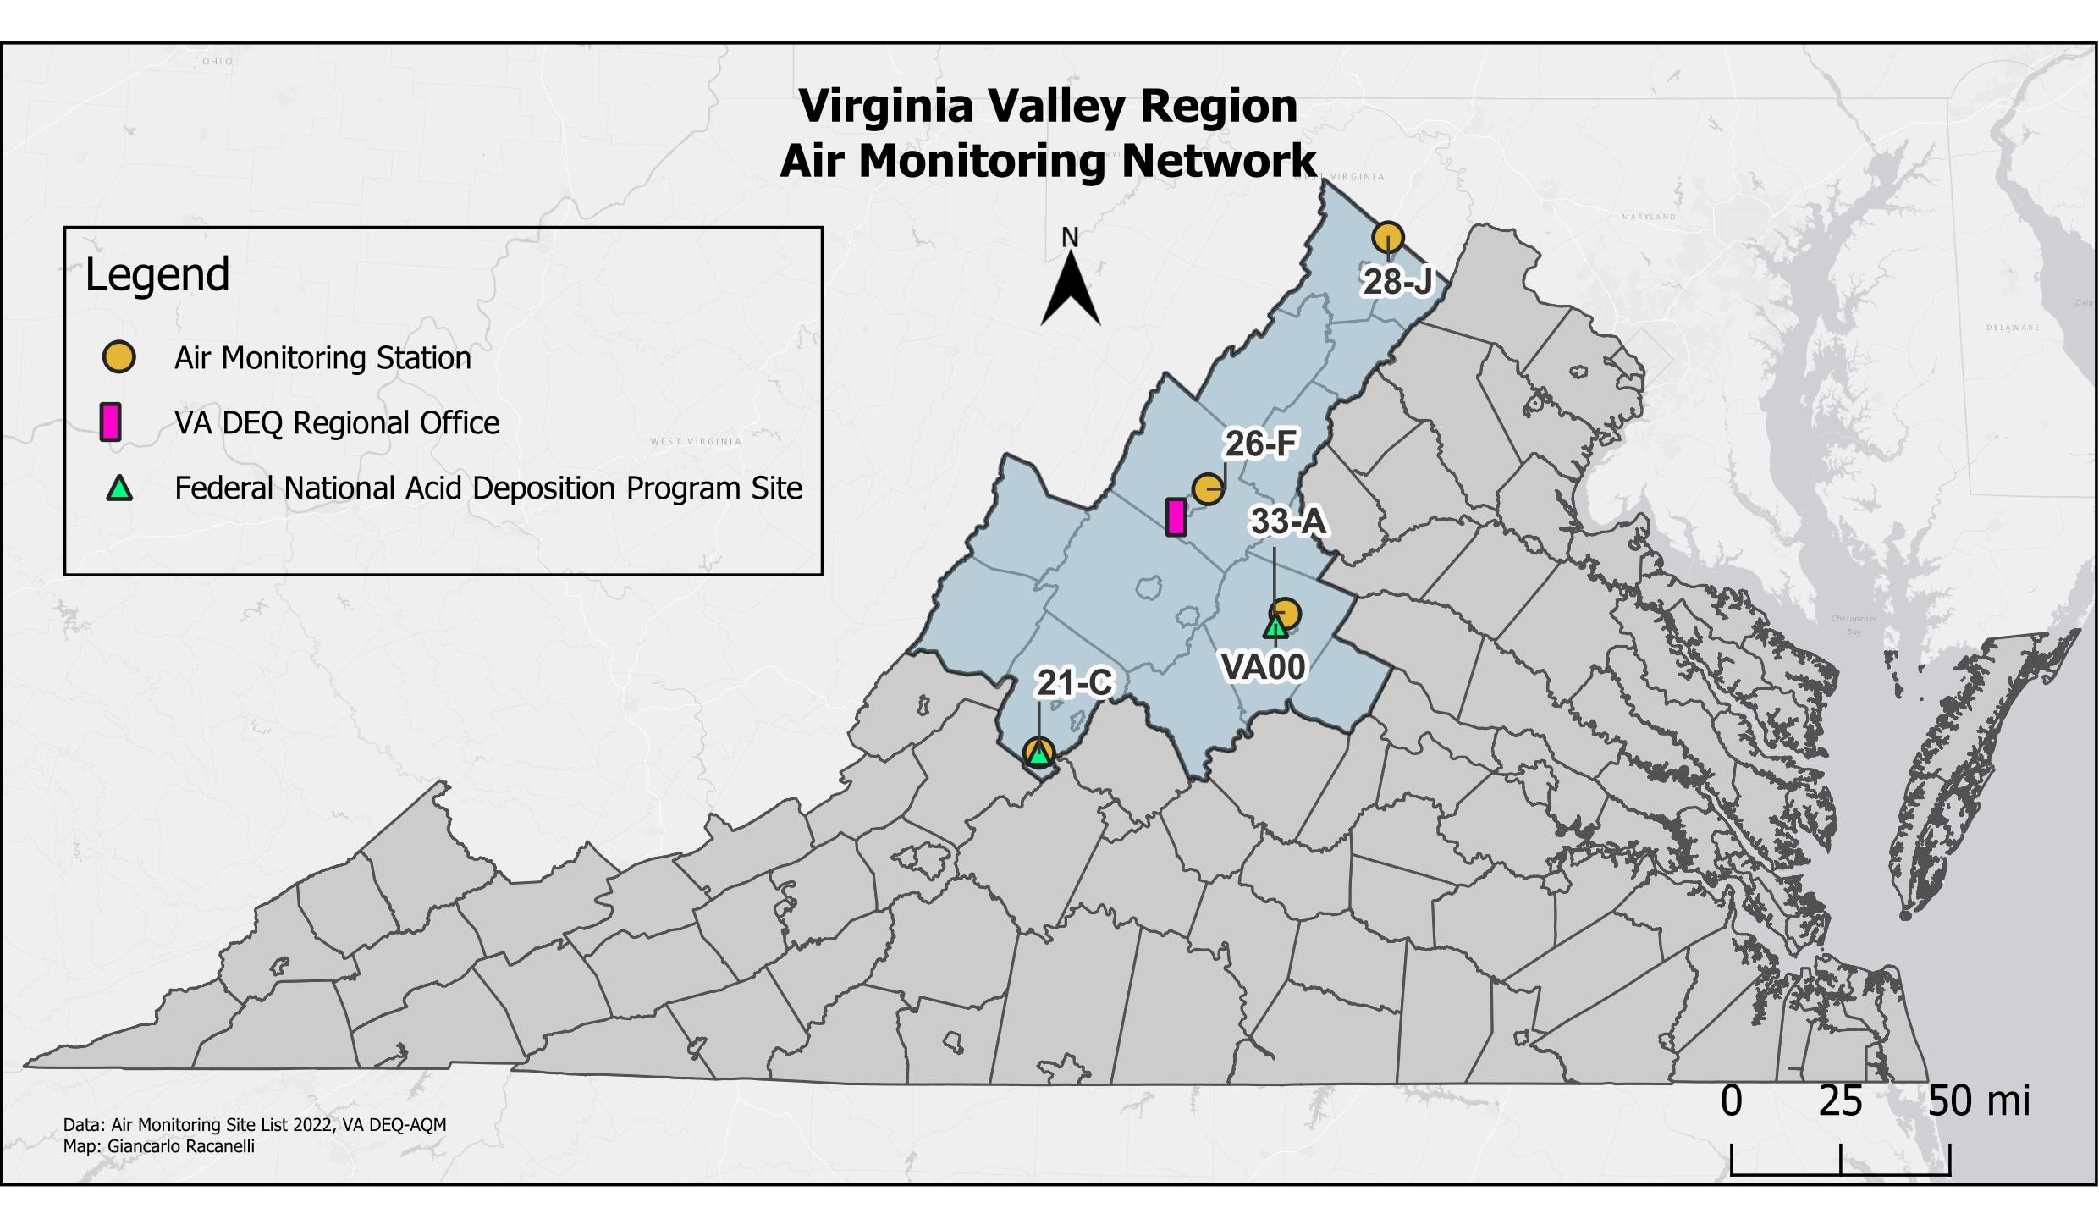

STATION  NUMBER | POLLUT. | LOCATION | EPA ID | CITY/COUNTY | LAT/LONG
21-C | O₃, IMPROVE | Natural Bridge Ranger Station | 51-163-0003 | Rockbridge Co. | 37.62668  -79.51257
26-F | PM_{2.5}, SO₂, NO₂,O₃ | Rockingham VDOT | 51-165-0003 | Harrisonburg  Rockingham Co. | 38.47753  -78.81952
28-J | O₃, PM_{2.5}, PM_{2.5} cont. | Woodbine Road  Lester Building Systems | 51-069-0010 | Rest  Frederick Co. | 39.28102  -78.08157
33-A | O₃, PM_{2.5}, PM_{2.5} cont. | Albemarle High School | 51-003-0001 | Albemarle Co. | 38.07657  -78.50397

STATION  NUMBER | POLLUT. | LOCATION | EPA ID | CITY/COUNTY | LAT/LONG
VA00 | NADP | Charlottesville | NA | Albemarle | 38.0402  -78.5427
VA99 | NADP | Natural Bridge Ranger Station | 51-163-0003 | Rockbridge Co. | 37.62668  -79.51257

Contact information for this Region:
Valley Regional Office
Tiffany Severs, Director
P.O. Box 3000
4411 Early Road
Harrisonburg, VA 22801
(540) 574-7808

Blue Ridge Monitoring Network

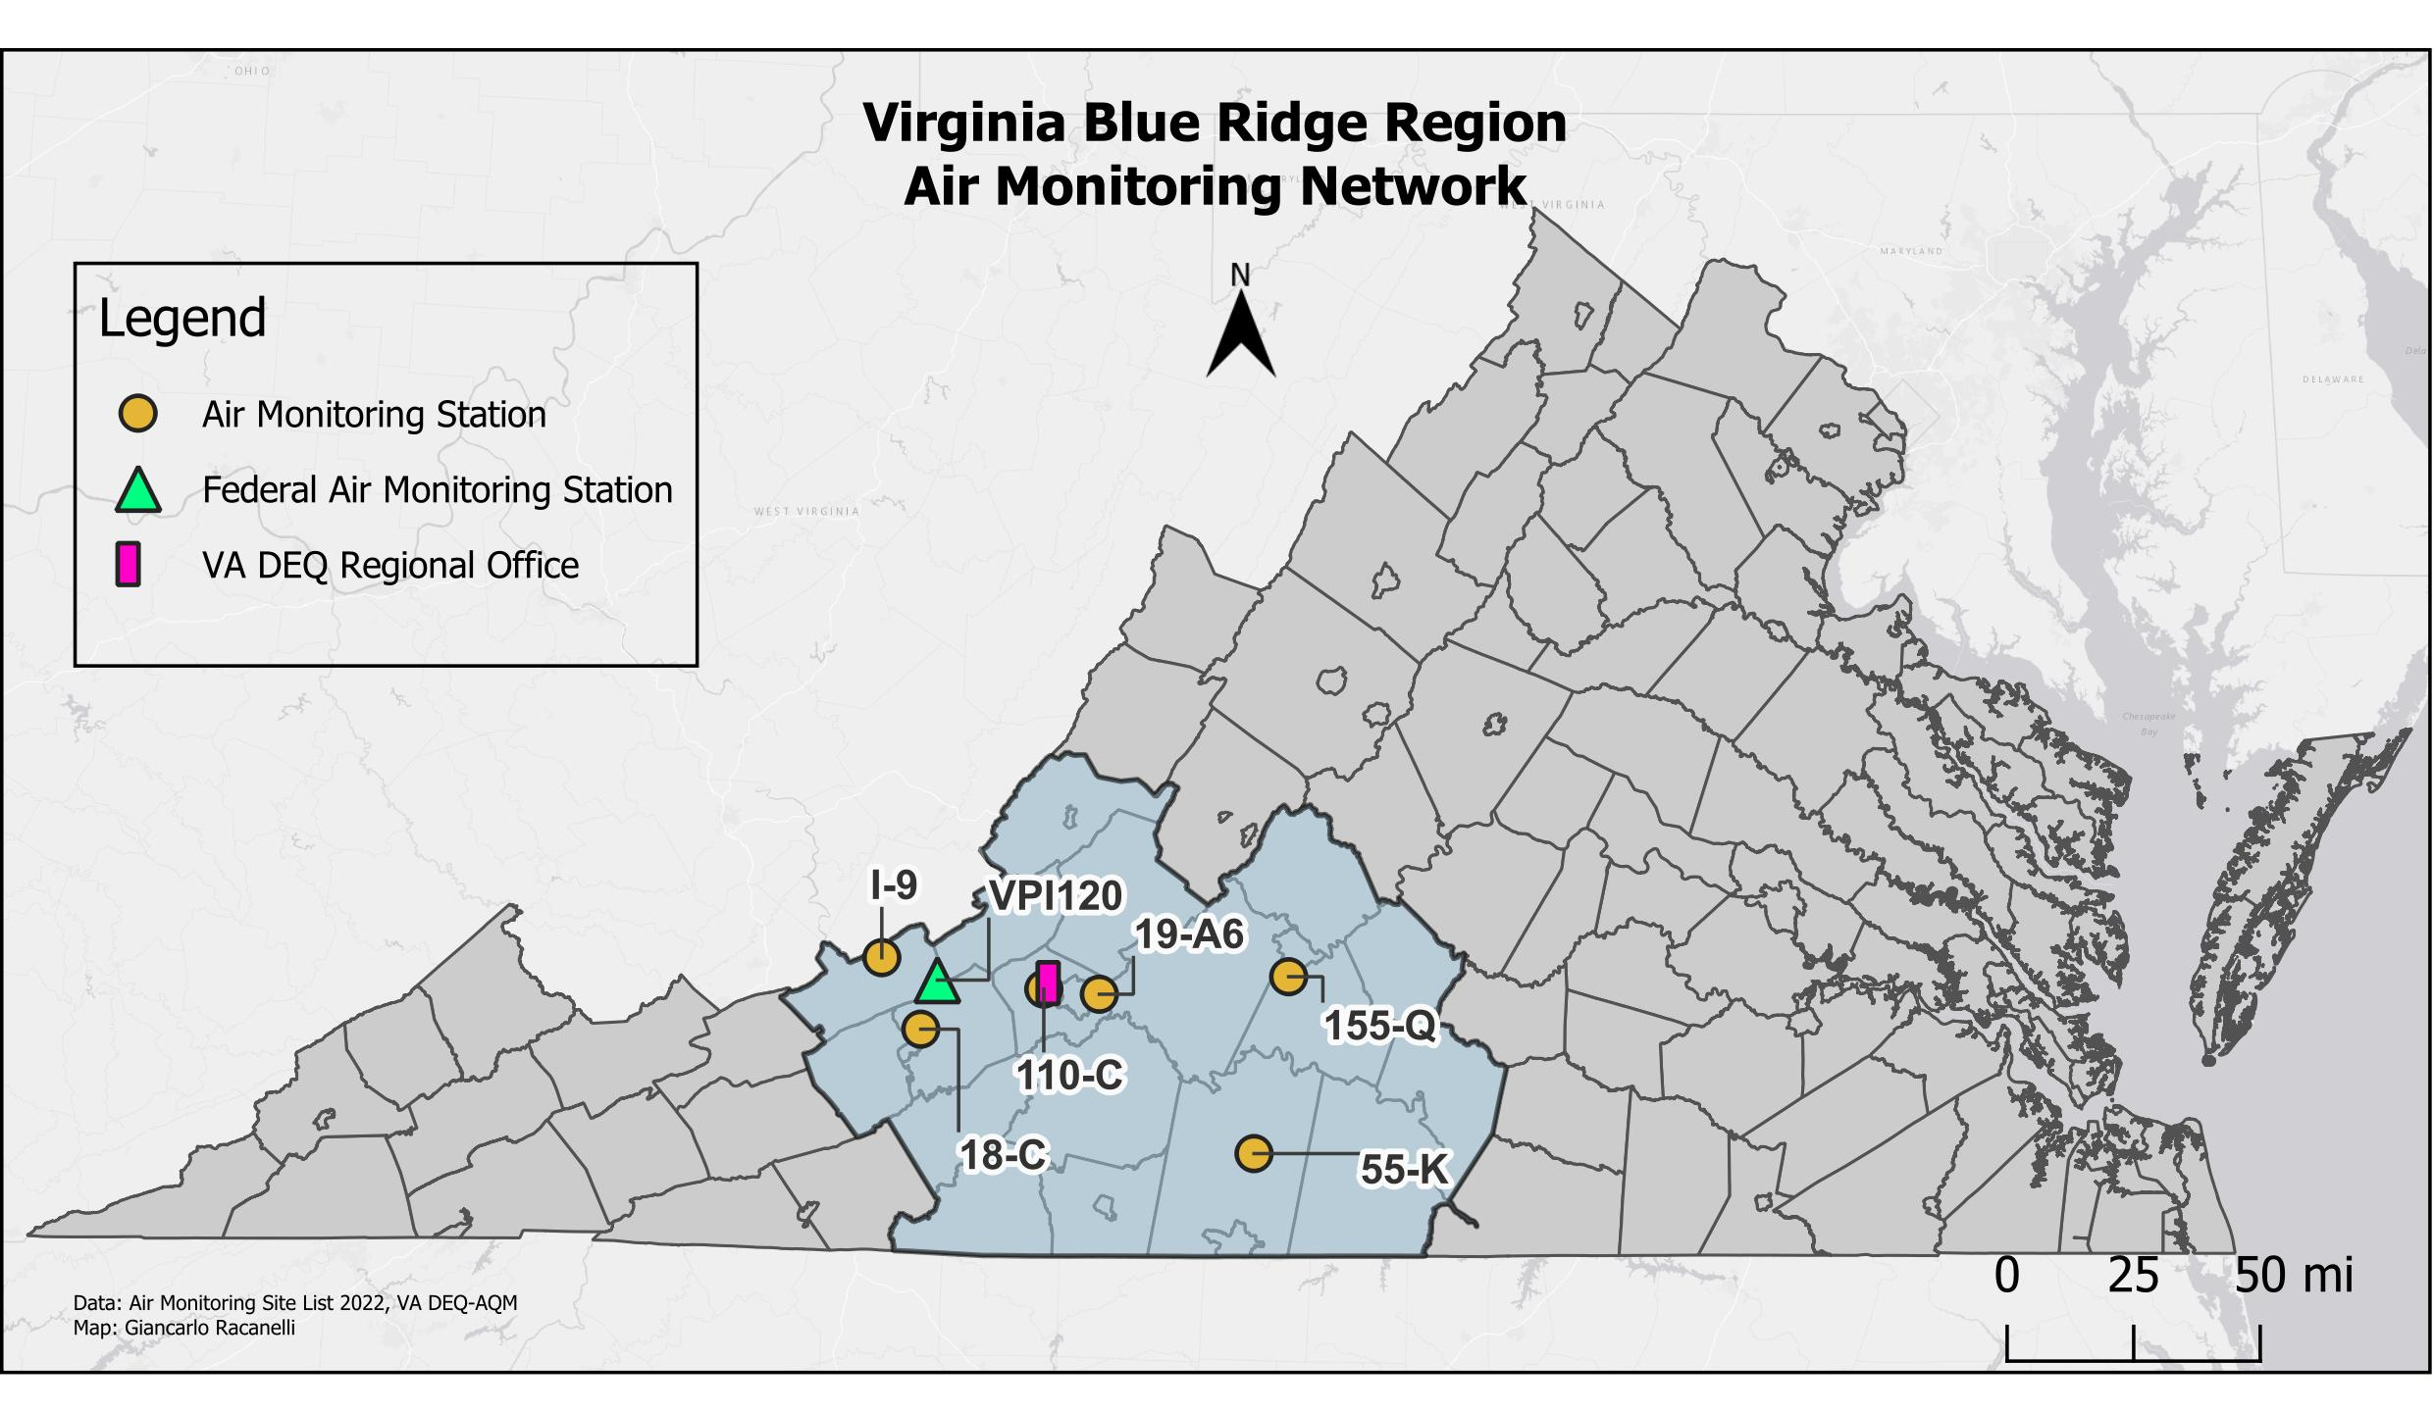

STATION  NUMBER | POLLUT. | LOCATION | EPA ID | CITY/COUNTY | LAT/LONG
18-C | Lead | Stroubles Creek Wastewater Treatment Plant | 51-121-0009 | Montgomery Co. | 37.18494  -80.51606
19-A6 | CO,SO₂, NO₂, O_{3,} PM_{2.5} | East Vinton Elementary School  Ruddell Road | 51-161-1004 | Vinton  Roanoke Co. | 37.28342  -79.88452
110-C | PM_{2.5} | Salem High School | 51-775-0011 | Salem | 37.29788  -80.08102
155-Q | PM_{2.5} | Leesville Hwy. & Greystone Dr. | 51-680-0015 | Lynchburg | 37.33175  -79.21478

STATION  NUMBER | POLLUT. | LOCATION | EPA ID | CITY/COUNTY | LAT/LONG
9-I | SO₂ | Giles County | 51-071-0007 | Giles County | 37.3863  -80.6539
55-K | NO₂ | Williams Transco | 51-143-0005 | Pittsylvania Co. | 36.83343  -79.337469
VPI120 /  VA13 | O₃, MDN | Blue Grass Trail | 51-071-9992 | Giles County | 37.3232  -80.4572

Contact information for this Region:
Blue Ridge Regional Office
Robert Weld, Director
901 Russell Drive
Salem, VA 24153
(540) 562-6870

Piedmont Monitoring Network
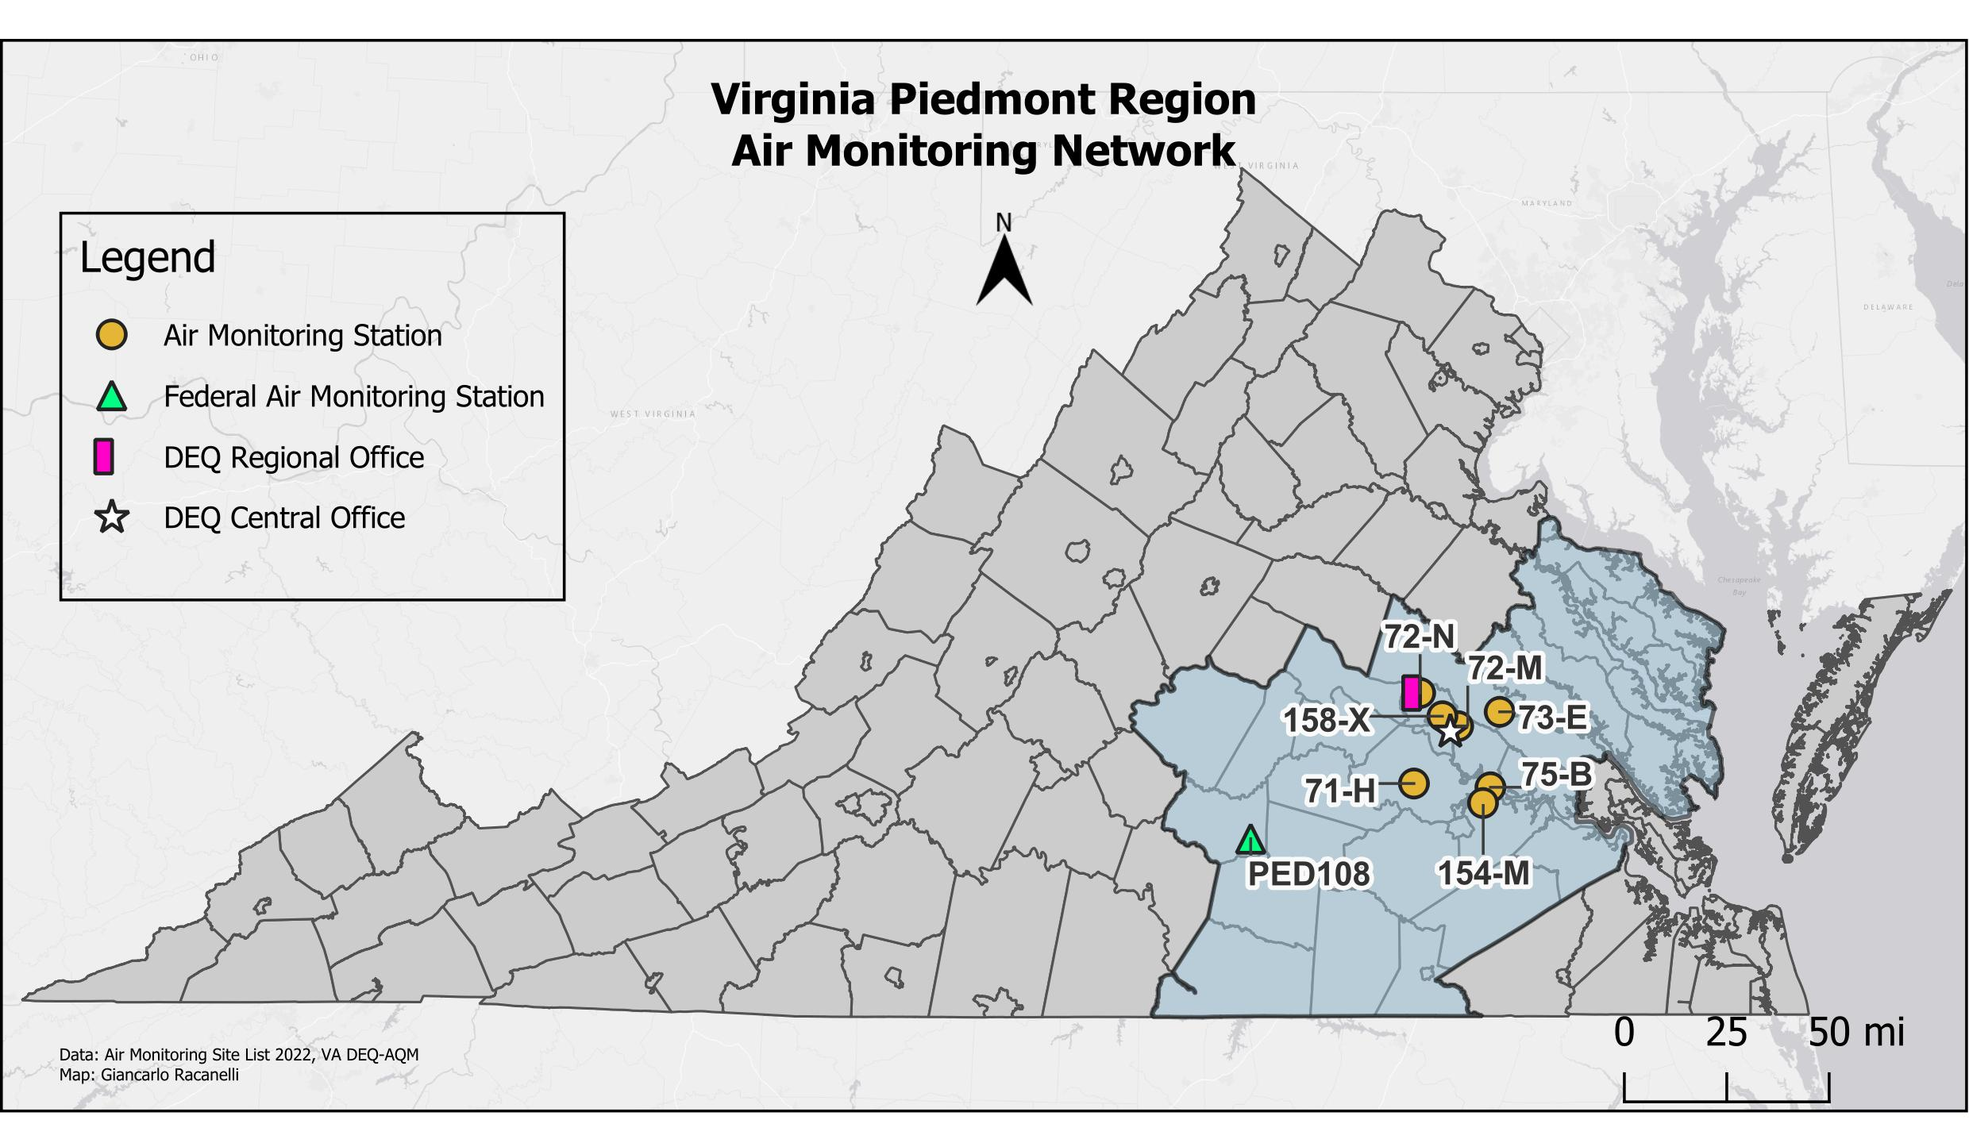
STATION  NUMBER | POLLUT. | LOCATION | EPA ID | CITY/COUNTY | LAT/LONG
71-H | O₃ | Beach Road  Highway Shop | 51-041-0004 | Chesterfield Co. | 37.35748  -77.59355
72-M | O₃, VOC, PM_{2.5}, PM₁₀, PM_{2.5} cont., Speciation, Toxics, Met, NCore, NATTS, PAMS | MathScience Innovation Center  2401 Hartman Street | 51-087-0014 | Henrico Co. | 37.55652  -77.40027
72-N | PM_{2.5} | DEQ-Piedmont Regional Office  4949-A Cox Road | 51-087-0015 | Henrico Co. | 37.67132  -77.56640
73-E | O₃ | McClellan Road | 51-085-0003 | Hanover Co. | 37.60613  -77.21880
75-B | O₃, NO₂, SO₂, PM_{2.5} | Charles City County  Route 608 | 51-036-0002 | Charles City Co. | 37.34438  -77.25925
154-M | PM₁₀, Toxics | Carter G. Woodson Middle School  1000 Winston Churchill Dr. | 51-670-0010 | Hopewell | 37.28962  -77.29182
158-X | CO, NO2, PM_{2.5} cont. | Joseph Bryan Park | 51-760-0025 | Richmond | 37.59088  -77.46925

STATION  NUMBER | POLLUT. | LOCATION | EPA ID | CITY/COUNTY | LAT/LONG
PED108/ VA24 | O₃, AMoN, NADP | Burkeville | 51-147-9991 | Prince Edward | 37.1655  -78.3069

Contact Information for this Region:
Piedmont Regional Office
James Golden, Director
4949-A Cox Road
Glen Allen, VA 23060
(804) 527-5053
Tidewater Monitoring Network

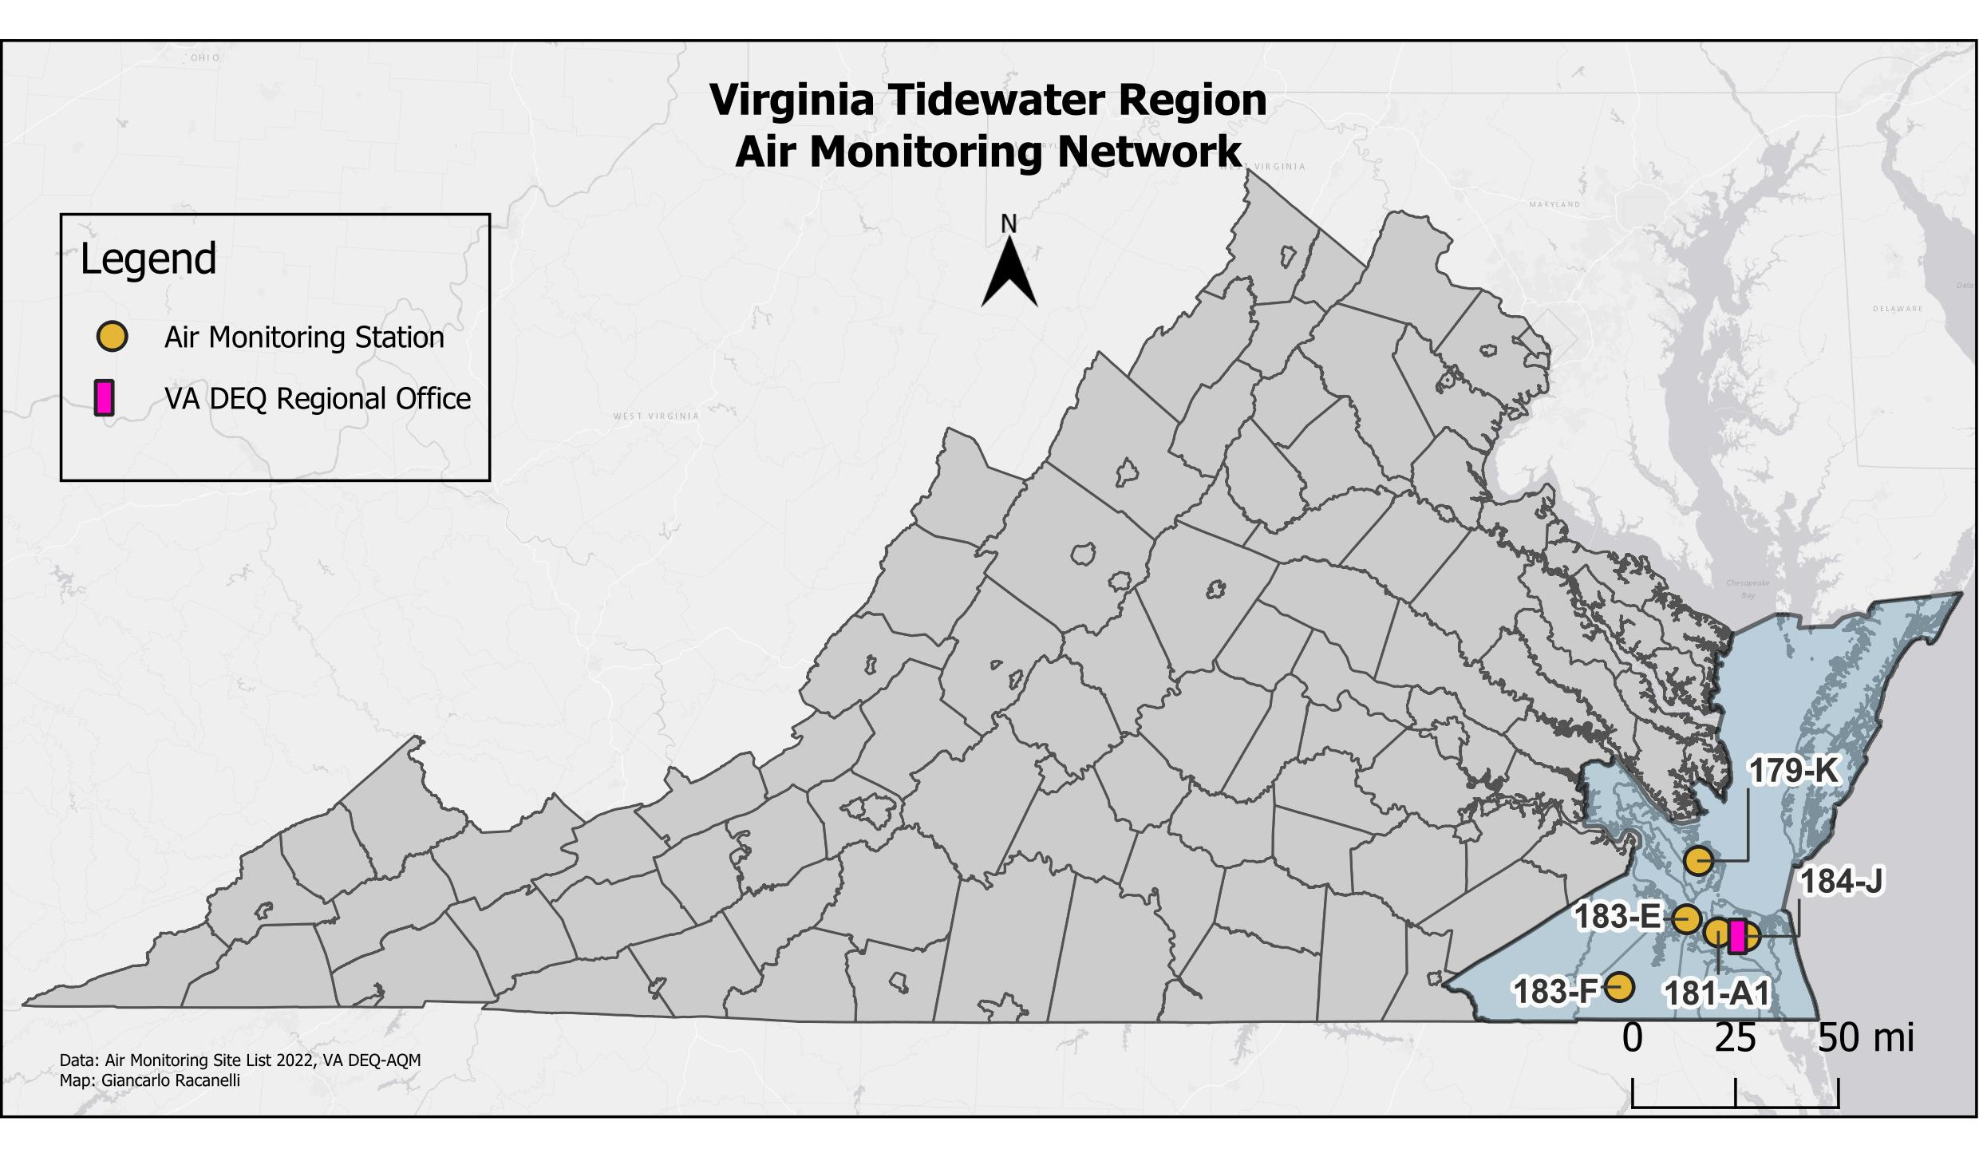

STATION  NUMBER | POLLUT. | LOCATION | EPA ID | CITY/COUNTY | LAT/LONG
179-K | CO, SO₂, NO₂, O₃, PM_{2.5}, PM_{2.5} cont., PM₁₀ | NASA Langley Research Center | 51-650-0008 | Hampton | 37.10373  -76.38702
181-A1 | CO, SO₂, NO₂, PM₁₀, PM_{2.5} | NOAA Property  2nd and Woodis Avenue | 51-710-0024 | Norfolk | 36.85555  -76.30135
183-E | O₃ | Tidewater Community College  Frederick Campus | 51-800-0004 | Suffolk | 36.90118  -76.43808
183-F | O₃ | Tidewater Research Station | 51-800-0005 | Suffolk | 36.66525  -76.73078
184-J | PM_{2.5} | DEQ – Tidewater Regional Office  5636 Southern Blvd. | 51-810-0008 | Va. Beach | 36.84188  -76.18123

Contact information for this Region:
Craig Nicol, Director
5636 Southern Blvd.
Virginia Beach, VA 23462
(757) 518-2173
Northern Monitoring Network
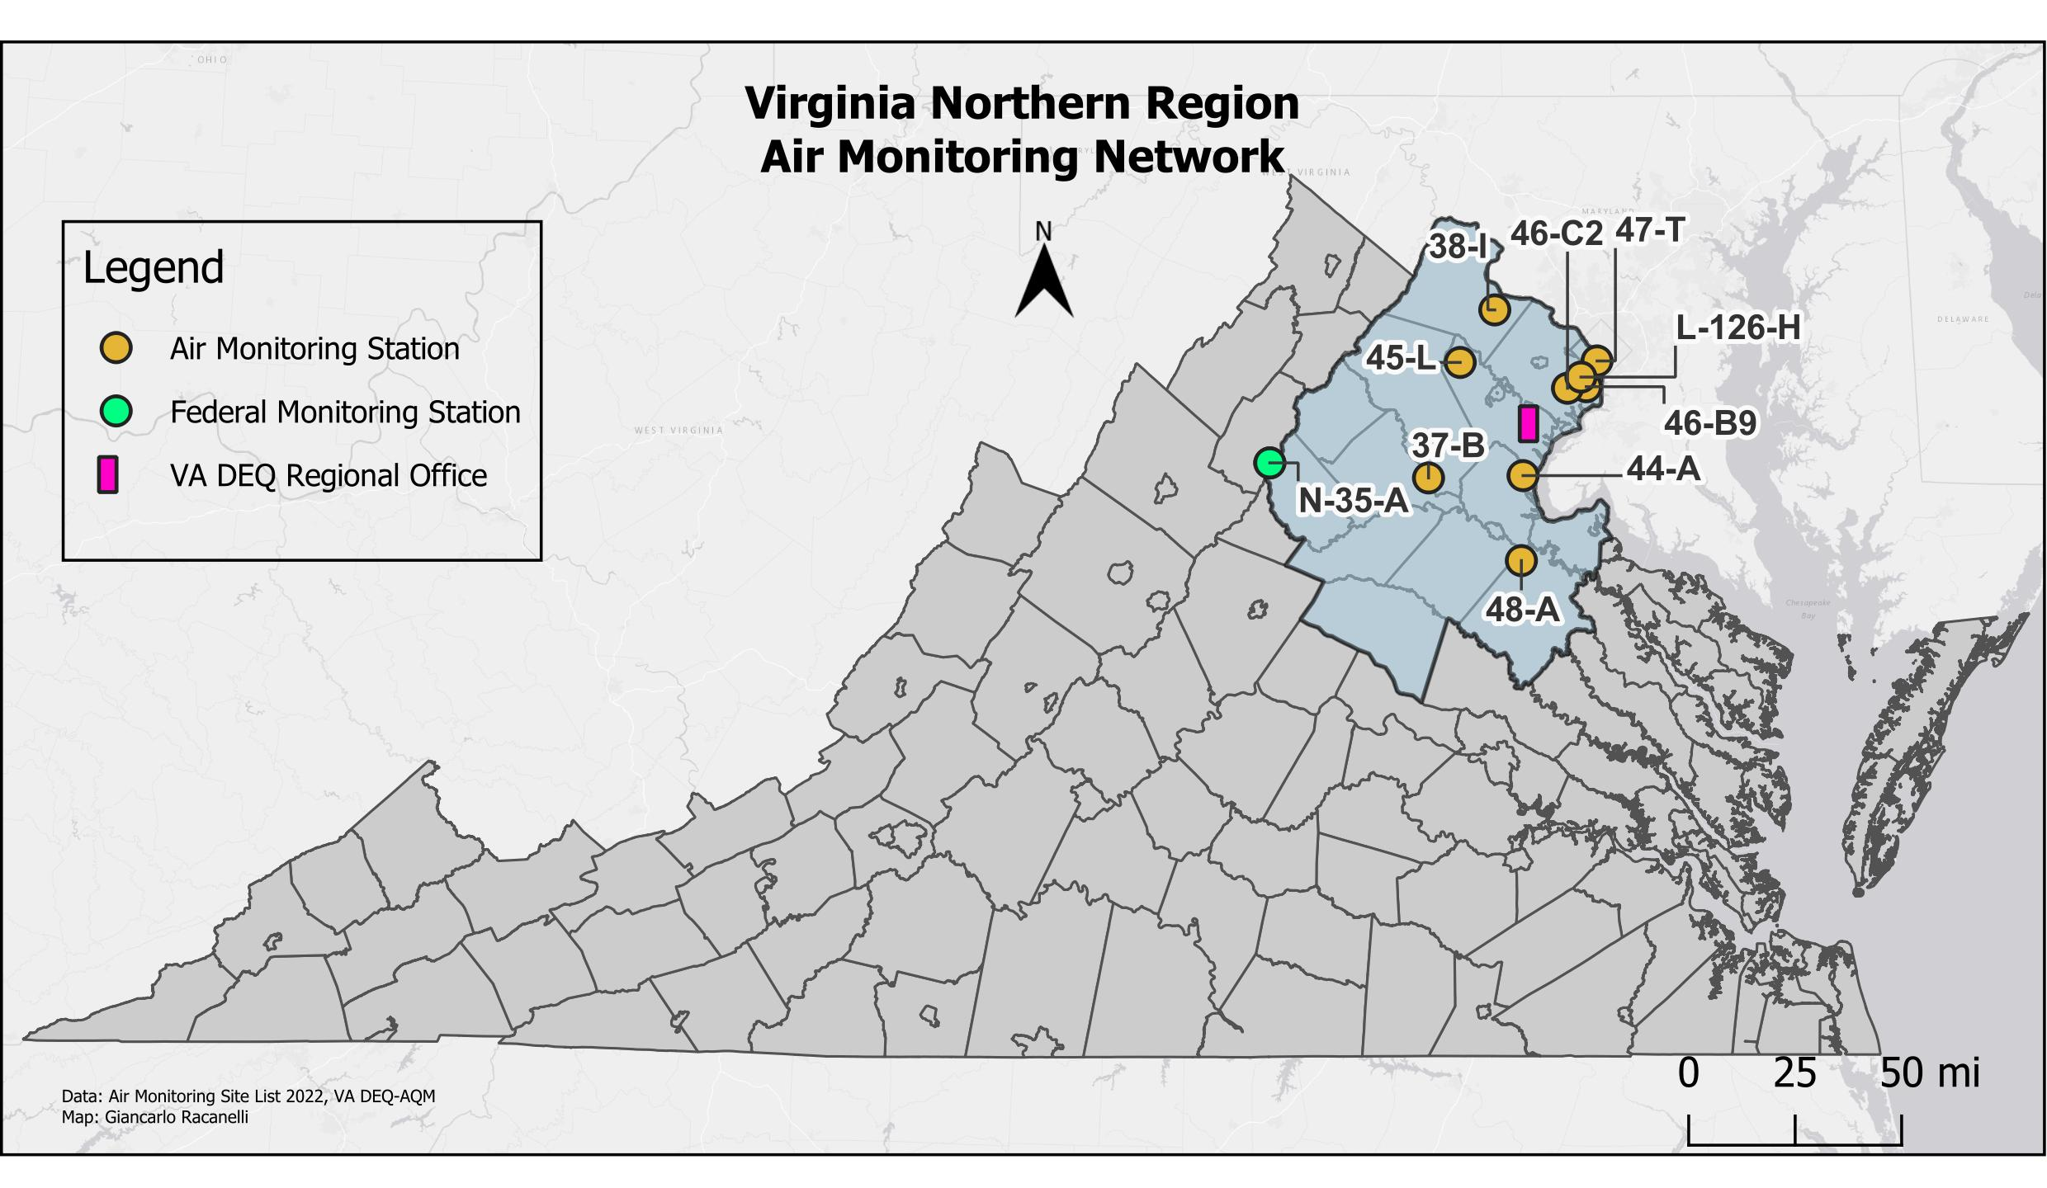
STATION  NUMBER | POLLUT. | LOCATION | EPA ID | CITY/COUNTY | LAT/LONG
37-B | O₃ | Phelps Wildlife Area  Route 651 | 51-061-0002 | Sumerduck  Fauquier Co. | 38.47367  -77.76772
38-I | O₃, NO₂, PM_{2.5} | Broad Run High School  Route 641 | 51-107-1005 | Ashburn  Loudoun Co. | 39.02473  -77.48925
44-A | O_{3,} PM₁₀ | Widewater Elementary School  Den Rich Road | 51-179-0001 | Widewater  Stafford Co. | 38.48123  -77.37040
45-L | O₃, NO₂ | Long Park, Route 15 | 51-153-0009 | Prince William Co. | 38.85287  -77.63462
46-B9 | SO₂, O₃, PM_{2.5}, PM₁₀ | Lee District Park  Telegraph Road | 51-059-0030 | Franconia  Fairfax Co. | 38.77335  -77.10468
46-C2 | CO, NO₂, PM_{2.5} cont. | 6831 Backlick Road | 51-059-0031 | Springfield  Fairfax Co. | 38.76835  -77.18347
47-T | CO, NO₂, O₃, PM_{2.5} | Aurora Hills Visitors Center  18th and Hayes Streets | 51-013-0020 | Arlington Co. | 38.85770  -77.05922
48-A | O₃ | U.S.G.S. Geomagnetic Center | 51-033-0001 | Corbin  Caroline Co. | 38.20087  -77.37742
L-126-H | PM₁₀ | 435 Ferdinand Day Drive | 51-510-0020 | Alexandria | 38.80493  -77.12687

STATION  NUMBER | POLLUT. | LOCATION | EPA ID | CITY/COUNTY | LAT/LONG
N-35-A | O3,TEOM, IMPROVE, MDN | Big Meadows, National Park Service | 51-113-0003 | Madison Co. | 38.52280  -78.43487

Contact Information for this Region:
Northern Regional Office
Thomas Faha, Director
13901 Crown Court
Woodbridge, VA 22193
(703) 583-3810

Data Capture Criteria

Calculated Value |  | Minimum Number of Observations
3-Hour Average | 3 Consecutive Hourly Observations
8-Hour Average | 6 Hourly Observations
24-Hour Average | 18 Hourly Observations
Quarterly Averages & 3-month Averages | 75% of Scheduled Samples
Yearly Averages | 75% of Total Possible Observations
Annual Weighted Means | Four Complete Quarterly Averages

National Ambient Air Quality Standards

Pollutant |  | Primary/  Secondary | Averaging  Time | Level | Form
Carbon Monoxide |  | Primary | 8-hour | 9 ppm | Not to be exceeded more than once per year
 |  |  | 1-hour | 35 ppm
Lead |  | Primary and Secondary | Rolling 3 month average | 0.15 μg/m³  ^{(a)} | Not to be exceeded
Nitrogen Dioxide |  | Primary | 1-hour | 100 ppb | 98th percentile of 1-hour daily maximum concentrations, averaged over 3 years
 |  | Primary and Secondary | Annual | 53 ppb ^{(b)} | Annual Mean
Ozone |  | Primary and Secondary | 8-hour | 0.070 ppm ^{(c)} | Annual fourth-highest daily maximum 8-hr concentration, averaged over 3 years
Particle Pollution | PM_{2.5} | Primary | Annual | 12.0 μg/m³ | Annual Mean, averaged over 3 years
 |  | Secondary | Annual | 15.0 μg/m³ | Annual Mean, averaged over 3 years
 |  | Primary and Secondary | 24-hour | 35 μg/m³ | 98th percentile, averaged over 3 years
 | PM₁₀ | Primary and Secondary | 24-hour | 150 μg/m³ | Not to be exceeded more than once per year on average over 3 years
Sulfur Dioxide |  | Primary | 1-hour | 75 ppb ^{(d)} | 99th percentile of 1-hour daily maximum concentrations, averaged over 3 years
 |  | Secondary | 3-hour | 0.5 ppm | Not to be exceeded more than once per year
^{(a)} In areas designated nonattainment for the Pb standards prior to the promulgation of the current (2008) standards, and for which implementation plans to attain or maintain the current (2008) standards have not been submitted and approved, the previous standards (1.5 µg/m3 as a calendar quarter average) also remain in effect.

^{(b)} The level of the annual NO2 standard is 0.053 ppm. It is shown here in terms of ppb for the purposes of clearer comparison to the 1-hour standard level.

^{(c)} Final rule signed October 1, 2015, and effective December 28, 2015. The previous (2008) O₃ standards additionally remain in effect in some areas. Revocation of the previous (2008) O₃ standards and transitioning to the current (2015) standards will be addressed in the implementation rule for the current standards.

^{(d)} The previous SO₂ standards (0.14 ppm 24-hour and 0.03 ppm annual) will additionally remain in effect in certain areas: (1) any area for which it is not yet 1 year since the effective date of designation under the current (2010) standards, and (2) any area for which implementation plans providing for attainment of the current (2010) standard have not been submitted and approved and which is designated nonattainment under the previous SO₂ standards or is not meeting the requirements of a SIP call under the previous SO₂ standards (40 CFR 50.4(3)). A SIP call is an EPA action requiring a state to resubmit all or part of its State Implementation Plan to demonstrate attainment of the required NAAQS.

Please see EPA's NAAQS Table for additional information.

Number of Criteria Pollutant Monitoring Sites

NCore/SLAMS 2022

REGION | PM_{2.5} | PM₁₀ | Pb | CO | SO₂ | NO₂ | O₃ | TOTAL
Southwest | 1 | 1 | --- | --- | --- | --- | 1 | 3
Valley | 4 | --- | --- | --- | 1 | 1 | 4 | 10
Blue Ridge | 3 | --- | 1 | 1 | 1 | 1 | 1 | 8
Piedmont | 5 | 3 | --- | 2 | 2 | 3 | 4 | 18
Tidewater | 3 | 2 | --- | 2 | 2 | 2 | 3 | 14
Northern | 5 | 1 | --- | 2 | 1 | 4 | 7 | 21
TOTAL | 21 | 7 | 1 | 7 | 7 | 11 | 20 | 74

Appendix B

Air Quality Internet Links

AirData – Access to national and state air pollution data
Outdoor Air Quality Data

Air Emission Data Sources
Emissions Sources

Air Now – AQI maps
Real Time AQI

American Lung Association:
USA Lung

AQS Data Mart (AQS data for the scientific and technical community):
Data Mart

CASTNET (Clean Air Status and Trends Network)
Castnet

Department of Environmental Quality link:
Virginia DEQ

Environmental Education for teachers and students:
Resources for teachers
DEQ Education webpage

EPA Popular Resources
Environmental Topics

EPA’s Technology Transfer Network (TTN) – Ambient Monitoring Technology Information Center (AMTIC)

IMPROVE
Interagency Monitoring of Protected Visual Environments

MARAMA
Mid-Atlantic Regional Air Management Association

Nonattainment area descriptions:
EPA's Green Book

U.S. EPA:
EPA
EPA Region 3 (Mid-Atlantic)

3-Day Monitoring Schedule for PM_{2.5}, PM₁₀, TSP and VOCs
Sampling Schedule Calendar

National Air Quality: Status and Trends of Key Air Pollutants
Air Trends

References

Code of Federal Regulations – 40 CFR 50 & 58
Electronic Code of Federal Regulations

Virginia Ambient Air Monitoring Data Reports
DEQ's Air Monitoring Publications

Air Quality System (AQS)
EPA's AQS

National Ambient Air Quality Standards
EPA NAAQS

